Ally Introduction
Ally by Blackboard is an accessibility software that is integrated directly into the Canvas Learning Management System (LMS). It scans all file formats (.doc, .docx, .png, PDF, etc.) in a course and produces an accessibility rating for those files. This rating is illustrated in the LMS by a speedometer icon that appears red (poor accessibility rating), yellow (moderate accessibility rating), and green (high accessibility rating). In addition to providing a rating, or score on the accessibility of any given file format, it also provides the user with step-by-step instructions for remediating the file and replacing all versions of the file within the LMS.

Level 1 Training Summary

The Canvas Course Design Foundations professional development course (Level 1) focuses on the layout and delivery of digital content in the Canvas Learning Management System (LMS). A top priority of this program is to ensure that content delivery in the LMS is consistently, logically, and accessibly provided to all learners. For the purposes of the Ally Study, we focused on the following Level 1 Learning Objective: To create accessible Canvas pages, assignments, discussion, and quizzes. Participants in this program, whom primarily completed the course in Summer, 2020, learned how to create content in an accessible format using the tools in the Canva Rich Content Editor, submitted samples, and received feedback from CTET Staff and course facilitators.

Methods
Overall Ally Scores(OAS) were collected for all courses taught in F19 and F20. To compare changes in OAS we selected courses that were taught by a single instructor, with that instructor teaching the same named course in both F19 and F20. To be sure that we were on looking at courses that were using the Canvas platform in some capacity we additionally filtered out courses that had 0 students, contained 0 course pages, or contained 0 course files.
Pairing F19/F20 courses with the same name, taught by the same instructor each term, we measured the difference in OAS ($δ_{OAS}=OAS_{F20}-OAS_{F19}$) between the two courses. We then compared $δ_{OAS}$ between two groups of course pairings. Group 1 consisted of 128 F19/F20 course pairings from faculty that had taken the Level 1 training in Summer 2020. Group 2 consisted of 237 F19/F20 course pairings from all other faculty.
To compare these groups, a hypothesis test for a difference of the mean differences in OAS between the two groups ($μ_{δ_{OAS},1}-μ_{δ_{OAS},2}$) was performed with a test of homogeneity of variance to confirm that the two $δ_{OAS}$ distributions were comparable.

Results

The trained faculty group had a mean increase OAS of $μ_{δ_{OAS},1}=17.9\%$ between their F19 and F20 courses with the same name, while the other faculty group saw a mean increase OAS of $μ_{δ_{OAS},2}=5.2\%$ between their F19 and F20 courses with the same name (Fig. 1). This difference of 12.7% is significantly greater than no difference ($p<0.001)$. The trained faculty group course pairings increase in OAS on average was over 3 times that of the other faculty group.
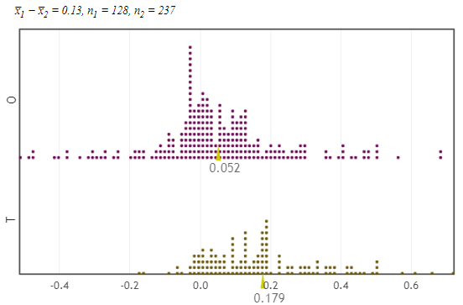
Figure 1: Distribution of $δ_{OAS}$ for both the trained faculty and other faculty
A test of homogeneity of variance was performed and successful, confirming that the two distributions were similar enough to compare $μ_{δ_{OAS}}$ between the two groups.

Discussion
The retooling of courses to accommodate a remote modality for Fall 2020 by faculty was an enormous task. Canvas as a platform saw double the weekly page view between F19 and F20…
Faculty within the training were guided to work on content in an existing course that they were planning to teach in the Fall.
Courses taught by the untrained faculty were more likely to have imported existing content over from a previous term, instead focusing their course development on new courses they had not developed as much.

