Thermodynamics Background
Introduction:
Thermodynamics explains much about phenomena that occur at the macroscopic level as well as the micoscopic level in the universe. In this project we will explore the how energy is transferred between matter. This is a fundamental principle in chemistry and is one topic that bridges across STEM fields. Several definitions are important to discuss about first before we talk about heat exchange. We define a system as a portion of matter which portion of matter undergoing a chemical or physical change. We can also define the surroundings which is all matter not including components of the measurement apparatus, that exchanges heat to or from the system. Additionally, scientists define the type of system they are studying. An open system [see Fig 1(a)] matter and energy can be freely exchanged between the boundary/ In a in a closed system [see Fig 1(b)] energy can be exchanged between the boundaries.
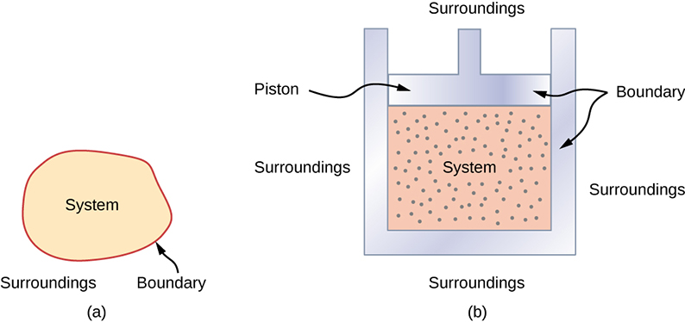
Figure 1: Defining what the system and the surroundings are critical in thermodynamics. Based on these definitions the type of system can be determined. a) open system b) a closed system
Reading Check 1!
a) Draw a simplified picture of the following scenarios and b) describe if they are an open or closed system and why. Define the system and surroundings for each scenario.
- A cheese monger places cheese in a refrigerated cheese cellar.
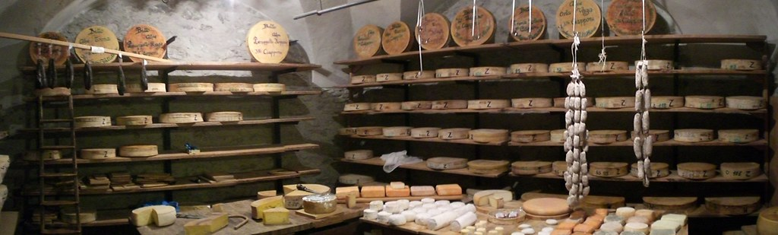
https://www.flickr.com/photos/mmondora/3337758923/
- picture:

- open/closed/system/surroundings

- Snow melts in your hand in winter.

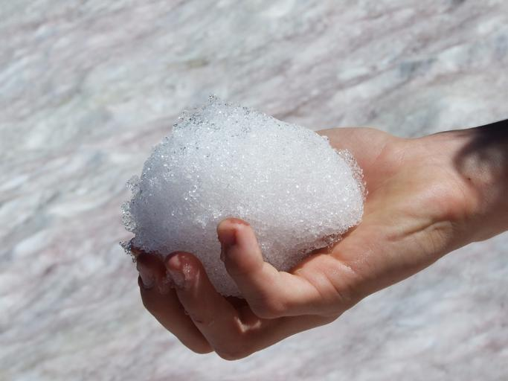
https://snappygoat.com/s/?q=bestof%3Aglacier+tunnel+honeycomb+snow+melt
- picture:

- open/closed/system/surroundings

- Hot baked potatoes in aluminum foil.
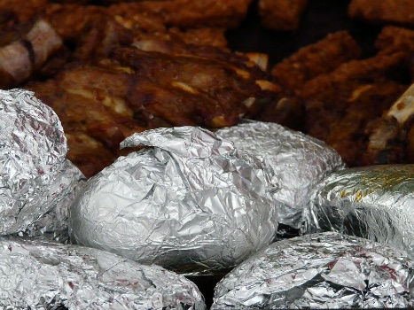
https://pixabay.com/photos/baked-potatoes-potato-dish-58735/
- picture:

- open/closed/system/surroundings

If we are interested in how heat transfer is converted into doing work, then the conservation of energy principle is important.

Background for the First Law of Thermodynamics
The first law of thermodynamics applies the conservation of energy principle to systems where heat transfer and doing work are the methods of transferring energy into and out of the system. The first law of thermodynamics states that the change in internal energy of a system equals the net heat transfer into the system minus the net work done by the system. In equation form, the first law of thermodynamics is
ΔU=q−w
ΔU ( sometimes referred to as ΔE in general chemistry books) is the internal energy or total energy of a given system. q is defined as the heat of the system and w is defined as work.

Background for the Second Law of Thermodynamics
Have you ever played the card game 52 pickup (see Figure 2) ? If so, you have been on the receiving end of a practical joke and, in the process, learned a valuable lesson about the nature of the universe as described by the second law of thermodynamics. In the game of 52 pickup, the prankster tosses an entire deck of playing cards onto the floor, and you get to pick them up. In the process of picking up the cards, you may have noticed that the amount of work required to restore the cards to an orderly state in the deck is much greater than the amount of work required to toss the cards and create the disorder.

https://www.flickr.com/photos/kasimetcalfe/113206065
Figure 2: Stroboscopic photography – “52 pick-up”
The second law of thermodynamics states that the total entropy of a system either increases or remains constant in any spontaneous process; it never decreases. An important implication of this law is that heat transfers energy spontaneously from higher- to lower-temperature objects, but never spontaneously in the reverse direction. This is because entropy increases for heat transfer of energy from hot to cold (see Figure 3). Here T is defined as temperature and q is defined as heat. Because the change in entropy is q/T, there is a larger change in ΔS at lower temperatures (smaller T). The decrease in entropy of the hot (larger T) object is therefore less than the increase in entropy of the cold (smaller T) object, producing an overall increase in entropy for the system.

Figure 3: The ice in this drink is slowly melting. Eventually, the components of the liquid will reach thermal equilibrium, as predicted by the second law of thermodynamics—that is, after heat transfers energy from the warmer liquid to the colder ice. (Jon Sullivan, PDPhoto.org)

Reading Check 2!
Using the information presented above, write a caption description for (a) (b) and (c). Explain how or why each relates to the second law of thermodynamics.

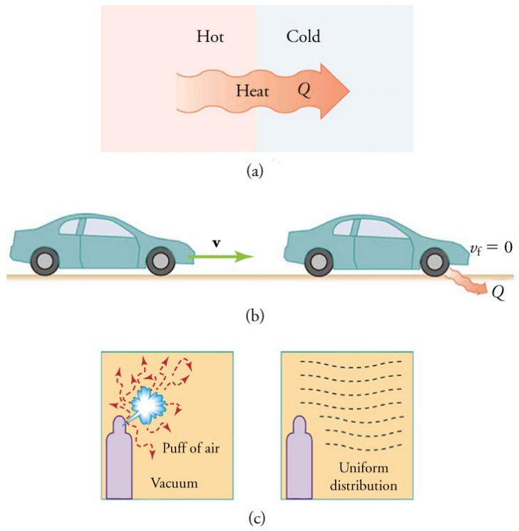
(a): ________________________
(b): ________________________
(c): ________________________
Figure 4 : The second law of thermodynamics

Background for specific heat
Historically, energy was measured in units of calories (cal). A calorie is the amount of energy required to raise one gram of water by 1 degree C (1 kelvin). However, this quantity depends on the atmospheric pressure and the starting temperature of the water. The ease of measurement of energy changes in calories has meant that the calorie is still frequently used. The Calorie (with a capital C), or large calorie, commonly used in quantifying food energy content, is a kilocalorie. The SI unit of heat, work, and energy is the joule. A joule (J) is defined as the amount of energy used when a force of 1 newton moves an object 1 meter. It is named in honor of the English physicist James Prescott Joule. One joule is equivalent to 1 kg m²/s², which is also called 1 newton–meter. A kilojoule (kJ) is 1000 joules. To standardize its definition, 1 calorie has been set to equal 4.184 joules.
We now introduce two concepts useful in describing heat flow and temperature change. The heat capacity (C ) of a body of matter is the quantity of heat (q) it absorbs or releases when it experiences a temperature change (ΔT) of 1 degree Celsius (or equivalently, 1 kelvin)
C=qΔT
Heat capacity is determined by both the type and amount of substance that absorbs or releases heat. It is therefore an extensive property—its value is proportional to the amount of the substance. Each substance has its own specific heat which is defined as the amount of heat required to heat one gram by 1 degree C. The specific heat capacity is an example of an intensive property- its value is independent of amount of the substance.

Substance | Symbol (state) | Specific Heat (J/g °C)
helium | He(g) | 5.193
water | H₂O(l) | 4.184
ethanol | C₂H₆O(l) | 2.376
ice | H₂O(s) | 2.093 (at −10 °C)
water vapor | H₂O(g) | 1.864
nitrogen | N₂(g) | 1.04
air |  | 1.007
oxygen | O₂(g) | 0.918
aluminum | Al(s) | 0.897
carbon dioxide | CO₂(g) | 0.853
argon | Ar(g) | 0.522
iron | Fe(s) | 0.449
copper | Cu(s) | 0.385
lead | Pb(s) | 0.13
gold | Au(s) | 0.129
silicon | Si(s) | 0.712
Table 1: List of specific heats for a variety of substances.

Reading Check 3!
Compare three substances (air + iron + water) if 10grams of each are heated at the same time from 10K to 150K. (Hint: use table #1)

Temp

Time

Project: Construction of a Zeer Pot
Background of the Zeer Pot:
Please read the following online article https://www.nationalgeographic.com/science/article/mohammed-bah-abba-explorer-moments-cooling-technology-helping-Africans for a description on what a Zeer pot is and how it can be used.

Explain how the article relates to thermodynamics:

Intro to Zeer pots
Background the construction of the Zeer Pot:

Please read the following online article about how to construct a Zeer pot:
https://web.archive.org/web/20140714185554/http://www.movement-verein.org/downloads/Movement_Clay-pot-cooler_english.pdf
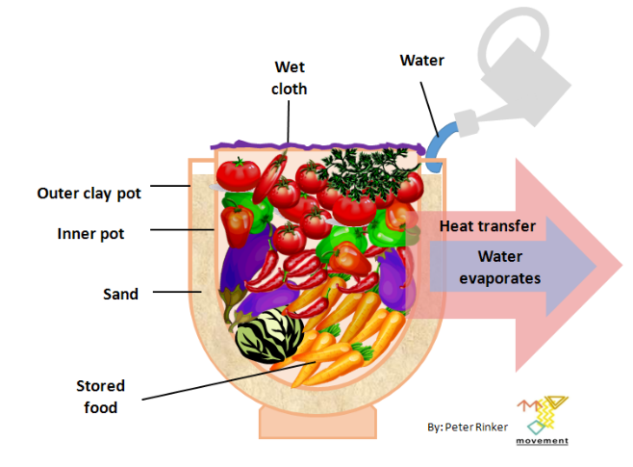
https://commons.wikimedia.org/wiki/File:Clay_pot_cooler_-_Canari_Frigo_-_Tonkrugk%C3%BChler.PNG
Figure 5: A schematic of the typical Zeer pot.
Zeer pots function based their ability to evaporate and exchange heat. As we have seen above the exchange of heat can be influenced by the materials chosen. Clay pots are generally used to make Zeer pots due to cost/availability/porosity/specific heat. A Zeer pot is an example of closed system and below is a description of how heat transfer takes place under a phase transition (see Figure 6).
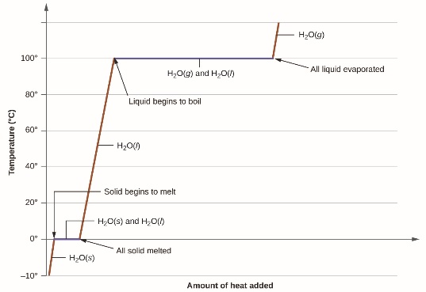
Figure 6: A heating curve of water. The diagonal portions of the plot describe the heating of a single phase and be related to the kinetic energy of a substance. The horizonal portions of the plot are phase transitions and related to the matters potential energy.
A typical heating curve for a substance depicts changes in temperature that result as the substance absorbs increasing amounts of heat. Plateaus in the curve (regions of constant temperature) are exhibited when the substance undergoes phase transitions. At this phase the system is in a dynamic equilibrium. Figure below

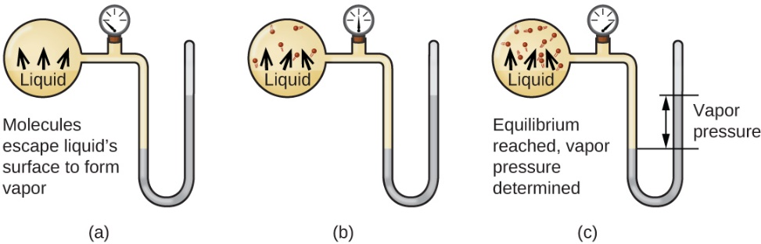
Figure 7: Vapor pressure in a closed system.

In a closed container (see Figure 7), dynamic equilibrium is reached when (a) the rate of molecules escaping from the liquid to become the gas (b) increases and eventually (c) equals the rate of gas molecules entering the liquid. When this equilibrium is reached, the vapor pressure of the gas is constant, although the vaporization and condensation processes continue.
We will next make a Zeer pot and take some experimental data.
Construction of a Zeer Pot
Materials:
A hydrometer, 2 pots, sand, a digital or wireless meat thermometer, tomatoes, a computer and graphing software(optional: small digital scale)
Please read the following suggestions to make a Zeer pot. Can you do better? Once you have your zeer pot fill it with something cheap like tomatoes make a plot of the champers humidity vs time, temperature vs time. You can also plot mass vs. time if you have access to a digital scale. (If you are using a digital thermometer, take the humidity and temperature readings (of the inside of the pot) every 30 seconds for 3 minutes then readings every 15 min for 2.5 hours. Take a reading after 12/24 hours also. Take the temperature and humidity of the room as well. If you have a wireless digital thermometer set up a measurement for 2.5 hours and take humidity readings like the digital thermometer case.
Make a plot using a graphing software and determine the rate of evaporation experimentally. Determine the minimum temperature that can be reached with your set up. Compare this rate / min. temp to other people in your class.
- What could you do to improve your set up?
- How long could you maintain your minimum temperature.
- Devise and experiment that could test how long your food would be viable for.
- How do you think the room humidity could affect your results.
- If you used a digital scale determine how often you would need to refile the zeer pot.

References
Arse`ne Chemin, Victor Dit Vehel, Aude Caussarieu, Nicolas Plihon, and Nicolas Taberle Am. J. Phys. 86 (3), March 2018
Openstax
Libretext
www.nationalgeographic.com
https://movement-verein.org/

