Vapor Pressure
Background Objectives:
Definition of Vapor Pressure and variables that affect vapor pressure.
Introduction:
Nearly all of us have heated a pan of water with the lid in place and shortly thereafter heard the sounds of the lid rattling and hot water spilling onto the stovetop. When a liquid is heated, its molecules obtain sufficient kinetic energy to overcome the forces holding them in the liquid and they escape into the gaseous phase. By doing so, they generate a population of molecules in the vapor phase above the liquid that produces a pressure—the vapor pressure of the liquid. In the situation we described, enough pressure was generated to move the lid, which allowed the vapor to escape. If the vapor is contained in a sealed vessel, however, such as an unvented flask, and the vapor pressure becomes too high, the flask will explode (as many students have unfortunately discovered). In this section, we describe vapor pressure in more detail.

Evaporation and Condensation
Because the molecules of a liquid are in constant motion, we can plot the fraction of molecules with a given kinetic energy (KE) against their kinetic energy to obtain the kinetic energy distribution of the molecules in the liquid (Figure 1), just as we did for a gas. As for gases, increasing the temperature increases both the average kinetic energy of the particles in a liquid and the range of kinetic energy of the individual molecules. If we assume that a minimum amount of energy (E₀) is needed to overcome the intermolecular attractive forces that hold a liquid together, then some fraction of molecules in the liquid always has a kinetic energy greater than E₀. The fraction of molecules with a kinetic energy greater than this minimum value increases with increasing temperature. Any molecule with a kinetic energy greater than E₀ has enough energy to overcome the forces holding it in the liquid and escape into the vapor phase. Before it can do so, however, a molecule must also be at the surface of the liquid, where it is physically possible for it to leave the liquid surface; that is, only molecules at the surface can undergo evaporation (or vaporization), where molecules gain sufficient energy to enter a gaseous state above a liquid’s surface, thereby creating a vapor pressure.
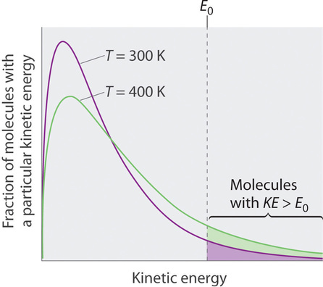
E₀ is the minimum KE needed to escape.
Figure 1. The Distribution of the Kinetic Energies of the Molecules of a Liquid at Two Temperatures. Just as with gases, increasing the temperature shifts the peak to a higher energy and broadens the curve. Only molecules with a kinetic energy greater than E₀ can escape from the liquid to enter the vapor phase, and the proportion of molecules with KE > E₀ is greater at the higher temperature. (CC BY-SA-NC; Anonymous by request)

To understand the causes of vapor pressure, consider the apparatus shown in Figure 2. When a liquid is introduced into an evacuated chamber (part (a) in Figure 2), the initial pressure above the liquid is approximately zero because there are as yet no molecules in the vapor phase. Some molecules at the surface, however, will have sufficient kinetic energy to escape from the liquid and form a vapor, thus increasing the pressure inside the container. As long as the temperature of the liquid is held constant, the fraction of molecules with KE>E₀ will not change, and the rate at which molecules escape from the liquid into the vapor phase will depend only on the surface area of the liquid phase.
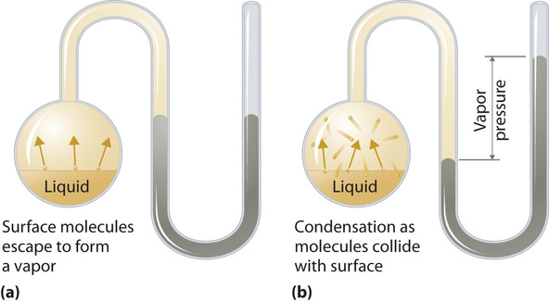
Figure 2: Vapor Pressure. (a) When a liquid is introduced into an evacuated chamber, molecules with sufficient kinetic energy escape from the surface and enter the vapor phase, causing the pressure in the chamber to increase. (b) When sufficient molecules are in the vapor phase for a given temperature, the rate of condensation equals the rate of evaporation (a steady state is reached), and the pressure in the container becomes constant. (CC BY-SA-NC; Anonymous by request)
As soon as some vapor has formed, a fraction of the molecules in the vapor phase will collide with the surface of the liquid and reenter the liquid phase in a process known as condensation (part (b) in Figure 2). As the number of molecules in the vapor phase increases, the number of collisions between vapor-phase molecules and the surface will also increase. Eventually, a steady state will be reached in which exactly as many molecules per unit time leave the surface of the liquid (vaporize) as collide with it (condense). At this point, the pressure over the liquid stops increasing and remains constant at a particular value that is characteristic of the liquid at a given temperature. The rates of evaporation and condensation over time for a system such as this are shown graphically in Figure 3.
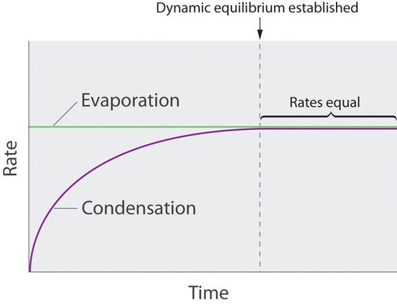
Figure 3: The Relative Rates of Evaporation and Condensation as a Function of Time after a Liquid Is Introduced into a Sealed Chamber. The rate of evaporation depends only on the surface area of the liquid and is essentially constant. The rate of condensation depends on the number of molecules in the vapor phase and increases steadily until it equals the rate of evaporation. (CC BY-SA-NC; Anonymous by request)

Equilibrium Vapor Pressure
Two opposing processes (such as evaporation and condensation) that occur at the same rate and thus produce no net change in a system, constitute a dynamic equilibrium. (Equilibrium review on Table1).
A system at equilibrium is in a state of dynamic balance, with forward and reverse reactions taking place at equal rates. If an equilibrium system is subjected to a change in conditions that affects these reaction rates differently (a stress), then the rates are no longer equal and the system is not at equilibrium. The system will subsequently experience a net reaction in the direction of greater rate (a shift) that will re-establish the equilibrium. This phenomenon is summarized by Le Châtelier’s principle: if an equilibrium system is stressed, the system will experience a shift in response to the stress that re-establishes equilibrium. | 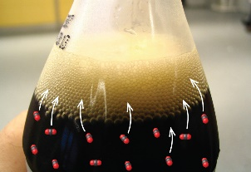  Opening a soft-drink bottle lowers the CO₂ pressure above the beverage, shifting the dissolution equilibrium and releasing dissolved CO₂ from the beverage. (credit: modification of work by “D Coetzee”/Flickr)
Table 1. Review on the Le Châtelier’s principle.
In the case of a liquid enclosed in a chamber (closed system review, Table 2) the molecules continuously evaporate and condense, but the amounts of liquid and vapor do not change with time. The pressure exerted by a vapor in dynamic equilibrium with a liquid is the equilibrium vapor pressure of the liquid.
If a liquid is in an open container (open system review, Table 2), however, most of the molecules that escape into the vapor phase will not collide with the surface of the liquid and return to the liquid phase. Instead, they will diffuse through the gas phase away from the container, and an equilibrium will never be established. Under these conditions, the liquid will continue to evaporate until it has “disappeared.”
Normally, a system must have some interactions with its surroundings. A system is called an isolated and closed system if it is completely separated from its environment—for example, a gas that is surrounded by immovable and thermally insulating walls. In reality, a closed system does not exist unless the entire universe is treated as the system, or it is used as a model for an actual system that has minimal interactions with its environment. Most systems are known as an open system, which can exchange energy and/or matter with its surroundings
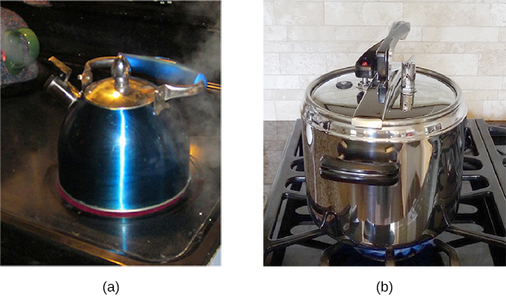
(a) This boiling tea kettle is an open thermodynamic system. It transfers heat and matter (steam) to its surroundings. (b) A pressure cooker is a good approximation to a closed system. A little steam escapes through the top valve to prevent explosion. (credit a: modification of work by Gina Hamilton; credit b: modification of work by Jane Whitney)

Table 2. Opened and Closed system review.
The speed with which the liquid will continue to evaporate depends on the vapor pressure of the liquid and the temperature. Volatile liquids have relatively high vapor pressures and tend to evaporate readily; nonvolatile liquids have low vapor pressures and evaporate more slowly. Although the dividing line between volatile and nonvolatile liquids is not clear-cut, as a general guideline, we can say that substances with vapor pressures greater than that of water (Figure 4) are relatively volatile, whereas those with vapor pressures less than that of water are relatively nonvolatile. Thus, diethyl ether (ethyl ether), acetone, and gasoline are volatile, but mercury, ethylene glycol, and motor oil are nonvolatile.
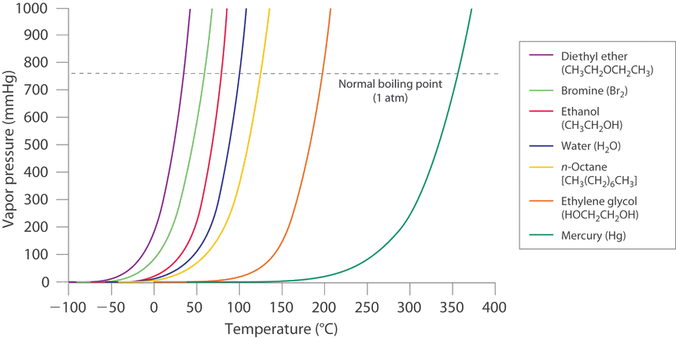Figure 4: The Vapor Pressures of Several Liquids as a Function of Temperature. The point at which the vapor pressure curve crosses the P = 1 atm line (dashed) is the normal boiling point of the liquid. (CC BY-SA-NC; Anonymous by request)
The equilibrium vapor pressure of a substance at a particular temperature is a characteristic of the material, like its molecular mass, melting point, and boiling point. It does not depend on the amount of liquid (Intensive properties review, Table 3) as long as at least a tiny amount of liquid is present in equilibrium with the vapor.
An intensive property is a property of matter that depends only on the type of matter in a sample and not on the amount.  For example: The electrical conductivity of a substance is a property that depends only on the type of substance. Silver, gold, and copper are excellent conductors of electricity, while glass and plastic are poor conductors. A larger or smaller piece of glass will not change this property. Other intensive properties include color, temperature, density, and solubility. | The copper wire shown in the picture below has a certain electrical conductivity. You could cut off the small end that sticks out, and it would have the same conductivity as the entire long roll of wire shown here. The conductivity is a property of the copper metal itself, not of the length of the wire.  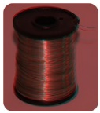  Copper wire.

Table 3. Intensive Properties Review
The equilibrium vapor pressure does, however, depend very strongly on the temperature and the intermolecular forces present, as shown for several substances in Figure 4. Molecules that can hydrogen bond, such as ethylene glycol, have a much lower equilibrium vapor pressure than those that cannot, such as octane. The nonlinear increase in vapor pressure with increasing temperature is much steeper than the increase in pressure expected for an ideal gas over the corresponding temperature range. The temperature dependence is so strong because the vapor pressure depends on the fraction of molecules that have a kinetic energy greater than that needed to escape from the liquid, and this fraction increases exponentially with temperature. As a result, sealed containers of volatile liquids are potential bombs if subjected to large increases in temperature. The gas tanks on automobiles are vented, for example, so that a car won’t explode when parked in the sun. Similarly, the small cans (1–5 gallons) used to transport gasoline are required by law to have a pop-off pressure release.
Group Activity: Vapor Pressure
Group roles (adapted from Collaborative learning techniques)
Facilitator: Moderates team discussion, keeps the group on task.
Recorder: Takes notes summarizing team discussions and decisions, and keeps all necessary records.
Reporter: Serves as group spokesperson to the class or instructor.
Timekeeper: Keeps the group aware of time constraints and deadlines.
Checker: Checks to make sure all group members understand the concepts and the group’s conclusions.
Group Activity: Compare the vapor pressures of systems A and B in each of the following scenarios, and justify your answer. (If not stated otherwise, the volume of the closed container is 1 L and the temperature of the liquid is 25 °C.)

Scenario | Answer
1)
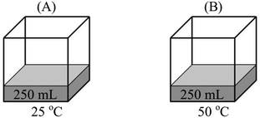

2)
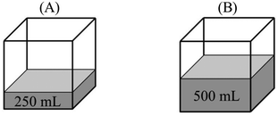

3)
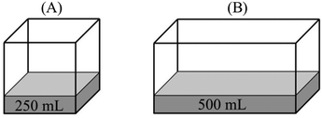

Scenario | Answer
4)
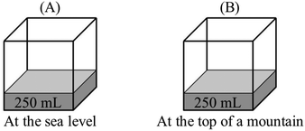

5)
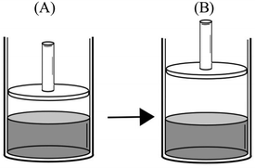
After the liquid–vapor equilibrium was established at 25 °C in a frictionless piston-cylinder (A), the piston is pulled upwards and fixed at that position (B).
6)
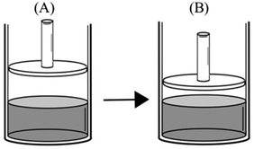
After the liquid–vapor equilibrium was established at 25 °C in a frictionless piston-cylinder (A), the piston is pushed down and fixed at that position (B).

Chem. Educ. Res. Pract., 2014,15, 366-379

References

1) https://chem.libretexts.org/
2) https://openstax.org/books/chemistry-2e
3) https://pubs.rsc.org/en/content/articlehtml/2014/rp/c4rp00024b
4) Barkley, E.F., Cross, K.P., & Major, C.H. (2005). Collaborative learning techniques. San Francisco: Jossey-Bass

