Hip Quiz Answers

1) What is the medial border of the femoral triangle?
- Sartorius
- Adductor longus
- Inguinal ligament
- Femoral nerve

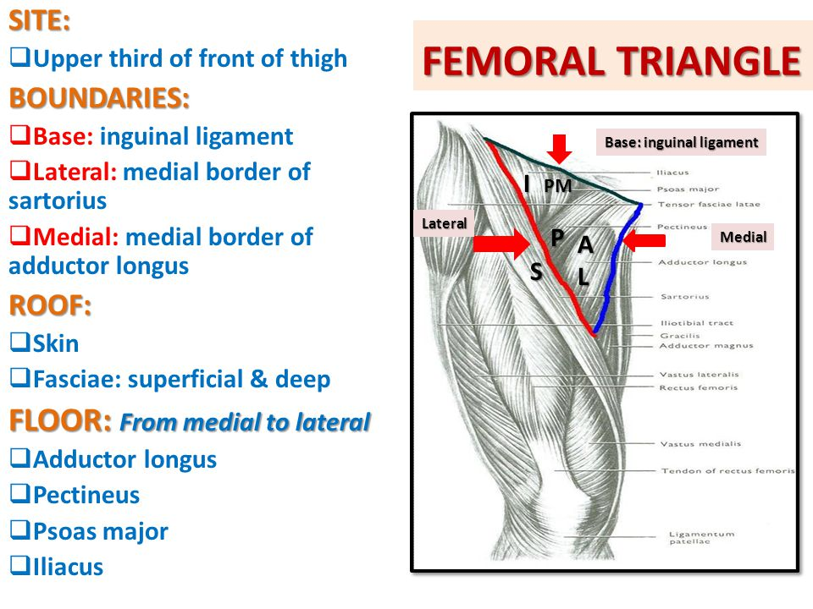

2) In the anterior hip, over which muscle does the lateral femoral cutaneous nerve initially emerge from proximally?
- Tensor fascia late
- Iliopsoas
- Rectus femoris
- Sartorius

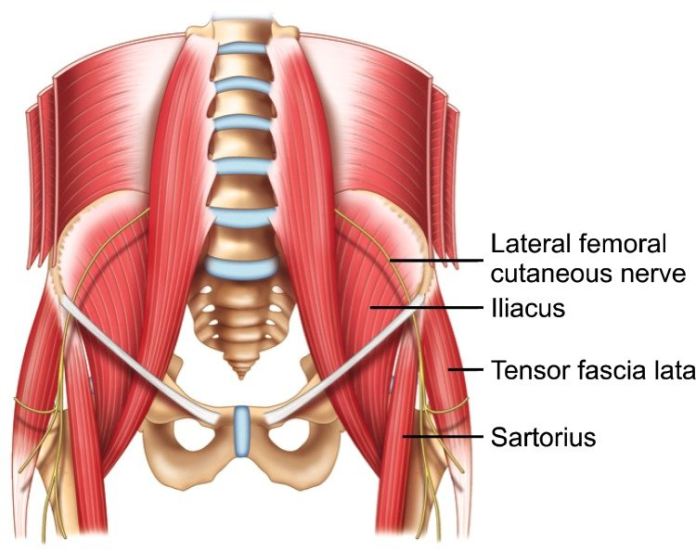

3) What finding on ultrasound differentiates between the posterior sacral foramina and the sacroiliac joint?
- Linear disruptions in the cortex
- Focal disruptions in the cortex
- Medial location
- Lateral Location
Lateral location & linear disruptions in the cortex are features of the SI Joint
Reference: Jacobson, page 236

4) In the transverse plane of the gluteal fold, all of the following structures make up the "hyperechoic triangle" EXCEPT:
- The conjoint tendon of biceps femoris long head and semitendinosus
- The piriformis muscle
- The sciatic nerve
- The semimembranosus tendon

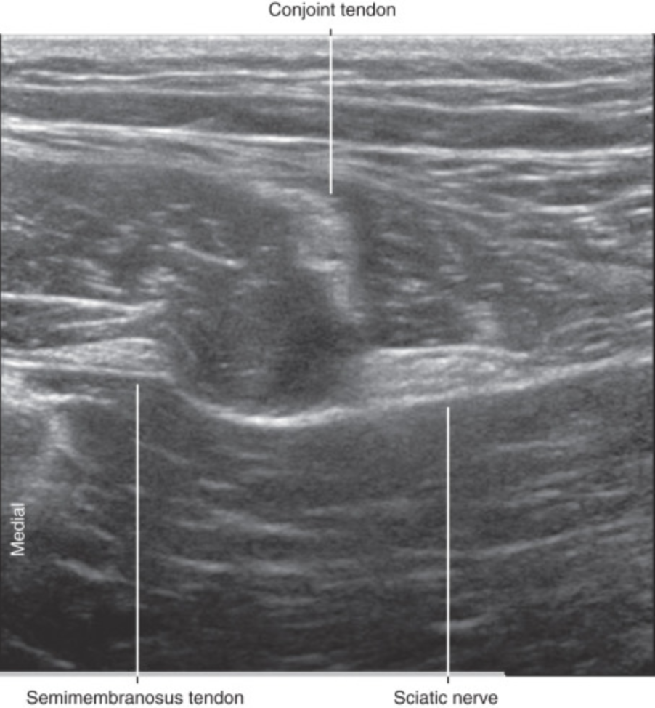

5) From superficial to deep, the adductor muscles are:
- Longus, Brevis, Magnus
- Longus, Magnus, Brevis
- Brevis, Magnus, Longus
- Magnus, Brevis, Longus
One mnemonic to describe the order of adductor muscles from anterior to posterior is “ALABAMa” (adductor longus, adductor brevis, adductor magnus). Between these respective muscles are located the anterior and posterior branches of the obturator nerve.
Reference: Jacobson, page 242

6) Which muscles insert on the iliotibial band?
- Gluteus maximus
- Gluteus minimus
- Tensor fascia latae
- Gluteus minimus
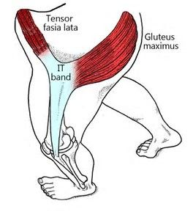

7) The gluteus medius attaches to which facet?
- The anterior facet
- The posterior facet only
- The lateral facet only
- The lateral facet and superior posterior facet
Gluteus minimus attaches to the anterior facet

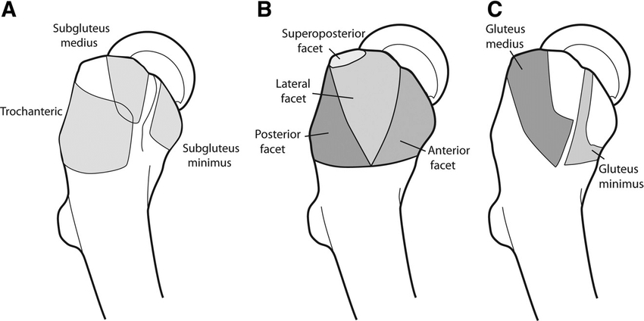

8) Which hip position can mimic a hip joint effusion?
- Internal rotation
- External rotation
- Extension and abduction
- Flexion and adduction
Reference: Jacobson, pages 249-250

9) How do you diagnose extra-articular internal snapping hip syndrome on ultrasound?
- Hip flexion and extension of affected limb while lying on contralateral side – external
- Straightening leg from a flexed, abducted, and externally rotated (frog leg position) position
- Stand and shift weight on the affected limb – external
- Resisted straight leg raise – intra articular
Hip flexion and extension of affected limb while lying on contralateral side – external snapping hip syndrome
Stand and shift weight on the affected limb – external snapping hip syndrome
Resisted straight leg raise – intra articular snapping hip syndrome
Reference: Jacobson, pages 266-270

10) In what procedure must the lateral circumflex artery be avoided?
- Piriformis injection
- Iliopsoas bursa injection
- Greater trochanteric bursa injection
- Intra-articular hip injection
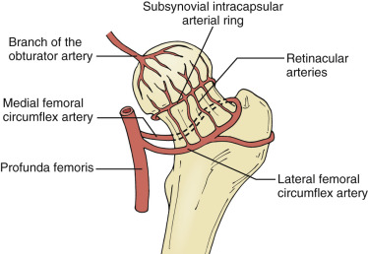
Reference: AMSSM Interventional Hip Video

11) What is the correct patient positioning for an in-plane intra-articular hip injection?
- lateral decubitus on asymptomatic side with both hips slightly flexed
- supine, hip in neutral rotation
- prone
- supine, hip in external rotation

Lateral decubitus on asymptomatic side with both hips slightly flexed is the position for greater trochanteric bursitis injection
Prone is the position for piriformis injection
Supine, hip in external rotation for iliopsoas bursa injection
Reference: Jacobson, Chapter 9 Interventional Techniques, page 427

12) Between what structures does the greater trochanteric bursa lie?
- the greater trochanter and the gluteus maximus.
- the iliopsoas and hip capsule
- the greater trochanter and the gluteus medius
- the ischial tuberosity and the gluteus maximus

Between the iliopsoas and hip capsule is the iliopsoas bursa
Between the greater trochanter and the gluteus medius is the gluteus medius bursa
Between the ischial tuberosity and the gluteus maximus is the ischiogluteal bursa

