
TRAIN TO LEARN EFFECTIVELY: TIP SHEETS

SIX STRATEGIES FOR EFFECTIVE LEARNING
This tip sheet was developed based on the research and writing of the Learning Scientists. These six strategies for effective learning are based on evidence-based research and the science of learning. We will explore: spaced practice, retrieval practice, elaboration, concrete examples, dual coding and interleaving. We’ve ordered the six strategies this way to help lay the foundation for good habits and practices, and to gain a better understanding of each strategy before moving on to the next. It’s also important to understand that these strategies can be used together! Let’s dive in!

Spaced Practice
How: Spaced Practice involves planning out multiple study sessions across a longer period of time rather than cramming all your tasks into one session.

After attending a lecture, take a break, and review recent course material and previous information to retain the content effectively — plan for your exams at least two weeks ahead of time. Spend 1 to 2 hours studying for each course over two weeks to avoid cramming in the last few days.
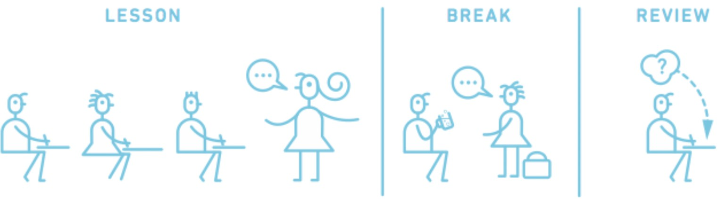

Graphic courtesy of O. Caviglioli (2019)
Why: Allowing time to forget content between study sessions helps you practice retrieval and provides opportunities for deeper learning. By reviewing course learnings over numerous smaller sessions, you shift information from short-term to long-term memory.

Example: Using business statistics course content as an example, students can block off time to study and re-study key concepts such as hypothesis testing and critical values on multiple days before an exam, rather than repeatedly studying and practicing these concepts right before the exam.

Things to remember:
- During your study session, use effective study strategies instead of just re-reading your course material.
- Don’t panic when you realize that you can’t recall some of what you learned in the previous study session! Spaced practice helps you to better identify what you may need more review of, and what you’re better understanding! It’s helping us move our learning into our long-term memory.

Retrieval Practice
How: Test yourself on the class materials, without having those materials open or nearby. Once finished, come back and review what you did right and what you may have gotten wrong. You can either make your own practice tests (e.g. flashcards) or use those available from your Professor, or those you create together with your peers.
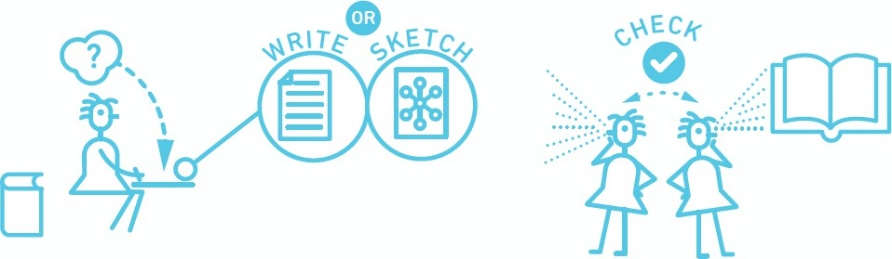

Graphic courtesy of O. Caviglioli (2019)
Why: It helps test your understanding of the material. When you are exposed to new information, it is stored in your temporary working memory and to transfer it to your long-term memory, your brain requires you to actively retrieve the information.

Example: In a Law & Business course, when studying the negligence test, students can practice writing out from memory the various steps for determining negligence, what they mean, and then recall what the next step might be.

Things to remember:
- Retrieval is hard and can feel uncomfortable! If you’re struggling, identify the things you’ve missed from your class materials, and work your way up to recalling it on your own with the class materials closed.
- Don’t only recall words and definitions. Make sure to recall main ideas, how things are related to or different from one another, and new examples

Elaboration

How: Describe concepts in your own words. Every time you think about the course material, try to add more details and more connections between ideas. Familiarize yourself with the material and then ask yourself: Why? How? What is this similar to? What is this different from? How would you explain it?

Graphic courtesy of
O. Caviglioli (2019)
Why: This helps you proactively connect ideas and concepts learned in class. It will also help identify what you may still need to refresh, review, or learn.

Example: Using cost-benefit analysis from a Finance course, a student may think about how that relates to her life. She may look at the coffee in her hand and consider that the cost to make this coffee could include:
- The coffee grounds;
- The barista’s labour to make the coffee;
- The materials to manufacture the cup and lid;
- The overhead of the shop;
- And more.

She may consider that the benefits from those costs could include:
- Customer satisfaction with the quality of the coffee;
- Customer satisfaction with the service at the shop;
- And more.

Things to remember:
- Make sure you describe and explain an idea accurately. Don’t overextend the elaboration. Always check your class materials or ask your Professor.
- Work your way up so that you can describe and explain without looking at your class materials.

Concrete Examples

How: Use or create specific examples to understand abstract ideas.

Why: Abstract ideas can be vague and hard to grasp. Human memory is designed to remember concrete information better than abstract information.

Example: After learning about the different inventory costing methods in Accounting, students can try brainstorming types of business that would use each method. For example: what kind of business would best benefit from a First-In, First-Out inventory costing method?

Things to remember:
- You may find examples on the internet that are not used appropriately. Make sure your examples are correct. Not sure if they are? Check with your Professor or T.A.
- Ultimately, creating your own relevant examples will be the most helpful for learning - and easiest to remember!

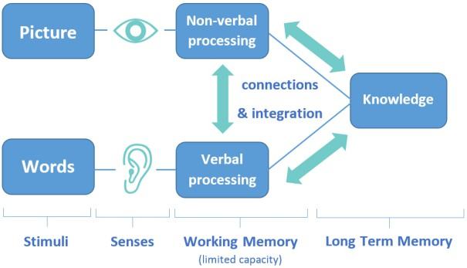
Dual Coding
How: This strategy combines words and visuals to help learn the content effectively. A few examples of how to do this include diagrams, infographics, flow charts, and timelines.

Why: This is a creative learning method that helps us stay more engaged and makes it easier to recall information instead of loading your brain with heavy course materials.

Example: Using the example of LP Sensitivity Analysis in a Managerial Decision Making course, students can first graph out the inequalities
before determining the feasibility region. Finally, from there, they can find the maximum and optimal point.

Things to remember:
- Approach course material from a visual and written standpoint, allowing yourself to encode information in your brain constructively.
- Test your knowledge by drawing visuals or writing using visuals from your memory. Think of it as a mini-quiz.

Interleaving
How: Switch between ideas or different types of problems while you study to make links between the different ideas.

The student studies topics A, B, C in the first study session, and then changes their study order to topics C, B, A in the second study session. They finish the session with topics A, C, B. They are then better able to make connections between those three topics at the end of the study session.
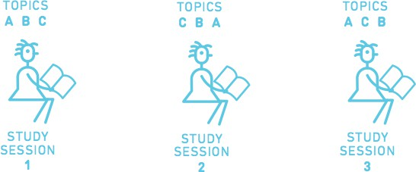


Graphics courtesy of O. Caviglioli (2019)
Why: It avoids studying one idea for too long. Going back over the ideas again in different order can strengthen your understanding.

Example:
Using on-the-job training from a Training & Development Human Resources course, after studying job-instruction training, students can switch to performance aids, and then to mentorships. Next study session, students can study the three in a different order, while noting any new connections they make as they do so.

Things to remember:
- While it’s good to switch between ideas, don’t switch too often, or spend too little time on any one idea; you need to make sure you understand them before moving on.
- Interleaving will feel harder than studying the same thing for a long time. Don’t worry! It’s helping you to have a better understanding of the material, and helps push it into your long-term memory.

To Sum Up
Effective learning that is stored in your long-term memory is within your reach! Use these strategies as stand-alones or use a mix of them - there’s no one way to learn. To sum up:
- Spaced practice is perfect for planning effective and manageable work sessions.
- Retrieval practice is great for getting a sense of what you already know and identifying gaps in your knowledge.
- Elaboration will lead to deeper insight on a topic.

- Concrete examples prove you have mastered the subject.
- Dual coding could double the effectiveness of the way you study
- Interleaving ensures you know the material and aren't simply memorizing it!

References
Weinstein, Y., Sumeracki, M., & Caviglioli, O. (2019). Understanding How We Learn: A visual guide.
Routledge. (Also accessible via https://www.learningscientists.org/).

Image Sources
Mohammed, F. (2019, January). Dual-Coding Theory by Allan Paivio (1971). Research Gate. Retrieved from https://researchgate.net/figure/Dual-Coding-Theory-by-Allan-Paivio-1971_fig5_345035940.

Weinstein, Y., Sumeracki, M., & Caviglioli, O. (2019). Understanding How We Learn: A visual guide.
Routledge. (Also accessible via https://www.learningscientists.org/).

