Learning Brain
Page 1 of 3
UDL & the
In the past decade, there have been unprecedented ways to examine the living brain and to better understand what happens during learning. Universal Design for
Learning (UDL) was inspired by such advances in cognitive neuroscience research and offers a framework that integrates what we know about the learning brain to inform the design of environments that support all learners.

First, let’s talk about the geography of the brain. Generally, incoming sensory information, such as what we see and hear, is received in the back of the brain, including the occipital and temporal lobes of the brain (Recognition networks), processed and relayed for meaning in the center of the brain (Affective networks), and is organized in the frontal lobes for response or action (Strategic networks).
While there is no linear progression for this process, this model for thinking about three broad learning networks can be helpful when we design learning experiences.

The UDL Guidelines and associated checkpoints align to this neurological organization and help educators address the predictable variability in learning that we know will be present in any environment. UDL recognizes variability in:

Engagement (the why of learning, which aligns with affective networks): interest, effort and persistence, and self regulation

Representation (the what of learning, which aligns with recognition networks): perception, language and symbols, and comprehension

Action & Expression (the how of learning, which aligns with strategic networks): physical action, expression and communication, and executive function

Knowing key facts about the brain can help inform learning design for the variability of learners.

There is no average brain.
Variability is the dominant feature of the nervous system. Like fingerprints, no two brains are alike. Each brain is a complex, interconnected web that is sculpted and influenced by genetics and interactions with the environment.

Variability can be overwhelming for educators who are planning for dozens of learners each day. Luckily, learner variability is predictable, and can be organized across three brain networks targeted by the UDL framework: affective, recognition, and strategic.

The concept of neuro-variability is important for educators, because it reminds us that learners do not have an isolated learning “style”, but instead rely on many parts of the brain working together to function within a given context. There is no single way a brain will perceive, engage with, or execute a task. Variability is not just an important consideration for thinking about differences between students, but also within students in different contexts.
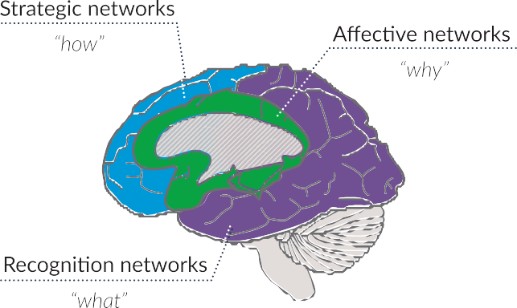

When we design learning environments proactively for variability, we anticipate and value the incredible strengths and diversity of our learners.

The brain has incredible plasticity.
Each brain is made up of billions of interconnected neurons that wire together to form unique pathways. We are
born with a foundation of brain structures. Over time, these structures change based on our experiences and interactions with our environment.

When we learn, some connections become stronger and faster. As Hebb’s Law (1949) states, “neurons that fire together wire together.” Connections that are not used are weakened and pruned away. In other words, “use it or lose it.”

Understanding the plasticity of the brain is important for educators, because it helps us recognize that learning is a constant growth process constructed over time. Proactive design of flexible pathways toward learning goals supports learners by building on the strengths and connections that are already established. Frequent, formative feedback and opportunities for active learning create and strengthen the connections within our learning brains. Our brains are not fixed, but grow and change with use.

What you know really matters.
Previous experiences drive our interest and engagement, perception and attention, and goals and actions. The nervous system constantly makes predictions and anticipates how we will fare in a particular environment or towards a particular goal. For example, if a learner is asked to do a math problem, read aloud, or respond to a prompt, the brain will recall prior experiences in that context. That recall drives perception, action, and engagement. Based on previous experiences, the brain decides which goals are valuable — or not valuable — to pursue.
Acknowledging the variability in learner background knowledge and experience is important for educators, because each learner brings a unique blend of experiences and expectations to each learning event. When we design for variability using the UDL framework, clarifying the goals and integrating flexibility in engagement, representation, and action and expression, we acknowledge that learners do not learn in one linear pathway. This approach fosters learning environments that value the uniqueness of our learners and the variability each brings. This empowers learners to maximize their strengths, focus on areas
of challenge, and drive their own learning processes. Ultimately, UDL helps foster expert learners who are purposeful and motivated, strategic and goal-directed, and resourceful and knowledgeable.

Goals drive the nervous system.
Essential to any learning experience is a clear goal. A clear goal enables the nervous system to direct energy
purposefully to build relevance, perceive information, and act strategically. Ultimately, educators and learners need to be aware of the intended learning goals so that they can begin to build connections, connect to background knowledge, and practice for expertise.

Recognizing that our brains are goal-driven is important for educators, because if we don’t make learning goals explicit to our learners, they have no way of knowing what the target is, how to reach it, or when they’ve achieved
it. Think about a GPS or navigation app. Without a destination, a GPS is simply a map with infinite possibilities and no directions. Once we input a destination, we can then decide whether we want a route without tolls, one that meanders through the countryside, or one that is the fastest or shortest distance. With a clear, explicit learning goal, learners are empowered to choose their best pathway to achieve that goal.

Our brains always have a goal, whether it’s to avoid a task, sneak a cookie from the jar, or complete a task with the least amount of effort. The more explicit we are with our learners about the goals and incorporate their own goals, the more meaningful the learning experience will be, the more purposeful the options available will be, and the less likely our brains will focus on competing goals.

Understanding these key facts about the learning brain not only helps educators in designing challenging, high quality learning opportunities, but they’re also incredibly
important for our learners to understand, as well. The more we understand about our own learning and how it happens, the further we advance toward the ultimate goal: becoming expert learners.

Suggested Citation: CAST (2018). UDL and the learning brain. Wakefield, MA: Author.
Retrieved from http://www.cast.org/our-work/publications/2018/udl-learning-brain-neuroscience.html

Resources
Human Connectome Project Brain Facts
Neuroscience for Kids

UDL Theory and Practice, Chapter 3: Variability

Brain Matters, from Harvard Graduate School of Education’s Dr. Todd Rose Annenberg Learner: Neuroscience and the Classroom
Why learning styles don’t exist, by Daniel Willingham Daniel Willingham’s Learning Styles FAQ
We Don’t Need Learning Styles by Elizabeth Stein, MiddleWeb Linking Research to Classrooms Blog from Kennedy Krieger Institute

