University of Pittsburgh swanson school of engineering
Industrial engineering department

Value Based Care and Contracting For Healthcare Providers
Caroline Kolman, P.E.
Contents
Introduction 3
Contracts Between Payers and Providers 4
Best Practices for Contract Management 5
Example 5
Value-Based Contracts 6
Quality Evaluation and Measures 8
Data Analytics and Strategies for Improvements in Population Health 11
Accountable Care Organizations (ACOs) 13
Patient Centered Medical Home Program 14
Technology Applications to Support Value Based Care 14
Telehealth 15
Remote Monitoring 15
Artificial Intelligence 15
Care management and outreach 15
Summary 15
Appendix A – Glossary of Terms 16
Appendix B – HEDIS Measures 18
Effectiveness of Care 18
Access/Availability of Care 19
Utilization 19
Risk Adjusted Utilization 19
Measures Collected Using Electronic Clinical Data Systems 20
Appendix C – NCQA Health Insurance Ratings – Example 21
Appendix D – Medicare Star Ratings Measures 23
Appendix E – ACO Quality Measures 25
25

Introduction
For many years, healthcare providers have been paid under a “fee for service” model, that is, they are paid for each service and/or supply that they use to deliver care to a patient, regardless of the outcome or results received by the patient. As one would expect, over time this has led to an increase of utilization – patient visits, testing, additional supplies – as higher volume translated to greater revenues for healthcare providers.
With the rapid increases in the cost of healthcare, there has been a shift in this mindset and a drive to reduce spend. Led by government sponsored programs (e.g., Medicare and Medicaid), the movement has been to reimburse providers based on an entire instance of care rather than pay for every individual service or item. New programs are being created where primary care physicians may be paid on a per member basis (e.g., a monthly care management fee for each enrollee) for all the care they provide their patients, regardless of cost. And new models of care, such as Accountable Care Organizations (ACOs), are also being developed and tested in the effort to control cost increases and improve health.
Along with these changes, payers are also creating incentive programs for providers. Better outcomes for patients can result in additional payments (rewards), while any declines in patient care and health can result in penalties. The assumption is that these value-based models will decrease the cost of care and improve health of patients. One payer showed that in 2018, value-based payment models reduced care costs by 35% for those members participating in the program.
But these changes in care and payment require vast amounts of data – patient information and diagnoses, risk factors for different types of care, statistical analyses, results of various clinical protocols and identifying the best care options, etc. As such, the move to value-based care has been slow – without good information and analytics, providers are wary of moving to these payment models and taking on risk, as many of their existing fee for service agreements are still profitable. To encourage participation, many of the new programs start out by only providing an “up-side”, that is, benefit for positive results but no penalties for declines, until the providers are comfortable with taking on full risk-based agreements. (According to the Health Care Payment Learning and Action Network, only 5.1% of 2018 payments to providers involved upside and downside risk, so a high percentage of those payments were still primarily fee-for-service.)
Decision makers have found that there are many factors that add up to affordable and quality healthcare. One area of increased focus is on social determinants and the impact on a patient’s overall health. Far beyond the control of a provider, payers are beginning to address some of these needs as well (such as access to care, education, reduced cost pharmaceuticals and healthy food) through innovative community programs and joint payer/government programs.
The road to value-based care is challenging given the many options and requirements, but the pressure to reduce cost and improve quality will not go away. Payers and providers need information and analytical capabilities to perform successfully in this space.

Contracts Between Payers and Providers

Healthcare payers, or health insurance plans, are typically large corporations that collect payments (premiums) from their members in exchange for paying for the medical services provided to those members. There may be limitations on these payments: a payer may not cover and pay for all types of medical care, they may require members to pay a portion of the expense, or they may even require members to use a specific healthcare provider or facility.
Payers use the premiums collected from their members to pay for their medical services, to cover any administrative costs they may incur (such as staffing, information systems, etc.) and to generate some level of profit. Payers are required by the Affordable Care Act (ACA) to submit reports to the Centers for Medicare and Medicaid Services (CMS) showing their percent of premium dollars spent on medical care vs. dollars for administrative costs and profit. This percent is known as the Medical Loss Ratio (MLR) and per the ACA, the payers are required to spend at least 80% or 85% of premium dollars on medical care. Should they fail to meet this threshold, the payer must reimburse their members the difference in the form of rebates.
With the goal of keeping medical costs as low as possible, payers will contract with providers to control and limit the cost of services. The payer can create a group of preferred providers that they will refer their members to (or require or incent the members to utilize) in exchange for discounts from the providers. Known as a “network” model, the payers negotiate extensive and complex contracts with their provider network.
Just as payers may enter into many provider contracts, the providers may also contract with many different payers. These contracts may be with commercial payers as well as with government program payers (Medicare, Medicaid). Each contract can be complex and should be negotiated with data and facts, which is why many providers struggle. Following are some key items to consider in negotiating payer contracts:
- Scope of services (list and detail) covered by the payer – and note associated codes for ease of claims processing
- Fee schedules/reimbursement rates for these services
- Reimbursement requirements – the information to be submitted (to ensure a complete, clean claim) and timely submission (the number of days a provider has to submit a claim after a service or visit). Most commercial insurance plans require claims to be filed within 90 days of the date of service.
- Network participation requirements – this includes credentialing clinical staff to ensure they are qualified to provide those services
- Claim denial dispute procedures – note the specific information and method required to respond to a claim denial/underpayment
- Term of the contract – Specify start date(s), date(s) of expiration, renewal requirements, etc.
- Notice periods for renegotiation and termination – there may be specific ranges of time for renegotiation well in advance of expiration (otherwise the contract may potentially auto-renew)
- Unilateral amendments – these clauses state that payers can change their agreed upon terms, such as reimbursement rates, requirements, etc., whenever they choose and without provider approval or agreement
For a provider, collecting their quality and cost data, then analyzing and modelling potential outcomes, is key to ensuring they can meet the terms of the contract, and remain profitable.

Best Practices for Contract Management
To better manage their contracts, providers can implement some of the following tactics:
- Implement a contract management system – having a centralized database of contracts helps manage terms and conditions, expiration dates and notification requirements, auto renewal clauses, etc. Staff familiarity with these contract details alleviates questions and avoids actions that may reduce reimbursements or even create denials. These databases can also be used to set up automatic notifications of deadlines and important provisions within the contract.
- Create a standard contract template – include key terms and conditions that are important to the provider organization. Use it as a starting point in negotiations, rather than using a payer’s standard template or contract.
- Analyze and compare payer fee schedules and other key contract requirements – by comparing fee schedules by unique diagnoses codes, providers can quickly assess which payers have higher reimbursements, and can use this information in negotiations in the future, as well as gain a better understanding of cost vs. reimbursement for profitability analyses. Understanding the patient characteristics within each payer network and the services they may frequently utilize can also provide critical insights.
- Create a stakeholder team comprised of administrators, financial experts and clinicians to provide input on payer contract terms and negotiations.

Example

Madison Medical Center contracts with the following payers: United Healthcare, Blue Cross Blue Shield of Michigan, Aetna and Centene. Madison conducted a comparison of reimbursement for MSDRG 470 - major joint replacement or reattachment of lower extremity without major complications or comorbidity. The Finance staff summarized the following data:

The staff observed the following:
- Average cost incurred by patient was fairly consistent across all payers
- There was a large variance for the higher paying payers (large spread between min and max)
- There was significant variance between payers, with some payments lower than the actual cost incurred

Their recommendations were to conduct more analysis to determine why Aetna and Centene payments were so low, and to try to renegotiate at next opportunity to increase the payments. They recommended focusing on increasing patient activity with United and Blue Cross to incent more of their patients to seek their care from Madison. They also suggested taking a closer look at costs with the supply chain team to see if there was any opportunity to reduce costs for supplies (typically implants are the highest cost items), as well as conduct discussions with clinicians to understand variances in care.

Value-Based Contracts
Value-based care, also known as pay-for-performance, incentivizes providers to achieve certain performance goals (e.g., positive patient outcomes, low cost, efficiency and efficacy, positive patient satisfaction scores), while penalizing them for poor patient outcomes, medical errors, and high costs. Value-based care began as an experiment, but its adoption has been rapid. The increasingly high cost and poor quality of healthcare has pushed health plans, employers/employer-sponsored plans, and government sponsored programs to seek a better model, and push providers towards value-based agreements (also known as “alternative payment models”).
Hospitals and health systems are already required to participate in some mandatory Medicare value-based models (if they want to participate and receive payment), such as:
- Value Based Purchasing Program (VBP) – Hospitals are measured and rewarded on how well they perform compared to all hospitals or how much they improve their own performance. The measures are based the quality of services provided and factors such as mortality, patient safety, efficiency, and cost reduction.
- Hospital Acquired Condition Reduction Program (HACRP) – Beginning in 2015, hospitals with an HAC score greater than the 75th percentile receive a 1 percent payment reduction in Medicare payments. The score is based upon patient safety and hospital associated infection rates.
- Hospital Readmissions Reduction Program (HRRP) – Starting in 2012, hospitals with excess readmissions receive reduced Medicare and Medicaid reimbursements. Excess readmissions are measured by a ratio of predicted 30-day readmissions divided by expected readmissions for the following diagnoses: heart attack, heart failure, pneumonia, chronic obstructive pulmonary disease (COPD), hip/knee replacement and coronary artery bypass graft surgery (CABG).
CMS continues to refine and develop new payment models (see CMS Innovation Center Homepage | CMS Innovation Center).
Following is an extract of some HRRP measures for a few Pennsylvania hospitals:

Additional examples of elective value-based payment models include:
- Pay for Performance – Providers can receive financial bonuses for achieving specific targets, such as care quality or cost. But since these are typically used in conjunction with fee-for-service models, they have shown to be insufficient or ineffective in making changes to behaviors or cost.
- Bundled payments – Payers pay providers one amount (“bundle”) for an episode of care, instead of paying individually for the hospital, physician, drugs, etc. There is an agreed-upon fixed dollar amount, so it is up to the provider to manage the costs and ensure it does not exceed the amount paid. Bundled payments have been tested out on cases like joint (knee) replacements and cardiac events.
- Shared savings – A provider continues to bill under the traditional fee-for-service model, but at the end of a period, the spend is compared to a target. If below target, some of the savings are shared with the provider. (This would be considered an “up-side” agreement – there is no risk, or down-side, for the provider if the spend is higher.) One example is the Medicare Shared Savings Program.
- Shared risk – Similar to shared savings, but in this case, if the spend is over target, the provider must pay some of the difference as a penalty.
- Capitation – A provider receives a set amount per person, per month (PP/PM) for each patient enrolled (typically used in primary care settings). This amount is to cover the patient for whatever treatment they need, and regardless of services they use, or cost incurred by the provider.
CMS continues to develop new approaches and models, and to recruit voluntary participation to improve health and reduce costs. (Plans for 2021 include the Primary Care First Model, and the Direct Contracting Model.) Alternative payment models like these require active care management, and accuracy in documentation and coding to ensure both proper record keeping and reimbursement. A simple omission or discrepancy can affect the accuracy of the patient’s illness severity, and impact quality measures and payment. Consider the following example:

Coding Example
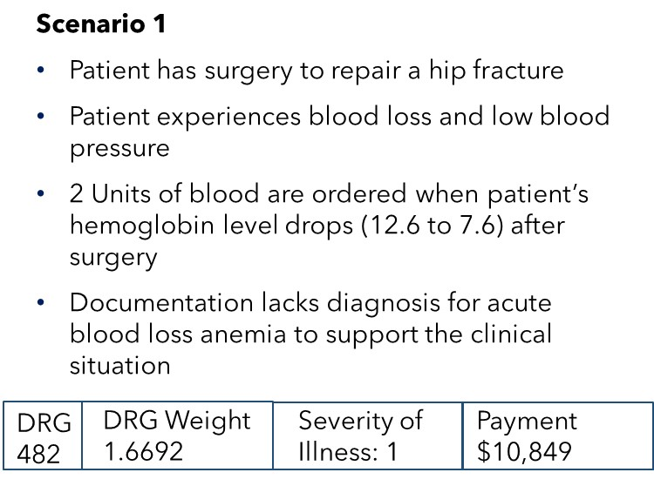
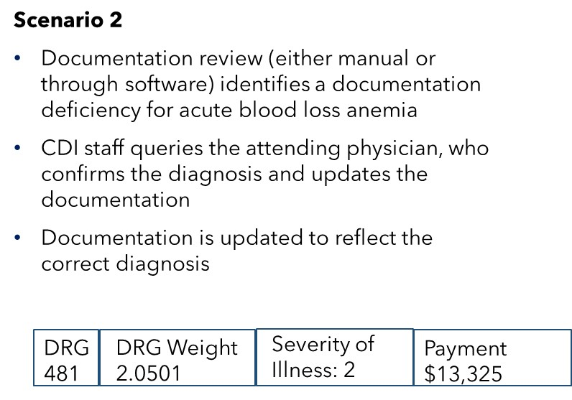
The benefit of coding reviews includes the following:
- Identifying inconsistencies between clinical and coding terminology
- Ensuring proper code assignment
- Identifying gaps in documentation, including potential quality issues, at point of care
- Ensuring complete code capture and preventing future denials
Additionally, providers may want to track additional key performance indicators, such as:
- Cost and revenue per patient
- Cost and revenue per treatment or illness
- Profit and lost by contract/payer

Quality Evaluation and Measures
The Centers for Medicare and Medicaid (CMS) have developed many quality measures that are used to evaluate the quality of health plans and providers. And similarly, health plans also have adopted these measures to evaluate and measure the performance of healthcare providers they work with. Health plans are rated in three categories: private or commercial plans which people enroll into through their employment or own their own; plans that serve Medicare beneficiaries; and plans that serve Medicare beneficiaries in the Medicare Advantage program.
CMS selected the National Committee for Quality Assurance (NCQA) to develop and collect measures from the following categories:
- quality measures from the Healthcare Effectiveness Data and Information Set (HEDIS)
- consumer satisfaction measures from the Consumer Assessment of Healthcare Providers and Systems (CAHPS), and
- results from NCQA’s review of a health plan quality processes (performance on NCQA Accreditation standards).
The overall rating of a health plan is the weighted average of a plan’s HEDIS and CAHPS measure ratings, plus Accreditation standards.
HEDIS consists of nearly seventy (70) different quality measures that can be used to compare the effectiveness of providers and health plans. The measures cover:
- Effectiveness of Care – e.g., controlling high blood pressure, conducting cancer screenings, measuring and monitoring body mass index (BMI)
- Access/Availability of Care – e.g., prenatal and postpartum care, access to primary care physicians
- Utilization – e.g., mental health utilization, antibiotic utilization
- Risk Adjusted Utilization – e.g., readmissions, emergency department utilization
- Measures Collected Using Electronic Clinical Data Systems – e.g., depression screening and follow-up, prenatal immunization status
More detail on the list of HEDIS measures can be found in Appendix B.
The Consumer Assessment of Healthcare Providers and Systems (CAHPS) scores measure member satisfaction through a random sample of plan members, asking questions about patients’ experiences with providers and customer service responses from health plans. (https://www.ahrq.gov/cahps/surveys-guidance/hcbs/index.html). They may include questions regarding getting needed care easily and quickly, satisfaction with physicians, and other similar questions.
For these measures, the scores range from 0 to 5, where 5 is the highest and 0 is the lowest, and the scores may be based on number of activities or availability of services (e.g., diagnostic tests). These ratings make it easy to compare plans when members are making decisions on healthcare coverage.

Example Healthplan Ratings
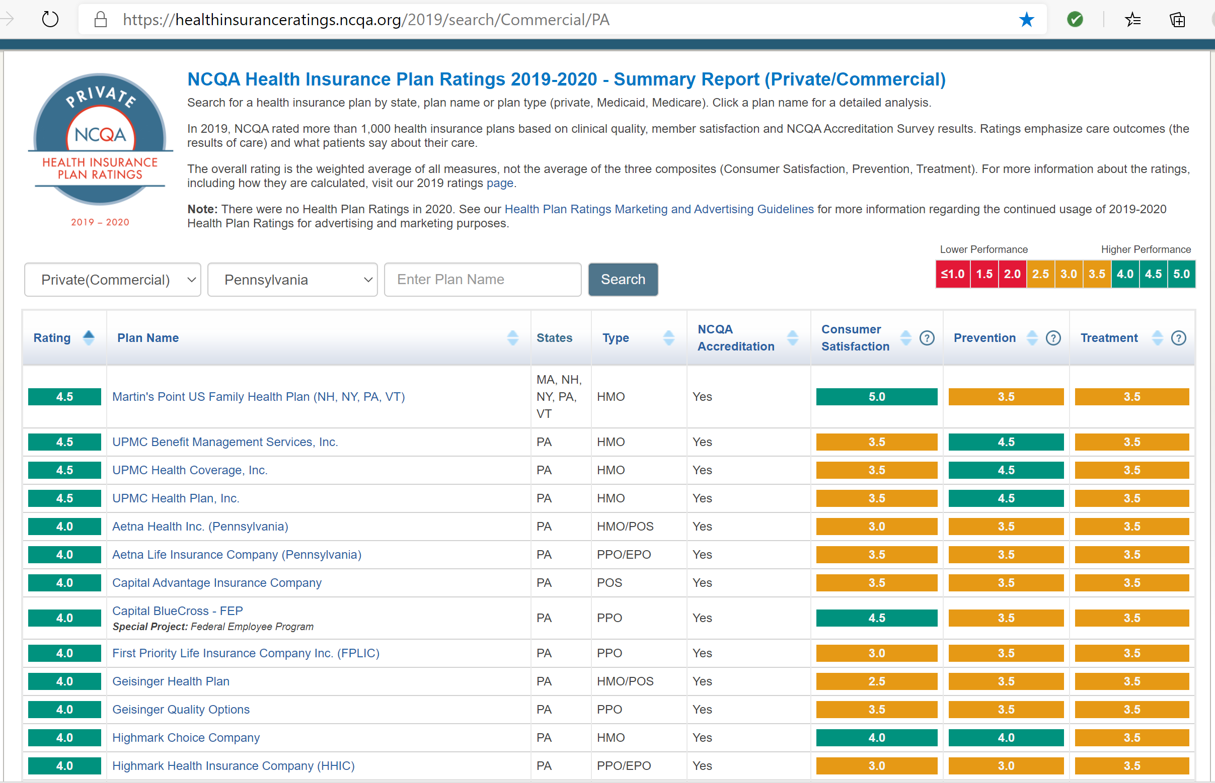

Appendix C lists a detailed health plan report and ratings by some of these key measures.
Similarly, CMS has created the Medicare Star Ratings system to provide quality and performance information to Medicare beneficiaries to help them in assessing and choosing their health plans and services. The Star Ratings include measures focused on the following five categories:
- Outcomes – Improvement to a person’s overall health
- Intermediate Outcomes – Actions taken that can assist in improving a person’s health (e.g. controlling blood pressure)
- Patient Experience – Measuring a person’s perspective on the quality of the care received
- Access – Processes and issues that could impede a person’s receiving care
- Process – Patient care services that can maintain or improve a person’s health
Appendix D lists the Medicare Star Ratings for Part C and D measures. Many commercial payers have also adopted the Star ratings (or similar quality ratings) in ranking and incenting their provider networks.
Medicaid plans can choose to be evaluated with one of three versions of the CAHPS survey: Adult CAHPS, Child CAHPS or Child with Chronic Conditions CAHPS (Child CCC). Plans can select the appropriate version when they complete a Healthcare Organization Questionnaire.
Health plans strive to achieve and maintain high ratings to stay competitive and continue to attract new members, but they must rely on their network of providers to help in achieving these ratings. As a result, they use quality measures and ratings to assess provider performance and incent their providers to improve members’ health and care.
Example: Process Improvement for Ratings
A physician practice has had the following ratings for three key measures in the last three years:
The health plan that has contracted with this practice is working to improve the plan’s ratings and is looking specifically at providers in their network. Their analysts and case managers observed the following:
- Two of the three measures are in decline
- The average of the rating has remained between 3 and 4, and dropping in the last year
- There is opportunity for improvement
They developed the following plan of action:
- Outreach to the provider network to ensure clinicians are recommending flu vaccine and BMI assessments to patients during routine visits
- Outreach to the members (direct mail, email, advertising) to remind them to get their flu vaccine
- Outreach to female patients for breast cancer screenings
- Incentives to both clinicians specifically for flu vaccine (additional $5 for each patient that receives the vaccine) and plan members (no charge for the office visit/vaccine)

Data Analytics and Strategies for Improvements in Population Health

Data analytics can be used to identify at-risk populations to help identify situations and behaviors that can impact patient health and cost of care. The Kaiser Family Foundation has developed a categorization of social determinants that can be tracked using public source data, and that can be used to identify at risk patients. The following table lists the categories and some examples of indicators:
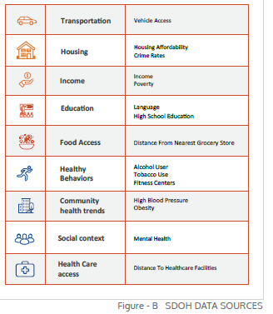
One example is incidence of diabetes. More than 30 million Americans have diabetes, primarily type 2 or adult-onset diabetes. The incidence of type 2 diabetes is correlated with income level – people in lowest income categories had twice the risk of those with high income.
Using publicly available data, health plans and healthcare providers can identify areas of high risk for type 2 diabetes. (Census tract data provides visibility into small areas within counties with a range of 2,500 to 8,000 people.) Using this type of data, patients can be provided data such as clinics and facilities close to their home, connect them with social agencies to help with transportation or food availability, and other information and resources that could lead to improved health outcomes and reduce healthcare costs.
Other ideas and strategies may include:
- Review clinical data to identify patients at highest risk (e.g., behavioral health, substance abuse) and contact regularly to encourage visits and care
- Improve access to primary care – regular and frequent primary care visits show 19% lower odds of premature death (but currently only 4-7% of healthcare dollars go towards primary care)
- Engage patients to manage their health through use of remote monitoring devices (particularly for high-risk patients) and easy to use apps
- Understand technical capabilities (or lack of) for some patients – audio may be the only means (e.g. lack of internet access) and clinicians may need to adapt
- Allow telehealth/tele visits - 24x7 access to clinical resources – as a benefit to members
- Increase use of ePharmacy applications and delivery of medications direct to consumer
- Implement software platforms to drive and define clinical workflows to guide clinicians on recommended care methods
- Train staff to manage digitally - simulation and online education
Other strategies to improve care and reduce costs include Accountable Care Organizations (ACOs) and Patient Centered Medical Homes (PC-MH) as outlined in the following sections.

Accountable Care Organizations (ACOs)
Managing the care of patients with complex or serious diseases and conditions may require many different care providers and organizations. Given that many of these patients have multiple acuities (e.g., a patient with high blood pressure may also be overweight, have diabetes, and require joint replacement surgery) and may have a different doctor for each of these issues, a coordinated approach is needed to ensure the patient is cared for appropriately and all these acuities (and treatments) are taken into consideration. Through its Innovation Center, CMS has provided several care models to incentivize providers to participate in, including several iterations of Accountable Care models designed to provide higher quality care to patients, reduce medical errors and reduce costs. The programs typically have defined start and end dates, with measures and reporting throughout the time frame.
An accountable care organization (ACO) is defined as a group of “doctors, hospitals and other health care providers, who come together voluntarily to give coordinated high-quality care to their Medicare patients.” The teams jointly make decisions on care for a patient, creating a more coordinated approach that can improve health outcomes and lower costs. Provider members may include those already in a health system or payer network or may even include independently practicing physicians. The benefits of an ACO (from BCBSTX) may include the following:
- Lower cost per member per month
- Fewer emergency room visits
- Fewer outpatient visits
- More office visits (preventative care)
ACO may be physician or hospital led – to date, physician-led ACOs have been more profitable than those led by hospitals. That is why it is important to collect data and key measures, and closely monitor revenues and costs; complex organizations like hospitals may find this to be more of challenge.
The CMS “Next Generation ACO Model” is an example of one such arrangement. Using experience learned from several other prior ACO models, CMS first offered this Advanced Alternative Payment Model (APM) in 2016 and anticipates the model will come to an end in December 2020. Eighteen ACOs participated in 2016; 45 in 2017 and 51 in 2018; 41 participated in 2019. If selected, providers had the option to participate for three years, with two additional one-year options. Performance is measured and reports are generated that include cost and quality measures, and these are used to determine both rewards for positive outcomes, and penalties for negative outcomes.
Following is an extract from a CMS ACO report for 2018:
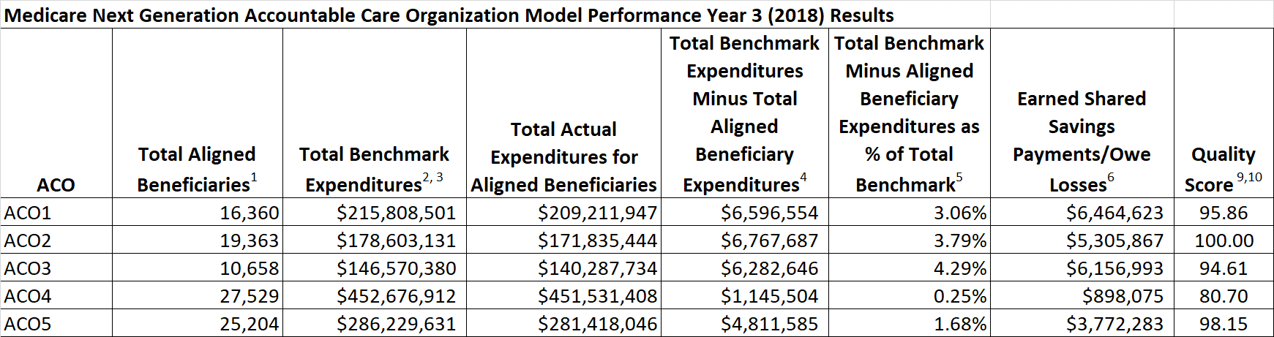
This segment shows the total spend compared to benchmarks/targets and resulting rewards or penalties.
Additionally, there are over 40 quality measures collected, such as:
- Readmissions within 30 days following discharge from the hospital for the same diagnosis
- Unplanned admissions for patients with diabetes, heart failure, and multiple chronic conditions
- Diabetic patients receiving an eye exam
- Patients receiving influenza immunization
There are both positive and negative measures collected, and each has its own values and scores. Like other quality measures, these are used to determine payments and penalties. Appendix E lists some current ACO quality measures.

Patient Centered Medical Home Program
The Patient Centered Medical Home (PC-MH) is a healthcare model that provides comprehensive primary care to its members. The PC-MH is endorsed by many physician groups, and is based upon several principles such as:
- Access and Continuity - Provide the care patients need—anytime, anywhere.
- Planned Care and Population Health - Use technology to be proactive about managing patients’ chronic conditions.
- Care Management - Identify which patients need additional support from the care team and provide those services.
- Patient and Caregiver Engagement - Encourage patient participation and shared decision making.
- Comprehensiveness and Coordination - Build relationships and coordinate care across the medical neighborhood.
Many such programs rely on a per-member per-month (PMPM) fee model for reimbursement (fixed rate per member), but as with other payment models, it requires the provider to collect and analyze cost and quality, which can be difficult for smaller physician practices without technology and resources.

Technology Applications to Support Value Based Care
For providers continuing down the value-based care path, other strategies and technology applications can support the data collection and improvement efforts required to be successful in the execution of these contracts.
Following are several examples of where technology and process improvement strategies can support these changes.

Telehealth
Telehealth – the ability to speak with a caregiver remotely via phone or video chats – has been in existence for some time, but with the arrival of the Covid pandemic, its use has increased significantly. Patients unable or unwilling to make an in-person visit can easily speak with and/or see their caregiver, and receive treatment advice and prescriptions, while also giving the caregiver an opportunity for visual insights to the patient’s condition. Telehealth can be a good option for patients in remote or rural settings, but technology requirements can make this more challenging (e.g., access to WiFi/internet).

Remote Monitoring
With the many personal devices available today, technology has made it simpler to obtain real time health information from patients. These devices can monitor blood pressure, heart rate, and many other key vital signs, and easily transmit to caregivers, who can then identify at-risk situations and act on the information (such as prescribing new drugs, calling them in for office visits, etc.). Online patient portals can also be used to create patient profiles, and get patients more actively engaged in their own healthcare through education and engagement.

Artificial Intelligence
Artificial intelligence (AI) enables computers and other machines to mimic the perception, learning, problem-solving and decision-making capabilities of the human mind. The development of computer capabilities along with the vast amounts of data available have made this progression possible. Speech recognition (e.g. Siri) and Roomba vacuums are examples of AI we are all familiar with.
In healthcare, AI has many applications that can more quickly identify health problems, such as:
- Reviewing imaging scans and analyzing for early detection of diseases
- Identifying effective vaccines against rapidly evolving Covid mutations
- Surgery-assisting robots for complex operations
- Chatbots that listen to and analyze patient symptoms and health concerns to diagnose illnesses and provide care
- Shortening the development time and cost to bring new drugs to market

Care management and outreach
For those patients that are unable or unwilling to utilize some of the technology applications, the “personal touch” still seems to be the most effective approach. Caregivers have found that just by texting or calling their patients, they are able to provide proactive care and address issues before they turned into high-cost and/or life-threatening problems. The proactive outreach can build a trusting relationship between the caregiver and patient, increase and improve communication, and improve a patient’s health.

Summary
Value-based care models have been in existence for more than a decade, yet many payers and providers still struggle to implement and see improvements from these alternative payment models. There are a number of strategies and technologies that can be deployed to more effectively manage these arrangements, requiring data and analytics to effectively manage patient care and associated costs.

Appendix A – Glossary of Terms

Allowed Amount – the maximum amount that a payer will reimburse a provider for a covered healthcare service. Also known as “eligible expense,” “payment allowance,” or “negotiated rate.”
Claim – a summary of an episode of care given to a patient that is submitted to a payer by the care provider to receive reimbursement for the cost of the care given.
Clean Claim – a claim that payers can process and reimburse without needing any additional information.
Contract Termination – the end of a formal agreement between entities. A contract may end for several reasons: 1) the term has expired; 2) all parties mutually agree to end the agreement; 3) one party may request to end the agreement; or 4) there may be a disagreement or breach in the terms of the contract, invoking clauses that end the agreement.
Dispute Resolution – process by which a provider and payer resolve a claim in question (denied or disputed claims)
Fee Schedule – list of fees or payments for specific services or supplies
Medicare - Medicare is a national health insurance program in the United States, started in 1966 under the Social Security Administration, and administered by the Centers for Medicare and Medicaid Services. It provides health insurance for Americans aged 65 and older, but also for some younger people with disabilities, as well as people with end stage renal disease and amyotrophic lateral sclerosis. Medicare is divided into four different parts (A, B, C and D). Medicare Part A covers hospital, skilled nursing and hospice services. Part B covers outpatient services (e.g., provider office visits). Part D covers most prescription drugs. Part C is an alternative plan called Managed Medicare or Medicare Advantage which allows patients to choose health plans with at least the same service coverage as Parts A and B (and most often more), often the benefits of Part D, and always an annual out-of-pocket spend limit (which Part A and B do not have).
Medicare Advantage – (aka Part C) A Medicare plan that provides members benefits through a private-sector health insurer. With these plans, a Medicare beneficiary pays a monthly premium to a private insurance company and receives coverage for inpatient hospital and outpatient services. Typically, the plan also includes prescription drug coverage, and may include some additional health benefits.
Medicaid - a government insurance program for persons of all ages whose income and resources are insufficient to pay for health care. Medicaid is funded by both Federal and State resources, but is administered by each state individually, so plans may vary from state to state.
Medical Necessity – healthcare services or supplies needed (necessary) to diagnose and/or treat a condition, illness, disease or injury.
Network Requirements – healthplans that engage (contract with) providers on behalf of their members must ensure that they maintain a network that is sufficient in number and types of providers, including providers that specialize in mental health and substance abuse services, to assure that all services will be accessible without unreasonable delay to their members. Healthplans may in turn require their members to utilize the providers in the network they have created.

Patient Centered Medical Home - a care delivery model whereby patient treatment is coordinated through their primary care physician to ensure they receive the necessary care when and where they need it, in a manner they can understand.
Unilateral Amendments – contract clauses that state payers can change their agreed upon terms, such as reimbursement rates, requirements, etc., whenever they choose and without provider approval or agreement

Appendix B – HEDIS Measures

Effectiveness of Care
- Prevention and Screening
  - Adult BMI Assessment
  - Weight Assessment and Counseling for Nutrition and Physical Activity for Children/Adolescents
  - Childhood Immunization Status
  - Immunizations for Adolescents
  - Lead Screening in Children
  - Breast Cancer Screening
  - Cervical Cancer Screening
  - Colorectal Cancer Screening
  - Chlamydia Screening in Women
  - Care for Older Adults
- Respiratory Conditions
  - Appropriate Testing for Children With Pharyngitis
  - Use of Spirometry Testing in the Assessment and Diagnosis of COPD
  - Pharmacotherapy Management of COPD Exacerbation
  - Medication Management for People With Asthma and Asthma Medication Ratio
- Cardiovascular Conditions
  - Controlling High Blood Pressure
  - Persistence of Beta-Blocker Treatment After a Heart Attack
  - Statin Therapy for Patients With Cardiovascular Disease and Diabetes
- Diabetes
  - Comprehensive Diabetes Care
- Musculoskeletal Conditions
  - Disease-Modifying Anti-Rheumatic Drug Therapy for Rheumatoid Arthritis
  - Osteoporosis Testing and Management in Older Women
- Behavioral Health
  - Antidepressant Medication Management
  - Follow-Up Care for Children Prescribed ADHD Medication
  - Follow-Up After Hospitalization for Mental Illness
  - Follow-Up After Emergency Department Visit for Mental Illness
  - Follow-Up After Emergency Department Visit for Alcohol and Other Drug Abuse or Dependence
  - Diabetes and Cardiovascular Disease Screening and Monitoring for People With Schizophrenia or Bipolar Disorder
  - Adherence to Antipsychotic Medications for Individuals With Schizophrenia
  - Metabolic Monitoring for Children and Adolescents on Antipsychotics
- Medication Management and Care Coordination
  - Annual Monitoring for Patients on Persistent Medications
  - Medication Reconciliation Post-Discharge
  - Transitions of Care
  - Follow-Up After Emergency Department Visit for People With Multiple High-Risk Chronic Conditions
- Overuse/Appropriateness
  - Non-Recommended Cervical Cancer Screening in Adolescent Females
  - Non-Recommended PSA-Based Screening in Older Men
  - Appropriate Treatment for Children With Upper Respiratory Infection
  - Avoidance of Antibiotic Treatment in Adults With Acute Bronchitis
  - Use of Imaging Studies for Low Back Pain
  - Use of Multiple Concurrent Antipsychotics in Children and Adolescents
  - Medication Management in the Elderly
  - Use of Opioids at High Dosage
  - Use of Opioids from Multiple Providers
- Measures Collected Through the Medicare Health Outcomes Survey
  - Fall Risk Management
  - Management of Urinary Incontinence in Older Adults
  - Physical Activity in Older Adults
- Measures Collected Through the CAHPS® Health Plan Survey
  - Flu Vaccinations
  - Medical Assistance with Smoking and Tobacco Use Cessation
  - Pneumococcal Vaccination Status for Older Adults

Access/Availability of Care

- Adults’ Access to Preventive/Ambulatory Health Services
- Children and Adolescents’ Access to Primary Care Practitioners
- Annual Dental Visit
- Initiation and Engagement of Alcohol and Other Drug Abuse or Dependence Treatment
- Prenatal and Postpartum Care
- Use of First-Line Psychosocial Care for Children and Adolescents on Antipsychotics

Utilization

- Child and Adolescent Well-Care Visits
- Frequency of Selected Procedures
- Identification of Alcohol and Other Drug Services
- Mental Health Utilization
- Antibiotic Utilization
- HAI Standard Infection Ratio

Risk Adjusted Utilization

- Plan All-Cause Readmissions
- Acute Hospital Utilization
- Emergency Department Utilization
- Hospitalization for Potentially Preventable Complications

Measures Collected Using Electronic Clinical Data Systems

- Depression Screening and Follow-Up for Adolescents and Adults
- Utilization of the PHQ-9 to Monitor Depression Symptoms for Adolescents and Adults
- Depression Remission or Response for Adolescents and Adults
- Unhealthy Alcohol Use Screening and Follow-Up
- Adult Immunization Status
- Prenatal Immunization Status
- Prenatal Depression Screening and Follow-up
- Postpartum Depression Screening and Follow-up

Appendix C – NCQA Health Insurance Ratings – Example
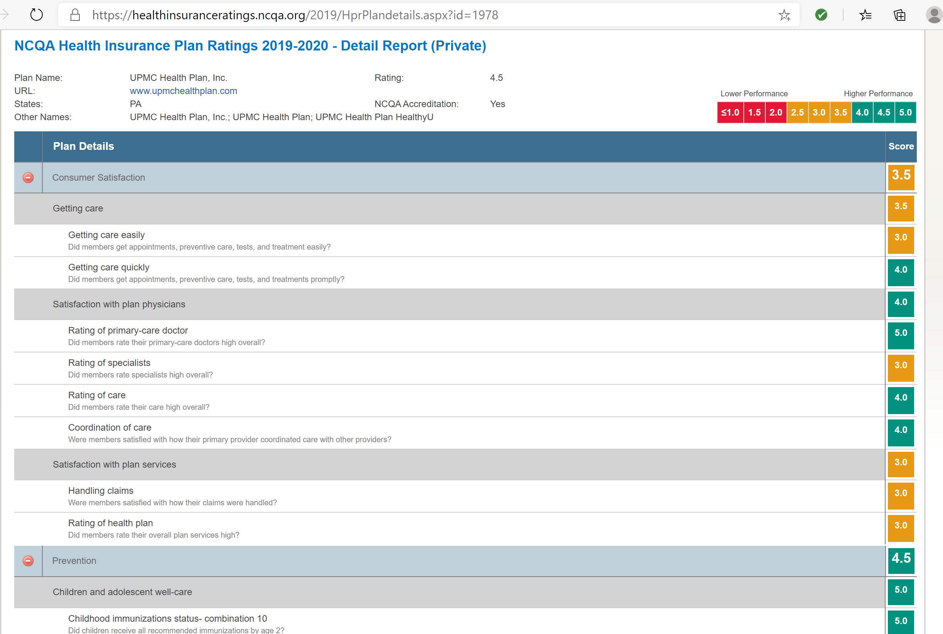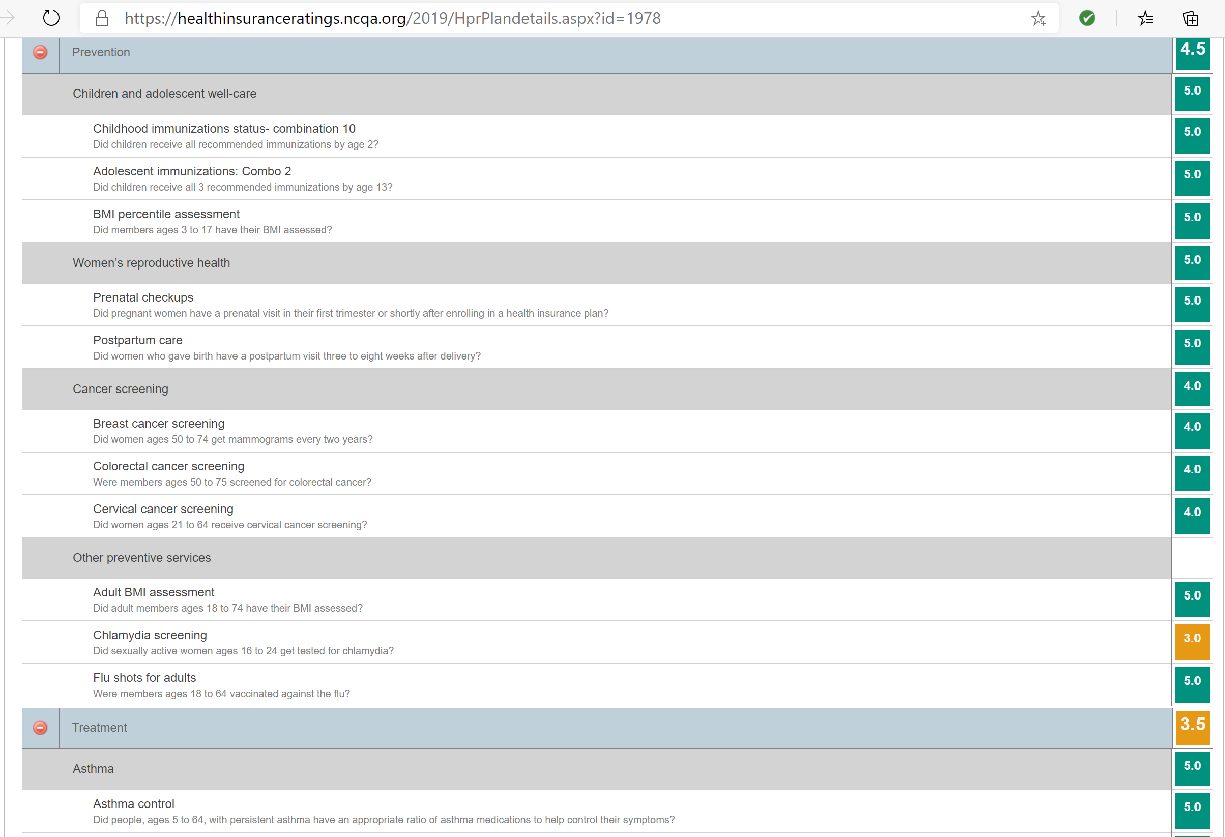
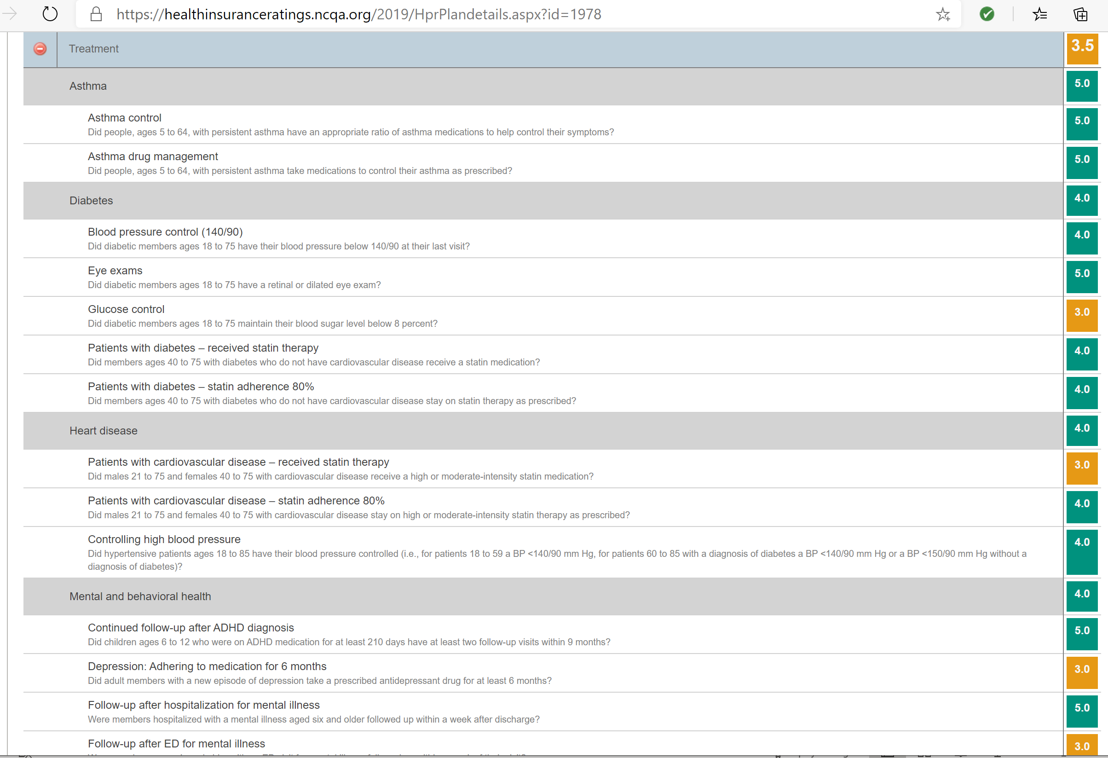


Appendix D – Medicare Star Ratings Measures

Appendix E – ACO Quality Measures

https://www.cms.gov/CCIIO/Programs-and-Initiatives/Health-Insurance-Market-Reforms/Medical-Loss-Ratio
https://revcycleintelligence.com/features/maximizing-provider-revenue-with-payer-contract-management
https://www.medicare.gov/hospitalcompare/readmission-reduction-program.html
Kaiser Family Foundation, Beyond Health Care: The Role of Social Determinants in Promoting Health and Health Equity, Samantha Artiga and Elizabeth Hinton, May 10, 2018.
https://www.cms.gov/Medicare/Medicare-Fee-for-Service-Payment/ACO#:~:text=Accountable%20Care%20Organizations%20(ACOs),care%20to%20their%20Medicare%20patients.
Shara McClure, Divisional Sr VP, Texas Healthcare Delivery, BCBSTX
https://innovation.cms.gov/innovation-models/next-generation-aco-model
CMS Medicare 2019 Part C & D Star Ratings Technical Notes, updated 11/8/2018

