Basics of Healthcare Revenue Cycle for Industrial Engineers
University of Pittsburgh swanson school of engineering
Industrial engineering department

Caroline Kolman, P.E.

Contents
Introduction 2
Stages of the Revenue Cycle 3
Pre-Arrival 3
Arrival 4
Care Integrity 4
Post Service Care & Revenue Recovery 5
Costing Systems and Billing 9
The Provider’s Chargemaster 9
Example Claim Calculation 10
Pricing Transparency 11
Monitoring & Reporting Systems 12
Payment Collection & Processing 12
Key Performance Indicators for Accounts Receivable 12
Other Metrics and Measures 15
Denials Management 15
Clean Claims Ratio 15
Categorizing Denials 16
Managing Denials 16
RAC Audits 17
Other Best Practices 17
Automation 17
Training and Job Aids 17
Cross-functional teams 18
Summary 18
Exercises 19
Appendix - Terminology and Definitions 22

Introduction

The way healthcare providers receive payment for the care they administer to their patients differs significantly from most other industries. If you walk into any retail establishment, you must pay for your purchase prior to leaving the store with the item(s). A healthcare provider receives payment from payers at best 30 days after the service was rendered, though they may collect co-pays from their patients at time of service (typically a small portion of the total amount they are due).
The revenue cycle is how a provider realizes revenue from the services provided to patients. It begins at the initial point of contact with the patient and normally ends when the provider files a claim and is paid for service (or writes off a patient’s account balance if no payment is received). Similar processes exist for hospitals (in-patient and out-patient care) and individual physician practices and specialties.
Figure 1 – Revenue Cycle Overview.
Historically, healthcare providers followed a fee-for-service delivery model, meaning that they basically billed – and were subsequently paid -- for every supply and service they delivered. Today, we see a movement towards newer payment models – where payers now pay only a fixed amount for an episode of care, or even align value (patient outcomes) with payment. The provider may only receive a set dollar amount for a type of diagnosis or level of care, forcing them to look closely at use of resources, documentation, level of care, and many other aspects related to their costs and ability to collect revenue (and ensure that the cost doesn’t exceed the payment). And further complicating matters, the average provider deals with 10 or more payers, each with their own unique contractual requirements.
As high deductible health plans have grown in popularity, providers face additional challenges in collecting payments directly from patients. Making these large payments has become an exceedingly difficult for many consumers, and providers find themselves with growing outstanding receivables and bad debt.
There are many players in the revenue cycle and a series of processes that are followed. It takes a coordinated approach between the front office (scheduling), the back office (billing/collections) and clinical staff to be successful. How well they execute on their responsibilities can mean the difference between a profitable practice and a money-losing practice, and this is where data analytics and process design can make an impact. The many tools used by industrial engineers and similar practitioners can identify weaknesses and problem areas and identify opportunities for improvement.

Stages of the Revenue Cycle

Pre-Arrival
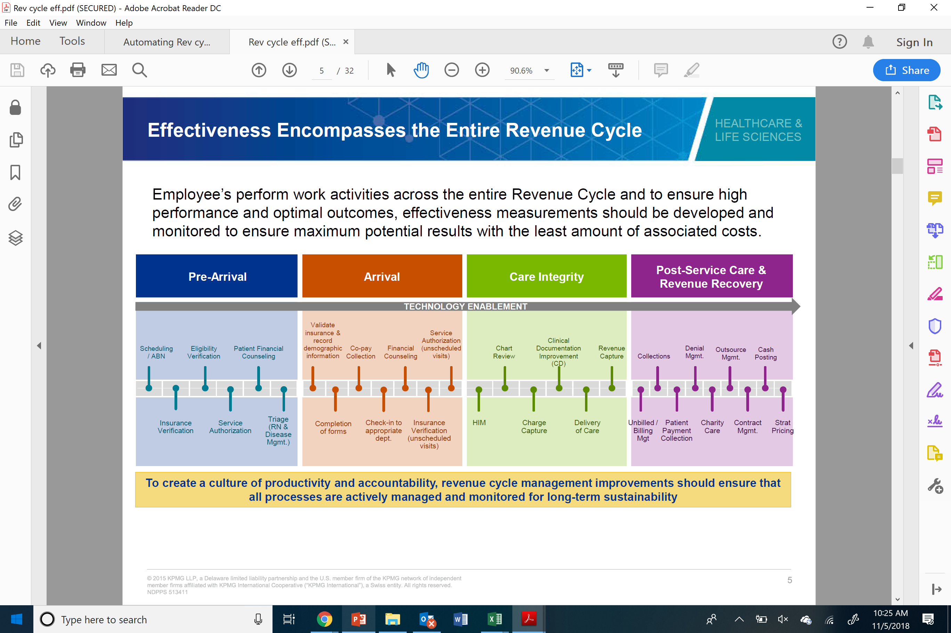
The time prior to a patient’s arrival to receive care is an opportune time to prepare and collect several key pieces of information. A healthcare provider’s staff should receive all relevant patient insurance information, and they should verify that the patient is still eligible and participating in the insurance plan. (Though not as common, the patient may have secondary as well as primary payer/coverage, so this question needs to be asked and information collected as well.) A provider may also need obtain authorization from the payer to provide this care (and ensure payment will be issued). This may require additional contact with the payer to verify and confirm.
Scheduling the care at a time that works for the patient and sending out reminders are also key strategies to ensure the patient makes the appointment. (Patient “no-shows” can be an issue for providers and can also be another revenue loss factor.) Staff must also work to fill up schedules as much as possible to avoid gaps in the clinicians’ workdays and ensure a steady stream of patients (and revenue).
Discussing the cost of care and payment arrangements with the patient prior to administering care is another strategy that providers can use. These types of discussions, while not always comfortable or pleasant, can help avoid issues later. (It may also require additional training for staff.) For example, a provider may ask a patient to sign an Advance Beneficiary Notice (“ABN”) in advance of a procedure. The ABN, also known as a waiver of liability, is considered a warning that Medicare may not pay for this particular care or treatment, and that the patient may be responsible for paying for this service if Medicare does not cover it.

Arrival
Once the patient arrives for care, a final check of all insurance information and eligibility should be completed. (Unfortunately, there are many instances where a patient’s insurance coverage changes from the time of scheduling to the actual service date, so it is always a good practice to verify eligibility again at time of service.) The patient completes any admission forms or other paperwork needed by the caregiver (such as additional health history, family contact information, etc.). The provider’s staff will verify the cost and insurance coverage, and most providers also collect any applicable co-payments from the patient upon arrival.
Many providers accept cash, check or credit card for payment. If the patient cannot make payment, they may be able to make some type of future payment arrangements or payment plans. Taking care of this issue at time of service also helps avoid non payments in the future.
If this care visit was not scheduled (emergency care), a call to the payer may be required for both verification of eligibility and authorization of service.
A final confirmation of payment arrangements or financial counseling may be conducted, again to ensure that the patient is able to pay whatever portion they are responsible for in a timely manner.

Care Integrity
Care Integrity encompasses all the services and supplies that are provide to the patient. If you consider a typical hospital stay or outpatient surgical procedure, a patient may be seen by several physicians, clinical staff, and nurses, who may utilize various supplies and instruments. They may be administered drugs and intravenous fluids. The patients utilize gowns, beds, sheets, and towels. They may require imaging, such as x-rays, or laboratory tests. These resources must be documented in the patient’s medical record, as well as diagnoses, treatments and outcomes, to ensure proper “charge capture.” This information must be documented so it can be included in the bill that is sent to the payer and patient.
A Health Information Management (HIM) department is responsible for the collection and processing of this data. Their staff may include:
- Medical coders – A coder will review the patient’s medical record and information to determine diagnosis or illness, look for pre-existing conditions or complications, treatments and outcomes. Based on this information they can determine the appropriate diagnosis and procedure codes that are ultimately used for billing.
- Coding compliance auditors – Auditors review the clinical documents, physician documentation, coding records and other data, looking for any issues or coding mistakes based on the data they review. A coding compliance program is an essential part of health information management, as it can ensure consistency and decrease risk of fraud and lost revenues. Frequent coding audits are essential, and best practices include a review of 3.5 to 5 percent of total cases each week.
- Clinical documentation specialists – Maintaining charts, medical records and reports are key responsibilities of the specialists; they proactively identify and correct any issues in the documentation. They will also work with clinicians when errors are identified and provide support and training, so they do not occur in the future. These reviews support the coders when they review the documents to ensure the proper codes are being used.
Similarly, a physician practice must also document the health, diagnosis and treatment for any patients they see in their offices. The information is coded by their internal billing/HIM teams and sent to payers for payment.

Post Service Care & Revenue Recovery
Once the care has been completed and the patient leaves the facility (hospital discharge, outpatient discharge or just leaving the doctor’s office), a bill must be generated and sent to the payer so the provider can collect payment. The first hurdle is to ensure that the documentation is complete, and the billing can be issued. There may be delays if the record or documentation is not complete (a status known as “discharged but not final billed,” or “DNFB”) so the HIM department makes every effort to ensure completeness as close to discharge as possible.
The billing information required by payers is entered on a UB04 form; there is a version for inpatient billing as well as outpatient as there are minor differences in the information and coding. (See Figures 3 and 4.) Before the move to electronic medical records, much of this processing was done on paper (forms printed and mailed for payment). Today the information is transmitted electronically.
Providers will have negotiated contracts with some payers; typically, these contracts provide some benefit to the payer and their members, such as pricing discounts. There may also be other quality- or results-based measures and programs that provide incentive payments to the provider.
Some providers utilize a clearinghouse to submit claims to a payer. A medical claims clearinghouse acts as a middleman between the provider and the payer, checking the claim for errors and then transmitting the claim to the payer. Once the claim is received by the payer, it is again reviewed to ensure adherence to the contract terms. If the information is correct, the payer will issue payment to the provider for the supplies and services.
In some cases, the information received by the payer is incorrect or has errors; in that case the payer may choose to deny the claim or pay a different (often lesser) amount than was billed. Denials and underpayment management is a serious and time-consuming function for these finance departments, which is why there is so much effort and focus on the front-end coding and review (prior to billing). (See “Denials” section for more information.) It is one of the most resource intensive processes within a healthcare provider’s operations, and a focus for process improvement in most organizations, as seen in Figure 2.

Figure 2 - Healthcare’s Wasted Dollars (billions)²

Managing the billing and revenue collection is a function of a provider’s Finance Department. As in any financial operation, cash is collected and posted to appropriate accounts, and monitored and reported. (See “Payment Processing” section.)
Patients that are not covered by any type of medical insurance or by government (Medicare or Medicaid) sponsored programs are classified as self-pay. In this case the bill is sent directly to the patient (not a payer). Some patients can manage and pay these bills, but many cannot, and they become part of charity or indigent care programs. Providers (primarily hospitals) find themselves in a difficult bind with these patients; they cannot turn them away when they arrive to receive care (typically in the Emergency Room) and they know they most likely will not be paid. Many providers set aside funding in their budgets to cover (and typically write off) these charges, and hope that what they collect from private insurers will help make up these shortfalls.
Figure 3 – Inpatient UB04 Form
Figure 4 – Outpatient UB04 Form

Costing Systems and Billing

The Provider’s Chargemaster
How does a provider determine how much they will bill? The key to this is the provider’s chargemaster. A chargemaster is a list of all the billable services and supplies that may be provided to a patient in their course of receiving care, along with their cost and the price billed (also referred to as the list price). These may be individual products (supplies or drugs), or a procedure (laboratory test or x-ray), or even a per day room cost. The provider uses the cost information to determine how much to bill for the episode of care.
When a patient receives care, everything is recorded in the patient’s record and reviewed by coders, who assign the appropriate codes for reporting and completing the claim. The codes translate into charges in the chargemaster.
The charge master pricing is based on the provider’s cost to provide the service or supply but often adjusted to include some margin; these adjustments may vary based on the type of service or supply. A provider uses this marked up pricing as a starting point in contract negotiations with payers. The charge to cost ratio is a commonly used benchmark; most hospitals ratio is in the 1.5 to 3.5 range but is dependent on many factors such as hospital size, costs, geographic location and payer mix. The payers are billed based on the negotiated contract pricing, such as a percent of charges or a fixed dollar amount. A self-pay patient will be charged the full amount that is listed in the chargemaster, and Medicare/Medicaid rates are often a fixed amount.
The chargemaster is reviewed frequently to ensure that the pricing is still relevant and covers the costs incurred by the provider. A hospital or healthcare system may enlist the help of a consultant or firm specializing in revenue management to help review the chargemaster pricing. These consultants have access to chargemasters across the country and can advise a provider when their pricing is out of synch with market pricing.
Within a hospital setting, the Finance Department oversees and manages the chargemaster review process. They may involve clinicians and physicians to ensure they are including all relevant supplies and services for the care, supply chain personnel for pricing and product selections, and coders and clinical documentation specialists to ensure they are up to date on changes and adjustments (e.g., added codes for new services provided, Medicare updates).
Figure 5 shows an extract of a hospital chargemaster, with several supplies and services and their costs listed.
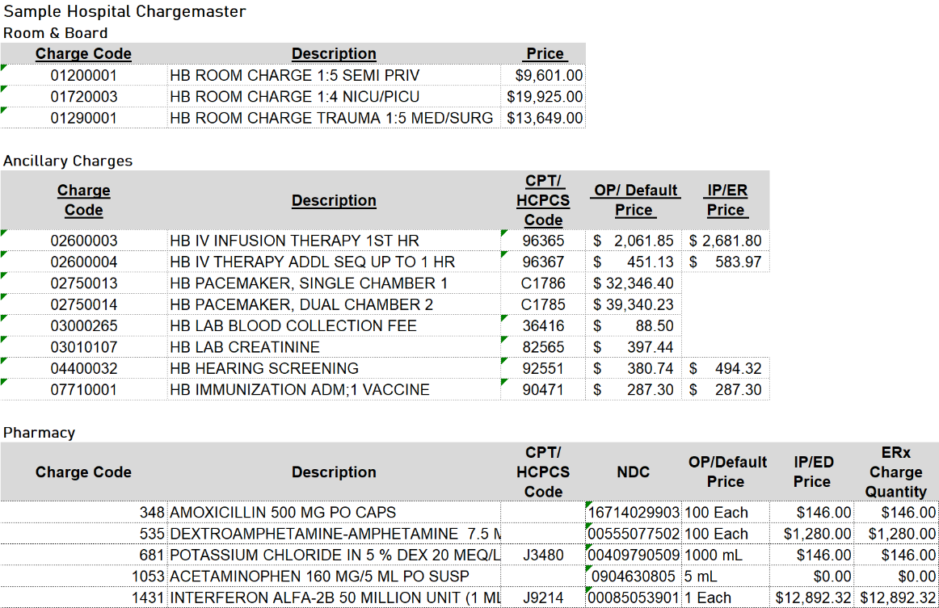
Figure 5 – Sample hospital chargemaster extract

Example Claim Calculation
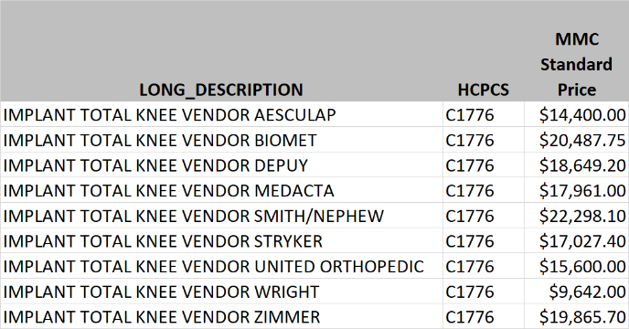
Miller Medical Center (MMC) developed their standard pricing for total knee implants based upon the brand of implant, as their pricing differed by vendor. The Finance Department developed the pricing schedule shown at right.
In their negotiations with Aetna, they agreed to accept 65% of standard charge for in-network patients, and 75% of standard for out-of-network patients.
Based upon this, MMC expects the following payment schedule for Aetna patients, and will submit claims with the following costs:
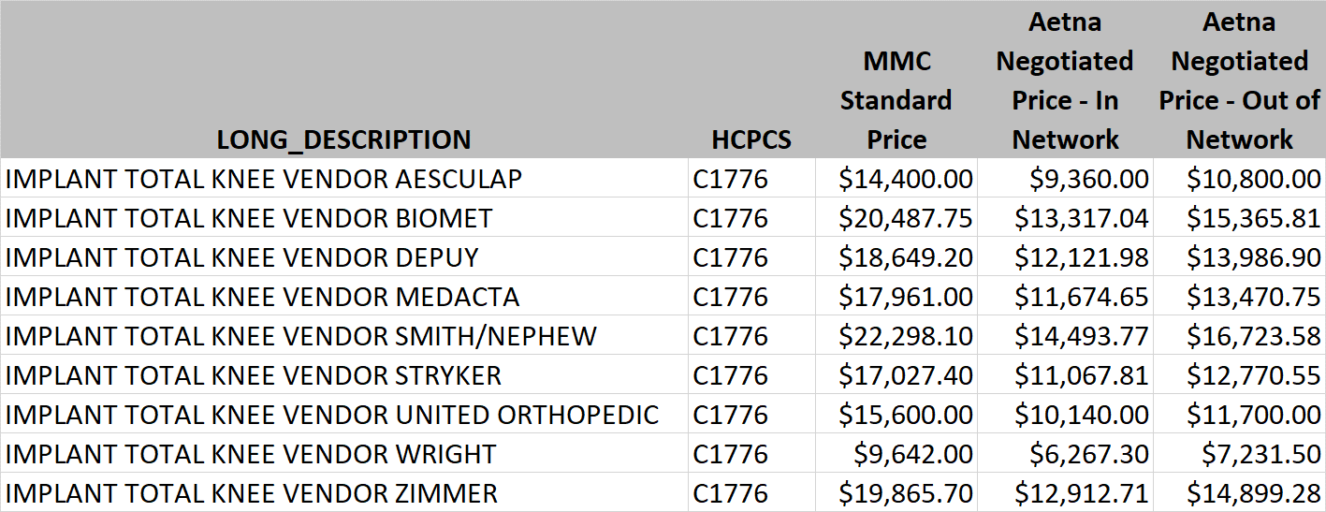

Pricing Transparency
In 2019, the Trump Administration passed an Executive Order to increase price transparency available to patients and potentially increase competition in the healthcare industry. In response to this order, the Department of Health and Human Services, the Department of Labor, and the Department of the Treasury (collectively, the Departments) proposed a rule that would require health plans to disclose pricing information to their participants up front prior to receiving care.
In the past there has been little information provided until a patient received the bill for care. Per CMS.gov, the rule proposes the following requirements to begin in 2021:
- Comprehensive Machine-Readable File: Hospitals will be required to make public all hospital standard charges (including the gross charges, payer-specific negotiated charges, the amount the hospital is willing to accept in cash from a patient, and the minimum and maximum negotiated charges) for all items and services on the Internet in a single data file that can be read by other computer systems. The file must include additional information such as common billing or accounting codes used by the hospital (such as Healthcare Common Procedure Coding System (HCPCS) codes) and a description of the item or service to provide common elements for consumers to compare standard charges from hospital to hospital.
- Display of Shoppable Services in a Consumer-Friendly Manner: Hospitals will be required to make public payer-specific negotiated charges, the amount the hospital is willing to accept in cash from a patient for an item or service, and the minimum and maximum negotiated charges for 300 common shoppable services in a manner that is consumer-friendly and update the information at least annually.
This would require that hospitals start reporting payment rates they have negotiated with health plans (commercial insurance/payers) publicly, which many providers regard as competitive information and they do not wish to share. (The American Hospital Association and other organizations have taken legal action to stop this initiative.)
Today, patients often lack access to useful price and quality information. While emergency situations do not lend themselves to price comparisons, patients may want to compare pricing (as well as quality and outcomes) for elective or “shoppable” procedures. Several healthcare providers now include cost estimator tools on their web sites for patients to calculate their cost prior to scheduling. By entering their specific health plan information, the estimators can give good estimate of total cost and out of pocket requirements for patients. But these tools do not make the cost information public, as the price transparency rule would require.

Monitoring & Reporting Systems
Monitoring processes and tracking key indicators (dollars and days) are key to effectively managing a healthcare provider’s finances and revenue cycle. There are a wide variety of measures and dashboards that can be created to pinpoint problem areas and identify where focused improvement efforts are needed.

Payment Collection & Processing
Cash flow management entails balancing the money coming in with payments going out and is key to financial viability and profitability. Healthcare providers are even more challenged as the cycle of invoicing and receiving payment can be prolonged (typically well over 30 days) when dealing with payers. They must set up tracking mechanisms to identify payments that have been received as well as those that have not been received.
As claims are processed and sent to the various payers, the provider’s Finance Department tracks the amounts outstanding, and the number of days unpaid. Typically, the accounts receivable (unpaid invoices) are grouped by number of days since issued, such as:
- 0 to 30 days
- 31 to 60 days
- 61 to 90 days
- 91 to 120 days
- More than 120 days
The amounts are grouped into these categories and can be reviewed regularly to determine where there may be problems, where additional information or documentation may be required, or other actions must be taken. It is important to actively manage these accounts, as the longer they go uncollected the less likely they are to ever be collected, either partially or in full.
As the payments are received from payers and patients, they are posted to the appropriate accounts and removed from the accounts receivable report.

Key Performance Indicators for Accounts Receivable
Key performance indicators provide a method of measuring the effectiveness of the accounts receivable function. Benchmarking can be used to compare the organization’s performance to an expected standard within the same industry, and trends can be identified. Following are some key performance indicators (KPIs) that are typically calculated and tracked by providers to manage their accounts receivable:

- Average number of days in accounts receivable (unpaid) – This tells you the average length of time it takes for a claim to be paid (receivables collected). The calculation is net patients accounts receivable within a specified period from the balance sheet divided by average daily net patient service revenue within that period from the income statement (total charges divided by total number of days). The target should be 30 to 40 days for a practice, and 40 to 45 days for a hospital. If the number is high, the provider should be looking for decreasing trend in days over time. You can also calculate the A/R days by specific payer to evaluate the collection effectiveness by payer (or self-pay patients).

Example: A Chicago hospital charged an average of $10M per month for the last 12 months and has a total of $15M in Accounts Receivable for the same time period. The average days in A/R is:
$15,000,000__
= ($10M * 12) / 365 = 45

- Cash collected as a percentage of net revenue – or Net collections rate (percent collected out of total allowed amount) – Cash collected in a period divided by the net revenue (amount charged) for the period. This ratio gives an indication of the effectiveness and success with collecting revenue (and avoiding write-offs and bad debt). It can also be split between payer and patient collectibles, as the reasons for non-payment may not be the same (eligibility for payment vs. ability to pay) and should be treated differently. Best practice is 95% or better; comparing net collection by payer can also identify problem areas or payers and signal process improvement opportunities.

Example: The same hospital collected $8.5M last month against the $10M in charges. The percent cash collected is:
$8,500,000
= $10,000,000 = 85%

- Percentage of claims collected less than 60 days from billing – Managing this metric is key as the more quickly claims are filed and paid, the more efficient the revenue cycle. The calculation is the total claims collected/paid within 60 days divided by the total number of claims filed in that period. As proven in many cases, the longer the days in AR, the less likelihood of ever receiving payment for a claim.
- Denials rate – Number of claims denied divided by the total number of claims filed. The goal is to keep this below 2% of claims filed. Trends should also be monitored, as they can be indicators of deeper process issues.

Example: The hospital filed 191,195 claims and received 5,542 denials. The denials rate is:
5,542
= 191,195 = 2.9%

- Discharged but not final billed (DFNB)/Unbilled AR – In this case the service was completed but the provider has not been able to file the claim. Some causes include not all charges being recorded and collected in the patient’s record, coding not completed, and even insurance not verified so staff does not know who to bill. This amount must also be managed, as the filing date can quickly go beyond allowable days for a payer, so it should be a priority for staff to get them completed and filed as quickly as possible. “Suspense period” is the amount of time a provider allows for the completion and submission of a claim (time to collect all the information required) following patient discharge. Best practice is a 3-day or less suspense period.
- Final Billed but not submitted to payer (FBNS) – In this case, the claim may need additional editing/scrubbing prior to submission to the payer. This number should be close to zero as possible.

Other reports and measures include:
- Payment aging from discharge by payer – As mentioned earlier, aging reports divide the accounts receivable into 30, 60, 90 120 days and over categories, based on the date of service or discharge. It is an important measure as it shows how delays in billing impact the ability to receive payment in a timely manner. It can also identify which payers are paying late and focus on process improvements to speed them up. Using a descending balance report can let staff focus on the highest balance accounts to focus collections.
- Cost to collect – This is the total revenue cycle departmental costs divided by patient collections. Best practice is a range from 1.6% to 2.4%, but most providers are consistently over 3%.
- Monthly write-offs and bad debt
- Point of service cash or Co-payment collection rate (from patient prior to service) – Cash collections up front (prior to service) divided by total cash collected. Best practice is 25 to 37% range.

Example: A hospital collected the following data for revenue cycle reporting for the previous year:
Patients accounts receivable | $ 57,127,000
Net patient service revenue | $ 489,504,000
Bad debt | $ 10,934,000

What is the days in accounts receivable? How does it compare to best practice?
Days in A/R = $57,127,000 / ($489,504,000/365) = 42.6
Best practice is 40 to 45 days, so this hospital is performing withing that range.
What is the percent bad debt?
% Bad Debt = $10,934,000 / $489,504,000 = 2.2%
Best practice is below 2% - this hospital is just above that, so they should take a closer look at their bad debt. Is it trending up or down? If going down, that is a positive indicator but if going up, they should look at some of the revenue cycle processes involving patient payment counseling.

Other Metrics and Measures
Other areas to monitor that may be more process focused include:
- Insurance verification (%) at time of admission (inpatient, outpatient)
- Average patient wait time for registration/appointment
- Patient no-show rates
- Denials overturned rate
- Inpatient/Outpatient charts coded per day
Considerable improvements can be made by tracking and measuring staff performance in areas such as these. Only by consistently measuring and providing staff feedback can providers make a difference in their service levels and revenues.
Figure 5 shows a sample report on insurance verification results for a healthcare provider.

Figure 5 – Insurance Verification reporting.

Denials Management
When a provider submits a claim for services, they expect that the claim will be honored and paid. However, due to mistakes such as data entry errors, missed documentation, or even failure to follow contract terms, payers may deny payment, or in some cases pay less than the provider is expecting to receive (underpayment). A provider’s denial management program focuses on reducing the number of claims that are not paid by payers, government programs and patients themselves.

Clean Claims Ratio
The clean claims ratio is the percent of claims that are paid when they are initially submitted. These claims have not been rejected or denied, have not been filed previously, and have no errors or underpayment. It is the goal for a provider to have a 95% or better clean claims ratio.
The more claims that are processed cleanly and paid timely, the less rework required by staff, so this is another area where root cause analysis can identify training deficiencies, process bottlenecks and other issues to target for improvement.

Categorizing Denials
Technical denials – Claims denied due to some type of administrative error. This may include inaccurate or missing demographic data, billing or coding errors, missing authorization, patient ineligibility or duplicate filings.
Medical denials – Claims denied for medical necessity reasons.
Partial payments or discrepancies (typically underpayment) – Typically caused by contract misinterpretation or coding errors.
Claim suspensions – The claim is placed “on hold” pending a review by the payer. Reviews are initiated by payers when there have been several errors on claims submitted by the provider. The payer will not process and make payment until the reviews are completed.
Late payments – Payment takes longer than anticipated, reducing cash flow. Providers should review contract terms to ensure they are in compliance, as well as local and state laws regarding prompt payment.

Managing Denials
Providers must actively track denied claims to quickly resolve issues and resubmit the claims to the payer. But how does staff know what actions to take, and more importantly, how to avoid this from happening on future claims?
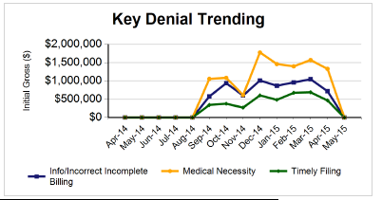
Revenue cycle staff must measure how frequently and why denials occur. A root cause analysis of denials is key to identify potential process issues and develop solutions to resolve them. Some reasons for denials may include:
- Duplicate claim filed
- Service not covered by patient’s plan
- Incorrect or incomplete information
- Patient not covered by plan
- Pre-certification or pre-authorization not obtained
- Not medically necessary
- Untimely filing (past deadline to submit)
- Diagnosis incorrect or inconsistent with documentation
Another way to review the information is to segregate by payer and determine if there is a pattern with certain payers as well.
The data must be tracked and analyzed as soon as denials are received so they can be resolved and resubmitted, if appropriate. Other actions include redesigning processes to avoid problems from recurring. One example is untimely/late filings; staff must be aware of deadlines by payer contract and ensure that the claims are submitted by the time designated. Another example is patients no longer qualifying for a plan (perhaps due to change in employment, life event, etc.). This is where a process improvement effort can ensure that admissions staff are checking for insurance eligibility at time of service and not letting that practice lapse.
Another way to view denials is to look for trends: Are occurrences or dollars increasing or decreasing? And is that for a specific denial category or payer? Can a reason be identified?
Example: Rural Hospital discovered a high number of denials for newborns due to lack of eligibility. After further investigation, it became clear that newborns were being denied coverage because they were not added to the family insurance policy within 30 days. The hospital used case management workers to ensure the newborn was added prior to leaving the hospital.

RAC Audits
Through legislation passed by Congress under the Medicare Modernization Act of 2003, The Centers for Medicare and Medicaid Services (CMS) were authorized to implement a nationwide Recovery Audit program, which reviews claims submitted to Medicare and Medicaid in order to uncover any errors or overpayments in these claims. CMS hires Recovery Auditor Contractors (RACs) who are paid on a contingency basis (a portion of the recovered claims dollars) to identify and correct any improper payments so CMS can avoid future improper payments on claims.

Other Best Practices

Automation
In many cases, technology can improve and modernize the healthcare revenue cycle, while also creating a better patient experience. However, technology typically comes with a high price tag, and not all providers can afford them. But following are some examples areas that can benefit from technology improvements, both patient-facing and operationally focused:
- Cost estimator tools – many providers have created a portal on their web sites to help patients estimate the cost of a procedure or care, splitting patient out-of-pocket and insurance/payer costs. These can be extended to help with co-pays and other payment arrangements.
- Patient portals to allow appointment scheduling, view test results, access medical history and records, pay medical bills, and communicate with physicians through email and texting.
- Apps to conduct tele-health sessions with doctors.
- Artificial intelligence solutions to improve coding and clinical documentation (and avoid denials and underpayments).
- Claims management and business intelligence tools to determine and fix root causes of denials and underpayments.
- Workflow automation to speed up documentation and claims processing.
- Blockchain technology for faster and more secure claims processing.

Training and Job Aids
As with any operation, the staff working in healthcare revenue cycle must be well trained in their roles to ensure efficient and effective revenue collection. Some needed skills include:
- Ability to comfortably speak with patients about payment and financial obligations. They need to be prepared to discuss the cost of treatment and educate patients on their responsibilities for fees. Practice management needs to make them aware of payment standards and requirements, and how best to address patients with financial challenges.
- Technology training to ensure the staff is getting optimal use of any technology investment. While not everyone has time to take courses offsite, there should be a “super user” on staff that can train new hires and provide refresh courses to staff.
- Analytical skills to process data and reports, identify problem areas, and devise solutions to improve operations.
- Understanding of payer contract terms and conditions. Staff should become familiar with the various requirements of different payers, to ensure proper claims processing and ensure patient eligibility.
In addition to training, management can provide job aids (checklists, help desks, computer prompts) to ensure processes and technology are all used effectively and according to a standard procedure.

Cross-functional teams
Healthcare revenue cycle is another area that can benefit from the use of cross functional teams to solve complex problems. Denials management is one such example: the root causes of denials can vary greatly, from simple administrative errors to complex coding and documentation. Team members with varying backgrounds working together can come up with innovative and original ideas to tackle a variety of problems. Clinicians can add great perspectives and ideas to these teams, and may see things differently than financial staff immersed in claims and billings.
Some guidelines for teams include:
- Assemble the right team members – those that have familiarity with the issue, that are comfortable working without a lot of guidance, and want to see positive change in their workplace.
- Clearly define the team’s goal – set this up before assembling the team, then make sure everyone is aware of the priorities.
- Communicate clearly and often
- Conduct periodic check-ins with management to review progress
- Celebrate successes – even if they are small!

Summary
A provider’s revenue cycle is how the provider realizes revenue from the services provided to patients. Inefficiencies in the processes can lead to problems with cash flow and can negatively impact financial health of the provider.
Using analytics to measure revenue collected and denied, along with the processes that support them, can improve the dollars and timeliness of collections. Monitoring trends, conducing root cause analyses, and utilizing cross functional teams are just some of the tactics providers can use to make these improvements.

Exercises

- The State of California requires each hospital in the state to submit a copy of their chargemasters along with a list of average charges for 25 common procedures every year. The attached data file shows an extract for 4 hospitals in California.
  - Compare the hospitals’ charges for each section. Use Excel conditional formatting to identify the highest and lowest cost for each procedure listed (with red as highest cost and green as lowest). Discuss reasons for the differences in charges.
  - If Torrance Hospital had an average charge to cost ratio of 4.3, what are the average costs for each procedure?
- A recent data extract from Medicare Provider Utilization and Payment data (https://www.cms.gov/Research-Statistics-Data-and-Systems/Statistics-Trends-and-Reports/Medicare-Provider-Charge-Data/Inpatient) shows the charges, average payments and average Medicare reimbursements for hospitals in the Dallas, TX area for DRG 291 – Heart Failure & Shock with Major Complications and Comorbidities.
  - Calculate the payment to charge percentage for each hospital for both total payments and Medicare payments.
  - Assume the hospitals’ charge to cost ratio is 4.2. What would their average charge be for this DRG? Compared to average payments, which hospitals are making money? Which are losing money?
- Monroe Healthcare System had the following financial results for the last 12 months:
Accounts Receivable (12 months) | $ 143,478,000
Net patient revenue (12 months) | $ 919,511,000
Bad debt (12 months) | $ 77,377,000

  - What are the days in Accounts Receivable for these 12 months? How does this compare to a target of 45 days in A/R? What next steps should the Finance Director consider?
  - What is the bad debt percentage of net revenue? How does this compare to a target of 2% or less? What strategies should they implement?
- University Medical Center finance staff generated the following aging report for this month:
  - Complete the table to show percentage of total for each of the 2-month increments.
  - Based on this data, what observations can you make about their payers and receivables?
  - What recommendations would you make to the finance staff for improvements to better manage their accounts receivable?
- Montgomery County Community Hospital has been tracking denials for the last several months and the finance staff has collected the following data:
  - Summarize the denials by reason and payer (using claims dollars).
  - What should be the Finance Director’s next actions and why?

- Brooks Medical Center has been tracking denials by reason for the last 6 months:
  - What trends do you see in the denials overall and by individual reason?
  - What process improvements might be needed (review each denial reason)?

Appendix - Terminology and Definitions

A
Allowed Amount: The sum an insurance company will reimburse to cover a healthcare service or procedure. The patient typically pays the remaining balance if there is any amount left over after the allowed amount has been paid. This amount should not be confused with co-pay or deductibles owed by a patient.
Aging: A formal medical billing term that refers to insurance claims that haven’t been paid or balances owed by patients overdue by more than 30 days. Aging claims may become denied if they aren’t filed in time with a health insurance company.
Ancillary Services: Any service administered in a hospital or other healthcare facility other than room and board, including biometrics tests, physical therapy, and physician consultations among other services.
Appeal: Appeal occurs when a patient or a provider tries to convince an insurance company to pay for healthcare after it has decided not to cover costs for someone on a claim. Medical billing specialists deal with appeals after a claim has been denied or rejected by an insurance company.
Applied to Deductible (ATD): This term refers to the amount of money a patient owes a provider that goes to paying their yearly deductible. A patient’s deductible is determined by their insurance plan and can range in price.
Assignment of Benefits (AOB): This term refers to insurance payments made directly to a healthcare provider for medical services received by the patient. Assignment of benefits occurs after a claim has been successfully processed with an insurance company.
Authorization: This term refers to when a patient’s health insurance plan requires them to get permission from their insurance providers before receiving certain healthcare services. A patient may be denied coverage if they see a provider for a service that needed authorization without first consulting the insurance company.
B
Beneficiary: The beneficiary is the person who receives benefits and/or coverage under a healthcare plan. The beneficiary of an insurance plan may not be the person paying for the plan, as is the case for young children covered under their parents’ plans.
C
Capitation: A fixed payment that a patient makes to a health insurance company or provider to recoup costs incurred from various healthcare services. A capitation is different from a deductible or co-pay.
Charity Care: This type of care is administered at reduced or zero cost to patients who cannot afford healthcare. Providers may offer charity care at their discretion.
Clean Claim: This refers to a medical claim filed with a health insurance company that is free of errors and processed in a timely manner. Some providers may send claims to organizations that specialize in producing clean claims, like clearinghouses.
Clearinghouse: Clearinghouses are facilities that review and correct medical claims as necessary before sending them to insurance companies for final processing. This meticulous editing process for claims is known in the medical billing industry as “scrubbing.”
Centers for Medicare and Medicaid Services (CMS): The CMS is the federal entity that manages and administers healthcare coverage through Medicare and Medicaid. CMS coordinates with providers and enrollees to provide healthcare to over 100 million Americans.
CMS 1500: The CMS 1500 is a paper medical claim form used for transmitting claims based on coverage by Medicare and Medicaid plans. Commercial insurance providers often require that providers use CMS 1500 forms to process their own paper claims.
Coding: Coding is the process of translating a physician’s documentation about a patient’s medical condition and health services rendered into medical codes that are then plugged into a claim for processing with an insurance company. Medical billing specialists must be familiar with many code sets in order to perform their job duties.
COBRA Insurance: A federal program that allows a person terminated from their employer to retain health insurance they had with that employer for up to 18 months, or 36 months if the former employee is disabled.
Co-Insurance: The percentage of coverage that a patient is responsible for paying after an insurance company pays the portion agreed upon in a health plan. Co-insurance percentages vary depending on the health plan.
Collection Ratio: This refers to the ratio of payments received relative to the total amount owed to providers.
Contractual Adjustment: This refers to a binding agree between a provider, patient, and insurance company wherein the provider agrees to charges that it will write off on behalf of the patient. Contractual adjustments may occur when there is a discrepancy between what a provider charges for healthcare services and what an insurance company has decided to pay for that service.
Coordination of Benefits (COB): COB occurs when a patient is covered by more than one insurance plan. In this situation one insurance company will become the primary carrier and all other companies will be considered secondary and tertiary carriers that may cover costs left after the primary carrier has paid.
Co-Pay: A patient’s co-pay is the amount that must be paid to a provider before they receive any treatment or services. Co-pays are separate from a deductible and will vary depending on a person’s insurance plan.
Current Procedural Technology (CPT) Code: CPT codes represent treatments and procedures performed by a physician in a 5-digit format. CPT codes are entered together with ICD-9 codes that explain a patient’s diagnosis. Medical billing specialists will enter CPT codes into claims, so insurance companies understand the nature of healthcare a patient received with a provider.
Credentialing: The application process for a provider to coordinate with an insurance company. Once providers have become credentialed with an insurance company, they have the opportunity to work with that company in providing affordable healthcare to patients.
Crossover Claim: When claim information is sent from a primary insurance carrier to a secondary insurance carrier, or vice versa.
D
Date of Service (DOS): The date when a provider performed healthcare services and procedures.
Deductible: The amount a patient must pay before an insurance carrier starts their healthcare coverage. Deductibles range in price according to terms set in a person’s health plan.
Demographics: The patient’s information required for filing a claim, such as age, sex, address, and family information. An insurance company may deny a claim if it contains inaccurate demographics.
Durable Medical Equipment (DME): This refers to medical implements that can be reused such as stretchers, wheelchairs, canes, crutches, and bedpans.
Downcoding: Downcoding occurs when an insurance company finds there is insufficient evidence on a claim to prove that a provider performed coded medical services and so they reduce or remove those codes. Downcoding usually reduces the cost of a claim.
Duplicate Coverage Inquiry (DCI): A formal request typically submitted by an insurance carrier to determine if other health coverage exists for a patient.
E
Electronic Claim: A claim sent electronically to an insurance carrier from a provider’s billing software. The format of electronic claims must adhere to medical billing regulations set forth by the federal government.
Electronic Funds Transfer: A method of transferring money electronically from a patient’s bank account to a provider or an insurance carrier.
Electronic Medical Records (EMR): EMR is a digitized medical record for a patient managed by a provider onsite. EMRs may also be referred to as electronic health records (EHRs).
Enrollee: A person covered by a health insurance plan.
Explanation of Benefits (EOB): A document attached to a processed medical claim wherein the insurance company explains the services they will cover for a patient’s healthcare treatments. EOBs may also explain what is wrong with a claim if it’s denied.
Electronic Remittance Advice (ERA): The digital version of EOB, which specifies the details of payments made on a claim either by an insurance company or required by the patient.
F
Fee for Service: This refers to a type of health insurance wherein the provider is paid for every service they perform. People with fee-for-service plans typically can choose whatever hospitals and physicians they want to receive care in exchange for higher deductibles and co-pays.
Fee Schedule: A document that outlines the costs associated for each medical service designated by a CPT code.
Financial Responsibility: Whoever owes the healthcare provider money has financial responsibility for the services rendered. Insurance companies or patients themselves may be financially responsible for the costs associated with care, and these responsibilities are typically outlined in a healthcare plan contract.
Formulary: A table or list provided by an insurance carrier that explains what prescription drugs are covered under their health plans.
Fraud: Providers, patients, or insurance companies may be found fraudulent if they are deliberately achieving their ends through misrepresentation, dishonesty, and general illegal activity. Medical billing specialists who deliberately enter incorrect or misleading information on claims may be charged with fraud.
G
Group Health Plan (GHP): A plan provided by an employer to provide healthcare options to a large group of employees.
Group Name: The name of the group, insurance carrier, or insurance plan that covers a patient.
Group Number: A number given to a patient by their insurance carrier that identifies the group or plan under which they are covered.
Guarantor: The party paying for an insurance plan who is not the patient. Parents, for example, would be the guarantors for their children’s health insurance.
H
Healthcare Financing Administration: The former name for what is now the CMS.
Healthcare Financing Administration Common Procedure Coding System (HCPCS): HCPCS is a three-tier coding system used to explain services, devices, and diagnoses administered in the healthcare system. Medical billing specialists utilize codes in the HCPCS daily to file claims.
Healthcare Insurance: This is insurance offered to a group or an individual to cover costs associated with medical care and treatment. Those covered by healthcare insurance typically must pay a premium for their plans in addition to various co-pays and/or deductibles.
Healthcare Provider: These are the entities that offer healthcare services to patients, including hospitals, physicians, and private clinics, hospices, nursing homes, and other healthcare facilities.
Healthcare Reform Act: The major healthcare legislation passed in 2010 designed to make healthcare accessible and less expensive for more Americans.
Health Insurance Claim: The unique number ascribed to an individual to identify them as a beneficiary of Medicare.
Health Insurance Portability and Accountability Act (HIPAA): HIPAA was a law passed in 1996 with an aim to improve the scope of healthcare services and establish regulations for securing healthcare records from unwanted parties.
Health Maintenance Organization (HMO): HMOs are networks of healthcare providers that offer healthcare plans to people for medical services exclusively in their network.
Hospice: This refers to medical care and treatment for persons who are terminally ill.
I
ICD-9 Codes: ICD-9 codes are an international set of codes that represent diagnoses of patients’ medical conditions as determined by physicians. Medical billing specialists may translate a physician’s diagnoses into ICD-9 codes and then input those codes into a claim for processing.
ICD-10 Codes: ICD-10 codes are the updated international set of codes based on the preceding ICD-9 codes. ICD-10 codes were made mandatory in the American healthcare system in October 1, 2015.
Incremental Nursing Charge: A fee for nursing services a patient is charged during the course of receiving healthcare.
Indemnity: A type of health insurance plan whereby a patient can receive care with any provider in exchange for higher deductibles and co-pays. Indemnity is also known as fee-for-service insurance.
In-Network: This term refers to a provider’s relationship with a health insurance company. A group of providers may contract with an insurance company to form a network of healthcare professionals that a person can choose from when enrolled in that insurance company’s health plan.
Inpatient: Inpatient care occurs when a person has a stay at a healthcare facility for more than 24 hours.
Intensive Care: Intensive care is the unit of a hospital reserved for patients that need immediate treatment and close monitoring by healthcare professionals for serious illnesses, conditions, and injuries.
M
Medicare Administrative Contractor (MAC): MACs are contract with the federal government to process Medicare claims.
Managed Care Plan: A health insurance plan whereby patients can only receive coverage if they see providers who operate in the insurance company’s network.
Maximum Out of Pocket: The amount a patient is required to pay. After a patient reaches their maximum out of pocket, their healthcare costs should be covered by their plan.
Medical Assistant: An employee in the healthcare system such as a physician’s assistant or a nurse practitioner who perform duties in administration, nursing, and other ancillary care.
Medical Coder: A medical coder is responsible for assigning various medical codes to services and healthcare plans described by a physician on a patient’s superbill.
Medical Billing Specialist: A medical billing specialist is responsible for using information regarding services and treatments performed by a healthcare provider to complete a claim for filing with an insurance company so the provider can be paid.
Medical Necessity: This term refers to healthcare services or treatments that a patient requires to treat a serious medical condition or illness. This does not include cosmetic or investigative services.
Medical Record Number: A unique number ascribed to a person’s medical record so it can be differentiated from other medical records.
Medicare Secondary Payer: The insurance company that covers any remaining expenses after Medicare has paid for a patient’s coverage.
Medical Savings Account (MSA): An MSA is an optional health insurance payment plan whereby a person apportions part of their untaxed earnings to an account reserved for healthcare expenses. A person with an MSA can only contribute a certain amount of their earnings per year. Any unused funds in an MSA at the end of the year will roll over to the next.
Medical Transcription: The process of converting dictated or handwritten instructions, observations, and documentation into digital text formats.
Medicare: Medicare is a government insurance program started in 1965 to provide healthcare coverage for persons over 65 and eligible people with disabilities.
Medicare Coinsurance Days: Referring to 61st through 90th days of inpatient treatment, the law requires that patients pay for a portion of their healthcare during Medicare coinsurance days.
Medicare Donut Hole: This term refers to the discrepancy between the limits of healthcare insurance coverage and the Medicare Part D coverage limits for prescription drugs.
Medicaid: Medicaid is a joint federal and state assistance program started in 1965 to provide health insurance to lower-income persons. Both state and federal governments fund Medicaid programs, but each state is responsible for running its own version of Medicaid within the minimum requirements established by federal law.
Medigap: Medigap is supplemental health insurance under Medicaid for eligible persons who need help covering co-pays, deductibles, and other large fees.
Modifier: Modifiers are additions to CPT codes that explain alterations and modifications to an otherwise routine treatment, exam, or service.
N
Non-Covered Charge (N/C): N/Cs are procedures and services not covered by a person’s health insurance plan.
Network Provider: A provider within a health insurance company’s network that has contracted with the company to provide discounted services to a patient covered under the company’s plan.
Non-participation: This is when a provider refuses to accept Medicare payments as a sufficient amount for the services rendered to a patient.
Not Otherwise Specified (NOS): This term is used in ICD-10 codes to describe conditions with unspecified diagnoses.
National Provider Identifier (NPI) Number: A unique 10-digit number ascribed to every healthcare provider in the U.S. as mandated by HIPAA.
O
Out-of-Network: Out-of-network refers to providers outside of an established network of providers who contract with an insurance company to offer patients healthcare at a discounted rate. People who go to out-of-network providers typically have to pay more money to receive care.
Outpatient: This term refers to healthcare treatment that doesn’t require an overnight hospital stay, including a routine visit to a primary care doctor or a non-invasive surgery.
P
Patient Responsibility: This refers to the amount a patient owes a provider after an insurance company pays for their portion of the medical expenses.
Primary Care Physician (PCP): The physician who provides the basic healthcare services for a patient and recommends additional care for more serious treatments as necessary.
Point of Service Plans: A plan whereby patients with HMO membership may receive care at non-HMO providers in exchange for a referral and paying a higher deductible.
Place of Service Code: A two-digit code used on claims to explain what type of provider performed healthcare services on a patient.
Preferred Provider Organization (PPO): A plan similar to an HMO whereby a patient can receive healthcare from providers within an established network set up by an insurance company.
Practice Management Software: Software used for scheduling, billing, and recordkeeping at a provider’s office.
Preauthorization: Some insurance plans require that a patient receive preauthorization from the insurance company prior to receiving certain medical services to make sure the company will cover expenses associated with those services.
Pre-Certification: A process similar to preauthorization whereby patients must check with insurance companies to see if a desired healthcare treatment or service is deemed medically necessary (and thus covered) by the company.
Pre-determination: A maximum sum as explained in a healthcare plan an insurance company will pay for certain services or treatments.
Pre-existing Condition (PEC): PEC is a medical condition a patient had before receiving coverage from an insurance company. A person might become ineligible for certain healthcare plans depending on the severity and length of their PEC.
Pre-exisiting Condition Exclusion: The existence of a PEC denies a person certain coverage in some health insurance plans.
Premium: The sum a person pays to an insurance company on a regular (usually monthly or yearly) basis to receive health insurance.
Privacy Rule: Standards for privacy regarding a patient’s medical history and all related events, treatments, and data as outlined by HIPAA.
Provider: A provider is the healthcare facility that administered healthcare to an individual. Physicians, clinics, and hospitals are all considered providers.
Provider Transaction Access Number (PTAN): This refers to a provider’s current legacy provider number with Medicare.
R
Referral: This is when a provider recommends another provider to a patient to receive specialized treatment.
Remittance Advice (R/A): The R/A is also known as the EOB, which is the document attached to a processed claim that explains the information regarding coverage and payments on a claim.
Responsible Party: The person who pays for a patient’s medical expenses, also known as the guarantor.
Revenue Code: A three-digit code used on medical bills that explains the kind of facility in which a patient received treatment.
Relative Value Amount (RVA): The median amount Medicare will repay a provider for certain services and treatments.
S
Scrubbing: A process by which insurance claims are checked for errors before being sent to an insurance company for final processing. Providers scrub claims in an attempt to reduce the number of denied or rejected claims.
Self-Referral: When a patient does their own research to find a provider and acts outside of their primary care physician’s referral.
Self-Pay: Payment made by the patient for healthcare at the time they receive it at a provider’s facilities.
Secondary Insurance Claim: The claim filed with the secondary insurance company after the primary insurance company pays for their portion of healthcare costs.
Secondary Procedure: This is when provider performs another procedure on a patient covered by a CPT code after first performing a different CPT procedure on them.
Skilled Nursing Facility: These are facilities for the severely ill or elderly that provide specialized long-term care for recovering patients. Skilled nursing facilities are alternative healthcare establishments to extended hospital stays and may be covered by eligible patients’ insurance policies.
Signature on File (SOF): A patient’s official signature on file for the purpose of billing and claims processing.
Software as a Service (SAAS): Medical billing software hosted off site by another company and only accessible with Internet access. SAAS is useful for providers who don’t want to maintain and update in-house medical billing software.
Specialist: A physician or medical assistant with expertise in a specific area of medicine. Oncologists, pediatricians, and neurologists are among the many specialists in the medical field.
Subscriber: The subscriber is the individual covered under a group policy. For instance, an employee of a company with a group health policy would be one of many subscribers on that policy.
Supplemental Insurance: Supplemental insurance can be a secondary policy or another insurance company that covers a patient’s healthcare costs after receiving coverage from their primary insurance. Supplemental insurance policies typically help patients cover expensive deductibles and copays.
T
Treatment Authorization Request (TAR): A unique number the insurance company gives the provider for billing purposes. A provider must receive the insurance company’s TAR number before administering healthcare to a patient covered by the company.
Taxonomy Code: Medical billing specialists utilize this unique codeset for identifying a healthcare provider’s specialty field.
Term Date: The end date for an insurance policy contract, or the date after which a person no longer receives or is no longer eligible for health insurance with company. Term dates are typically determined on a case-by-case basis.
Third Party Administrator (TPA): The name for the organization or individual that manages healthcare group benefits, claims, and administrative duties on behalf of a group plan or a company with a group plan.
Tax Identification Number (TIN): A unique number a patient or a company may have to produce for billing purposes in order to receive healthcare from a provider. The TIN is also known as the employment identification number (EIN).
Type of Service (TOS): A field on a claim for describing what kind of healthcare services or procedures a provider administered.
U
UB04: A form used by providers for filing claims with insurance companies. The UB04 form has a format similar to that of the CMS 1500 form.
Unbundling: This term refers to the fraudulent practice of ascribing more than one code to a service or procedure on a superbill or claim form when only one is necessary.
Untimely Submission: Claims have a specific timeframe in which they can be sent off to an insurance company for processing. If a provider fails to file a claim with an insurance company in that timeframe, it is marked for untimely submission and will be denied by the company.
Upcoding: Upcoding is the fraudulent practice of ascribing a higher ICD-10 code to a healthcare procedure in an attempt to get more money than necessary from the insurance company or patient.
Unique Physician Identification Number (UPIN): A unique six-digit identification number given to physicians and other healthcare personnel, which has subsequently been replaced by a national provider identifier (NPI) number.
Usual Customary and Reasonable (UCR): The UCR is the amount of money stipulated in a contract that an insurance company agrees to pay for healthcare costs. After passing the UCR a patient is typically responsible for covering their healthcare costs.
Utilization Limit: The limit per year for coverage under certain available healthcare services for Medicare enrollees. Once a patient passes the utilization limit for a service, Medicare may no longer cover them.
Utilization Review (UR): An investigation or audit performed to optimize the number of inpatient and outpatient services a provider performs.
W
Write-Off: This term refers to the discrepancy between a provider’s fee for healthcare services and the amount that an insurance company is willing to pay for those services that a patient is not responsible for. The write-off amount may be categorized as “not covered” amounts for billing purposes.

Some patients may be covered by their own (employer-based) coverage but may also have secondary coverage through a spouse or other source. It is up to the provider’s staff to request the information, but too often is neglected or forgotten.
“High Level of Waste in Health Spending, Says Medicare and Medicaid Boss,” Medical News Today, Dec. 5, 2011, http://www.medicalnewstoday.com/articles/238654.php.
https://www.cms.gov/newsroom/press-releases/trump-administration-announces-historic-price-transparency-requirements-increase-competition-and

