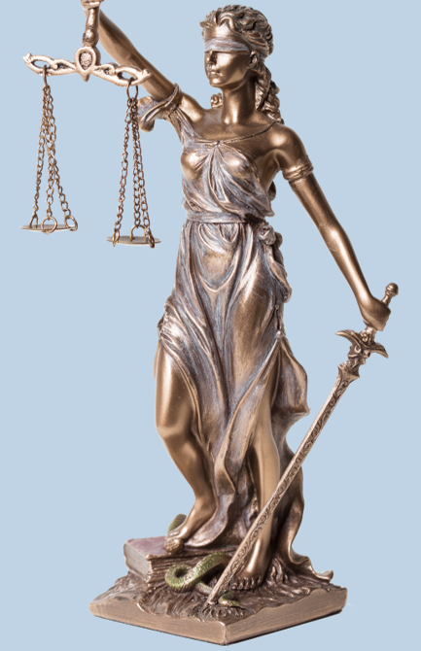
Lady Justice Group Activity
As a group, using a critical lens of the criminal justice system, discuss if you believe Lady Justice is an accurate representation of the criminal justice system in America. What changes, if any, will your group make to the original design?
In written form, please use the space below to describe what modifications your group will make to Lady Justice.

The Sword | The Blindfold
The Scale | The Toga
The Snake | The Book
In the space below, feel free to draw, add comments that you wish to add to your group’s version of Lady Justice:

