MAC-112, Machining Technology II

Quiz Questions and Answers:

Week 1:

What should employers prioritize to protect employees from workplace hazards?
Providing comprehensive healthcare plans
Using all feasible engineering and work practice controls*
Offering bonuses for completing safety training
Encouraging employees to bring their own PPE
points:1.00

When must employers provide PPE to employees?
Only if the employees request it
At the employees' expense
At no cost to employees, except for specific items*
Only for high-risk jobs
points:1.00

What is an example of an engineering control to eliminate workplace hazards?
Providing safety training to employees
Using personal hygiene practices
Substituting less harmful materials*
Encouraging job rotation of workers
points:1.00

What must employees be trained on regarding PPE?
How to design new PPE
Proper care, maintenance, and disposal of PPE*
How to request free PPE from the employer
The brand names of different PPE items
points:1.00

Which of the following is a cause of foot injuries that safety shoes can protect against?
Slippery surfaces*
Loud noises in the workplace
Bright lights
Extreme temperatures
points:1.00

What is the proper disposal method for shop rags that come in contact with general shop liquids?
Throw them in any garbage bin
Leave them on the floor for the janitor to pick up
Store them in your locker for reuse later
Dispose of them in the red metal garbage cans with foot pedal opening mechanism*
points:1.00

Who are considered Authorized Employees in Lockout/Tagout procedures?
Machine operators who use the equipment daily
Maintenance staff who perform the work and apply the lockout/tagout devices*
Employees who come into the area where the work is being done
All employees in the facility
points:1.00

What are the four main types of electrical injuries?
Cuts, bruises, burns, falls
Electrocution, electrical shock, burns, falls*
Trips, slips, fractures, concussion
Chemical burns, radiation exposure, heat exhaustion, lacerations
points:1.00

What is the purpose of a Ground-Fault Circuit Interrupter (GFCI)?
To detect high voltage in electrical circuits
To prevent overloads in electrical systems
To protect against dangerous electrical shocks*
To regulate the flow of current in appliances
points:1.00

Which of the following is NOT a clue that electrical hazards exist?
Tripped circuit breakers or blown fuses
Warm tools, wires, cords, connections, or junction boxes
GFCI that shuts off a circuit
Employees wearing proper protective equipment*
points:1.00

What should be done before inspecting or making repairs on electric equipment?
Turn on all power sources to ensure proper function
Use flexible cords instead of fixed wiring
Deenergize the electric equipment*
Increase the voltage for better performance
points:1.00

What is one potential danger of using flexible cords improperly?
They are more durable than fixed wiring
They are less susceptible to damage
They can cause shocks, burns, or fires*
They are not approved by OSHA regulations
points:1.00

What are the four main types of electrical injuries mentioned in the PowerPoint?
Electrocution, electrical shock, burns, falls*
Dizziness, disorientation, fainting, nausea
Sprains, bruises, lacerations, concussions
Strains, fractures, burns, cuts
points:1.00

What is the purpose of grounding in electrical systems?
To increase voltage
To reduce current flow
To provide a conductive connection to the earth for protection*
To decrease resistance
points:1.00

What is the primary danger of inadequate wiring in electrical systems?
Risk of fire due to overheating*
Increased voltage levels
Higher resistance in the circuit
Reduced energy consumption
points:1.00

Which type of machine guard is described as a movable barrier device that protects the operator at the point of operation before the machine cycle can be started?
Fixed guard
Interlocked guard
Adjustable guard
Gate*
points:1.00

What are some responsibilities of employees regarding machine safety, according to the text
Ensure all machinery is properly guarded
Train employees on specific guard rules
Immediately correct machine guard deficiencies
Report machine guard problems to supervisors immediately*
points:1.00

Week 2:

What is the primary function of an angle grinder?
Shaping metal parts
Polishing cylindrical surfaces
Cutting, deburring, and cleaning*
Sharpening cutting tools
points:1.00

What is the typical power rating range for bench grinders?
100-500 W
500-3000 W*
3000-5000 W
5000-10,000 W
points:1.00

Which type of grinder is commonly used for fine detailing and light work?
Die Grinder*
Belt Grinder
Bench Grinder
Centerless Grinder
points:1.00

What is a characteristic feature of hand grinders?
They are fixed to workstations.
They are used for heavy-duty grinding.
They accept different attachments like grinding discs and wire wheels.*
They are typically operated with both hands
points:1.00

Which type of grinder is specifically made for sharpening cutting tools such as drill bits and milling cutters?
Belt Grinder
Precision Grinder
Jig Grinder
Tool and Cutter Grinder*
points:1.00

What are the three different interactions that occur between the abrasive and the machined material during grinding?
Cutting, welding, sliding
Cutting, plowing, sliding*
Cutting, polishing, sliding
Cutting, chipping, sliding
points:1.00

Which type of grinding maximizes metal removal but sacrifices surface finish?
Precision grinding
Ultra-precision grinding
Rough grinding*
Creep feed grinding
points:1.00

What is the primary purpose of creep feed grinding?
To make deep cuts in steel materials at low speeds*
To achieve ultra-precision surface finish
To maximize metal removal at high speeds
To remove unwanted metal with little concern for surface finish
points:1.00

What is the purpose of superfinishing in the grinding process?
To remove material quickly
To improve surface finish and remove peaks and valleys*
To maximize metal removal
To achieve ultra-precision cuts
points:1.00

Week 3:
True or False: The metal removal rate for a milling machine is higher than that of a lathe.
True*
False
points:1.00

Which of the following parts of a milling machine is the main supporting frame mounted on the base?
Knee
Column*
Spindle
Saddle
points:1.00

Which of the following parts of a milling machine sits on top of the knee?
Base
Column
Arbor
Saddle*
points:1.00

True or False: the accuracy of the cutter depends of the strength, accuracy, and rigidity of the arbor.
True
False*
points:1.00

True or False: for a milling machine, the work can only be fed in a longitudinal direction?
True
False*
points:1.00

Which of the following is NOT a type of milling machine?
Hand milling machine
Horizontal milling machine
Diagonal milling machine*
Vertical milling machine
points:1.00

True or False: the lathe machine rotates the workpiece about an axis to perform different operations.
True*
False
points:1.00

From the options below, select the types of operations performed on a lathe (you can select multiple answers if needed)
Turning*
Facing*
Chamfering*
Drilling*
points:1.00

Which of the following is not a main part of a lathe machine?
Bed
Headstock
Feed Rod
Carriage
Footstock*
points:1.00

Which of the following are types of lathe machines?
Speed lathe machine*
Spindle lathe machine
Bench lathe machine*
Carriage lathe machine
points:1.00

Week 4:

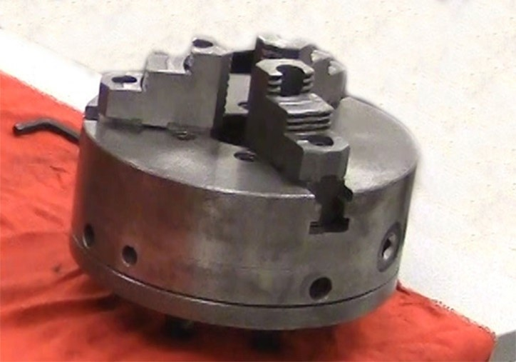What type of chuck is pictured above?
points:1.00

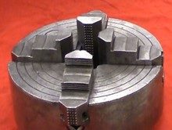
What type of chuck is shown in the picture above?
points:1.00

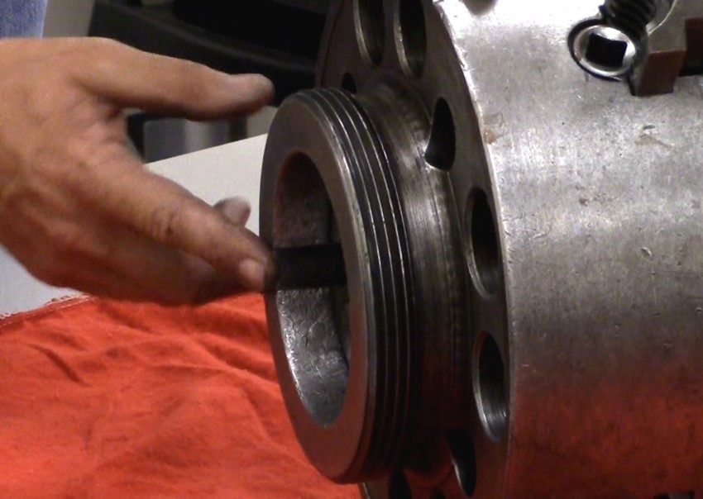What mounting type is shown in the picture above?
points:1.00

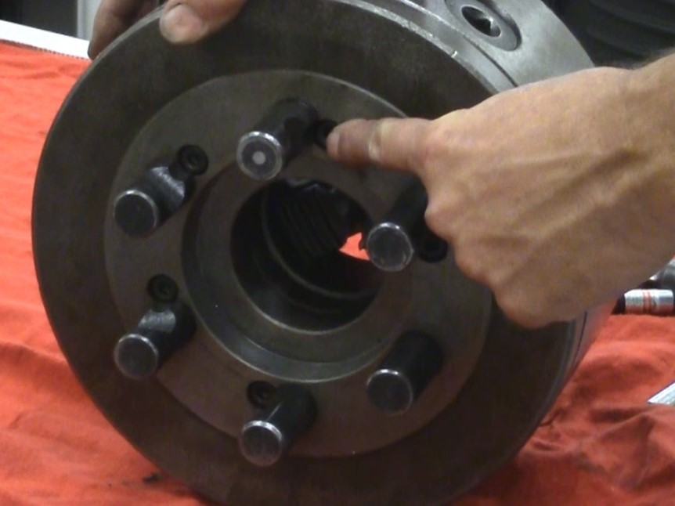What type of mount is shown in the picture above?
points:1.00

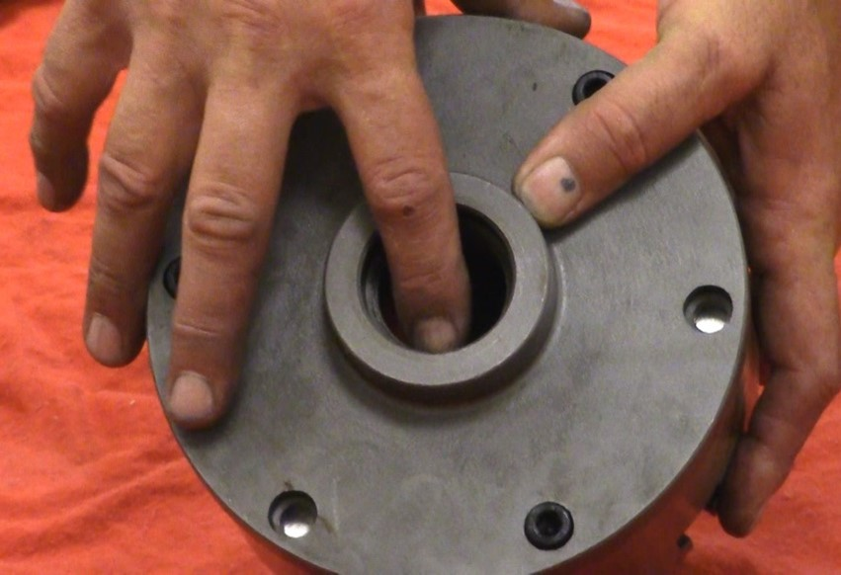What type of mount is shown in the picture above?
points:1.00

Week 5:
Week 5’s Quiz is linked in the main course PDF.

Week 6:
Week 6’s Quiz/Worksheet is linked in the main course PDF.

