MAC-112, Machining Technology II

Exam Questions and Answers

Mid-Term Exam Questions:

What types of PPE do employers not have to provide PPE for employees at no cost to them? (Select all that apply)
Safety-toe footwear*
Prescription safety eyewear*
Everyday clothing and weather-related gear*
Fashionable boots*
points:1.00

Which of the following is an example of an engineering control?
Using wet methods to suppress dust.
Providing safety glasses to employees.
Enclosing a hazardous process to prevent exposure.*
Training employees on proper PPE usage.
points:1.00

True or False: employers must train employees on the limitations of their PPE as part of their PPE training program.
True*
False
points:1.00

Which of the following is not an example of personal protective equipment (PPE)?
Safety glasses
Face shield
Bowler hat*
Earplugs
points:1.00

True or False: there are different classes of hard hats.
True*
False
points:1.00

True or False: you do not have to empty the lathe trough of chips after creating your parts.
True
False*
points:1.00

True or False: you can leave dirty shop rags laying around, they are perfectly safe.
True
False*
points:1.00

Which of the following is not an energy source used in most machining shops?
Gas
Mechanical
Electrical
Nuclear*
points:1.00

True or False: the scope of lockout/tagout covers both services of machines and equipment and maintenance of machines and equipment.
True*
False
points:1.00

Which of the following is not a step in applying lockout/tagout.
Preparing for shutdown
Shut down machine
Isolate machine from energy sources
Apply the lockout/tagout device
Keep the stored energy alone*
Verify isolation of machine prior to beginning maintenance
points:1.00

True or False: Electrical burns are serious injuries that require immediate attention.
True*
False
points:1.00

True or False: a ground-fault circuit interrupter can shut off electricity flow in as little as 1/40th of a second should it detect a ground fault.
True*
False
points:1.00

Which of the following is not a cause of a machine accident?
Reaching in to clear equipment
Properly adhering to lockout/tagout*
Unauthorized persons doing maintenance on machines
Loose machine guards
points:1.00

Which of the following are requirements for machine safeguards?
Prevent contact*
Loose fitting
Protect from falling objects*
Obstruct the view of the work
points:1.00

Which of the following is not type of machine guard?
Fixed
Interlocked
Spinning*
Self-adjusting
points:1.00

What are the three major interactions that occur between the abrasive and the machined material in grinding processes?
Cutting, turning, and milling
Cutting, plowing, and sliding*
Turning, sliding, and rolling
Plowing, rolling, and rubbing
points:1.00

What is the purpose of superfinishing in grinding operations?
To remove surface finish peaks and provide a good hardness*
To increase the speed of grinding operations
To eliminate the need for coolant in grinding
To reduce the life of grinding wheels
points:1.00

What is the primary function of an angle grinder?
Shaping metal parts
Cutting through dense materials
Sanding and grinding*
Grinding cylindrical surfaces
points:1.00

What is the typical power rating range for hand grinders?
200-500W
500-1000W*
1000-200W
2000-3000W
points:1.00

What is the primary purpose of a universal grinder?
Shaping metal parts
Sharpening cutting tools*
Sanding and polishing
Grinding cylindrical surfaces
points:1.00

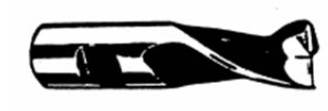
What type of cutting tool is shown above?
Double End
Roughing End Mill
Single End*
Counter Sink
points:1.00

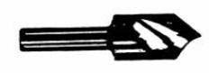
What type of cutting tool is shown above?
Countersink*
Double End
Counterbore
Threader
points:1.00

Match the following acronym with it's definition. These are terms related to feeds and speeds.
SFM (CS)
Surface Feet Per Minute
RPM
Revolutions Per Minute
IPT
Inches Per Tooth
IPM
Inches Per Minute
IPR
Inches Per Revolution
points:5.00

Define what voltage is.
points:1.00

Define what an insulator is.
points:1.00

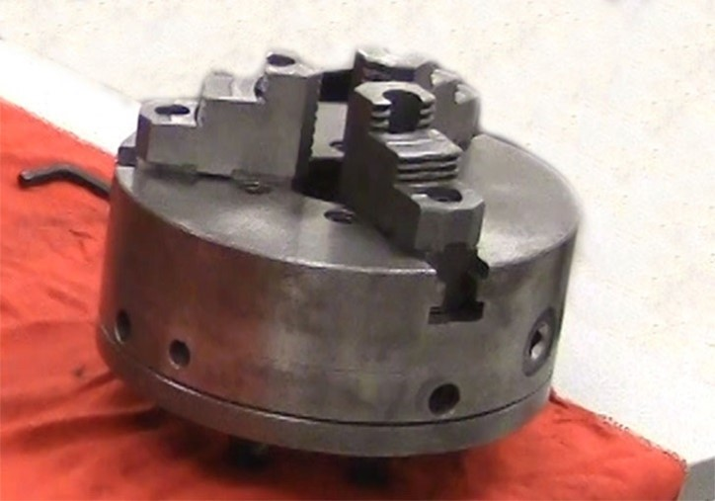What type of chuck is pictured above?
points:1.00

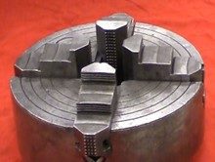
What type of chuck is shown in the picture above?
points:1.00

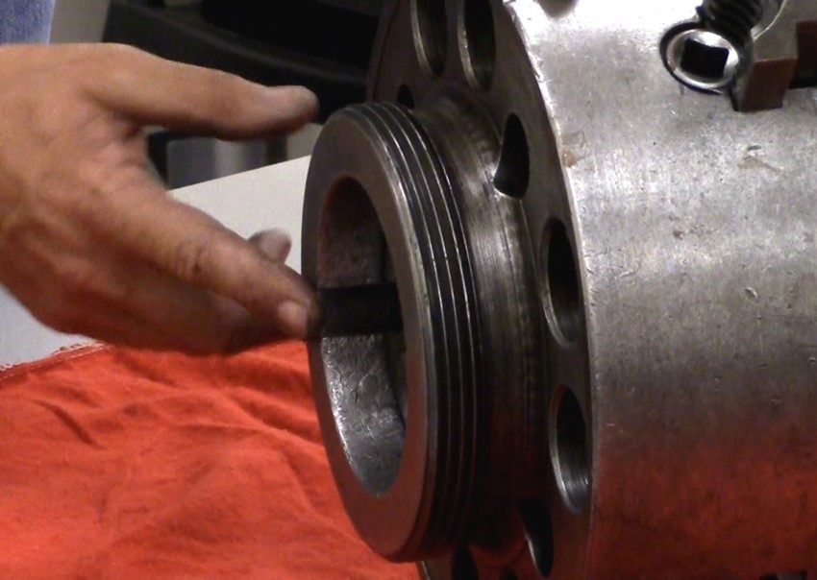What mounting type is shown in the picture above?
points:1.00

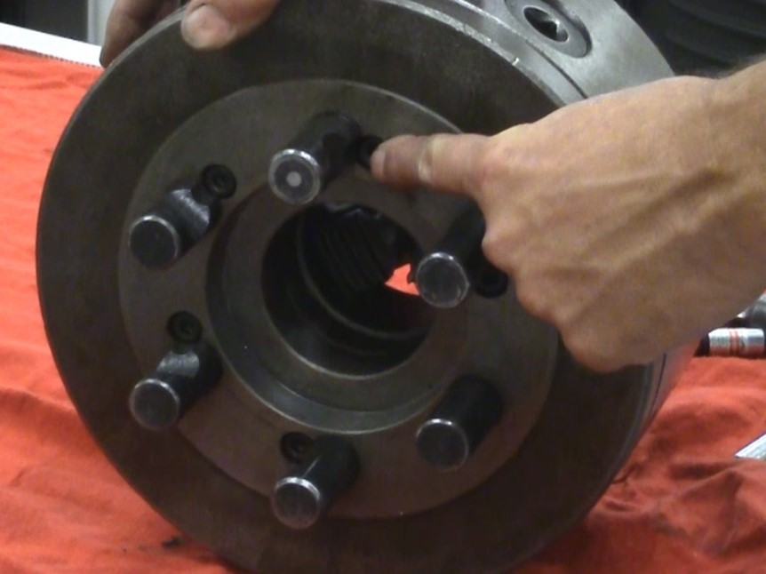What type of mount is shown in the picture above?
points:1.00

Define what a conductor is.
points:1.00

Final Exam Questions and Answers:

Which of the following is not an example of an engineering control?
Substitute less harmful material
Enclose process
Isolate process
Lack of ventilation*
points:1.00

Which of the following is not an example of personal protective equipment (PPE)?
Safety glasses
Face shield
Bowler hat*
Earplugs
points:1.00

Which of the following is not an example of personal protective equipment (PPE)?
Safety Glasses
Face Shields
Rain Coats*
Earplugs
points:1.00

Part of employee training for PPE must include training on proper care, maintenance, and disposal of PPE?
True*
False
points:1.00

True or False: Face shields can protect employees from impact hazards?
True
False*
points:1.00

Which of the follow classes of hard hats are used for electrical work?
Class G
Class E*
Class D
Class C
points:1.00

True or False: When cleaning up the shop before closing, all chips must be swept/vacuumed up from the vise and the floor?
True*
False
points:1.00

Which of the following is not a primary energy source used in most machine shops?
Electrical
Gas
Fluid
Thermodynamic*
points:1.00

Which of the following is not a step in applying lockout/tagout.
Preparing for shutdown
Shut down machine
Isolate machine from energy sources
Apply the lockout/tagout device
Keep the stored energy alone*
Verify isolation of machine prior to beginning maintenance
points:1.00

True or False: the scope of lockout/tagout covers both services of machines and equipment and maintenance of machines and equipment.
True*
False
points:1.00

True or False: when removing lockout/tagout any employee can remove the lockout/tagout device.
True
False*
points:1.00

True or False: currents grater than 75 mA can cause rapid ineffective heartbeats.
True*
False
points:1.00

True or False: electrical burns typically occur on the hands
True*
False
points:1.00

Which of the following is not type of machine guard?
Fixed
Interlocked
Spinning*
Self-adjusting
points:1.00

Which of the following is not a location where mechanical hazards occur?
Point of operation
Moving Parts
In-running nip points
The on-off switch*
points:1.00

What is the primary difference between rough grinding and precision grinding?
Precision grinding removes more material than rough grinding.
Rough grinding focuses on surface finish, while precision grinding balances metal removal and size control.*
Precision grinding is faster than rough grinding.
Rough grinding is only used for cylindrical workpieces.
points:1.00

Which factor does NOT affect the interaction between the abrasive and the workpiece in grinding processes?
Machine tool
Work material
Wheel selection
Machine color*
points:1.00

Which type of grinding machine is bolted to a workbench and has two wheels for heavy-duty grinding and polishing?
Die Grinder
Belt Grinder
Bench Grinder*
Pedestal Grinder
points:1.00

Which type of grinding machine is specifically designed for producing gears?
Precision Grinder
Jig Grinder
Gear Grinder*
Surface Grinder
points:1.00

What is the purpose of superfinishing in grinding operations?
To remove surface finish peaks and provide a good hardness*
To increase the speed of grinding operations
To eliminate the need for coolant in grinding
To reduce the life of grinding wheels
points:1.00

What is the most common style of grinding machine?
Surface Grinder*
Jig Grinder
Centerless Grinder
Gear Grinder
points:1.00

What type of cutting tool is shown above?
Double End
Roughing End Mill
Single End*
Counter Sink
points:1.00

What type of cutting tool is shown above?
Countersink*
Double End
Counterbore
Threader
points:1.00

Match the following acronym with it's definition. These are terms related to feeds and speeds.
SFM (CS)
Surface Feet Per Minute
RPM
Revolutions Per Minute
IPT
Inches Per Tooth
IPM
Inches Per Minute
IPR
Inches Per Revolution
points:5.00

What type of chuck is pictured above?
points:1.00

What type of chuck is shown in the picture above?
points:1.00

What mounting type is shown in the picture above?
points:1.00

What type of mount is shown in the picture above?
points:1.00

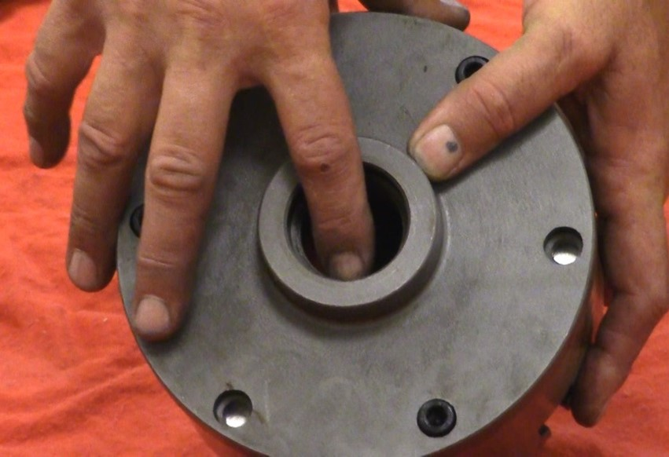

What type of mount is shown in the picture above?
Points: 1.00

