MAC 111 Quiz Questions and Answers:

Week 1:
True or false: the knob on top of a band saw makes the blade more taut
True*
False
points:1.00

A good rule of thumb is the lower the guard of a bandsaw to what distance above the work?
1 inch
1/2 inch
1/4 inch*
1/8 inch
points:1.00

Amputations with drill presses typically occur due to which of the following getting entangled in the rotating drill bit?
Operating gloves
Jewelry
Loose-fitting clothing
All of the above*
points:1.00

True or false: it is perfectly safe to perform maintenance on a drill press without deenergizing the press?
True
False*
points:1.00

Which of the following is not a common cause of eye injury on the job?
Flying particles
Splashing molten metal
Splashing acids
Intense light
Splashing water*
points:1.00

True or false: welding shields protect eyes from burns caused by infrared or intense radiant light.
True*
False
points:1.00

True or false: face shields protect employees from impact hazards.
True
False*
points:1.00

Common causes of foot injuries include:
Heavy objects falling/rolling onto an employee's foot
Sharp objects piercing soles or uppers of ordinary shoes
Molten metal splashing on feet
Hot or wet surfaces
All of the above are common causes of foot injuries*
points:1.00

Which of the following is not a hand tool safety guideline?
Make sure blades and sharp tools point away from aisle areas
Use tools with splintered wooden handles*
Only use a tool for it's intended purpose
Don’t alter a tool
Keep knives and scissors sharp
points:1.00

Explain the differences between safety spectacles and safety goggles.
points:1.00

Week 2:

According to the material you read this week, what is the definition of desired part?
1 point

Multiple Choice

True or False: tolerances control deviation from specified dimensions?
- A. True
- B. False
1 point

File Upload

Make readings from the ruler shown below
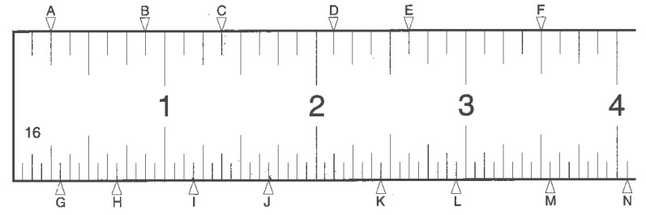
figure: Ruler
A
B
C
D
E
F
G
H
I
J
K
L
M
N
Disciplines: Machine Tool Theory
Tags: CIM S-3, CIM S-6, CIM S-8, Graduations, Machining and Measurement, Measurement
1 point

Multiple Choice

What is the reading of this Dial Caliper?
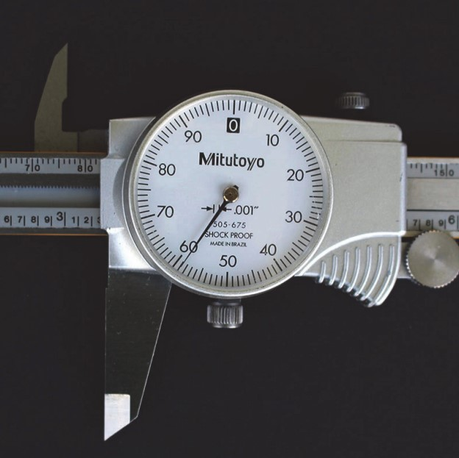
figure: Dial Caliper
- A. a) 3.130"
- B. b) 3.259"
- C. c) 3.123"
- D. d) 3.360"
- E. e) 3.590"
Disciplines: Machine Tool Theory
Tags: CIM A-1, CIM A-2, Calipers, Measuring Tools, Test Indicators​
1 point

What is the reading of this Dial Caliper?
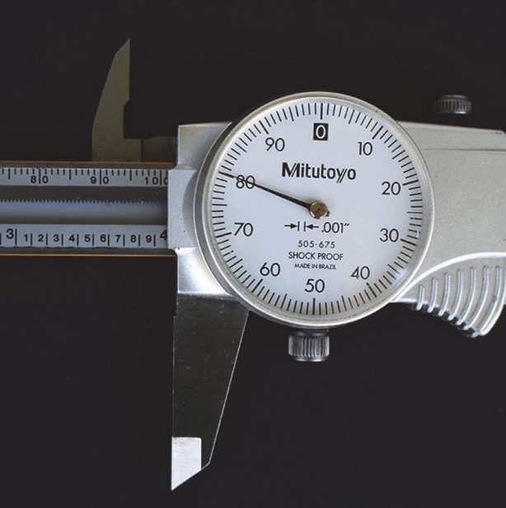
figure: Dial Caliper
- A. a) 3.000"
- B. b) 3.980"
- C. c) 4.800"
- D. d) 4.000"
- E. e) 3.080"
Disciplines: Machine Tool Theory
Tags: CIM A-1, CIM A-2, Calipers, Measuring Tools, Test Indicators​

Week 3:

What is the primary function of a power saw?
Drilling holes in metal
Cutting material to a desired length or contour*
Polishing surfaces
Welding metal together
points:1.00

What are some safety precautions to observe when using a power saw?
Keep hands close to the saw blade
Disconnect the power supply after blade removal/installation*
Use bare hands to push material into the blade
Handle saw blades roughly during removal/installation
points:1.00

What are the two types of band saws mentioned in the text?
Vertical type and drill type
Horizontal type and miter type
Vertical type and horizontal type*
Drill type and miter type
points:1.00

What components make up a vertical band saw?
Base and table
Table and frame
Vise and blade
Column, head, and base*
points:1.00

What are some safety and operational tips mentioned for using a metal cutting circular saw?
Wear safety equipment and handle blades roughly*
Cut flat bar with the thick profile vertical
Avoid verifying setup before cutting
Over pressure the blade for faster cutting
points:1.00

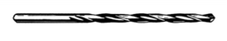

True or False: the above picture is of a straight shank twist drill.
True*
False
points:1.00

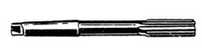
True or False: The above picture shows reamer with a straight shank.
True
False*
points:1.00

Which of the following is not a type of drill press drive?
Cone pully drive
Variable speed drive
Screw jack drive*
Gear head drive
points:1.00

Which of the following is not an attachment/accessory used with a drill press?
Drill chuck
Floating chuck
Steel sockets
Sinking chuck*
points:1.00

Describe the difference between drilling and boring.
points:1.00

Week 4:

What does Cutting Speed (CS) refer to in machining?
The rate at which the tool is moved into the part
The rate at which the part is moved into the tool
The circumferential speed of the milling cutter*
The number of teeth on the cutter
points:1.00

How is Feed rate measured in machining? Select all that apply.
Feet per minute (FPM)
Inches per revolution (IPR)*
Revolutions per minute (RPM)
Inches Per Minute (IPM)*
points:1.00

What formula is used to convert Cutting Speed (CS) to Spindle Speed (RPM)?
RPM = (CS × Diameter of cutter) / 3.82
RPM = (4 × CS) / (Diameter of cutter)*
RPM = (CS × Diameter of cutter) / 2.54
RPM = (CS × Diameter of cutter) / 1.62
points:1.00

Which equation is used to calculate Inches Per Minute (IPM) for milling operations?
IPM = Feed rate × Number of teeth × RPM
IPM = Feed per tooth × Number of teeth × RPM
IPM = Cutting speed × Number of teeth × RPM
IPM = Cutting speed × Feed per tooth × RPM*
points:1.00

In machining low-carbon steel at 80 SFPM and 122 RPM with a 2½” diameter heavy-duty plain milling cutter with 8 teeth and 0.004” feed per tooth, what is the Feed Rate?
0.032 inches per minute
0.096 inches per minute*
0.320 inches per minute
0.768 inches per minute
points:1.00

Week 5:
What is a common cause of amputation from milling machines?
Wearing gloves while operating the machine
Entangling jewelry or loose-fitting clothing in the cutter*
Operating the machine with the safety door selector switch off
Inspecting the gearbox while the machine is stopped
points:1.00

Which safeguarding method protects operators from point-of-operation hazards on milling machines?
Installing awareness devices around the milling table
Using barriers and warning signs
Installing guards that enclose the milling cutter's point-of-operation*
Performing periodic inspections
points:1.00

What should operators do before loading or unloading parts on a milling machine?
Measure the part while the cutter is rotating
Wear gloves and loose-fitting clothing for protection
Secure long hair in a net or cap
Ensure the cutter is adequately guarded and not rotating*
points:1.00

What is a secondary safeguarding method for milling machines?
Using presence-sensing devices
Inspecting the machine gearbox while operating
Removing the point-of-operation guard
Using splash shields or chip shields*
points:1.00

According to safety guidelines, what should operators do when inspecting the milling machine or making adjustments?
Wear gloves to protect their hands
Check the direction of cutter rotation before cutting*
Hold the end milling cutter in a drill chuck
Keep the vise handle wedged against the saddle while axis is moving
points:1.00

What is a primary safeguarding method for protecting operators from milling machine hazards?
Using splash shields and chip shields
Installing guards around power transmission components*
Keeping the machine's electrical disconnect in the on position
Performing minor servicing without lockout/tagout
points:1.00

Which action can lead to amputation from milling machines, according to the provided case histories?
Shutting off the machine and disengaging the clutch before servicing
Checking the edge of a sample while the cutter is rotating*
Using presence-sensing devices for safeguarding
Inspecting the gearbox with the machine stopped
points:1.00

What is recommended regarding work-holding devices when operating a milling machine?
Use a jig or vise that prevents adjustment of the guard
Place the jig or vise so force must be exerted toward the cutter
Wear gloves and loose-fitting clothing for extra protection
Never adjust the guard to accommodate work-holding devices*
points:1.00

How should operators perform servicing and maintenance activities on milling machines?
While the machine is stopped but still energized*
When the cutter is rotating and adequately guarded
Without considering energy control programs
By bypassing primary safeguarding methods
points:1.00

What is a recommended practice for operators regarding clothing and jewelry while operating milling machines?
Wear gloves to prevent injuries
Secure long hair in a net or cap*
Wear loose-fitting clothing for comfort
Reach around the cutter to remove chips while it's running
points:1.00

Week 6:

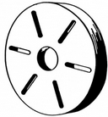
True or False: the above sketch is a sketch of a face plate for a lathe machine.
True*
False
points:1.00

Match the machining operation with its definition/description
Turning
Removing material from outside surface of part
Facing
Removing material from the end surface of part
Grooving
Cutting a recess in work
Boring
Enlarging an existing hole
Chamfering
Producing a flat, angular surface on the edge of a machined part
Knurling
Producing a raised surface of work to improve grip or appearance or to increase diameter
Treading
Forming internal or external threads with a single-point tool
Drilling
Producing a hole with a drill
Reaming
Enlarging a hole slightly with a multi-fluted cutter
Forming
Producing a desired shape by using tools to ground that shape
Shouldering
Fishing surface where two diameters or steps meet
Tapering
Producing uniform change in diameter of a part as measured along its axis
Filling
Chamfering or reducing diameter of work with a file while work is rotating
Polishing
Improving surface of part with abrasive cloth while work is turning
Cutoff
Cutting a part from work with a thin tool while work is rotating
Tapping
Producing internal threads with a tap, using the lathe tailstock to guide tap
Center Drilling
Producing a tapered hole in end of work so that part can be held between centers or be used as starting hole for drilling operation
points:17.00

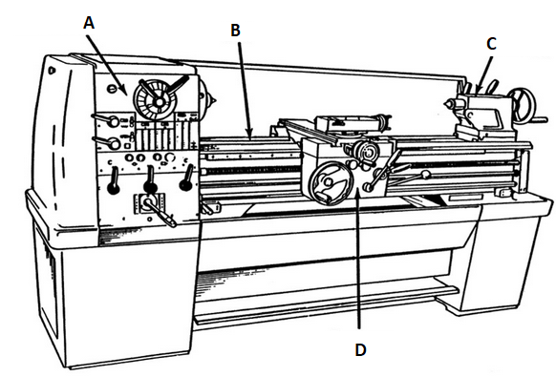

Match with lathe machine part with it's corresponding letter above. A [blank], B [blank], C [blank], D [blank]
Headstock
Bed
Tailstock
Carriage
points:1.00

