MAC 111 Exam Questions and Answers

Mid-Term Exam Questions:

What are some common hazards associated with band saws?
Electric shock and burns
Falling objects and slippery surfaces
Contact with blade, nip points, kickback*
Exposure to intense light and chemicals
points:1.00

Which of the following is NOT a recommended safety control for drill presses?
Using appropriate PPE
Removing gloves before operating the drill press
Adjusting the drill press while the drill bit is rotating*
Securing material to the drill press bed with clamps
points:1.00

What is one primary safeguarding method recommended for drill press operations?
Using barricades to separate employees
Wearing gloves and loose clothing
Installing guarding over motor, belts, and pulleys*
Adjusting the drill press while it is in operation
points:1.00

What is the purpose of spark-resistant tools in the workplace?
To prevent slips and trips
To reduce the risk of static electricity buildup*
To protect against falling objects
To avoid distractions while working
points:1.00

Which safety guideline is recommended for using cutting tools?
Carry sharp tools in your pocket
Test tool sharpness with fingers
Use dull blades for cutting
Start the cut close to your body, then cut outward*
points:1.00

What should you do before using any hand tool?
Inspect it for wear and damage*
Use it without checking for safety
Modify the tool if needed
Use the tool for multiple operations at once
points:1.00

What is the primary function of a power saw?
Grinding material into smaller pieces
Cutting material to a desired length or contour*
Shaping material using heat and pressure
Forming material through compression
points:1.00

Which safety precaution should be observed when using a vertical band saw?
Use gloves to handle band saw blades
Keep fingers well clear of the blade at all times*
Adjust the band saw blade while it is in operation
Use the band saw without a miter guide attachment
points:1.00

What is the purpose of abrasive cutoff saws?
Producing curled chips for metal cutting
Cutting material too hard for a metal saw*
Making accurate square or mitered cuts
Providing a continuous band blade for cutting
points:1.00

What should you do immediately after using the chuck key or drill drift on a drill press?
Leave it in the chuck or spindle
Store it on the drill press table
Remove it from the chuck or spindle*
Use it to remove hot tools
points:1.00

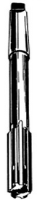
True or False: the above drill bit picture is a countersink.
True
False*
points:1.00

Which of the following is not a type of drill press drive?
Cone pully drive
Spiral pulley drive*
Variable speed drive
Gear head drive
points:1.00

Which of the following are operations performed on a drill press? (select all that apply)
Drilling*
Boring*
Tapping*
Sawing
points:1.00

True or False: All workholding devices must be secured to the table with clamps or bolts.
True*
False
points:1.00

What does Cutting Speed (CS) refer to in machining?
The rate at which the tool is moved into the part
The rate at which the part is moved into the tool
The circumferential speed of the milling cutter*
The number of teeth on the cutter
points:1.00

How is Feed rate measured in machining? Select all that apply.
Feet per minute (FPM)
Inches per revolution (IPR)*
Revolutions per minute (RPM)
Inches Per Minute (IPM)*
points:1.00

What formula is used to convert Cutting Speed (CS) to Spindle Speed (RPM)?
RPM = (CS × Diameter of cutter) / 3.82
RPM = (4 × CS) / (Diameter of cutter)*
RPM = (CS × Diameter of cutter) / 2.54
RPM = (CS × Diameter of cutter) / 1.62
points:1.00

What is one of the primary safeguarding methods recommended for protecting operators from milling machine hazard areas?
Using gloves and loose-fitting clothing
Installing guards around power transmission components*
Checking the cutter rotation while the machine is running
Ignoring warning signs and barriers
points:1.00

What should operators avoid doing while the milling machine is in motion or not locked or tagged out?
Cleaning chips or adjusting coolant*
Using proper safeguarding devices
Wearing gloves and jewelry
Engaging the machine way oil pump
points:1.00

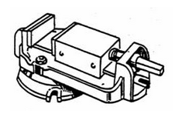
What milling machine accessory is pictured above?
Precision vise*
Vee block and clap
Hold-down clamp
Angle plate
points:1.00

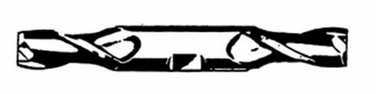
True or False: the above image show a double end cutting tool.
True*
False
points:1.00

Match the machining operation with its definition/description
Turning
Removing material from outside surface of part
Facing
Removing material from the end surface of part
Grooving
Cutting a recess in work
Boring
Enlarging an existing hole
Chamfering
Producing a flat, angular surface on the edge of a machined part
Knurling
Producing a raised surface of work to improve grip or appearance or to increase diameter
Treading
Forming internal or external threads with a single-point tool
Drilling
Producing a hole with a drill
Reaming
Enlarging a hole slightly with a multi-fluted cutter
Forming
Producing a desired shape by using tools to ground that shape
Shouldering
Fishing surface where two diameters or steps meet
Tapering
Producing uniform change in diameter of a part as measured along its axis
Filling
Chamfering or reducing diameter of work with a file while work is rotating
Polishing
Improving surface of part with abrasive cloth while work is turning
Cutoff
Cutting a part from work with a thin tool while work is rotating
Tapping
Producing internal threads with a tap, using the lathe tailstock to guide tap
Center Drilling
Producing a tapered hole in end of work so that part can be held between centers or be used as starting hole for drilling operation
points:17.00

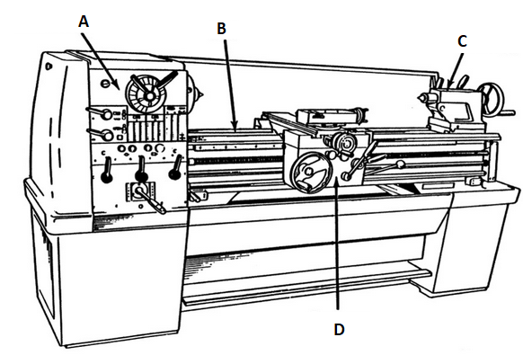

Match with lathe machine part with it's corresponding letter above. A [blank], B [blank], C [blank], D [blank]
Headstock
Bed
Tailstock
Carriage
points:1.00

Final Exam:
What primary safeguarding method can be installed to guard the operator and other employees from rotating parts, flying chips, and cuttings on a drill press?
Barricades
Automatic machines
Shields attached to the quill*
Conducting periodic inspections
points:1.00

What is a secondary safeguarding method that may be used to supplement primary safeguarding methods for drill presses?
Removing the chuck after each use*
Adjusting the drill press while the bit is rotating
Using gloves, jewelry, and loose-fitting clothing while operating the drill press
Wearing long hair loose during drilling operations
points:1.00

What type of eye protection must employers provide for employees exposed to potential eye injuries during drill press work?
Welding shields
Safety spectacles*
Conductive shoes
Face shields
points:1.00

What is a recommended guideline for using hand tools safely according to the provided text?
Use tools with dull blades for safer handling
Carry sharp tools in your pocket for easy access
Always alter a tool to fit the specific task at hand
Remove cracked saw blades from service*
points:1.00

What is a key safety guideline when operating a bandsaw?
Wear loose-fitting clothing and jewelry for comfort.
Keep the blade guard open for better visibility.
Use push sticks or devices to keep hands away from the blade.*
Adjust the blade tension while the bandsaw is running.
points:1.00

True or false: face shields can protect you from impact hazards
True
False*
points:1.00

What is the primary function of a power saw?
To drill holes in materials
To shape materials into desired contours*
To fasten materials together
To polish surfaces
points:1.00

What precaution should be taken when handling band saw blades?
Use bare hands for a better grip.
Handle with care as large springy blades can be dangerous.*
Use gloves to protect hands from the blade.
Remove the power supply after handling blades.
points:1.00

What is the difference between a horizontal and vertical band saw?
Horizontal saws use continuous band blades, while vertical saws use toothed blades.
Horizontal saws lower the blade onto the material, while vertical saws feed the material into the blade.*
Horizontal saws have a coolant reservoir, while vertical saws do not.
Horizontal saws are faster than vertical saws.
points:1.00

What is the purpose of using a miter guide attachment or work-holding device with a power saw?
To increase the cutting speed
To reduce the noise level
To keep fingers well clear of the blade*
To cool down the blade during operation
points:1.00

What type of saw is recommended for cutting materials too hard for a metal saw to cut?
Power saw
Cold saw
Band saw
Abrasive cutoff saw*
points:1.00

True or False: Cone pulley drives are found on floor mounted machines like box column and radial drill presses.
True
False*
points:1.00

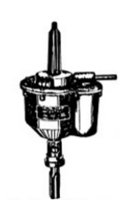
True or False: the above picture is an image of a tapping attachment.
True*
False
points:1.00

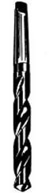
True or False: the above picture is an image of a straight shank twist drill.
True
False*
points:1.00

Which of the following is a workholding/set-up device used in drill press operations?
Angle Vise*
J-Clamp
T-Block
S-Bolt
points:1.00

What is Cutting Speed (CS) in milling expressed as?
Inches per minute (IPM)
Revolutions per minute (RPM)
Surface feet per minute (SFM)*
Feet per tooth (FTP)
points:1.00

How do you convert Cutting Speed (CS) to Spindle Speed (RPM) for milling?
Divide CS by the diameter of the cutter
Multiply CS by 4 and divide by the diameter of the cutter*
Divide the diameter of the cutter by CS
Multiply CS by the number of teeth on the cutter
points:1.00

What is Feed Rate (F) measured in for milling?
Inches per tooth (IPT)
Surface feet per minute (SFM)
Inches per revolution (IPR)
Inches per minute (IPM)*
points:1.00

How do you calculate Feed Rate (F) per tooth for milling?
Multiply Feed Rate (F) by the number of teeth on the cutter
Divide Feed Rate (F) by the number of teeth on the cutter*
Divide Feed Rate (F) by the diameter of the cutter
Multiply Feed Rate (F) by the diameter of the cutter
points:1.00

What is the recommended speed for machining with a .500 diameter HSS two-fluted end mill?
1600 RPM*
1800 RPM
2000 RPM
2200 RPM
points:1.00

Which of the following is a primary safeguarding method for milling machines?
Using splash shields and chip barriers
Installing awareness devices around the milling table
Ensuring proper guard installation at the point of operation*
Providing safety training for machine operators
points:1.00

What safety equipment is mandatory for operators while operating milling machines?
Long hair tied back and restrained
Jewelry and loose-fitting clothing
Safety glasses and safety toe shoes*
Gloves and aprons
points:1.00

What should operators do before inspecting the part or making any adjustments on a milling machine?
Securely clamp the vise to the table
Remove the vise handle and return it to the tool box
Engage the machine way oil pump
Shut off the machine*
points:1.00

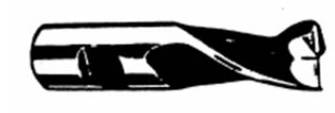
True or False: the image above is one of a single end cutting tool.
True*
False
points:1.00

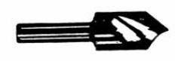
Which of the following is the image above a showcase of?
Countersink*
Counterbore
Double End Cutting Tool
Four-flue end mill
points:1.00

Define hypotenuse
points:1.00

Define sine
points:1.00

Define cosine
points:1.00

Define tangent
points:1.00

Match the machining operation with its definition/description
Turning
Removing material from outside surface of part
Facing
Removing material from the end surface of part
Grooving
Cutting a recess in work
Boring
Enlarging an existing hole
Chamfering
Producing a flat, angular surface on the edge of a machined part
Knurling
Producing a raised surface of work to improve grip or appearance or to increase diameter
Treading
Forming internal or external threads with a single-point tool
Drilling
Producing a hole with a drill
Reaming
Enlarging a hole slightly with a multi-fluted cutter
Forming
Producing a desired shape by using tools to ground that shape
Shouldering
Fishing surface where two diameters or steps meet
Tapering
Producing uniform change in diameter of a part as measured along its axis
Filling
Chamfering or reducing diameter of work with a file while work is rotating
Polishing
Improving surface of part with abrasive cloth while work is turning
Cutoff
Cutting a part from work with a thin tool while work is rotating
Tapping
Producing internal threads with a tap, using the lathe tailstock to guide tap
Center Drilling
Producing a tapered hole in end of work so that part can be held between centers or be used as starting hole for drilling operation
points:17.00

Match with lathe machine part with it's corresponding letter above. A [blank], B [blank], C [blank], D [blank]
Headstock
Bed
Tailstock
Carriage
points:1.00

