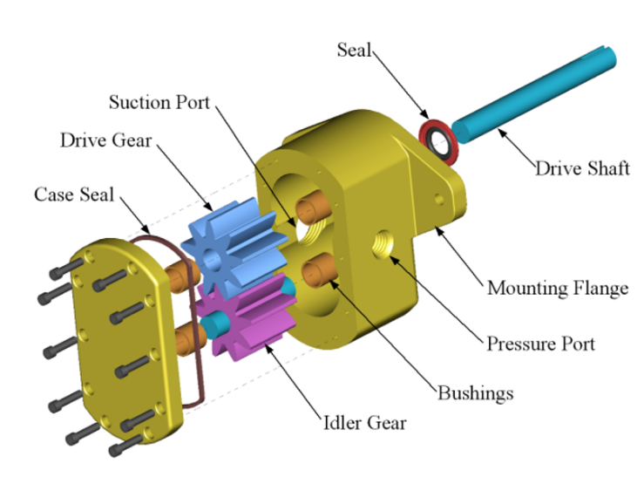
What type of view is shown in the image above?
- Exploded View*
- 3D Model
- Illustration
- Isometric Drawing
points:1.00
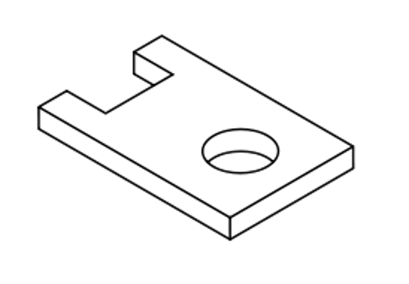
What type of drawing is shown above?
- Assembly Drawing
- Isometric Drawing*
- 3D Model
- One Line Diagram
points:1.00
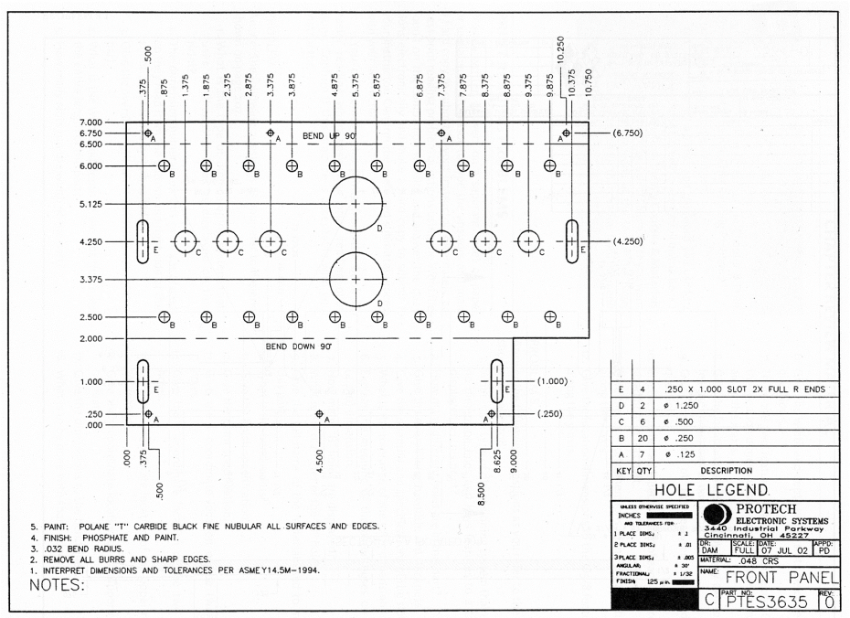
What type of drawing is shown in the image above?
- 3D Illustration
- Cutaway View
- Schematic Diagram
- Panel Drawing*
points:1.00
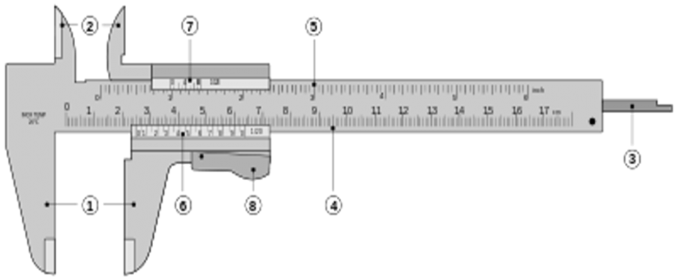
Match the vernier caliper parts from the word back with their respective number.
- Outside large jaws
- Inside small jaws
- Depth probe
- Main scale
- Main scale
- Vernier scale
- Vernier scale
- Retainer
points:1.00
A scale of 1:5 means what?
Another name for a View that shows (3) dimensions is
What (2) attributes of a part can be seen in the Top View?
A drawing scale of 5:1 means what?

