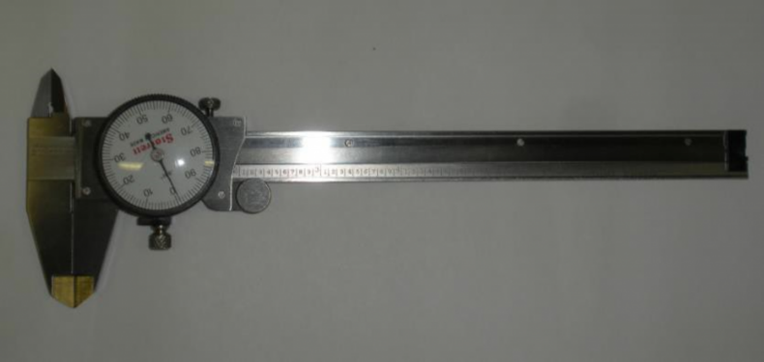
What type of measuring tool is shown above?
- Electronic Caliper
- Dial Caliper*
- Micrometer
- Depth Gauge
points:1.00
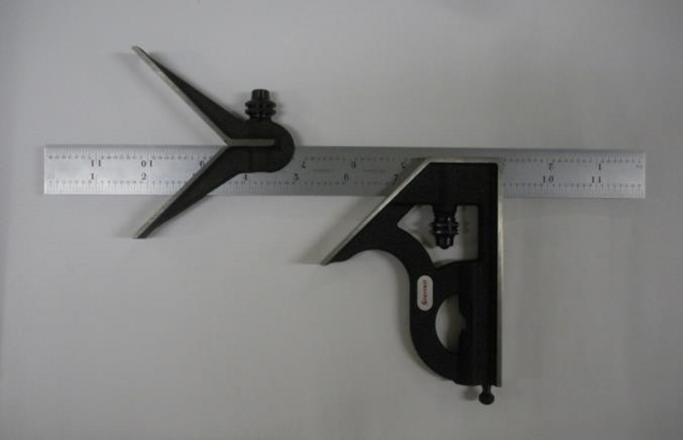
What type of measurement tool is shown above?
- Micrometer
- Protractor
- Combination Square*
- Height Gauge
points:1.00
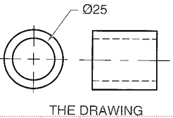
What machining process is shown with the above symbol?
- Bore*
- Counterbore
- Countersink
- Ream
points:1.00
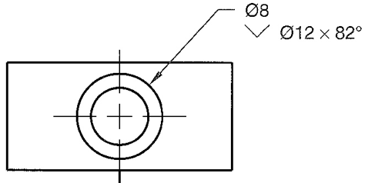
What machining process is shown by the image above?
- Counterdrill
- Counterbore
- Ream
- Countersink*
points:1.00
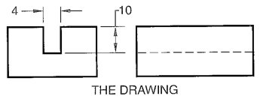
True or False: The above symbol is instructing the person to perform a kerf.
True*
False
points:1.00
What do you need to identify a thread?
- A caliper
- A thread gauge
- A table to match your information
- All of the above are needed*
points:1.00
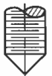
What type of standard screw point is the above symbol asking for?
- Half Dog
- Cone*
- Cup
- Oval
points:1.00
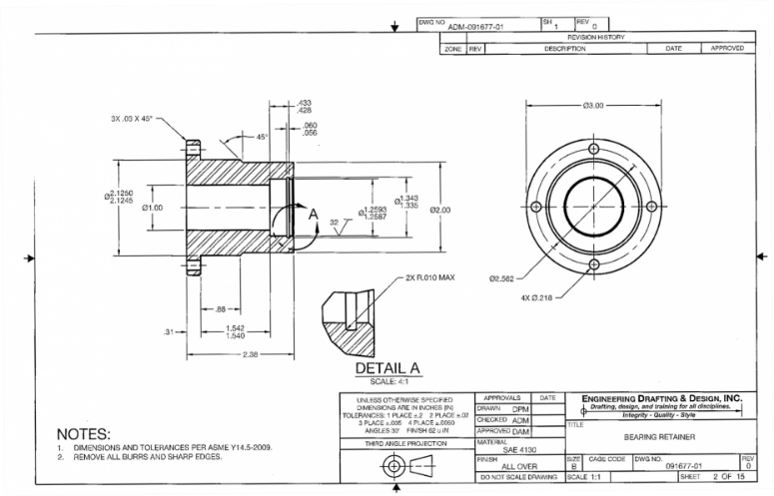
What kind of working drawing is shown above?
- Monodetail*
- Multidetail
- Single View
- Broken-Out Assembly
points:1.00
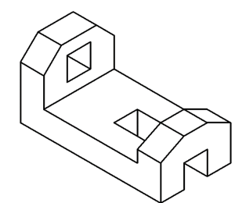
What type of pictorial view is shown by the picture above?
- Axonometric*
- Oblique
- Perspective
points:1.00
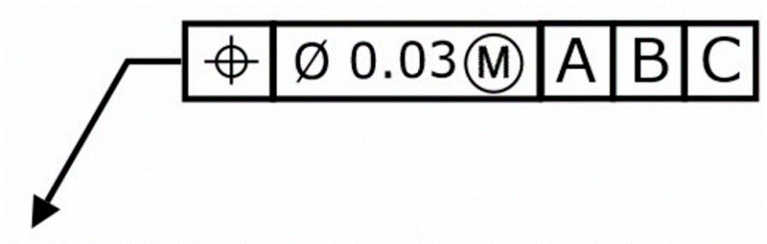
True or False: The above feature control frame has 3 datums.
True*
False
points:1.00
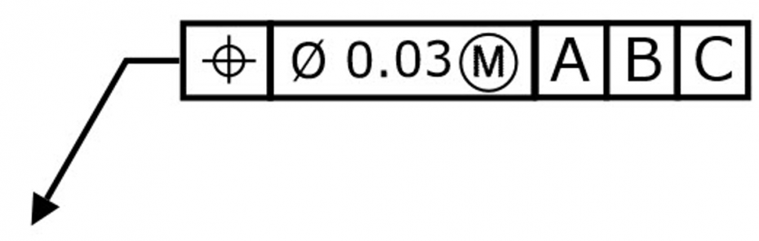
The above feature control frame has a 3-micron diameter tolerance.
True
False*
points:1.00
True or False: Surface Perpendicularity is a tolerance that controls perpendicularity between two 90-degree surfaces.
True*
False
points:1.00

True or False: An interference fit occurs when two tolerance mating parts will always interfere when assembled.
True*
False
points:1.00

