1.3
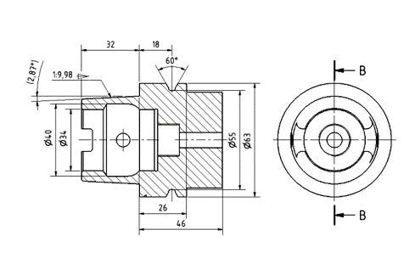
What type of drawing is shown above?
- Part Drawing*
- Isometric Drawing
- Assembly Drawing
- Illustration
points:1.00

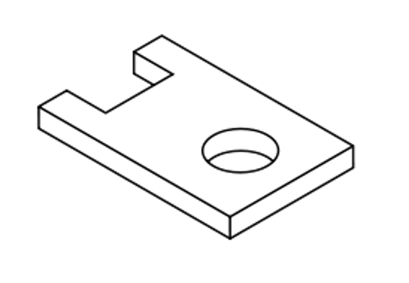
What type of drawing is shown in the above image?
- Illustration
- Assembly Drawing
- 3D Model
- Isometric Drawing*
points:1.00

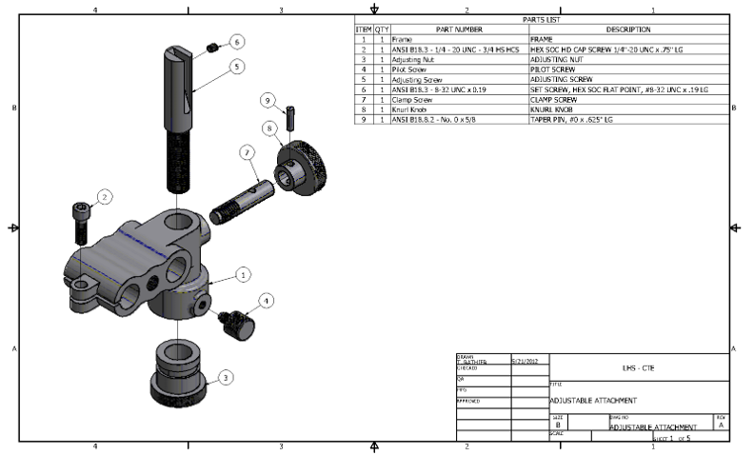
What type of drawing is shown above?
- Illustration
- Assembly Drawing
- 3D Model
- Exploded View
points:1.00
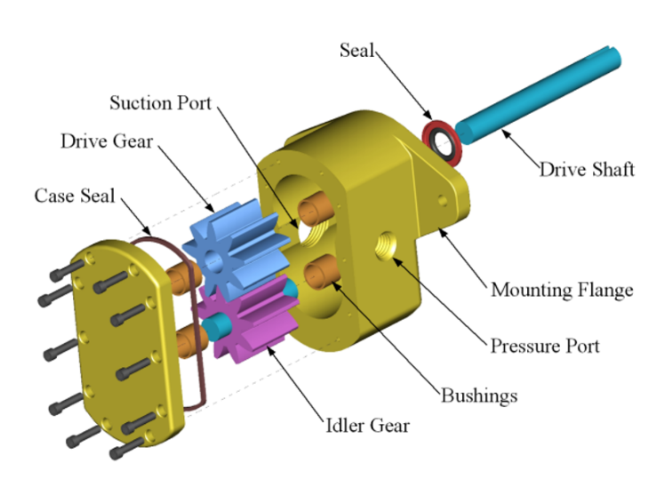
What type of drawing is shown in the image above?
- Assembly Drawing*
- Shop Drawing
- 3D Model
- Exploded View
points:1.00
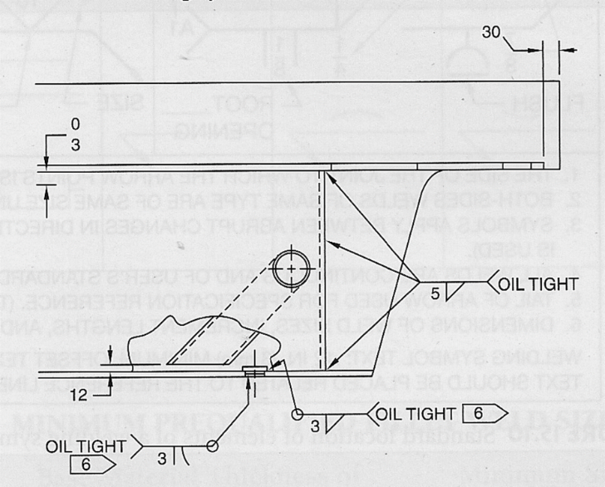
What type of drawing is shown above?
- Cable Diagram
- Shop Drawing*
- Illustration
- Isometric Drawing
points:1.00

2.3

True or False: The line shown above is known as a visible line.
True
False*
points:1.00
True or False: Trying to draw lines in a long stroke will typically cause the line to curve.
True*
False
points:1.00

3.3
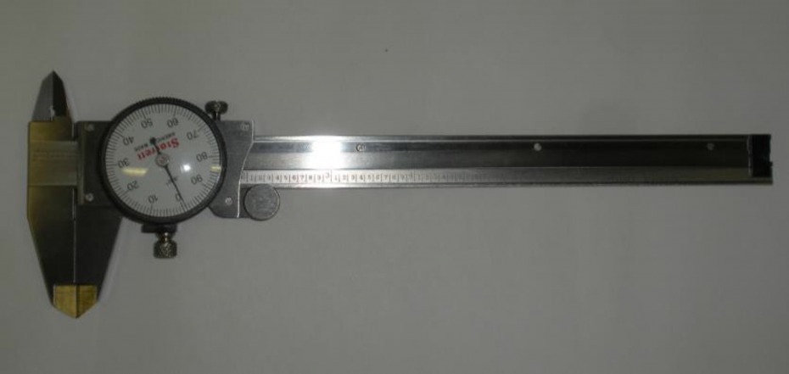
What type of measuring tool is shown above?
- Dial Caliper*
- Electronic Caliper
- Micrometer
- Depth Gauge
points:1.00
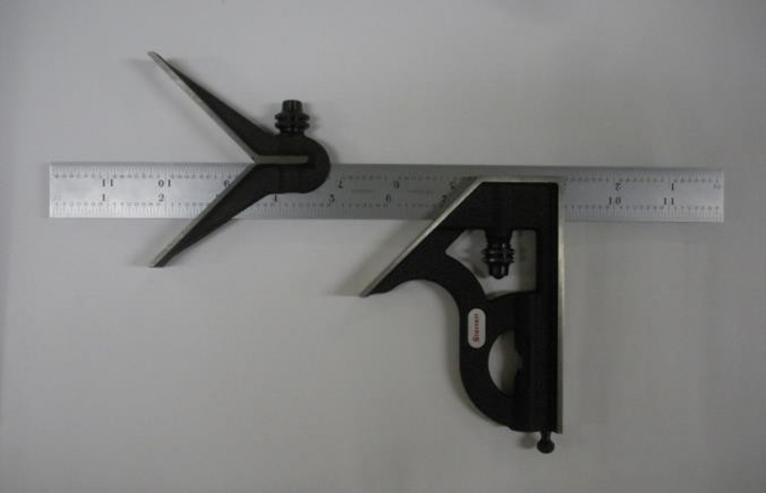
What type of measurement tool is shown above?
- Micrometer
- Combination Square*
- Protractor
- Height Gauge
points:1.00
Match the following words to their descriptions.
The lines which show the visible parts in a view
Used to indicate edges, intersections, etc., that are behind other features of the part
Shows the course through which the center travels.
Shows alternate positions of parts and also the location of parts that are not integral parts of the item depicted.
Used when it is not necessary to show all of a part.
A thin line that extends from the part or feature being dimensioned.
Used to show the location of a cut for a sectional view or the direction from which a view is taken
Used in combination with a cutting plane line to depict the inner structure of an object.
Used in conjunction with extension lines to indicate a linear distance.
- Object Line
- Hidden Line
- Center Line
- Phantom Line
- Break Line
- Extension Line
- Cutting Plane
- Section Plane
- Dimension Line
points:9.00

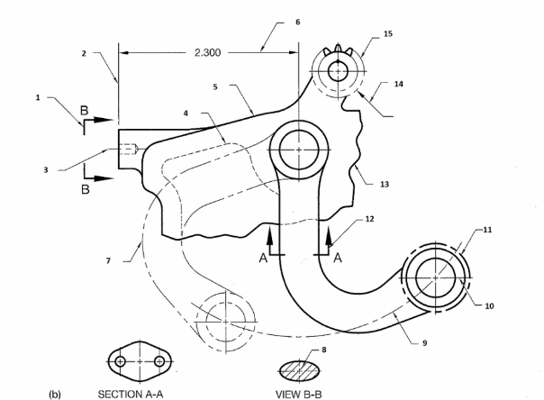
Look at the image above. Fill in the blank below corresponding the correct line type to the correct number. The word bank has all of the line types for you to choose from.
- Extension Line
- Viewing Plane Line
- Centerline
- Hidden Line
- Object Line
- Dimension Line
- Phantom Line (Alternative Position)
- Section Line
- Centerline (Path of Motion)
- Centerline
- Chain Line
- Cutting Plane Line
- Break Line (Short)
- Leader Line
- Phantom Line (Repetitive Features)
points:15.00

8.3
What is the most common feature found on a machining drawing?
- Bore
- Drill*
- Counterbore
- Countersink
points:1.00
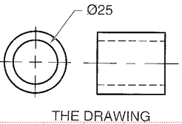
What machining process is shown with the above symbol?
- Bore*
- Counterbore
- Countersink
- Ream
points:1.00
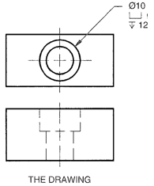
What type of machining process is shown with the above symbol?
- Bore
- Ream
- Counterbore*
- Spot face
points:1.00

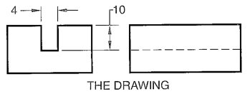
True or False: The above drawing is instructing the person to perform a kerf?
True*
False
points:1.00
What is a spot face?
points:1.00

9.3
True or false: Classes 1A and 1B have the loosest fit of the classes of thread.
True*
False
points:1.00

True or false: Classes 3A and 3B are the most common thread classes.
True
False*
points:1.00

Which of the following is not a type of thread?
- Unified screw threads
- Miniature screw threads
- Maximized screw threads*
- Pipe threads
points:1.00

True or false: Acme threads are the best choice for power transmission and carrying loads.
True*
False
points:1.00

What do you need to identify a thread?
- A caliper
- A thread gauge
- A table to match your information
- All of the above are needed*
points:1.00

Which of the following are factors that can impact torque?
- Thread contamination
- Thread damage
- Surface finish
- Speed of tightening
- All of the above*
points:1.00

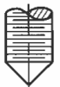
What type of standard screw point is the above symbol asking for?
- Half Dog
- Cup
- Oval
- Cone*
points:1.00
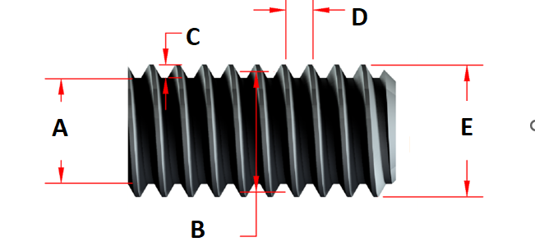
Please match the letter above with the definition it represents.
- Minor Diameter
- Pitch diameter
- Depth
- Pitch
- Major diameter
points:1.00

10.3
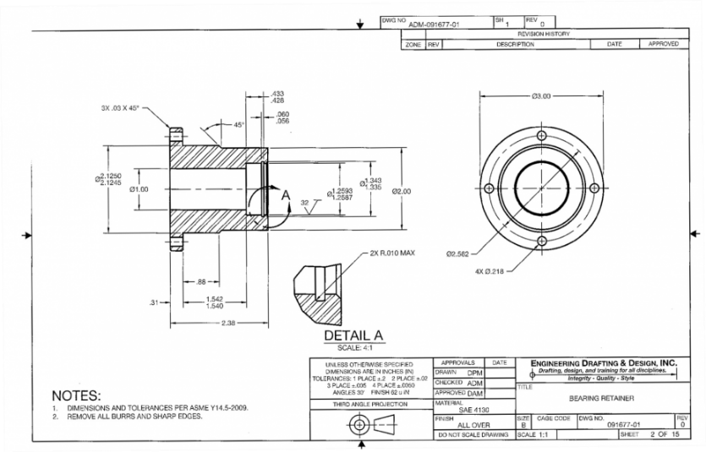
What kind of working drawing is shown above?
- Mon detail*
- Multidetail
- Single View
- Broken-Out Assembly
points:1.00
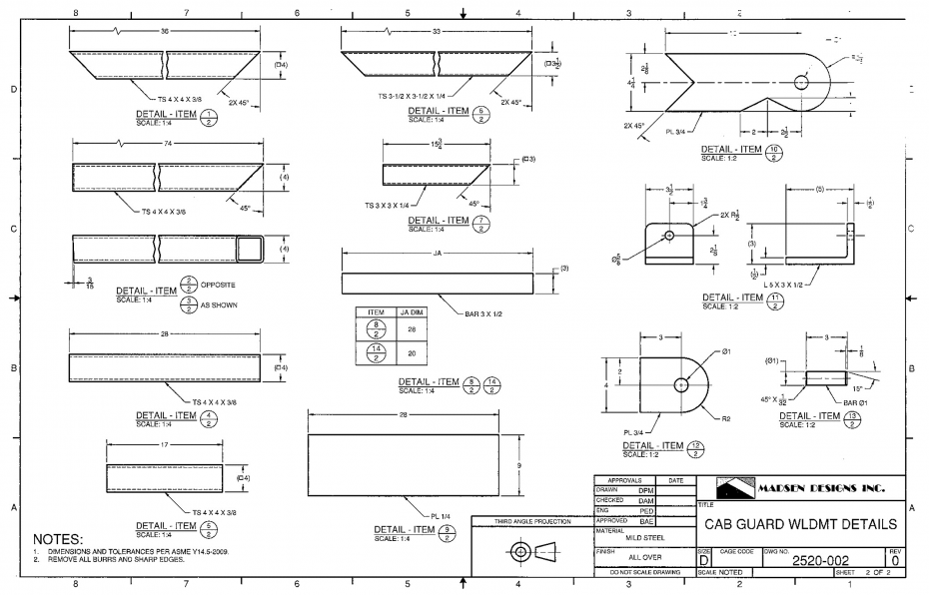
What kind of working drawing is shown above?
- Mon detail
- Single View
- Multidetail*
- General Assembly
points:1.00
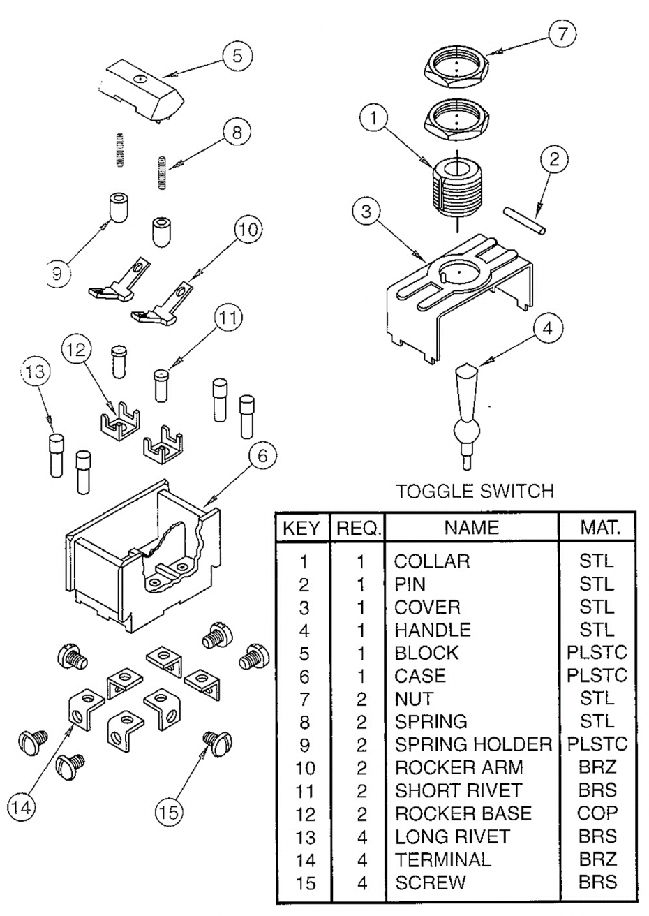
What type of working drawing is shown above?
- Subassembly with Parts List
- Detail Assembly
- Exploded Isometric Assembly Drawing*
- Pictorial Assembly
points:1.00
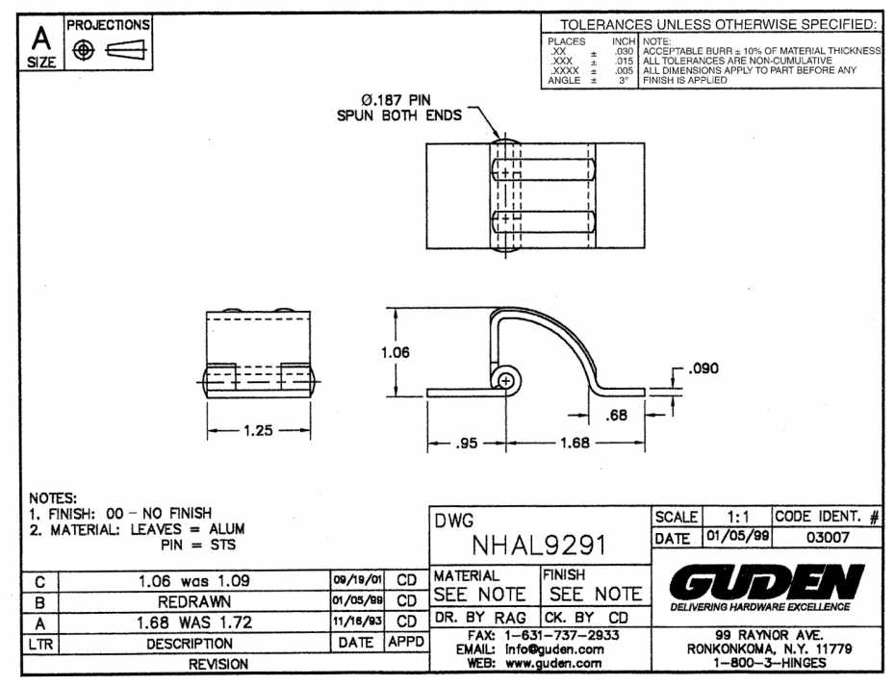
What type of working drawing is shown above?
- Detail Assembly*
- Pictorial Assembly
- Full Section Assembly
- Layout Assembly
points:1.00

13.3
How many symbols are used in GD&T
- 12
- 14*
- 13
- 8
points:1.00
Which of the following describes GD&T?
- It's a system of dimensioning and tolerancing mechanical parts
- It's a system that is more powerful than traditional dimensioning and tolerancing
- It's a system that allows you to know with 100% certainty your parts will fit and function at the assembly level
- It's a system so you learn vocabulary, definitions, rules, and then apply symbols
- It's a system but it only works if design/engineering/manufacturing all agree to use the same system
- All of the above are descriptions*
points:1.00
Whare are the benefits of GD&T?
- You can be certain that your parts will fit and function properly at the assembly level
- Save time &amp; money by reducing the number of design-manufacturing-test fit cycles
- Conveys your design intent to the: machinists, inspectors, future designers inheriting your work
- All of the above*
points:1.00

Orientation features do not have to be giving in relation to the datum
True
False*
points:1.00

Angularity is used to callout out every angle except 90 and 180
True*
False

14.3
True or False: Datum references are always required for orientation controls?
True*
False
points:1.00
What are the three basic control types in GD&T?
points:1.00

Define what Perpendicularity is
points:1.00

Define what Parallelism is
points:1.00

Define what angularity is
points:1.00

