3.3
True or False: 95% of today's welding is done with ferrous alloys.
True*
False
points:1.00

Which is the principal hardening agent in steel?
- Copper
- Aluminum
- Carbon*
- Sulphur
points:1.00

Which alloying element is known for helping metal resist atmospheric corrosion?
- Cobalt
- Manganese
- Chromium
- Copper*
points:1.00

Which of the following was not one of the space-lattice types we covered?
- Body-centered cubic
- Hexagonal close packed
- Face-centered cubic
- All of the above were covered*
points:1.00

True or false: A metal that is sensitive to heat condition or heat changes may require head treatment both before and after welding.
True*
False
points:1.00

True or false: blowholes, gas pockets, and inclusions are the result of problems with metallurgy.
True
feedback: Incorrect: issues with electrode manipulation is what leads to these issues
False
feedback: Correct: instead, issues with electrode manipulation is what leads to these issues.
points:1.00

True or False: carbon steel solidifies at a higher temperature than pure iron.
True
False*
points:1.00
Define what a ferrous alloy is.
points:1.00

4.3
True or False: Soldering is the process of joining two metal components together by melting solder.
True*&
False
points:1.00

Solder is generally made from a mixture of what two metals?
- Copper and Iron
- Tin and Cobalt
- Tin and Copper*
- Copper and Carbon
points:1.00

True or False: the soldering processes melts the solder but not the two pieces of metal being joined together.
True*
False
points:1.00

Which of the following is typically not a piece of safety equipment recommended when soldering?
- Soldering iron holder
- Safety glasses
- Fan
- Respirator*
points:1.00

True or False: you would not use brazing when trying to join dissimilar metals.
True
False*
points:1.00
What are the key factors to consider when selecting a brazing alloy for a specific application, and how do these factors impact the overall effectiveness of the brazing process?
points:1.00

Can you explain the significance of surface preparation in the brazing process, and how proper cleaning and flux application contribute to achieving strong and reliable joints?
points:1.00

6.3
True or false: as deposited, the weld metal should have higher yield strength than the parent metal.
True*
False
points:1.00
True or false: over welding may cause distortion and high locked-in stresses that reduce the effective weld strength.
True*
False
points:1.00

Which of the following is not a cause of weld spatter?
- Too high a welding current
- Wrong electrode
- Improper electrode manipulation*
- Wrong polarity
points:1.00

True or False: Incomplete penetration is more of an appearance defect than a structural one.
True
False*
points:1.00

Which of the following is not a cause of incomplete penetration?
- Welding speed is too fast
- Improper joint preparation
- Insufficient welding current
- The electrode used is too large
- All of the above are causes*
points:1.00

True or False: the general cause of the brittle weld is the use of excessive heat in the making of a weld
True*
False
points:1.00

True or False: Fillet welds can be multiple layers
True*
False
points:1.00

intro: Match the defect with its description.
is when the weld lifts off the base metal. Also called insufficient penetration
Lack of fusion
occurs at the toes of the weld when the base metal is cut out by the arc and not replaced.
Undercut
occurs at the toes of a weld when the filler metal flows over the base metal without fusing to it.
Overlap occurs when the height of the filler metal is below the required weld size.
Fillet welds that have legs smaller than the required weld size are underfilled.
Underfill
is when sponge like holes appear in the weld.
Porosity
points:1.00

[blank] and [blank] are the two most important properties in evaluating how well a joint will perform
wordbank: Weld porosity**Metallic fusion

Tensile Strength **Toughness
Tensile Strength **Toughness
points:1.00

Describe what arc blow is?
points:1.00

Name 3 of the most common flaws or imperfections in fillet welds
points:1.00

At what part of a horizontal fillet weld does undercut most likely occur?
points:1.00

How does a welder solve undercut while welding?
points:1.00

8.3
What is not a cause of porosity
- Dirty parent metal
- Wrong type of shielding gas
- Contaminated gas
- Too much shielding gas*
points:1.00

True or false: one fix for porosity is to make sure your equipment is moisture free.
True*
False
points:1.00

Which of the following is not a type of welding crack?
- Crater
- Convex*
- Cold
- Hot
points:1.00

True or false: Shocking the metal refers to cooling the weld too slow under shielding gas?
True
False*
points:1.00

Which of the following is not a cause of undercut?
- Arc length is too short*
- Too many amps/too much heat
- Not enough filler metal
- Too fast a travel speed
points:1.00

Which of the following are ways to fix overlap?
- Use less filler wire
- Use a smaller filler wire
- Use correct welding angle
- Increasing your volts (MIG welding
- All of the above are ways to fix overlap*
points:1.00

Which of the following is not a way to fix distortion?
- Increase welding travel speed
- Letting the weld cool between passes
- Weld only on one side*
- Use lots of tacks
points:1.00

True or False: increasing travel speed will lower the chances of burn through
True*
False
points:1.00

True or False: Too slow a travel speed causes lack of fusion
True
False*
points:1.00

True or False: spatter can be caused by too steep a work angle
True*
False
points:1.00

9.3
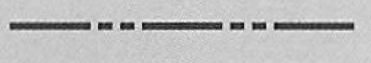
What type of lines are shown above?
- Cutting Plane Lines*
- Center Lines
- Extension Lines
- Hidden Lines
points:1.00
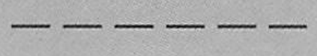
What type of lines are shown above?
- Object Lines
- Center Lines
- Hidden Lines*
- Phamtom Lines
points:1.00
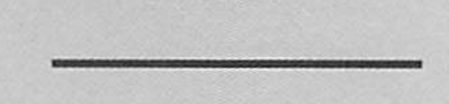
What type of lines are shown above?
- Object Lines*
- Dimension Lines
- Center Lines
- Phantom Lines
points:1.00
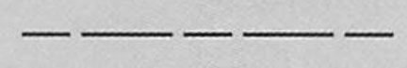
What type of lines are shown above?
- Dimension Lines
- Extension Lines
- Hidden Lines
- Center Lines*
points:1.00
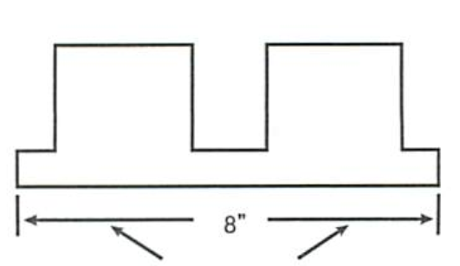
What type of lines are the arrows pointing to on the image above?
- Section Lines
- Center Lines
- Dimenson Lines*
- Object Lines
points:1.00

True or False: Fillet welds are the most common and usually the most economical type of weld in the industry?
True*
False
points:1.00

Which of the following joints are commonly used when fillet welding? (select all that apply)
- T-Joint*
- Lap Joint
- Face Joint
- J-Joint
points:1.00

True or False: Groove welds are formed in a groove between two pieces of material.
True*
False
points:1.00

Which of the following are types of groove welds? (select all that apply)
- Bevel grooves*
- Barrell grooves
- U-Groove*
- Flare Groove*
points:1.00

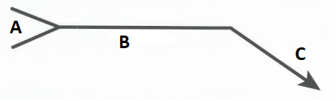
Match the part of the above welding symbol with the correct letter above
- Tail
- Reference Line
- Arrow
points:1.00

10.3
Which of the following is not a primary metal transfer method with GMAW?
- Short-circuiting
- Globular
- Spray
- Pulsed spray
- All of the above are GMAW transfer method*
points:1.00

Which of the following is not a classification for shielding gasses:
- Active gasses
- Inert gasses
- Inactive gasses*
points:1.00

True or false: mig welding requires the use of inert gas only.
True
feedback: but shielding gas mixtures can contain active gasses
False
points:1.00

Which is not one of the most common GMA welding applications?
- Car and other vehicles
- Manufacturing plants
- The construction industry
- Pipe welders
- General repair
- All of the above are common applications of GMAW*
points:1.00

<p>Which of the following is not an advantage of MIG welding?
- Most straightforward arc welding process to master
- Inexpensive equipment
- Produces less spatter, sparks, and smoke than TIG welding*
- Works with commonly welded metals
points:1.00

What metals can be welded by the GMAW process?
points:1.00

What is the purpose of the gas in the GMAW process?
points:1.00

Why is a constant-voltage power course required in GMAW?
points:1.00

What are the advantages of helium gas in GMAW?
points:1.00

What do you do if a "bird-nest" occurs?
points:1.00

11.3
True or False: FCAW is suitable for outdoor welding/windy conditions?
True*
False
points:1.00

True or False: Compared to SMAW and GTAW; FCAW there is less skill required for FCAW
True*
False
points:1.00

Which of the following is not a disadvantage of FCAW?
- Melted contact tip
- Equipment is less mobile compared to SMAW or GTAT
- Creates more fumes than stick welding
- All of the above are disadvantages*
points:1.00

True or False: The typical shielding gas for FCAW is 70/30 mixture.
True
False*
points:1.00

Which of the following are pros of FCAW-G? (select all that apply)
- High Deposition Rates*
- Low Spatter*
- Easy Slag Removal*
- Does Not Require Gas
points:1.00

True or False: FCAW-G is the better welding process to use for outdoor welding when compared to FCAW-S
True
False*
points:1.00

What does FCAW stand for?
points:1.00

What does FCAW-S stand for?
points:1.00

12.3
What is another name for SMAW?
- Stick Welding*
- Stuck Welding
- Strike Welding
- Seam Welding
points:1.00
Which of the following is not a weld cleaning tool?
- Chipping hammer
- Wire brush
- Stringer brush
- CLR*
points:1.00
What does SMAW stand for?
points:1.00

What direction does the current flow in DCEN?
points:1.00

What direction does the current flow in DCEP?
points:1.00

13.3
Which of the following is not a quality of GTAW?
- Produces high-quality welds in most metals and alloys
- May be used on a wide rage of thicknesses
- Lots of spatter*
- Requires little or no post-weld cleaning
points:1.00

True or False: GTAW is usable in all positions?
True*
False
points:1.00

True or False: when DC current is used for TIG welding, it is almost always used with electrode positive (DCRP)
True
False*
points:1.00
True or False: for GTAW the weld area must have great care taken to make sure they are cleaned before welding.
True*
False
points:1.00

Which of the following are special notes regarding safety precautions for GTAW:
- GTAW welding arcs can jump through gloved fingers, thus, great care must be taken care of with hand placement.
- GTAW arcs can jump higher in open air so all connections should be thoroughly insulated.
- Any water leaks should be corrected immediately due to water being a good path for electrical currents.
- All of the above are special precautions with GTAW.*
points:1.00

True or False: GTAW is most frequently associated with aluminum.
True
False
points:1.00

Describe two common causes for arc wander.
points:1.00

Describe two parameters that control penetration in GTAW welding.
points:1.00

14.3
True or False: Carbon arc cutting power supplies use DC electricity.
True*
False
points:1.00

Which of the following should be inspected during setup?
- Electrode holder insulators
- Electrode holder clamps securely around carbon cutting rod
- Air holes in electrode holder
- Air hose and fittings
- All of the above*
points:1.00

Which of the following is a principle of Oxyfuel Cutting?
- Burns a fuel gas and oxygen to generate focused heat
- Metal temperature is raised to cutting temperature
- Pressurized oxygen stream cuts the metal
- Torch travels the length of the cut
All of the above are principles*
points:1.00
Match the following plasma arc cutting terms with its definition.
The molten metal that solidifies on the bottom of the cut
Dross
The width of the material removed during the cut
Kerf
A guide placed on the work piece that the operator uses to keep the torch on the desired cut line
Fence
points:3.00
Describe the differences between DCEN and DCEP polarities.
points:1.00

Describe the differences between open circuit voltage and conventional load voltage.
points:1.00

