True or False: it is recommended to remove the electrode from holder when not in use
True*
False
points:1.00

How many feet should oxygen cylinders be stored away from fuel cylinders?
- 10 Feet
- 15 Feet
- 20 Feet
- 25 Feet*
points:1.00

Which of the following are safety problems in oxy-fuel equipment?
Handling high pressure cylinders
- Withdrawal rate from acetylene cylinders
- Reverse flow
- Backfire
- Flashback
- All of the above*
points:1.00

Which of the following are ways to prevent secondary voltage shock? You can select multiple answers.
- Wearing wet gloves
- Keep your welding cable and electrode holder in good condition*
- Touching the electrode
- Keep dry insulation between your body and the metal being welded*
points:1.00

Which type of fumes can cause metal fume fever?
- Barium
- Zinc*
- Silica
- Copper
points:1.00

True or False: Arc rays are incapable of burning eyes and skin?
True
False*
points:1.00

Which of the following is not a cause of backfire?
- Delivery pressure too high for the tip used*
- Loose hose connections
- Touching the tip against the work piece
- Too short of a tip-to-work distance
points:1.00

Which of the following are uses of a measuring scale?
- Measuring
- Straight edge for cutting
- Straight edge for drawing straight lines
- All of the above are uses*
points:1.00
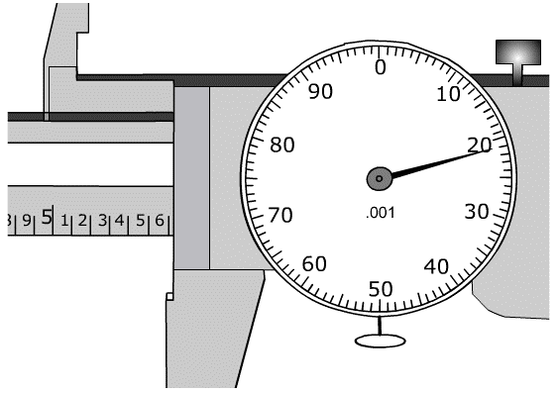
What is the reading of the above dial caliper?
- 6.521
- 5.621*
- 5.400
- 5.892
points:1.00

Ferrous metals are alloys that contain iron.
True*
False
points:1.00

What alloying element is known for improving corrosion-resisting qualities?
- Copper*
- Cobalt
- Carbon
- Nickel
points:1.00

True or False: Solder is a soft metal alloy generally made from a mixture of copper and aluminum
True
False*
points:1.00

Which of the following is not true about backfires?
- It is momentary retrogression of the flame in the torch tip
- The user hears a “pop” and the flame is extinguished
- The flame may be reignited if an adjacent ignition source is present
- It is a major safety concern*
points:1.00

True or False: sustained backfire can cause severe damage to the torch?
True*
False
points:1.00

What is another name for SMAW?
- Stick Welding*
- Stuck Welding
- Seem Welding
- Strike Welding
points:1.00

<p>Which of the following are common uses of SMAW?
- Industrial fabrication
- Shipbuilding
- Pipelines
- Buildings
- All of the above*
points:1.00

True or False: Voltage is the movement of charge particles in a specific direction
True
False*
points:1.00

True or False: Current is measured in amps
True*
False
points:1.00

What are the parts of a SMAW outfit?
- Welding machine
- Electrode
- Workpiece leads
- Electrode holder
- All of the above are parts of a SMAW outfit*
points:1.00

Which tool is not used to clean a weld?
- Chipping hammer
- Wire brush
- Stringer brush on the grinder
- Chipping goggles
- Vacuum cleaner*
points:1.00

True or False: FCAW is used on stainless steels?
True*
False
points:1.00

Which of the following are disadvantages of FCAW?
- Irregular wire feed
- More costly filler material/wire as composed to GMAW
- Creates more fumes than stick welding
- All of the above are disadvantages*
points:1.00

Which of the following is not a piece of PPE for FCAW?
- Leather welding gloves
- Cotton welding gloves*
- Welding shield
- Leather welding jacket
points:1.00

Which of the following is not a type of weave technique?
- Crescent
- Zig zag
- Stitch
- Cross stitch*
- Box weave
points:1.00

Which of the following is a type of weld pass?
- Over pass
- Full pass
- Root pass*
- Cool pass
points:1.00

Which of the following are causes of Arc Wander?
- Current too low
- Electrode or work contamination
- Magnetic arc blow
- Unstable gas shield
- All of the above are causes*
points:1.00

Which of the following is not a disadvantage of GTAW?
- Lower deposition rates
- Requires high level of operator skill
- Lots of spatter*
- Higher level of UV rays
points:1.00

Which of the following is not a type of GTAW torch?
- Gas cooled
- Coolant cooled*
- Water cooled
points:1.00
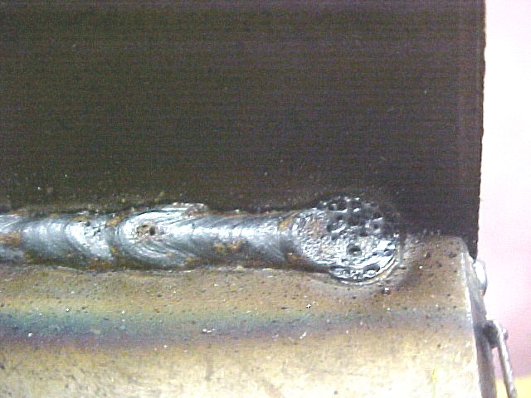
What welding defect/discontinuity is pictured in the image above?
- Undercut
- Porosity*
- Overlap
- Excessive concavity
points:1.00
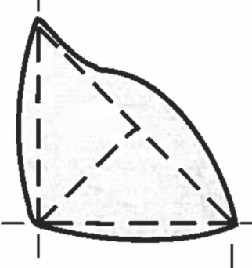
What type of welding defect/discontinuity is shown above?
- Spatter
- Excessive weld reinforcement
- Excessive convexity*
- Overlap
points:1.00
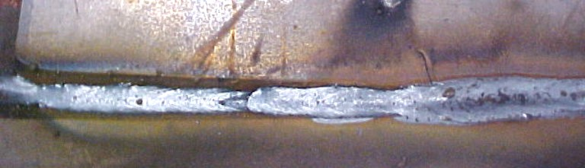
What type of weld defect/discontinuity is shown above?
- Underfill*
- Overlap
- Incomplete penetration
- Excessive penetration
points:1.00

Which of the following is not a type of porosity?
- Uniformly scattered
- Randomly scattered*
- Clustered porosity
- Linear porosity
- Piping/wormhole porosity
points:1.00
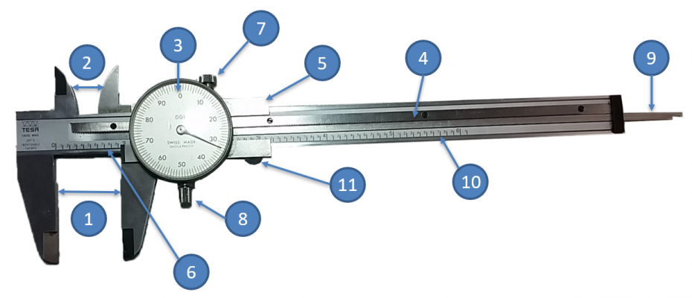
Match the caliper part with he number on the image above.
- Outside Jaws
- Inside Jaws
- Dial
- Blade
- Slider
- Reference Edge
- Clamp Screw
- Bezel Lock
- Depth Probe
- Main Scale
- Thumbwheel
points:1.00

Define what flashback is.
points:1.00

Explain the differences between semi-precision and precision measurement
points:1.00

Describe the process of quenching.
points:1.00

Describe the difference between soldering and welding.
points:1.00

What is an inert gas?
points:1.00

Describe the spray transfer process?
points:1.00

Describe the globular transfer process?
points:1.00

Describe the pulsed-arc transfer process?
points:1.00

What does SMAW stand for?
points:1.00

What does FCAW stand for?
points:1.00

What is arc wander?
points:1.00

What does GTAW stand for?
points:1.00

Define what undercut is.
points:1.00

Outline one cause for poor fusion.
points:1.00

Describe carbon arc cutting
points:1.00

