Which of the following is a hazard in Welding?
- Electrical hazards
- Arc radiation
- Fumes &amp; gases
- Cylinder handling
- All of the above are hazards*
points:1.00

True or False: it is safe to wear synthetic materials in the welding lab
True
False*
points:1.00

Which of the following is not a safety rule for plasma and oxyfuel torches?
- Be aware of where the sparks you make land
- Never cut in a manner that sends sparks or slag into torch hoses and electrical wires
- Acetylene cylinders should be opened all the way*
- Oxygen cylinders should be opened all the way
points:1.00

True or False: when cylinders are being stored, they should be chained upright against a wall
True*
False
points:1.00
How many feet should oxygen cylinders be stored away from fuel cylinders?
- 10 Feet
- 15 Feet
- 20 Feet
- 25 Feet*
points:1.00

Which of the following is not a cause of backfire?
- Delivery pressure too high for the tip used*
- Loose hose connections
- Touching the tip against the work piece
- Too short a tip-to-work distance
points:1.00

True or False: metal fume fever can cause flu-like symptoms.
True*
False
points:1.00

What is considered a combustible material?
- Wood and paper products
- Plastics
- Chemicals
- Rags
- All of the above are combustible*
points:1.00

True or False: damage to semi-precision tools will affect their accuracy
True*
False
points:1.00

Which of the following are uses of a measuring scale?
- Measuring
- Straight edge for cutting
- Straight edge for drawing straight lines
- All of the above are uses*
points:1.00

Calipers offer four measuring capabilities, which of the following is NOT one of them
- Outside dimensions
- Inside dimensions
- Depth measurements
- Step measurements
- Curve measurement*
points:1.00

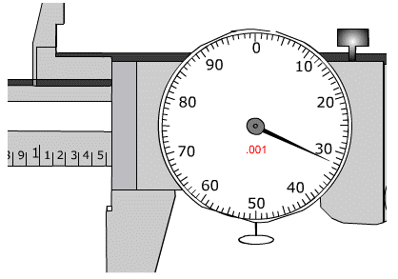
What is the measurement of the dial caliper above?
- 1.532*
- 1.500
- 1.520
- 1.589
points:1.00

True or False: aluminum is the principle hardening agent in steel.
True
False*
points:1.00

True or False: Brazing is the same technique as soldering, but the temperature is above 840 degrees.
True*
False
points:1.00

Which of the following is not an advantage of soldering:
- It takes less equipment to get started
- It is easier to re-do mistakes when soldering joints
- It is simpler to join different types of metal together
- Temperatures to melt solder are high compared to welding*
points:1.00
Which of the following is not a common application of soldering
- Jewelry making
- Making musical instruments
- Plumbing
- Sheet metal fabrication*
- Joining electrical components
points:1.00

Which of the following is not a cause of weld spatter?
- Too high a welding current
- Wrong electrode
- Improper electrode manipulation*
- Wrong polarity
points:1.00

True or False: the general cause of a brittle weld is not using enough heat in the making of a weld?
True
False*
points:1.00

Define what reverse flow is
points:1.00

Describe the difference between ferrous and non-ferrous metals.
points:1.00

Describe the process of quenching.
points:1.00

What is admixture?
points:1.00

Describe the difference between soldering and welding.
points:1.00

Describe what arc blow is.
points:1.00

