1.3
True or False: It takes 1-2 years to train a CNC operator
True
False*
points:1.00

True or False: cartesian system maps positivie/negative values on X- and Y- axes relative to origin.
True*
False
points:1.00

True or False: G-codes are preparatory commands
True*
False
points:1.00

Match the part listed in the word bank with its corresponding location on the diagram shown above.
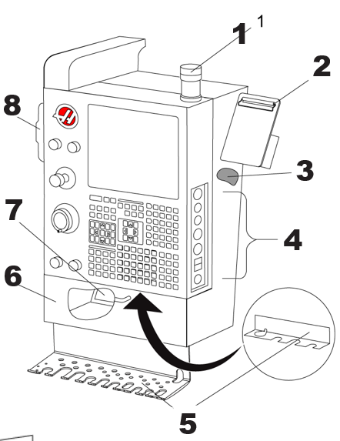
Work Beacon
Clipboard
Operator's Manual and Assembly Data
Side panel controls
Tool holder
Storage tray
G- and M-code reference list
Remote jog handle
points:1.00
What does CNC stand for?
points:1.00

2.3
True or False: A yellow triangle safety decal describes a hazard?
True*
False
points:1.00

Which of the following safety decals describes a prohibited action?
Yellow Triangle
Red Circle with Slash Through*
Green Circle
Black Circle
points:1.00

True or false: you should wear gloves at all times in a machine shop?
True
False*
points:1.00

True or false: Be sure to inspect the inside of the machine to check for loose tools or anything that could cause problems as the machine runs before you power on the machine.
True*
False
points:1.00

True or false: when starting the machine up for the day, you need to reset the axes to home zero.
True*
False
points:1.00

For G Coding, G90 means incremental positioning.
True
False*
points:1.00

What is the recommended action suggested by the above image?

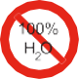
What is the prohibited action suggested by the above image?

4.3
What does Sin mean in trigonometry?
- Opposite over hypotenuse*
- Adjacent over hypotenuse
- Opposite over adjacent
points:1.00

What is tangent in trigonometry?
- Opposite over hypotenuse
- Adjacent over hypotenuse
- Opposite over adjacent*
points:1.00
Label each side of the triangle.<br><br>A [A], B [B], C [C]
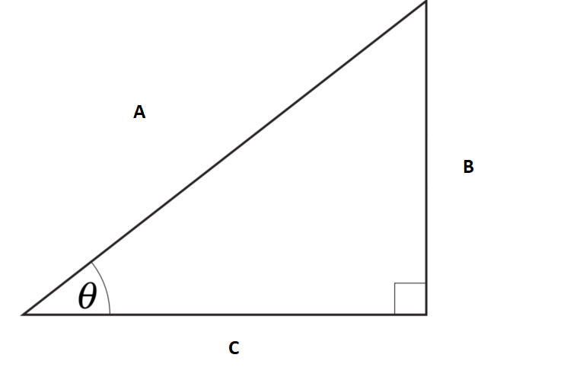
Hypotenuse
Opposite
Adjacent
points:1.00
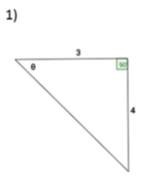
Find the value of the six trigonometric functions
points:1.00
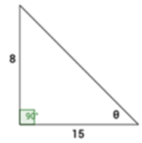
Find the value of the six trigonometric functions
points:1.00
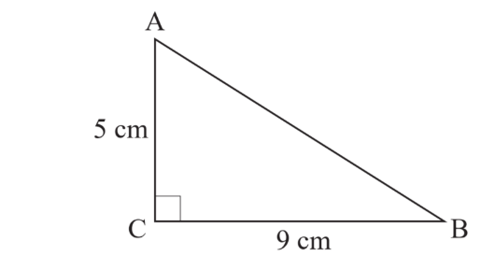
Calculate the length of the side AB of this triangle
points:1.00
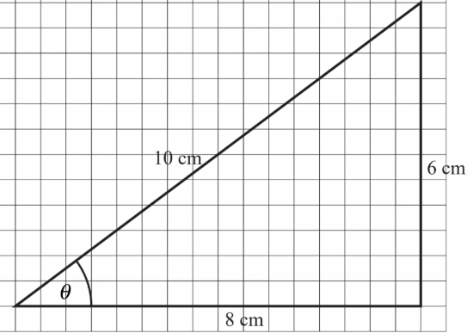
Calculate the sine, cosine, and tangent of this angle.
points:1.00
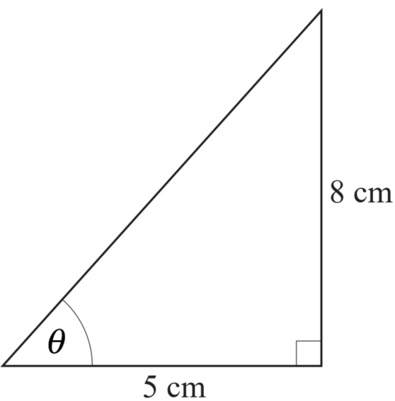
Calculate the angle in this triangle
points:1.00

5.3
True or False: for G codes, the universal rule is that codes from the same group cannot be used more than once on the same line.
True*
False
points:1.00

True or False: modal G codes do not remain effective until another G code from the same group is used.
True
False*
points:1.00

What is the function of the G10 code?
- Rapid Motion
- Exact Stop
- Programmable Offset Setting*
- Tread Cutting Path
points:1.00

What is the function of the G98 code?
- Circular Interpolation
- Tool Nose Compensation CANCEL
- Drill Canned Cycle
- Feed Per Minute*
points:1.00

True or False: all M codes are activated or cause an action to occur after everything else on a block has been completed.
True*
False
points:1.00

True or False: you can use multiple M codes per block in a program.
True
False*
points:1.00

What is the function of the M00 code?
- Program Stop*
- Program End
- Spindle Stop
- Coolant On
points:1.00

True or False: the F address character is used to select the feed rate applied to any interpolating G codes or canned cycles.
True*
False
points:1.00

True or False: the O program number is used to identify a program
True*
False
points:1.00
Define what a part program is.
points:1.00

