Which of the following are job responsibilities for a CNC Operator (select all that apply
- Loading/Unloading Parts*
- Assembling the CNC machinery
- Inspection/Reporting*
- Replacing worn tools*
points:1.00

True or False: Swing arm type ATC changes tools much faster than the carousel-type ATC?
True*
False
points:1.00

True or False: G-codes are miscellaneous functions?
True
False*
points:1.00

Which of the following are applications of CNC machining? (select all that apply)
- Milling*
- Drilling*
- Boring*
- Grinding*
points:1.00

True or False: a yellow triangle safety decal describes a hazard?
True*
False
points:1.00

Which of the following are types of safety decals? (select all that apply)
- Yellow triangles*
- Blue circles
- Orange triangles
- Black circles with slash-through
points:1.00

What is tangent in trigonometry?
- Opposite over hypothenuse
- Adjacent over hypotenuse
- Opposite over adjacent*
points:1.00

True or False: for G codes, the universal rule is that codes from the same group can be used more than once on the same line?
True
False*
points:1.00

True or False: modal G codes do not remain effective until another G code from the same group is used.
True
False*
points:1.00

What G Code would you use to cancel a canned cycle?
- G98
- G101
- G80*
- G99
points:1.00

Programs must begin and end with which of the following signs?
- @
- *
- %*
- #
points:1.00

True or False: when starting a program, the only thing on that line should be the starting sign?
True*
False
points:1.00

True or False: once selected, a canned cycle is active until cancelled with a G80 code?
True*
False
points:1.00

Which of the following is not an inspection method for machine parts?
- Visual inspection
- Dimension inspection
- Material verification
- Touch inspection*
points:1.00
intro: Match the quadrant with its positioning on a coordinate plane.
Quadrant 1
Top right at X+, Z+
Quadrant 2
Top left at X+, Z-
Quadrant 3
Bottom left at X-, Z-
Quadrant 4
Bottom right at X-, Z+
points:4.00
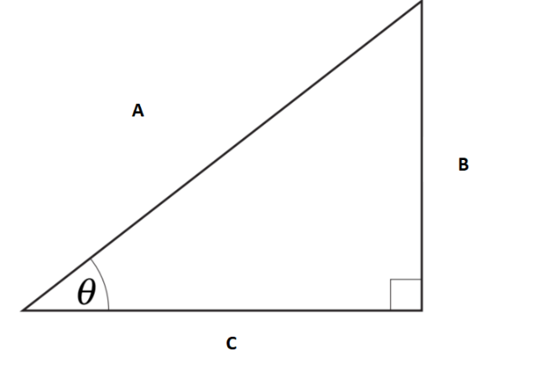
Label each side of the triangle. A [A], B [B], C [C]
Hypotenuse
Opposite
Adjacent
points:1.00
Explain the difference between cartesian coordinate and polar coordinate systems.
points:1.00

<p>Describe the difference between conventional and climb milling?</p>
points:1.00

List five factors that can affect the accuracy of CNC machines.
points:1.00
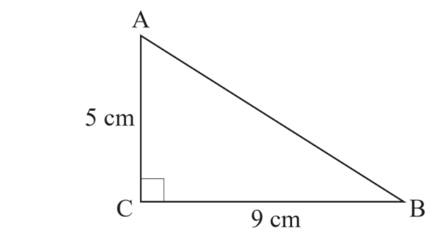
Calculate the length of the side AB of this triangle
points:1.00
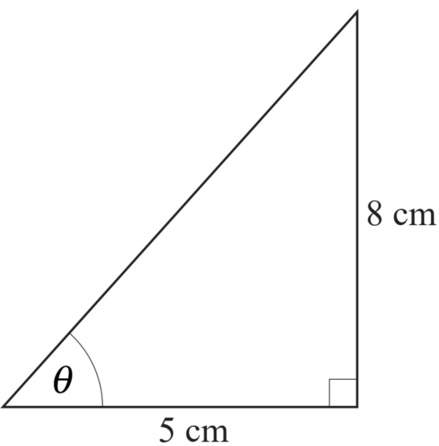
Calculate the angle in this triangle
points:1.00

What is a canned cycle?
points:1.00

