1.3
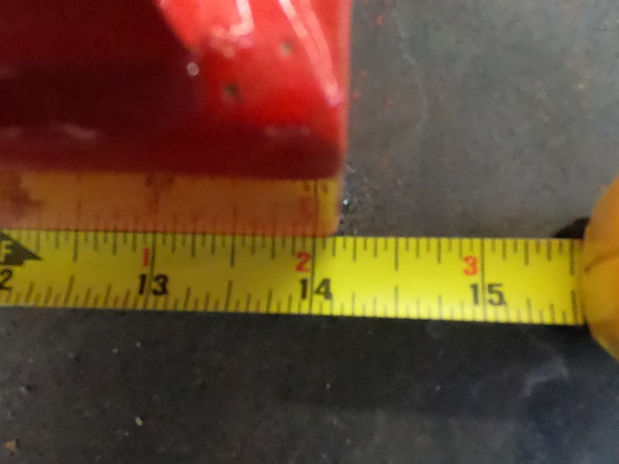
What is the measurement shown here?
- 14 1/16
- 14
- 14 1/8*
- 14 3/16
points:1.00
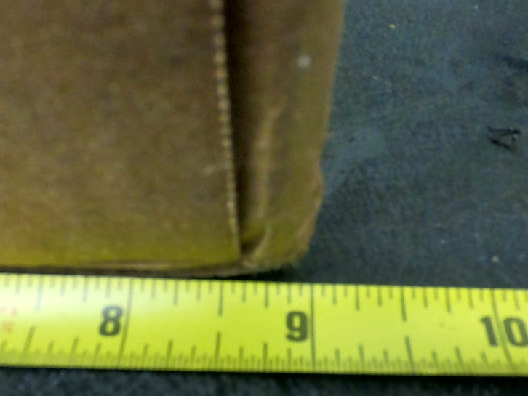
What is the measurement at the end of the box?
- 8 1/2
- 9*
- 9 1/8
- 8 7/8
points:1.00
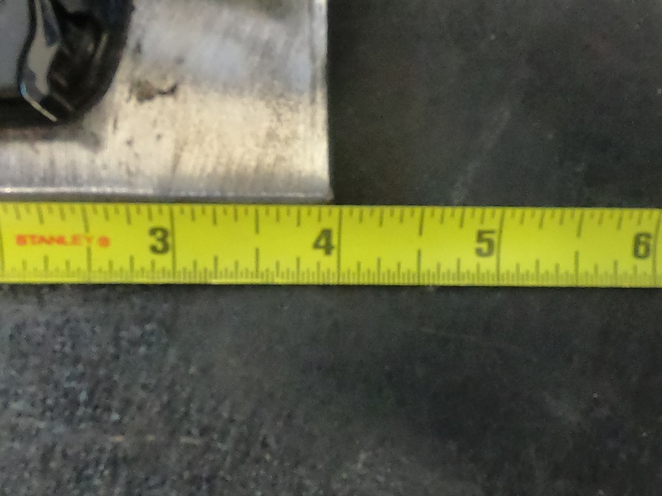
What is the measurement shown at the end of the plate?
- 4
- 3
- 3 15/16*
- 4 1/8
points:1.00
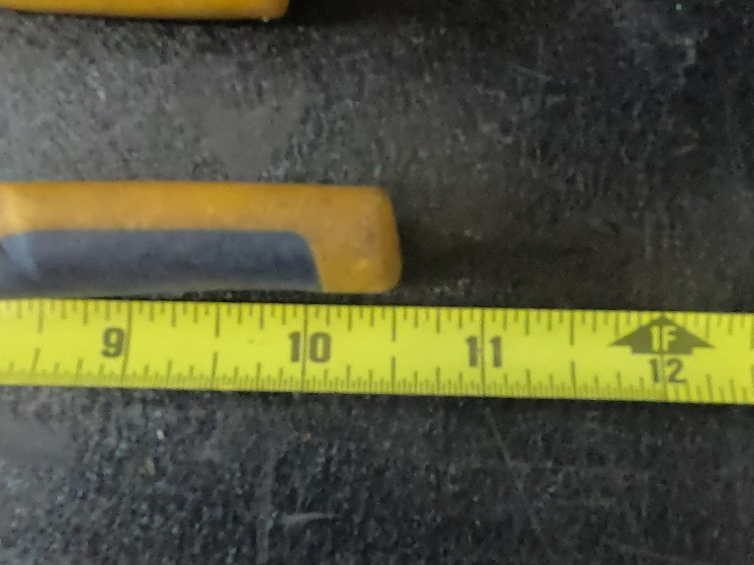
What is the measurement at the end of the pliers?
- 10
- 11
- 9
- 10 9/16*
points:1.00
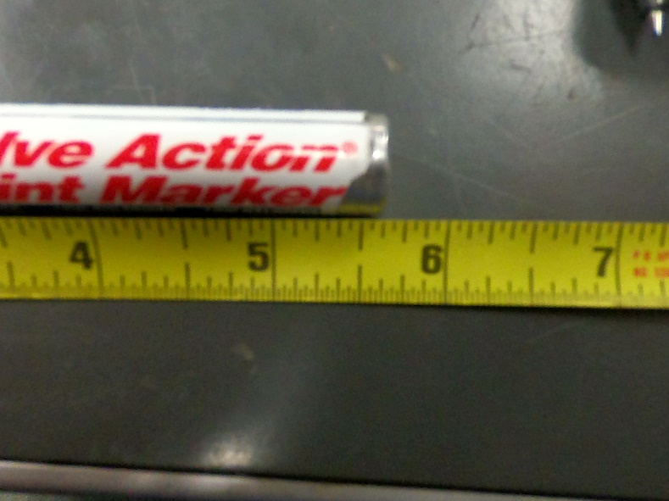
What is the measurement at the end of the marker?
- 5 1/2
- 5 5/8*
- 6
- 5
points:1.00
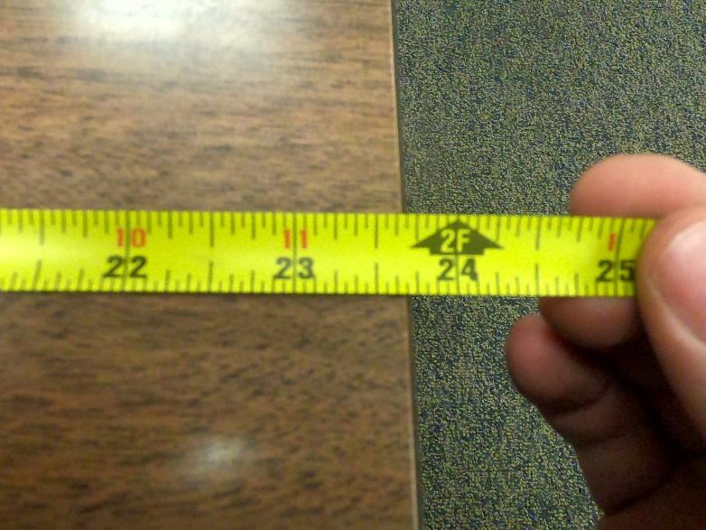
What is the measurement at the end of the desk?
- 23
- 23 3/4
- 23 11/16*
- 22
points:1.00
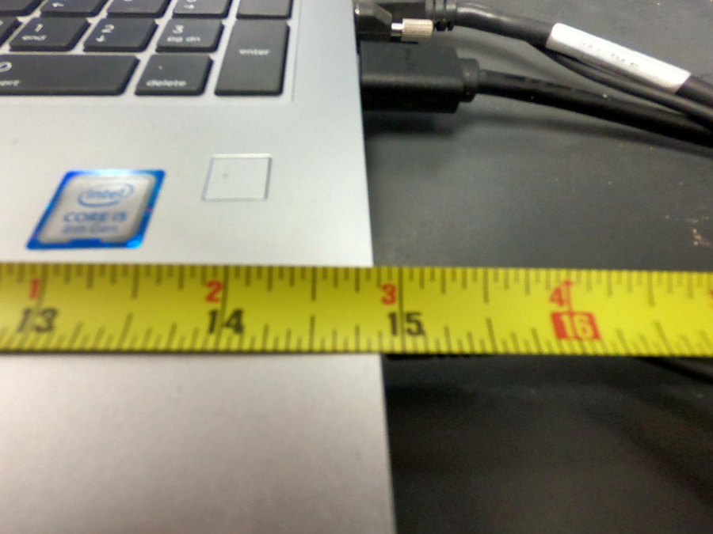
What is the measurement at the end of the computer?
- 15
- 14 1/2
- 14
- 14 7/8*
points:1.00

True or False: Protractors cannot measure angles inside an object?
True
False*
points:1.00

True or False: An angle is the intersection between two lines.
True*
False
points:1.00

A quadrilateral has now many sides?
- 3
- 4*
- 5
- 6
points:1.00

The calculation Area = b x h is used to calculate the area of which of the following? (You can select multiple answers if needed)
- Parallelogram*
- Rectangle*
- Triangle
- Trapezoid
points:1.00
Match the welding method to its abbreviation
Automatic Welding
AU
Manual Welding
MA
Mechanized Welding
ME
Semi-Automatic Welding
SA
points:4.00

What are protractors used to measure?
points:1.00

Define what a whole number is.
points:1.00

What is the difference between radius and diameter?
points:1.00

2.3
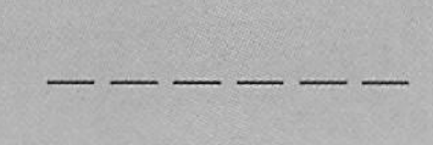
What type of blueprint lines are shown above?
- Object Lines
- Hidden Lines*
- Center Lines
- Phantom Lines
points:1.00

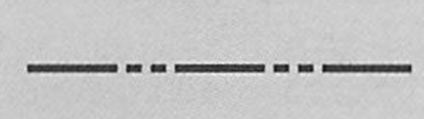
What type of blueprint lines are shown above?
- Short break Lines
- Phantom Lines*
- Cutting Plane Lines
- Section Lines
points:1.00

What type of lines are thick, heavy lines that represent the main lines of the outside of the part being constructed?
- Object Lines*
- Dimension Lines
- Section Lines
- Hidden Object Lines
points:1.00

True or False: Short break lines are thin while long break lines are heavier.
True
False*
points:1.00
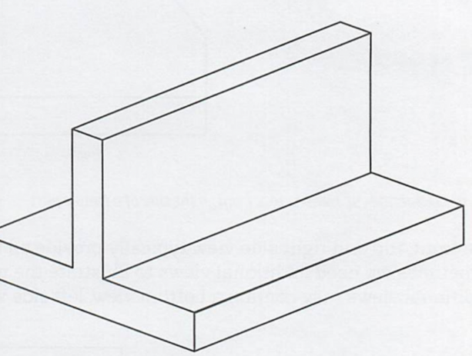
What type of drawing is shown above?
- Orthographic Projection
- Isometric Drawing*
- Multi-View Drawing
- Auxilary View
points:1.00
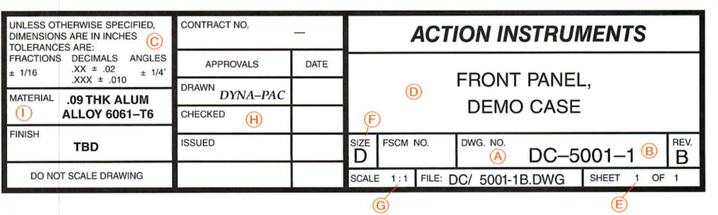
What part of a title block is A in the above image?
- Name of Part
- Dash Number
- Scale of Drawing
- Drawing Number*
points:1.00
Which of the following sections is the letter H above corresponding too?
- Responsible Signature Area*
- Material
- Dash Number
- Permitted Part Size Tolerances
points:1.00

4.3
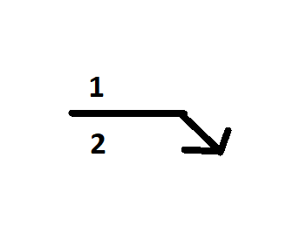
Which number is the arrow side of this welding symbol?
1
2*
points:1.00
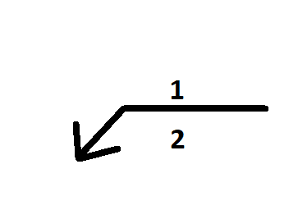
Which number on this weld symbol is the other side?
1*
2
points:1.00
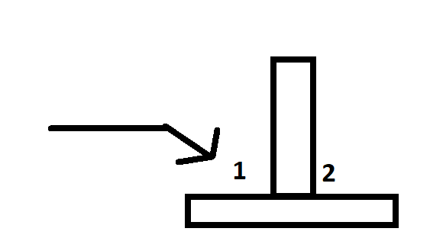
Which number is the arrow side on this diagram?
1*
2
points:1.00
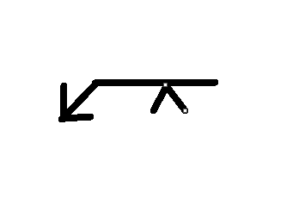
Which side of the weld would the Single V Groove Weld be performed on according to this diagram?
- Arrow Side*
- Other Side
points:1.00
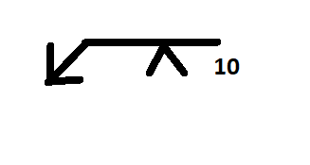
What does the number 10 on this weld symbol mean?
- Size of the weld
- Length of the weld*
- The number of welds
points:1.00

True or False: You read weld symbols from left to right.
True*
False
points:1.00

5.3
Which side of the fillet weld symbol would you write the dimension giving the size of the weld?
- Left*
- Right
points:1.00

Which of the following information is contained by a combined weld symbol?
- Weld Joint
- Weld Type
- Welding Operation
- All of the above*
points:1.00

Which of the following is not an element of a welding symbol?
- Reference Line
- Arrow
- Basic Weld Symbol
- Contour Line*
- Dimension and Other Data
- Supplementary Symbols
- Finish Symbols
- Tail
- Specification, Process or Other Reference
points:1.00
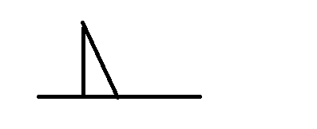
The weld symbol above is for what type of weld?
- Bevel
- Plug
- Fillet*
- Square
points:1.00
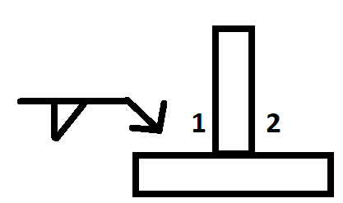
Which side would you do the weld on as specified by this welding symbol?
- Side 1*
- Side 2
points:1.00
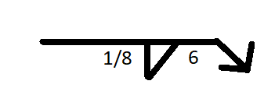
What does the number 6 mean in the above welding symbol?
- Number of passes for the weld
- Length of the weld*
- Thickness of the weld
points:1.00
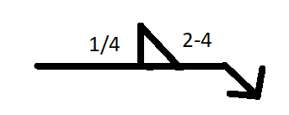
What type of weld is the above welding symbol showing?
- Staggered intermittent fillet weld
- Staggered intermittent groove weld
- Intermittent fillet weld*
- Chain intermittent fillet weld
points:1.00

True or False: The diagram below shows the correct interpretation of the below welding symbol?
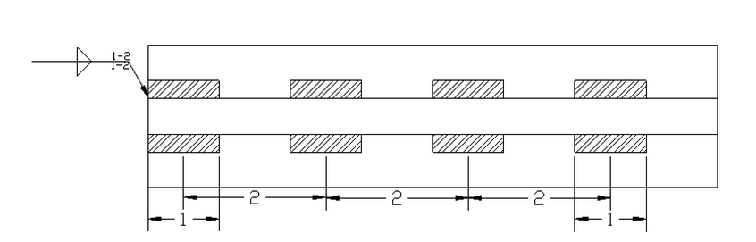
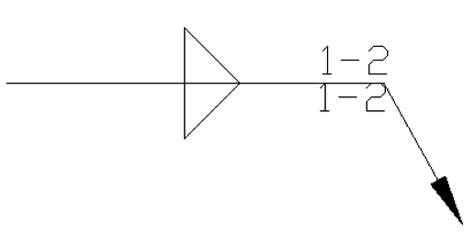
True*
False
points:1.00
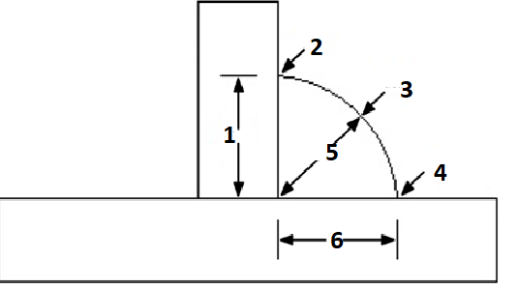
Identify each part of the fillet weld by number in the diagram above.
points:3.00

Describe the distinction between a welding symbol and a welding symbol.
points:1.00

For an intermittent fillet weld length of “2-4” what is the 2 a measurement for?

7.3
Plug or slot welds are determined by their what?
- Hole depth
- Hole shape*
- Hole width
points:1.00
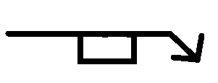
What type of weld symbol is pictured in the welding symbol above?
- Bevel
- Seem
- Plug*
- Filet
points:1.00
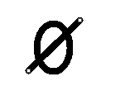
What does the above symbol mean?
- Finishing Method
- Contour Symbol
- Diameter Symbol*
- Slot Weld
points:1.00

Which of the following is not a piece of information you would find in a title block of a print?
- Drawing Number
- Premitted Part Size Tolerances
- Scale of Drawing
- Material
- All of the above*
- None of the above
points:1.00

True or False: The reference line is always drawn vertically
True
False*
points:1.00

Which of the following is not a welding type use to create a spot weld.
- Resistance Welding
- GMAW*
- GTAW
- Electrion Beam
- Ultrasonic
points:1.00
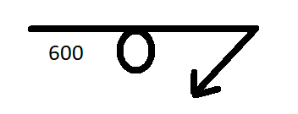
What type of weld is signified by the above welding symbol?
- Plug
- Seam
- Spot*
- Stud
points:1.00
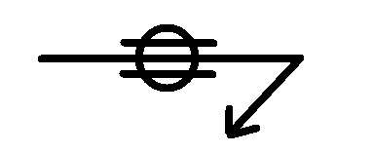
What type of weld is the above symbol for?
- Plug
- Seam*
- Stud
- Spot
points:1.00
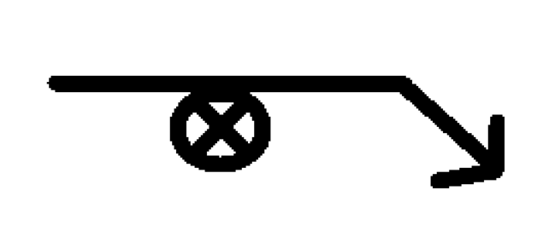
What type of weld is denoted by the welding symbol above?
- Seam
- Stud*
- Groove
- Plug
points:1.00
What is a continuous weld made on or between the surfaces of overlapping parts?
points:1.00

10.3
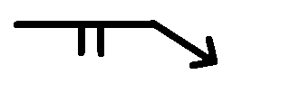
What type of weld does the above welding symbol indicate?
- Signle-Square Groove Weld*
- Single-V-Groove Weld
- Double-Square Groove Weld
- Single - V - Groove Weld
points:1.00

What type of groove weld requires the least material preparation of any groove weld?
- Single-Bevel Groove Weld
- Single-Square Groove Weld*
- Single-V Groove Weld
- Single-Flare-V Groove Weld
points:1.00

What two types of welds are used to weld round or square tubing with rounded corners?
- U-Groove and J-Groove Welds
- Square and G-Groove Welds
- Intermittent Groove and Back Welds
- Flare V-Groove and Flare Bevel-Groove Welds*
points:1.00

What side of the weld symbol is the length of a groove weld specified on?
- Left
- Right*
points:1.00
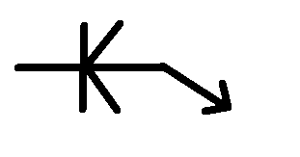
What type of weld is indicated by the above symbol?
- Single-Bevel Groove Weld
- Single-Flare V Groove Weld
- Double Flare V Groove Weld
- Double-Bevel Groove Weld*
points:1.00

12.3
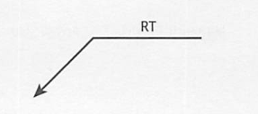
What testing method is the above welding symbol representing?
- Proof Test Arrow Side
- Radiographic Test Other Side*
- Radiographic Test Arrow Side
- Radiographic Test No Side Significance
points:1.00

True or Fase: A defect is a term used to describe a rejectable weld, due to not meeting inspection criteria.
True*
False
points:1.00

True or False: You cannot use non-destructive testing on both sides of a weld joint.
True
False*
points:1.00

Which of the following is not a common edge preparation for a weld joint?
- Square Edge Shape
- Bevel Edge Shape
- Flange Edge Shape
- Triple Bevel Edge Shape*I
points:1.00

Which of the following is a type of surfacing variation?
- Buildup
- Buttering
- Cladding
- Hard Facing
- All of the above*
points:1.00

Match the non-destructive examination with it's abbreviated symbol.
Acoustic emission examination
AET
Leak examination
LT
Neutron radiographic examination
NRT
Proof testing
PRT
Visual examination
VT
points:5.00
Define what electromagnetic examination is.

Define what liquid penetrant examination is.

Define what ultrasonic examination is.
What purpose does developer play during dye penetrant testing?

