1.1
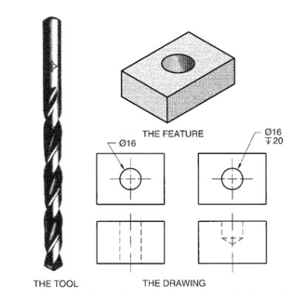
What type of manufacturing process is show in the image above?
- Ream
- Drill*
- Bore
- Counterbore
points:1.00
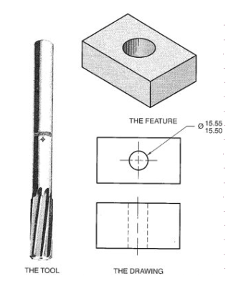
What type of manufacturing process is shown in the image above?
- Ream*
- Drill
- Bore
- Counterbore
points:1.00
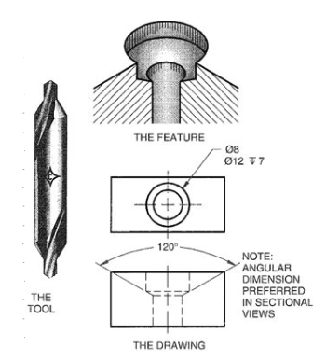
What manufacturing process is shown in the image above?
- Bore
- Counterbore
- Countersink
- Counterdrill*
points:1.00
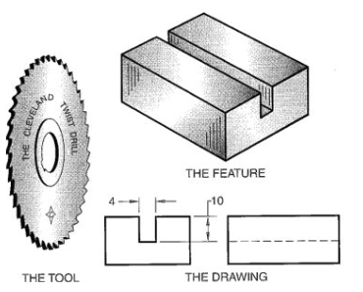
What type of manufacturing process is shown in the image above?
- Kerf*
- Counterbore
- Dovetail
- Countersink
points:1.00
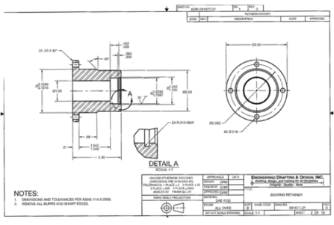
What type of blueprint drawing is shown in the image above?
- Multidetail drawing
- Detail assembly
- Monodetail drawing*
- Exploded ISO
points:1.00

What is the purpose of indicating the vise?
- To align the milling table
- To secure the workpiece*
- To ensure the mill head is perpendicular
- To adjust spindle speed
points:1.00

Name three types of milling cutters.
- End mills, spring collets, rotary tables
- Conventional, climb, face milling
- Square, hexagonal, ball
- Solid shafts, keyed holes, two-fluted*
points:1.00

Explain how a spring collet works.
- Used for tramming the head
- Holds round workpieces at 90-degree increments
- Allows easy removal of the tool by tapping the draw bar*
- Locks the quill at the highest position
points:1.00
Explain the difference between a 2D model and a 3D model.
points:1.00

1.2
What does the term "Concentricity" refer to in GD?
- The deviation of a horizontal surface from a nearby vertical surface
- The true position of a hole from a set of reference datums
- The circularity of a machined hole within two concentric cylinders*
- The maximum deviation of a milled surface from perpendicularity
points:1.00

What is the purpose of Geometric Dimensioning and Tolerancing (GD)in manufacturing?
- To control surface roughness
- To define part tolerances related to relationships, form, and fit*
- To expedite the quoting process
- To improve the appearance of metal parts
points:1.00

What is the purpose of the end relief (clearance) angle in a lathe tool bit?
- To create a keener cutting edge
- To prevent chips from flowing away
- To provide support under the cutting edge*
- To enhance surface roughness
points:1.00

What properties should lathe tool bits possess according to your text?
- Soft, heat-resistant, and flexible
- Brittle, wear-resistant, and low-temperature tolerance
- Hard, wear-resistant, capable of withstanding high temperatures, and able to withstand shock*
- Ductile, wear-prone, and low-temperature tolerance
points:1.00

Why does the depth of cut per pass, or infeed per pass, need to be carefully managed in threading?
- To increase cutting force
- To avoid exponential growth in metal removal with successive passes*
- To reduce metal removal rate
- To speed up the threading process
points:1.00

1.3
What should you do before handling any power tools, including a bandsaw? (Select all that apply)
- Wear safety googles*
- Wear safety gloves*
- Minimize loose clothing*
points:1.00

True or false: you should select a faster cutting speed setting on a band saw when cutting softer materials?
True*
False
points:1.00

What are some safety precautions mentioned for using the surface grinder?
- Always strike the wheel against the material to test its integrity.
- Ensure the magnetic chuck is dirty before placing material on it.
- Wear safety glasses, secure long hair, and keep the guard in place over the grinding wheel.*
- Turn off the start/stop button when performing maintenance work
points:1.00

What should be done to ensure the grinding wheel is suitable for the material being worked on?
Check the wheel's color.
Use a softer grade wheel for hard materials.
Examine the wheel's manufacturer instructions and consider factors such as material hardness, amount of stock to be removed, and area of grinding contact. *
Select a wheel with a high bond strength
points:1.00
What are the two main types of band saws available in the market?
points:1.00

