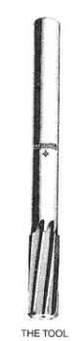
What manufacturing process is the tool above used for?
- Reaming
- Drilling*
- Boring*
- Counter sinking
points:1.00
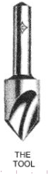
What manufacturing process is the above tool used for?
- Counter Drill
- Counter Bore
- Reaming
- Counter Sink*
points:1.00
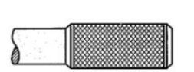
What type of knurl is shown in the image above?
- Straight
- Diamond*
points:1.00

True or False: 3D models are the most common way of representing blueprint drawings.
True
False*
points:1.00

True or False: bilateral tolerance allows a dimension to vary both above and below basic size.
True*
False
points:1.00

True or False: the minor diameter is the smallest diameter of a thread.
True*
False
points:1.00

When it comes to pipe threads, what does NPT stand for.
- National Pipe Thread*
- Natural Pipe Thread
- Neutral Pipe Thread
- Nautical Pipe Thread
points:1.00

How should you select the grinding wheel for a surface grinder based on the material being ground?
- The harder the material, the softer the grade of the wheel should be.
- Choose a wheel with a grit size that matches the desired finish.
- Use a softer abrasive for softer materials and a harder abrasive for harder materials.*
- Only vitrified bonded wheels should be used regardless of the material.
points:1.00

What safety precaution should be taken regarding long hair when using the surface grinder?
- It should be tied back to prevent it from getting caught in the machine.*
- It should be kept untied for better visibility.
- It should be tucked into the shirt collar.
- It should be left loose to avoid restriction of movement.
points:1.00

What are some of the considerations for geometric dimensioning and tolerancing mentioned in your text?
- Diameter and thickness
- Surface finish and roughness
- True position, flatness, and concentricity*
- Length and width
points:1.00

What is the purpose of indicating the vise?
- To locate the edges of the vise
- To check the hardness of the vise
- To measure the dimensions of the vise
- To ensure the vise is properly aligned with the mill table*
points:1.00

What tool is used for tramming the head?
- End mill
- Dial indicator*
- Protractor
- Edge finder
points:1.00
You are cutting 5/16-18-3A threads. What is the approximate in-feed?&nbsp;
points:1.00

What is the angle, set from vertical, of the compound rest for threading?
points:1.00

What specific thread feature are you measuring if you are using a thread mic?
points:1.00

What is the difference between "pitch" and "pitch ø"?
points:1.00

List five safety guidelines to observe when operating the vertical milling machine.
points:1.00

Define what climb milling is.
points:1.00

Describe what tramming is.
points:1.00

Define what pitch diameter is.
points:1.00

The distance of actual contact of two mating threads measured along the length of the two threads is the what?
points:1.00

What feature of mating threads determines the class of fit?
points:1.00

How many classes of fit are there in the Unified National System?
points:1.00

What is the name for the rotating device that transmits power to the carriage for thread-cutting motion?
points:1.00

Name the device used to track the timing of half-nut lever engagement.
points:1.00

What measuring tool is used to visually inspect the form, or shape, of an external thread?
points:1.00

List three safety precautions to observe when operating a vertical bandsaw.
points:1.00

Name the three different types of tooth patterns for saws.
points:1.00

How many saw teeth should be engaged in the workpiece at any given time?
points:1.00

Explain how to use a push stick.
points:1.00

When wheel is finer, a 60 grit or a 36 grit?
points:1.00

How is a ring test performed?
points:1.00

When should a grinding wheel be dressed?
points:1.00

What semi-precision tool is used to take angular measurements?
points:1.00
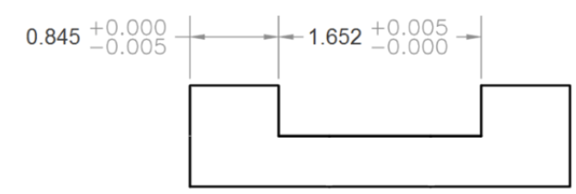
Using the print, provide the X axis moves. Roughing endmill is ø 7/8, leaving 0.020; finish endmill is ø 1.125. Provide answers to 4 decimal places and do not include units. Answer the following
- Rough Pass Left Side
- Rough Pass Right Side
- Finish Pass Left Side
- Finish Pass Right Side
points:1.00

