1.3
Which of the following are types of CNC Milling Machines (select all that apply)
- Vertical milling*
- Horizontal milling*
- Multi-axis milling*
points:1.00

True or False: for multi-axis machines, each additional axis represents an additional type of movement?
True*
False
points:1.00

True or False: 3 axis machines offer the greatest efficiency for complicated parts?
True
False*
points:1.00

Which of the following is the maximum amount of axis a CNC milling machine can operate with?
- 7
- 9
- 10
- 12*
points:1.00

True or False: 4-axis milling machines have issues with quick wear and tear of the worm gear mechanism
True*
False
points:1.00

Which of the following are axes that a 5 axis CNC milling machine works with (select all that apply)
- X-Axis*
- Y-Axis*
- B-Axis
- A-Axis*
- H-Axis
points:1.00

Which of the following is not a benefit of an automatic tool changer?
- Increased efficiency
- Increased accuracy
- Reduced downtime
- Increased safety for employees
- All of these listed are benefits*
points:1.00

True or false: disc-type automatic tool changes can hold 8-20 different tools
True*
False
points:1.00
What do automatic tool changers do?
points:1.00

Describe two differences between a disc automatic tool changer and a linear automatic tool changer?
points:1.00

2.3
Which of the following are key elements of a CNC milling machine? (select all that apply)
- Column and Base*
- Knee*
- Elbow
- Work Table*
- Spinner
points:1.00

True or False: the column and base typically houses the oil and coolant systems for the machine?
True*
False
points:1.00

True or False: the knee of the machine cannot be adjusted up and down, it is completely stationary
True
False*
points:1.00

True or False: the work table is a circular piece of cast iron with T-slots for clamping a workpiece directly to it
True
False*
points:1.00

True or False: the spindle holds and drives the cutting tools
True*
False
points:1.00

Which of the following are parts of the control panel for a CNC machine (select all that apply)
- Input Device*
- Display Unit*
- Keyboard*
- Tape Feeder
points:1.00

True or False: T-Slots are the most common method of positioning and holding down your workholding solution.
True*
False
points:1.00
What is a disadvantage to using a T-slot?
points:1.00

Explain how tooling plates work.
points:1.00

Identify at least two characteristics of a good milling vise.
points:1.00

3.3
Just some of the OSHA documented injuries from machinery include: (select all that apply)
- Crushed hands and arms*
- Severed fingers and limbs*
- Lacerations and abrasions*
points:1.00

The purpose of machine guarding is to protect workers from: (select all that apply)
- Nip points (or pinch points in general)*
- Rotating parts*
- Flying chips and sparks*
points:1.00

By OSHA definitions, these are the types of barrier guards: (select all that apply)
- Enclosure guards*
- Fixed barrier guards*
- Floating barrier guards
- Glass barrier guards
points:1.00

True or False: interlocking guards disengage power and prevent machine cycling?
True*
False
points:1.00

Lockout/Tagout is intended to prevent:
- Injuries from stored energy
- Someone from turning the power on while work is in progress
- Violations of copyright laws
- All of the above
- Only a and b*
points:1.00

True or False: when doing lock out/tag out, you do not have to relieve the machine of stored energy?
True
False*
points:1.00
What are the three things you should never do when someone else has a tagout label applied?
points:1.00
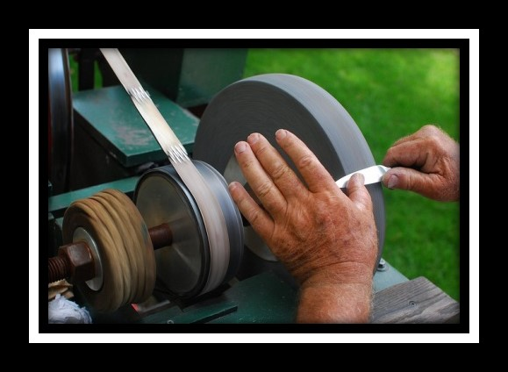
What is the hazard or hazards in this photo?
points:1.00
In a right triangle, which trigonometric ratio represents the ratio of the side opposite the angle to the hypotenuse?
- Sin*
- Cos
- Cot
- Csc
- Tan
points:1.00
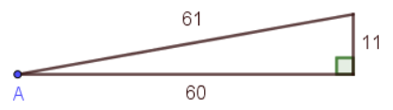
What is the Sin of A
- 61/11
- 60/61
- 11/61*
- 11/60
points:1.00
What is the tangent of A
- 11/61
- 61/11
- 60/11
- 11/60*
points:1.00
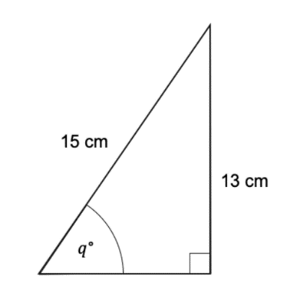
Find the size of the angle marked q to 1 decimal place.
- 60.1*
- 63.1
- 70.1
- 72.1
points:1.00

6.3
What does the M00 code do in CNC machining?
- Starts the spindle clockwise.
- Stops the spindle, turns off coolant, and stops look-a-head processing.*
- Initiates tool change along with a tool number.
- Turns on coolant.
points:1.00

When is the M01 code used in CNC machining?
- Starts the spindle clockwise.
- Stops the spindle.
- Initiates an optional program stop command similar to M00.*
- Calls a local subroutine.
points:1.00

What does the G54 coordinate system represent in CNC machining?
- Work Coordinate #1 (Part zero offset location).*
- Machine Home (in rapid traverse).
- Absolute Programming Positioning.
- Cutter Compensation ON LEFT of programmed tool path.
points:1.00

When is the G83 code used in CNC milling?
- Stops the spindle.
- Circular interpolation - Counter clockwise.
- Peck Drill - Canned cycle.*
- Coolant ON command.
points:1.00

What is the function of the G02 code in CNC milling?
- Starts the spindle clockwise.
- Rapid traverse motion.
- Canned cycle - Drill.
- Circular interpolation - Clockwise.*
points:1.00

