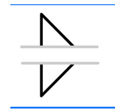
Which of the following types of weld is the above symbol for?
- Fillet*
- Plug
- Slot
- Stud
points:1.00
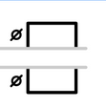
Which of the following types of weld is the above symbol for?
- Fillet
- Slot
- Plug*
- Stud
points:1.00
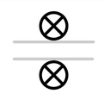
Which of the following welding types is the above symbol for?
- Plug
- Slot
- Fillet
- Stud*
points:1.00
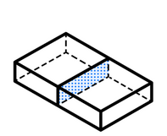
What type of joint is the above image representing?
- Corner Joint
- Butt Joint*
- Edge Joint
- Lap Joint
points:1.00
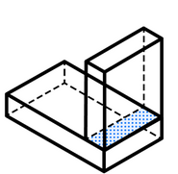
Which of the following joint types is the above image showing?
- Corner Joint*
- Edge Joint
- Butt Joint
- Lap Joint
points:1.00

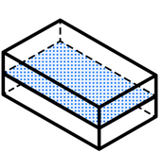
Which of the following joint types is the above diagram showing?
- Lap Joint
- Butt Joint
- Edge Joint*
- T Joint
points:1.00

True or False: You always read the information on welding symbols from right to left.
True
False*
points:1.00
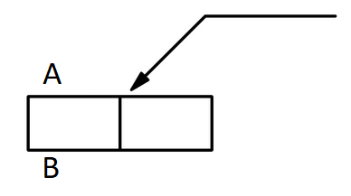
Which side is arrow side according to this diagram?
- Side A*
- Side B
points:1.00
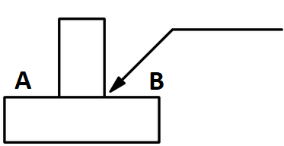
What side is other side according to the above welding symbol?
- Side A*
- Side B
points:1.00
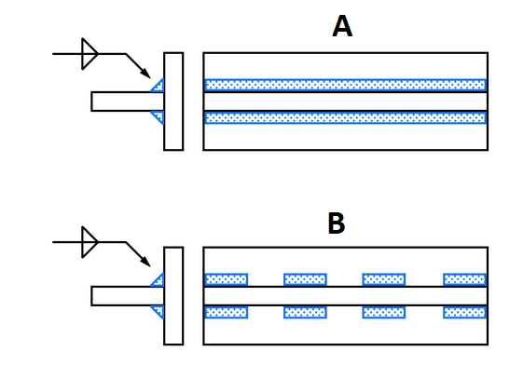
Which of the two diagram showcases intermittent welding?
- Diagram A
- Diagram B*
points:1.00
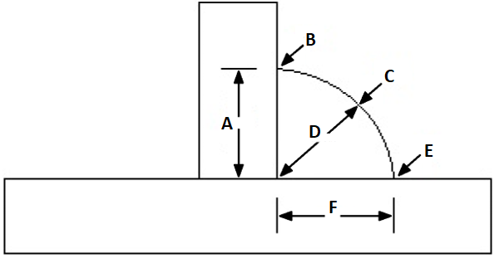
Looking at the above welding symbol, what is the length and pitch of the weld?
- Length 1, Pitch 4*
- Length 4, Pitch 1
points:1.00

Which of the following is not a finishing method of a weld?
- Chipping
- Grinding
- Rolling
- Clear Coating*
points:1.00
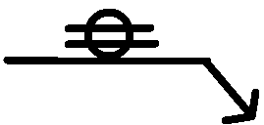
What is the above weld symbol for?
- Stud
- Seam*
- Groove
- U Weld
points:1.00

What type of lines are thick, heavy lines that represent the main lines of the outside of the part being constructed?
- Object Lines*
- Dimension Lines
- Section Lines
- Hidden Object Lines
points:1.00

True or False: Short break lines are thin while long break lines are heavier.
True
False*
points:1.00
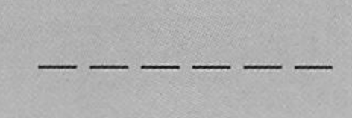
What type of blueprint lines are shown below Object Lines
- Hidden Lines*
- Center Lines
- Phantom Lines
points:1.00
Which of the following parts of a fillet weld correspond with the above letters? (Some answers are repeated) [A] [B] [C] [D] [E] [F]
Leg
Toe
Crown
Throat
Toe
Leg
points:1.00
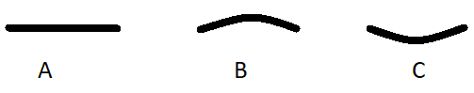
Please match the following contours with their corresponding symbol above: [A], [B], [C]
Flat
Convex
Concave
points:1.00
What is the main difference between plug and slot welds?

