In the example of Word Address "N01 G02 X1500 Y2000 F4 S400 T10," what does the letter 'G' represent?
- Gear ratio
- Preparatory command
- Graphical representation
- General instruction
points:1.00
What is the primary difference between vertical milling and horizontal milling in CNC machining?
- The type of material removed
- The direction of tooling rotation *
- The cost-effectiveness
- The number of axes
points:1.00
In CNC machining, what distinguishes a 5-axis milling machine from a 3-axis or 4-axis machine?
- Pivoting action at the joint of the table*
- Geneva Mechanism for continuous machining
- Use of CAD/CAM programming
- Ability to simultaneously hit five different sides of a part
points:1.00

part of a CNC milling machine is responsible for holding and driving the cutting tools, as well as serving as a placeholder for various tools?
- Column and Base
- Power Feed Mechanism
- Work Table
- Spindle *
points:1.00

According to OSHA, what are the common hazards associated with points of operation?
- Electrical shocks and burns
- Pinch points and cutting edges*
- Noise pollution
- Slip and fall accidents
points:1.00

What is the function of Interlocking Guards in machine safety?
- To provide additional power to the machine
- To regulate temperature in the workplace
- To shut off power and prevent machine cycling when the guard is opened*
- To improve the aesthetics of the machine
points:1.00

In CNC programming, what does the G90 code signify?
- Canned cycle CANCEL
- Absolute Programming Positioning*
- Peck Drill - canned cycle
- Work Coordinate #1 (Part zero offset location) Return
points:1.00

What is Cutting Speed (CS) in milling, and how is it measured?
- The rate at which the tool is moved into the part, measured in inches per minute.
- The revolutions per minute (RPM) of the milling cutter.
- The distance the cutter would roll on the floor in one minute, measured in surface feet per minute (SFM).*
- The width of cut (W) in inches.
points:1.00

In milling, what is the formula to calculate Spindle Speed (RPM), and how is it applied?
- RPM = (3.82 × CS) / D
- RPM = (CS × 4) / D
- RPM = IPM × N × FTP*
- RPM = (D × RPM) / (3.82)
points:1.00

What is the relationship between cutting speed and work material hardness, and how does it influence recommended cutting speed?
- The harder the work material, the faster the cutting speed; the softer the material, the slower the cutting speed.*
- The softer the work material, the faster the cutting speed; the harder the material, the slower the cutting speed.
- Cutting speed is not influenced by work material hardness.
- Cutting speed is solely determined by the type of cutter used.
points:1.00

What is the purpose of using oil during the drilling and tapping process?
- To make the cut smoother and quieter.
- To increase the speed of the spindle.
- To keep the bits from overheating and breaking, and to clean out the chips.*
- To prevent the need for pecking.
points:1.00

What is the significance of pecking in drilling or tapping procedures?
- To rotate the handle a full turn then back a half turn.
- To ensure the drill or tap is straight and centered.
- To remove chips and allow the piece to cool, preventing overheating and breakage.*
- To select the appropriate drill size from the chart.
points:1.00

In CNC programming, what is the significance of the "/" symbol?
- It specifies the end of a CNC program.
- It defines an optional block that can be ignored with the "Block Delete" button.*
- It indicates the start of a new block.
- It is used to separate G and M codes
points:1.00

What is the correct order of blocks in a CNC program?
- Rapid to position above part, Coolant On, Spindle On, Machining operation.
- Start Program, Load Tool, Spindle Off, Coolant Off.
- Program Start, Load Tool, Coolant On, Move to safe position.*
- Spindle On, Coolant On, Rapid to safe plane, End program.
points:1.00

What is the purpose of the "%" symbol in a CNC program?
- Indicates the start or end of the program.*
- Represents a comment to the operator.
- Initiates a rapid motion.
- Defines an optional block.
points:1.00

Which G-code is used for rapid motion?
- G01
- G02
- G00 *
- G03
points:1.00

What does G43 do in CNC programming?
- Activates tool length compensation. *
- Defines an arc in the clockwise direction.
- Controls spindle direction.
- Cancels cutter diameter compensation.
points:1.00

Which G-code cancels cutter diameter compensation?
- G42
- G40 *
- G43
- G41
points:1.00

When is Cutter Radius Compensation (CRC) used in a CNC machining program?
- Only for small-sized tools
- To compensate for the tool centerline
- To shift the cutter edge along the tool path*
- Only when the tool diameter is constant
points:1.00

What is the primary advantage of using Cutter Radius Compensation (CRC) in CNC programming?
- Simplifies the CNC simulator
- Only works for contour shapes
- Reduces the need for CNC machine setup
- Allows various tool sizes without changing the part shape*
points:1.00

What does the term "center cutting" refer to in the context of endmills?
- The ability to cut on both the bottom and sides of the cutter
- The number of flutes on the endmill
- The material used to manufacture the endmill
- The capacity to create holes in a material by plunging*
points:1.00

When using jobbers drills for deep holes, what cycle is recommended to break chips?
- Continuous drilling
- Peck drill cycle*
- Spot drilling
- Center drilling
points:1.00

What is the purpose of center drilling before performing a drilling operation?
- To calculate the Z depth accurately
- To reduce burrs on parts
- To ensure a smooth chamfer
- To get the drilling operation off to a good start*
points:1.00

Which conditional switch is used to perform a test of a CNC program with no material, allowing for machine movement without actual cutting?
- Single Block
- Option Stop
- Block Delete
- Dry Run*
points:1.00

Which dimension of quality is concerned with the product's reputation and the perceived standing of the company or product in the eyes of the consumers?
- Performance
- Reliability
- Features
- Perceived Quality*
points:1.00

Which dimension of quality is concerned with how long the project with last?
- Performance
- Reliability
- Durability*
- Serviceability
points:1.00
Describe the difference between incremental and absolute position.
points:1.00

How do Fixture Sub-Plates (Tooling Plates) contribute to efficient CNC machining, especially in terms of setup time?
points:1.00

What is the main purpose of CNC interpolation in machining on CNC machines?
points:1.00

Describe the difference between Climb vs Conventional Milling
points:1.00
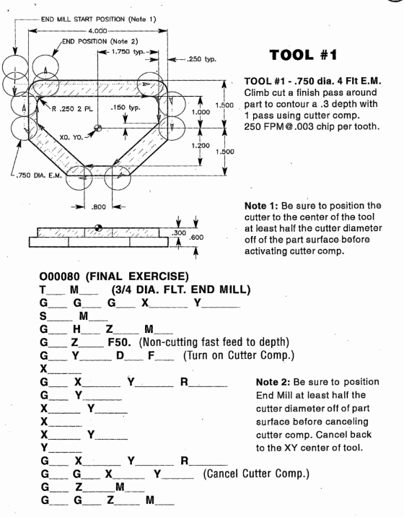
Fill out the final exercise code as depicted above using the above shop print.

