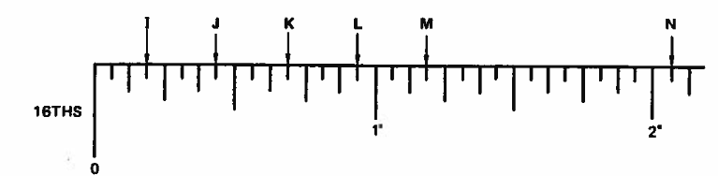
What is the proper measurement for J on the above image?
- 7/16ths of an inch*
- 5/16ths of an inch
- 9/16ths of an inch
- 3/16ths of an inch
points:1.00
What is the measurement for M on the above image?
- 3/16ths of an inch
- 2 and 3/16ths of an inch
- 1 and 3/16ths of an inch*
- 15/16ths of an inch
points:1.00
What is the measurement for K pictured above?
- 3/16ths of an inch
- 1 and 3/16ths of an inch
- 11/16ths of an inch*
- 2 and 3/16ths of an inch
points:1.00

How many sides does a pentagon have?
- 3
- 6
- 4
- 5*
points:1.00
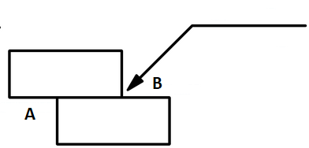
Which side of the joint is the arrow side according to the above welding symbol?
Side A
Side B*
points:1.00
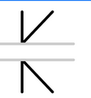
What type of weld is the symbol above signifying.
- V Groove
- Flare V
- Double Bevel
- Bevel*
points:1.00
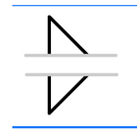
What type of weld does the above symbol signify?
- Fillet Weld*
- Groove Weld
- Stud Weld
- Back Weld
points:1.00
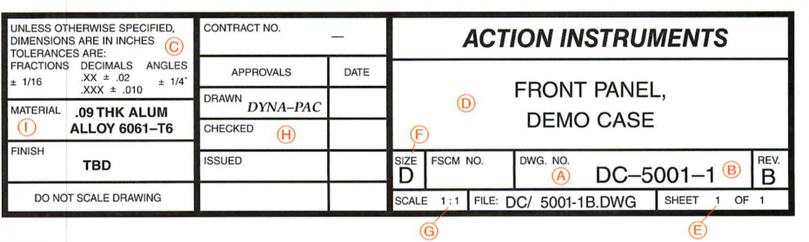
What part of a title block is A pointing to.
- Dash Number
- Drawing Number*
- Sheet Number
- Permitted part size tolerances
points:1.00
What part of a typical title block is the letter B referring to.
- Dash number*
- Drawing number
- Drawing sheet size
- Scale of the drawing
points:1.00
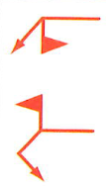
What type of weld is the above symbol signifying.
- Fillet Weld
- Field Weld*
- Slot Weld
- Stud Weld
points:1.00
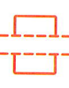
What type of weld is the above symbol signifying?
- Plug Weld
- Seam Weld
- Slot Weld*
- Edge Weld
points:1.00
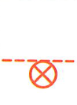
What type of weld is the above welding symbol signify.
- Seam Weld
- Groove Weld
- Fillet Weld
- Stud Weld*
points:1.00
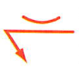
What type of contour is the weld symbol above signifying.
- Flush/Flat
- Concave*
- Convex
points:1.00
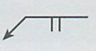
What type of groove weld is the above weld symbol signifying.
- Double Squared Groove Weld
- Single Bevel Groove Weld
- Single V Groove Weld
- Squared Groove Weld*
points:1.00
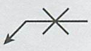
What type of weld is signified by the image above?
- Double Flare V Groove Weld
- Double V Groove Weld*
- Double U Groove Weld
- Double Bevel Groove Weld
points:1.00
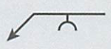
What type of weld is signified by the image above?
- Single Bevel Groove Weld
- Single J Groove Weld
- Single U Groove Weld*
- Single V Groove Weld
points:1.00
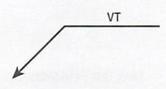
What type of testing method is the above image signifying?
- Visual Test, Other Side*
- Visual Test, Arrow Side
points:1.00
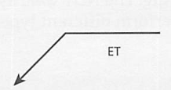
What type of testing method is signified by the above symbol?
- Electromagnetic Testing, Other Side
- Electromagnetic Testing, Arrow Side*
points:1.00
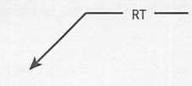
What type of testing method is signified by the symbol above?
- Radiographic testing, arrow side
- Radiographic testing, other side
- Radiographic testing, no side significance*
points:1.00

Visual examination is one of the most extensively used inspection practices for the following reasons:
- It is easy to perform
- It is used by all workers who are associated with welding practices
- It is relatively inexpensive
- All of the above are reasons*
points:1.00
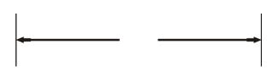
What type of blueprint line is shown above?
- Extension Line
- Dimension Line*
- Object Line
- Center Line
points:1.00
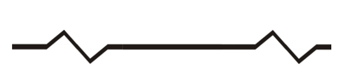
What type of blueprint line is shown above?
- Long Break Line*
- Short Break Line
- Phantom Line
- Section Line
points:1.00
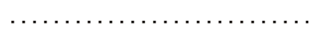
What type of blueprint line is pictured above?
- Object Line
- Leader Line
- Extension Line
- Phantom Line*
points:1.00

True or False: The first number in the AISI-SAE classification system indicates the basic type of steel.
True*
False
points:1.00

Conventional drafting tools include which of the following:
- T-Squares
- Triangles
- Scales
- Pencils
- All of the above are common drafting tools*
points:1.00

What does the number 2 mean in the AISI-SAE classification system?
- Nickel Steel*
- Carbon Steel
- Silicon-Manganese Steel
- Chromium Steel
points:1.00
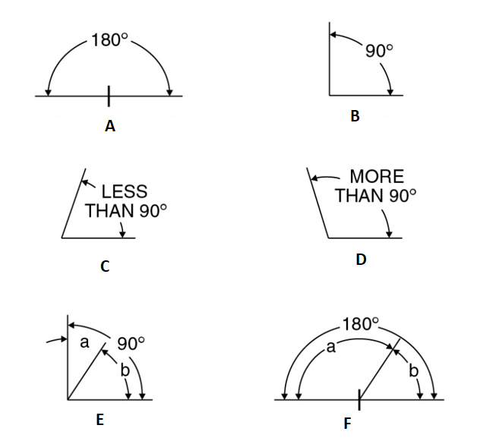
Please go ahead and match each type of angle in the work bank with it's corresponding angle in this image.<br><br>A [A], B [B], C [C], D [D], E [E], F [F]
- Straight Angle
- Right Angle
- Acute Angle
- Obtuse Angle
- Complementary Angle
- Supplementary Angle
points:1.00
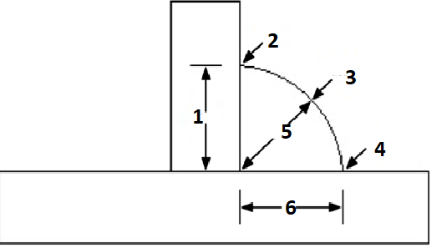
Match the part of the fillet weld with the corresponding number above. 1 [1], 2[2], 3[3], 4[4], 5[5], 6[6]
- Leg
- Toe
- Crown
- Toe
- Thorat
- Leg
points:1.00
What does AU abbreviation mean when discussing welding methods?
points:1.00

What is the main difference between a plug weld and a slot weld.
points:1.00

What is the difference between non-destructive and destructive testing methods?
points:1.00

Describe how Dye Penetrant Testing works.

Explain the differences between an isometric drawing and an orthographic drawing.
points:1.00

