1.3
True or false: it is perfectly fine to wear gloves while operating equipment.
True
False*
points:1.00

True or false: You can throw away leftover chips in any trash cans.
True
False*
feedback: All chips must be thrown away in appropriately labeled drums.
points:1.00

Which of the following are parts of proper clean up after working on a milling or lathe machine.
- Chips need to be vaccumed or swept up from the vises and the floor surrounding the machine.
- Mats must be shaken out and swept around.
- The lathe trough must be emptied of chips.
- Tools must be put away in proper storage locations.
- All of the above.*
points:1.00

True or false: Shop rags must be disposed of in red metal containers.
True*
False
points:1.00

Which of the following are smart practices for ergonomics?
- Task Rotation.
- Good posture.
- Pushing instead of pulling.
- All of the above are smart practices.*
points:1.00

Which of the following are solutions for awkward lifting posture.
- Use your back when lifting from a low location.
- Place heavy objects on the floor.
- Avoid twisting, especially when bending forward while lifting.*
- Keep your elbows and load as far away from your body as possible.
- Turn by twisting your torso while carrying loads.
points:1.00

Which of the following are minimul requirements for safeguards.
- Be secure.
- Prevent contact.
- Protect from falling objects.
- Create no new hazzards.
- Create no interference.
- Allow safe lubrication.
- All of the above are minimum requirements for safeguards.*
points:1.00
Fill in the blank: [slips], [trips], [falls], account for 15% of all accidential deaths. &nbsp;
slips**trips**falls
slips**trips**falls
slips**trips**falls
points:1.00

The three basic areas of moving parts that require safeguarding are [answer a], [answer b], and [answer c].
point of operation**power transmission apparatus**other moving parts
point of operation**power transmission apparatus**other moving parts
point of operation**power transmission apparatus**other moving parts
points:1.00

2.3
Look at the steel rule. What is the measurement between the 2 arrows
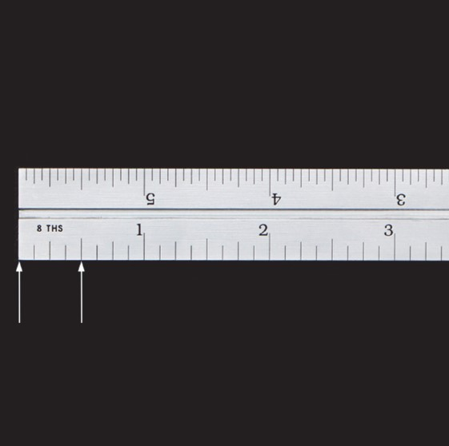
- 1/8"
- 4/8"*
- 5/8"
- 3/16"
- 4/16"
points:1.00

Look at the steel rule and notice which steel rule is showing for the type of measurement. What is the measurement between the 2 arrows?
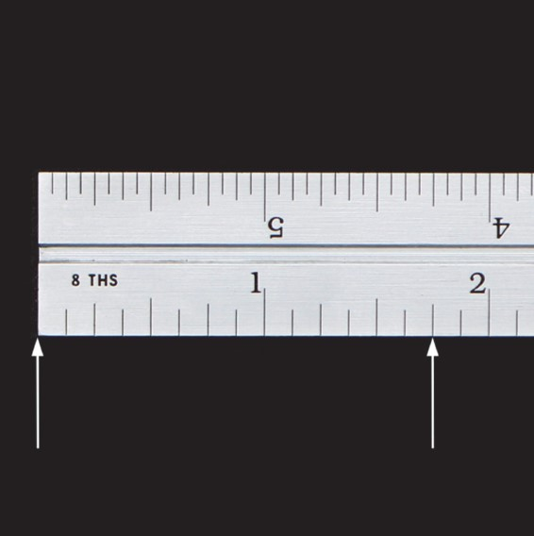
- 6/8"
- 1/8"
- 1 and 6/8"*
- 5/8"
- 1 and 7/8"
points:1.00

Look at the steel rule. What is the measurement between the 2 arrows?
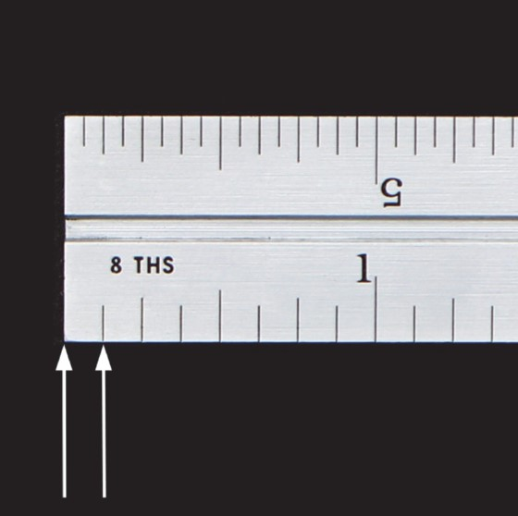
- 1/16'
- 1/32"
- 1/8"*
- 1 and 1/8"
- Answers A and C are correct
points:1.00

Look at the photo and notice which steel rule is shown for the type of measurement. What is the measurement between the 2 arrows?
- 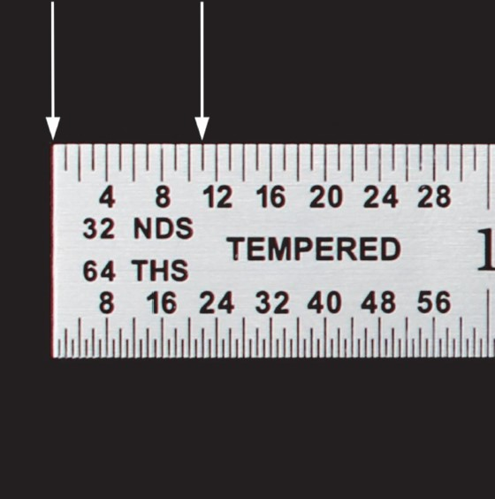
- 1/8"
- 11/8"
- 11/64"
- 10/64"
- 11/32"*
points:1.00

Look at the photo and notice which steel rule is shown. What is the measurement between the 2 arrows? Look at ALL answers carefully. There may be 2 or more correct answers so answer appropriately?
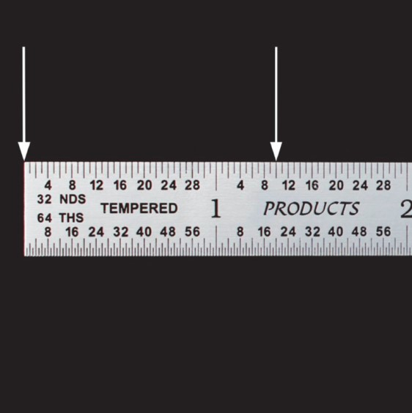
- 1 and 9/32"
- 1 and 10/12"
- 1 and 10/32"*
- Answers A and C are correct
- None of the above
points:1.00

Look at the photo. What is the measurement between the 2 arrows? Look at ALL answers carefully. There may be 2 or more correct answers so answer appropriately.
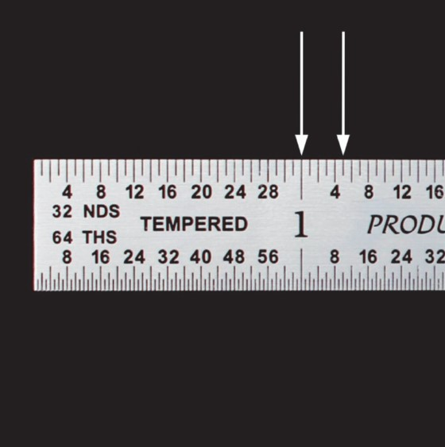
- 5/32"*
- 1 and 5/32"
- 5/64"
- Answers B and C are correct
- None of the answers are correct
points:1.00

3.3
There are proper and improper ways to quickly adjust the opening of the micrometer. Is spinning the micrometer as shown a proper way?
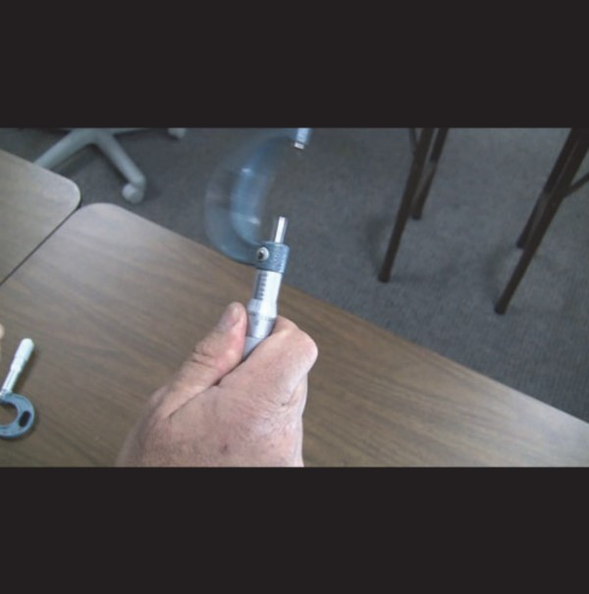
Yes
No*
points:1.00

Look at the photo and identify the part name.
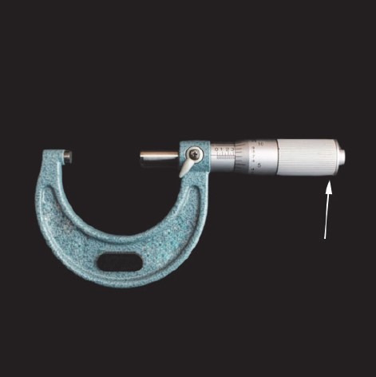
- Lock
- Spindle
- Anvil
- Friction Drive*
- Frame
points:1.00

Look at the photo and identify the part name.
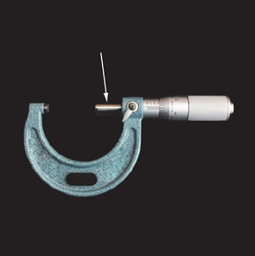
- Thimble
- Spindle*
- Barrel/Sleeve
- Fraction Drive
- Frame
points:1.00

Look at the photo and identify the part name.
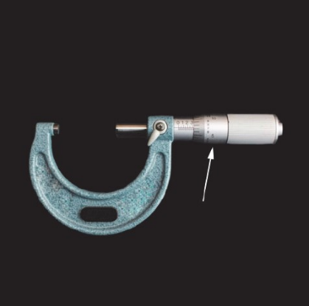
- Thimble*
- Lock
- Barrel/Sleeve
- Anvil
- Frame
points:1.00

Look at the photo and identify the part name.
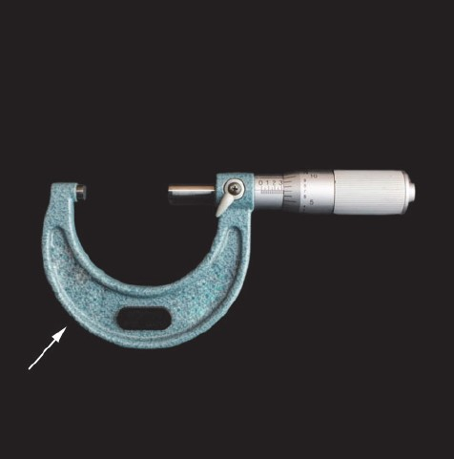
- Anvil
- Barrel/Sleeve
- Friction Drive
- Frame*
points:1.00

Look at the photo and identify the part name.
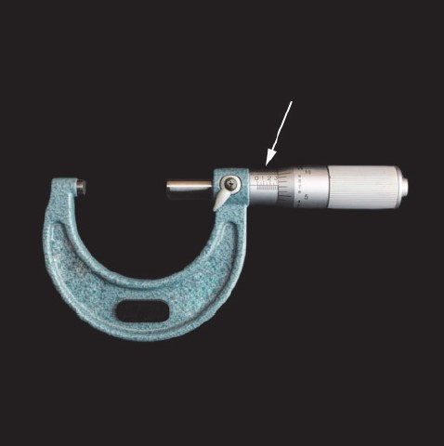
- Lock
- Spindle
- Barrel/Sleeve*
- Friction Drive
- Frame
points:1.00

There are proper and improper ways to quickly adjust the opening of the micrometer. Is rolling the thimble on the finger as shown a proper way?
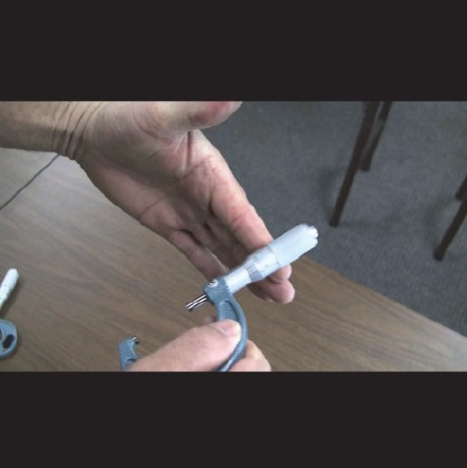
Yes*
No
points:1.00

Using a 2 to 3 INCH MICROMETER. Shown in the photo is the reading from a 2 - 3 inch micrometer. What is the correct precision reading?
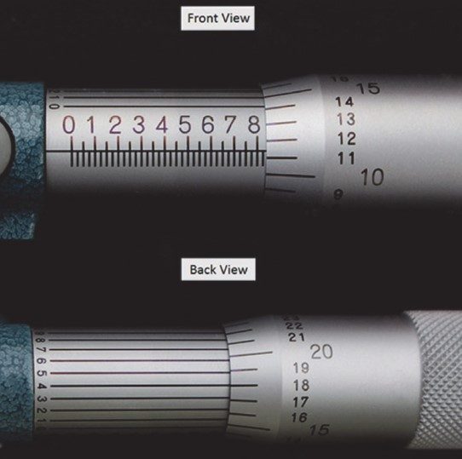
- 0.8364
- 8.3604
- 2.8360
- 2.8364*
- 2.8378
points:1.00

Using a 0 to 1 INCH MICROMETER. Shown in the photo is the reading from a 0 - 1 inch micrometer. What is the correct precision reading?
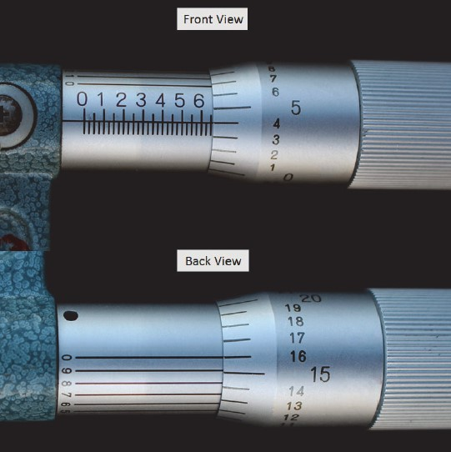
- 3.0
- 0.300
- 6.416
- 0.654*
- 0.250
points:1.00

Using a 2 to 3 INCH MICROMETER. Shown in the photo is the reading from a 2 - 3 inch micrometer. What is the correct precision reading?
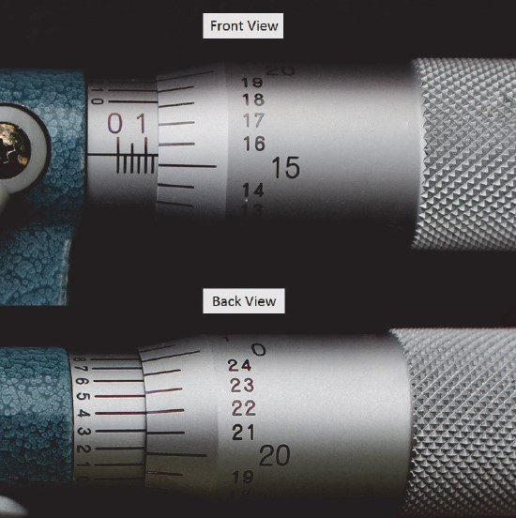
- 1.2515
- 2.1414
- 2.1404*
- 2.4040
- 0.1404
points:1.00

What is the reading of this Dial Caliper?
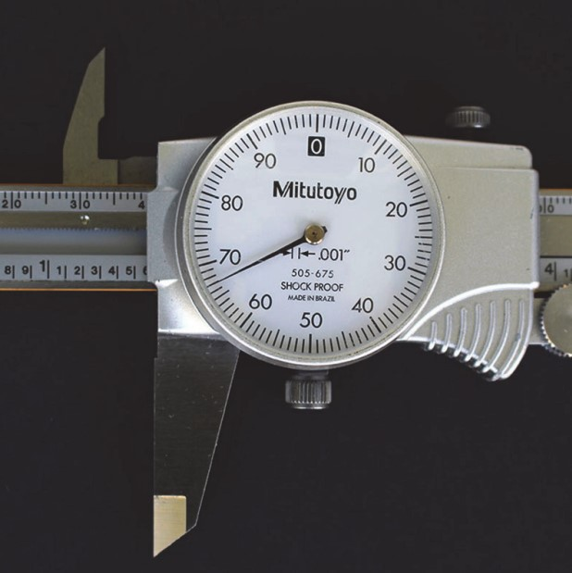
- 3.67"
- 1.567"*
- 0.700"
- 1.600"
points:1.00

What is the reading of this Dial Caliper?
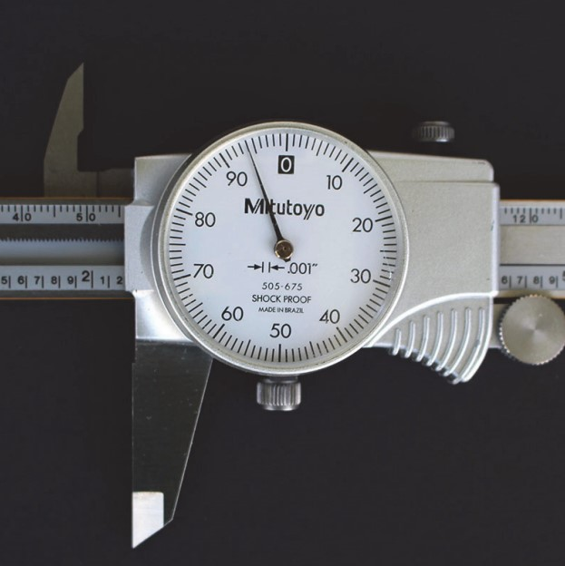
- 3.0
- 2.200
- 2.940
- 12.940
- 2.194*
points:1.00

What is the reading of this Dial Caliper?
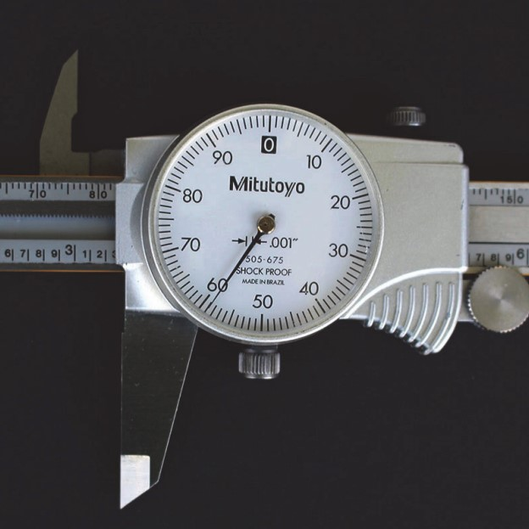
- 3.130
- 3.259*
- 3.123
- 3.360
- 3.590
points:1.00

What is the reading of this Dial Caliper?
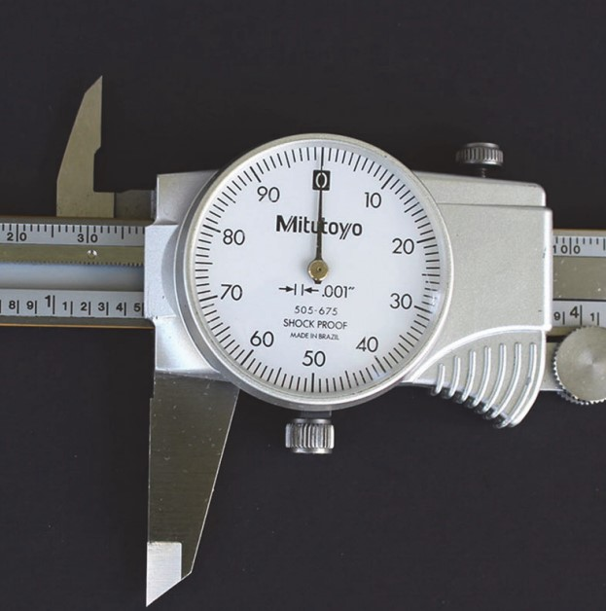
- 5.000
- 1.000
- 2.000
- 4.12"
- 1.500"*
points:1.00

What is the reading of this Dial Caliper?
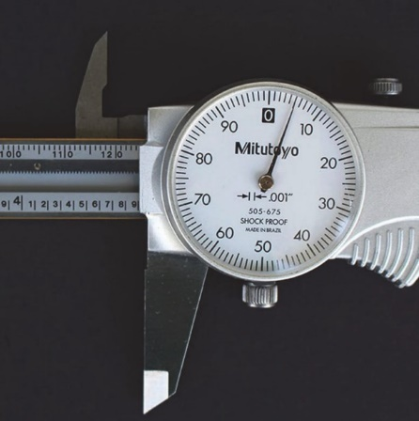
- 9.500"
- 4.005"
- 0.005"
- 4.095"*
- 4.950"
points:1.00

What is the reading of this Dial Caliper?
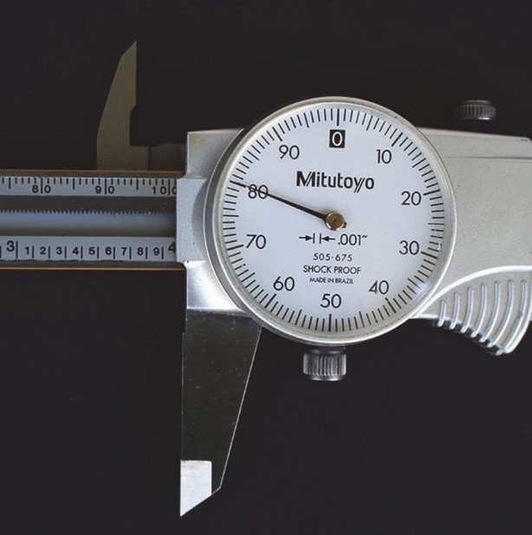
- 3.000"
- 3.980"*
- 4.800"
- 4.000"
- 3.080"
points:1.00

What is the reading of this Dial Caliper?
- 5.194
- 5.000"
- 2.230"
- 5.094"*
- 2.243"
points:1.00

4.3
A metal that contains iron is called
- Ferrous*
- Nonferrous
points:1.00

A metal that does not contain iron is called
- Ferrous
- Nonferrous*
points:1.00

Stainless steel contains ________ to help with corrosion.
- Aluminum
- Silver
- Chromium*
points:1.00

An alloy contains ________ or more metals.
- Two*
- Six
- Four
points:1.00

Tool steels are used for ________ and _______ metals.
- salting and heating
- shining and polishing
- cutting and forming*
points:1.00

5.3
Which of the following is not something you look for in a spark test to recognize steel?
- Length of spark.
- Color of spark.
- Trajectory of spark.
- Intensity of spark light.*
points:1.00

Spark tests are good for differenting steels that are _________________
of different families of steel.*
of similar composition to one another.
points:1.00

True or false: during a bounce test a soft steel will cause the glass bead to bounce higher than a hard steel.
True
False*
feedback: The harder the steel is the more bounce it causes during a bounce test.
points:1.00

Which of the following are properties of nonferrous metals.
- Lightweight
- Good conductivity
- Corrosion resistant
- Strong and better performance at higher temperatures
- All of the above are properties of nonferrous metals*
points:1.00

True or false: copper is both a good electrical and thermal conductor.
True*
False
points:1.00

True or false: titanium is not a strong metal.
True
False*
points:1.00

What is added into ductile iron to give it it's properties?
- Magnesium*
- Copper
- Zinc
- Tin
points:1.00

6.3
Describe the advantages of servo motor over a stepper motor.
points:10.00

What makes an encoder so valuble on a feedback system?
points:10.00

What is the difference between a manual machine and a CNC machine?
points:20.00

Why are ball screws so important to the machining process?
points:10.00

What is a turning center?
points:10.00

What is the distinguishing feature that usually indicates a machine is a "machining center?"
points:10.00

Describe the difference between a CNC operator and a CNC programmer.
points:10.00
What is the difference between an open feedback system and a closed feedback sytem? Also, which is the better option for CNC machines?
points:20.00

7.3
Which of the following are CNC jobs.
- CNC Operator
- CNC Setup Person
- CNC Programing
- CNC Manager
- All of the above are CNC jobs.*
points:1.00

Which of the following is not a chip-making process.
- Turning & Boring
- Milling
- Hole making
- Abrasive machining
- Sawing
- Broaching
- Shredding*
- Shaping & planing
points:1.00

What tool do you check the coolant with in a CNC machine?
- 123 Block
- Caliper
- Refractometer*
points:1.00

What is a low cost tool used to remove oil from the coolant?
- Sump Pump
- Skimmer*
- Throw Out Bearing
points:1.00
The three cutting input parameters are [blank], [blank], and [blank]
speed**feed**depth of cut
speed**feed**depth of cut
speed**feed**depth of cut
points:1.00
Why is it important to keep the coolant concentration levels accurate?
points:5.00

Describe the proper way to mix coolant.
points:3.00

9.3
What button do you press to turn the machine on?
- Power On*
- E Stop
- Alt Del
points:1.00

What button would you press to change the feeds and speeds while the program is running?
- Parameters
- Overrides Button*
- Program Control
points:1.00

Which button should you hit in case of an emergency to turn the machine off?
- Power-Up
- E Stop*
- Diagnostic
points:1.00

Which button would you press to start a program?
- Override
- E Stop
- Cycle Start*
points:1.00

What button stops the feed mid-program if you want to check a part?
- Feed Hold*
- E Stop
- Cycle Hold
points:1.00

Where do you store the tool and work offsets?
- Off Set Register*
- Machine Screen
- Tool Screen
points:1.00

10.3
Which axis controls the up/down direction?
- X
- Y
- Z*
points:1.00

12.3
Which of the following is not a primary factor that affects tool life?
- RPM
- Feed Rate
- Sharpness of the tool*
- Depth of cut
points:1.00

Reducing the speed of the machine's RPM results in how much of an increase in tool life?
- 50%
- 60%
- 90%*
- 80%
points:1.00

Cutting fluds come in which three basic varieties?
- Cutting Oils*
- Emulsified Oils*
- Synthetic*
- Machining Oils
points:1.00

True or false, the G43 command deals with tool length compensation.
True*
False
points:1.00

When setting a tool offset, which button do you press to center the tool over the part?
- Hand Jog*
- Zero Reset
- MDI DNC
- List Prog
points:1.00

What is the max spinde speed with the door open on a Haas Machine?
- 800 RPM
- 600 RPM
- 750 RPM*
- 700 RPM
points:1.00

13.3
On the position screen, which of the following is not a position type shown on the screen?
- Relative
- Absolute
- Machine
- Work*
points:1.00

What can cause errors with the RS232 Port?
- Electrical Surges
- Bad Cable
- Defective comm port on memory board
- Defective comm port on master board
- All of the above*
points:1.00

True or False: The power supply unit is responsible for maintaining a regeneration circuit for the FANUC machine?
True*
False
points:1.00

All FANUC part numbers start with what letter?
- A*
- B
- C
- D
points:1.00

For the part number A06B-6079-H201 what does the number 2 towards the end stand for.
- That this unit runs on a DC charge
- This unit has two axis capability*
- The type of encoder used inside the part
- The type of shaft used on the motor
points:1.00

All Fanuc motors start with the following number:
- A06A
- A06B*
- A06C
- A06D
points:1.00
What does the FANUC stand for?
points:1.00

