Which of the following are parts of proper clean up after working on a milling or lathe machine.
- Mats must be shaken out and swept around.
- Chips need to be vaccumed or swpet up from the vises and the floor surrounding the machine.
- The lathe trough must be emptied of chips.
- Tools must be put away in proper storage locations.
- All of the above are parts of a proper clean up.*
points:1.00

Which of the following are smart practices for ergonomics.
- Task rotation
- Proper lifting
- Pushing, not pulling
- All of the above are smart practices*
points:1.00

Which of the following is not a common lifting injury?
- Back sprains
- Neck injuries*
- Elbow injuries
- Muscle pulls
points:1.00

When lifting you should bend at the waist to maintain proper spine alignment.
True
False*
points:1.00
Reading the ruler in the image below, what is the measurement between the two arrows?
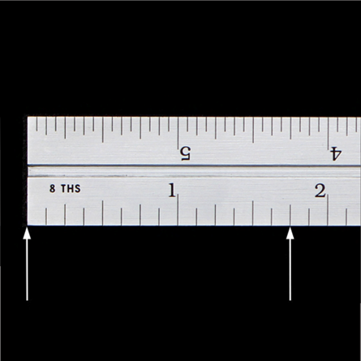
- 6/8"
- 1/8"
- 1 and 6/8"*
- 5/8"
- 1 and 7/8"
Points:1.00

Reading the ruler in the image below, what is the measurement between the two arrows?
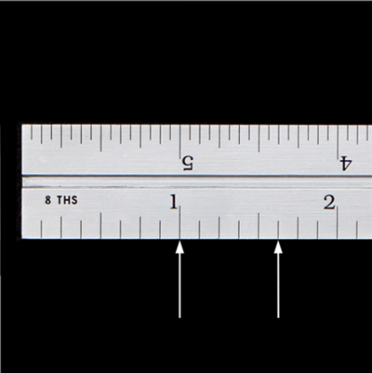

- 1 and 5/8
- 13/8
- 5/8*
- Answers 1 and 2 are correct.
- None of the above.
Points:1.00
Look at the steel rule. What is the measurement between the 2 arrows?
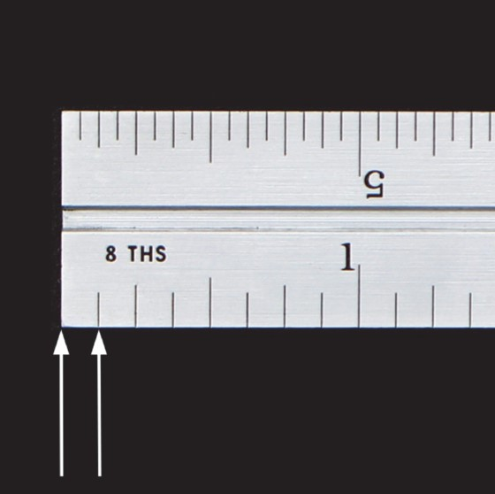
- 1/16'
- 1/32"
- 1/8"*
- 1 and 1/8"
- Answers A and C are correct
points:1.00
Look at the photo and notice which steel rule is shown for the type of measurement. What is the measurement between the 2 arrows?
- 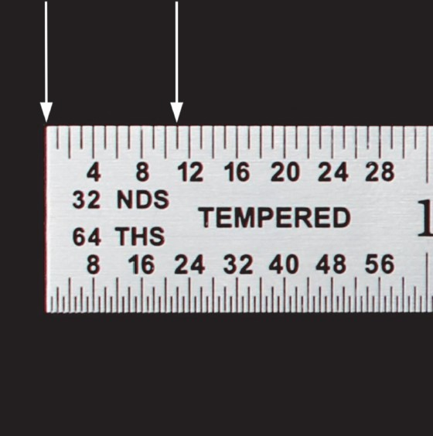
- 1/8"
- 11/8"
- 11/64"
- 10/64"
- 11/32"*
points:1.00
Look at the photo and identify the part name.
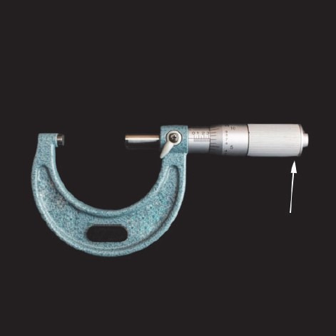
- Lock
- Spindle
- Anvil
- Friction Drive*
- Frame
points:1.00

Look at the photo and identify the part name.
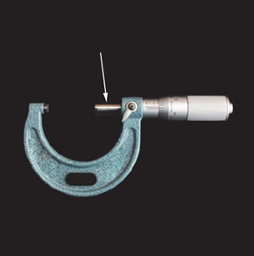
- Thimble
- Spindle*
- Barrel/Sleeve
- Fraction Drive
- Frame
points:1.00

Look at the photo and identify the part name.
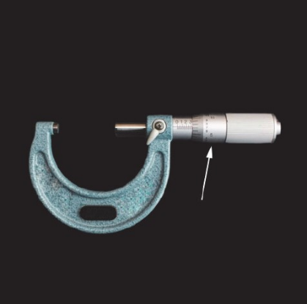
- Thimble*
- Lock
- Barrel/Sleeve
- Anvil
- Frame
points:1.00
Which of the following is not a property of metals?
- Chemical
- Electrical
- Mechanical
- Physical
- Elasticity*
points:1.00

Which of the following are properties of ceramics?
- High melting point
- Resist conducting heat and electricity
- Brittle
- Resist corrosion
- All of the above are properties of ceramics.*
points:1.00

<p>True or false: spark tests are good for differentiating steels that are of different families of steel?</p>
True*
False
points:1.00

Which of the following is not a property of nonferrous metals?
- Good conductivity
- Heavyweight*
- Corrosion resistant
- Strong and better performance at higher temperatures
- All of the above are properties of nonferrous metals
points:1.00

True or false: copper is a good electrical conductor but not a good thermal conductor.
True
False*
points:1.00

What is a low cost tool used to remove oil from the coolant?
- Sump Pump
- Skimmer*
- Throw Out Bearing
points:1.00

Which of the following are CNC jobs?
- CNC Operator
- CNC Setup Person
- CNC Programmer
- CNC Manager
- All of the above are CNC jobs.*
points:1.00

Which button would you press to start a program?
- Cycle Start*
- Override
- Power on
- E Stop
points:1.00

Where do you store the tool and work offsets?
- Off Set Screen
- Off Set Register*
- Machine Screen
- Tool Screen
points:1.00

What button would you press to change the feeds and speeds while the programing is running?
- Parameters
- Feed Adjuster
- Override Button*
- Program Control
points:1.00

What is the max spindle speed with the door open on a Haas Machine?
- 800 RPM
- 700 RPM
- 600 RPM
- 750 RPM*
points:1.00

When setting a tool offset, which button do you press to center the tool over the part.
- Hand Job*
- Zero Reset
- MDI DNC
- List Prog
points:1.00

True or false: a "dial indicator" can be used to see how the true center of the cutter is with respect to the spindle.
True*
False
points:1.00

Every HAAS program must start and end with a certain sign, which one below is that sign?
- #
- +
- %*
- *
points:1.00
The three cutting parameters are [blank], [blank], and [blank].
speed**feed**depth of cut
speed**feed**depth of cut
speed**feed**depth of cut
points:1.00

The three parts of a twist drill are [blank], [blank], and [blank]
shank**body**point
shank**body**point
shank**body**point
points:1.00
Explain the difference between a thermoplastic and a thermosetting plastic?
points:1.00

Explain the difference between a ferrous iron and a nonferrous iron.
points:1.00

What is the difference between a manual machine and a CNC machine?
points:1.00

Why are ball screws so important to the machining process?
points:1.00

What is a turning center?
points:1.00

Describe the proper way to mix coolant.
points:1.00
What is the difference between an open feedback system and a closed feedback system? Also, which is the better option for CNC machines?
points:1.00

