Which of the following is appropriate to wear while working in a manufacturing setting.
- Neck ties
- Scarves
- Jewelry
- Safety glasses*
points:1.00

True or false, it is ok to throw oily rags away into a regular trash can.
True
False*
points:1.00

Which of the following are slip, trip, and fall hazards?
- Cords
- Grease
- Clutter
- Ice
- All of the above are slip, trip and fall hazards.*
points:1.00

Select which of the following are power transmission apparatuses.
- Flywheels*
- Feed mechanisms
- Connecting rods*
- Spindles*
- Rotating parts
- Belts*
points:1.00

What is the reading of this Dial Caliper?
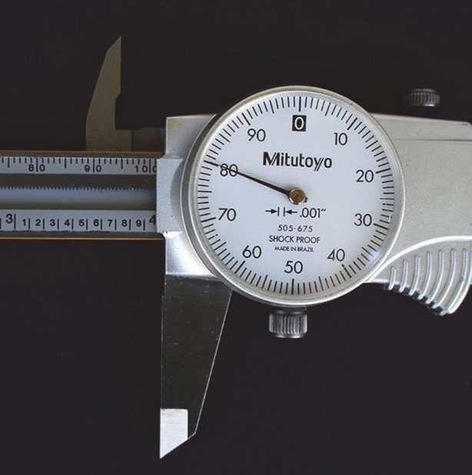
- 5.194'
- 5.000"
- 2.230"
- 5.094"*
points:1.00

A metal that does contain iron is called?
Ferrous*
Nonferrous
points:1.00

True or false: during a bounce test a hard steel will cause the glass bead to bounce higher than a soft steel.
True*
False
points:1.00

An alloy steel with this element may be requested when toughness is necessary.
- Lead
- Copper
- Nickel*
- Aluminum
points:1.00

What ingredients are necessary to refine iron?
- Ore
- Limestone
- Coke
- Air
- All of the above*
points:1.00

After smelting, ore is called?
- Alloy Steel
- Pig Iron*
- Slag
- Steel
points:1.00

What are three jobs associated with a CNC Machine</p>
- Machine Tool Operator
- CNC Operator
- CNC Supervisor
- CNC Programmer
- A, B, and D are jobs associated with a CNC machine*
- A, C, and D are jobs associated with a CNC machine.
points:1.00

What is a low cost tool used to remove oil from the coolant?
- Sump Pump
- Skimmer*
- Throw out bearing
- Full filtration units
points:1.00
An alloy contains [blank] or more metals.
two
points:1.00

The three cutting input parameters are [blank], [blank], and [blank]
speed**feed**depth of cut
speed**feed**depth of cut
speed**feed**depth of cut
points:2.00
What is a turning center?
points:5.00

What features does a CNC Machine have that a Manual Machine does not?
points:5.00

Explain the difference between an open loop system and a closed loop system.
points:5.00

Describe the difference between a CNC operator and a CNC programmer.
points:5.00

Describe the differences between "up milling" and "down milling".
points:5.00
Make readings from the ruler shown below
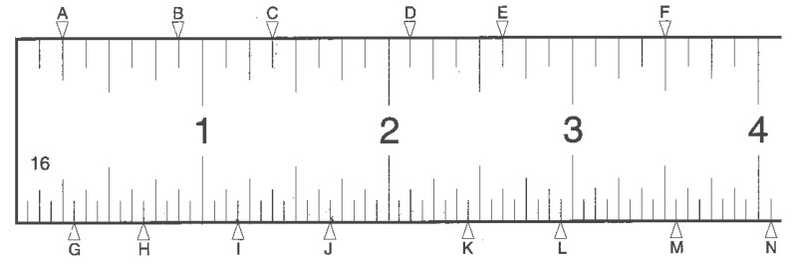
points:14.00

