ATR 112 Final Exam Questions and Answers

What does PLC stand for?
Professional Logic Controller
Programmable Leverage Controller
Programmable Logic Controller*
Programmable Linux Controller
points:1.00

What is the feature of the ControlLogix system that allows modules to be removed from the chassis without powering down?
Processors
Remove and Insert Under Power*
Bonus Modules
I/O Modules
points:1.00

In a RSLogix program, what type of toolbar has features like file operations, searching, and routine verification.
Path Toolbar
Online Toolbar
Control Toolbar
Standard Toolbar*
points:1.00

Which of the following is not a function of the output window?
Viewing Errors
Search results
Reset the program*
View all tags in the current routine
points:1.00

True or False: If the PLC processor is in the run position, editing and downloads are possible.
True
False*
points:1.00

True or False: you would use an RC circuit in an application where clock accuracy is very important.
True
False*
points:1.00

A PMW signal is square-wave?
True*
False
points:1.00

True or False: proportional, integral, derivative (PID) controllers are among the most widely used controllers in industry?
True*
False
points:1.00

Which of the following is not an example of an open loop system?
Washing Machine
Electric Bulb
Air Conditioner*
Inkjet Printer
points:1.00

Which of the following are the two types of closed loop control systems?
Input and Output Feedback Signal
Positive and Negative Feedback Signal*
Start and Stop Feedback Signal
Energized and De-Energized Signal
points:1.00

What part of the mechatronic system is considered the "mind"?
Controller*
Sensors&
Graphical User Interfaces
Drive Circuits
points:1.00

What type of system is the only type applicable to automation?
Open Loop
Closed Loop*
Feedback Loop
Control Loop
points:1.00

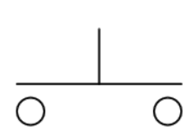
What type of button is shown in the image above?
Normally Closed
Normally Open*
Selector Switch
Temperature Limit Switch
points:1.00

Which of the following is not a factor when choosing a sensor?
Accuracy
Dynamic Range
Sensitivity
Reliability
Solar Powered*
points:1.00

What was the main cause of the worker’s fatality in the July 21, 1984, robot-related incident?
The worker was not trained to operate the robot.
The robot malfunctioned, causing an unexpected movement.
The worker entered the robot's operating range despite warnings and safety barriers.*
The worker was trapped by the robotic arm while performing maintenance.
points:1.00

According to NIOSH, what safety measure is recommended to prevent workers from entering a robot's operational area?
Installing barriers that require key access to open.
Using gates with electrical interlocks to stop robot operation when opened.*
Only allowing maintenance workers access to robotic systems.
Limiting the speed of the robot’s movements during all operations.
points:1.00

What type of interlock device is where the power course of the hazard is directly interrupted due to the movement or opening of the guard?
Control Interlocking
Power Interlocking*
points:1.00

True or False: all hard hats offer electrical protection.
True
False*
points:1.00

Which of the following best describes how a pneumatic actuator works?
It converts electrical energy into mechanical motion using pressurized steam.
It converts energy, typically in the form of compressed air, into mechanical motion.*
It uses hydraulic fluid to create rotary mechanical motion.
It requires ignition or electricity to operate efficiently.
points:1.00

What is the main function of shock absorbers in a vehicle?
To support the vehicle's weight
To provide additional horsepower
To dampen and control the movement of the vehicle's springs*
To adjust the vehicle’s steering automatically
points:1.00

Which type of shock absorber is commonly used in modern vehicles, especially in the front suspension?
Coilover
DSSV damper
MacPherson strut *
Leaf spring
points:1.00

What is the primary function of an indexing table?
To perform drilling operations on large parts
To rotate or index around an axis, stop, dwell, and repeat the process*
To provide manual actuation of a machine tool
To move parts vertically along the Z-axis
points:1.00

Which of the following factors is NOT commonly used to determine which indexing table is best for a particular application?
Mass Moment of Inertia
Repeatability
Allowable Backlash
Maximum table height*
points:1.00

True or False: a contactor is a special type or relay designed to handle heavy power loads?
True*
False
points:1.00

True or False: capacitive proximity sensors will sense metal objects as well as nonmetallic materials?
True*
False
points:1.00

Which type of robot is specifically designed to work alongside humans, assisting with dangerous and repetitive tasks?
Humanoids
Cobots*
Educational robots
AGVs (Automated Guided Vehicles)
points:1.00

Which generation of robots is characterized by being the first to include artificial intelligence, aiming to mimic human beings?
First generation
Third generation
Fourth generation
Fifth generation*
points:1.00

Which component in a standard hobby servo provides feedback for monitoring the position of the output shaft?
DC motor
Potentiometer*
Gearbox
PWM pin
points:1.00

What type of control signal is typically used to control the position, speed, or direction of a hobby servo?
Direct Current (DC)
Pulse Width Modulation (PWM) *
Alternating Current (AC)
Frequency Modulation (FM)
points:1.00

What is the primary method used to control the speed of a DC motor in a circuit?
Adjusting the current
Changing the motor terminals
Pulse Width Modulation (PWM)*
Increasing the motor torque
points:1.00

Which of the following components is used to control the direction of a DC motor?
Resistor
Capacitor
H-Bridge circuit
Diode
points:1.00

What is a key benefit of an Automated Storage and Retrieval System (AS/RS) in a warehouse operation?
Increased manual labor requirements
Improved use of vertical storage space*
Reduced inventory density
Increased conveyor system usage
points:1.00

In a Goods-to-Person (G2P) order picking system within an AS/RS, how is the product retrieved for the worker?
The worker manually picks the product from shelves
The worker walks to each product location to pick the order
A robot or shuttle retrieves and delivers the product directly to the worker*
The product is delivered through a conveyor belt only
points:1.00

Which of the following is an advantage of pneumatic grippers?
High cost
Light weight *
Limited gripping force
Only suitable for large objects
points:1.00

What is the primary difference between parallel and angular pneumatic grippers?
Parallel grippers have more fingers than angular grippers.
Parallel grippers move their fingers radially, while angular grippers move them in a parallel motion.
Parallel grippers move their fingers in a parallel motion, while angular grippers move them radially. *
Angular grippers are used for large objects, and parallel grippers for small objects.
points:1.00

Match the parts of the work-cell with it's definition.
Zone 1 Safe Zone - the area outside of the work-cell: there are no restrictions on human traffic.
Zone 2 Warning Zone - the area inside the work-cell not in reach of the equipment: Only authorized personal are allowed in this zone.
Zone 3 Hazard Zone - the area inside the work-cell that cannot be accessed as long as the equipment is in motion: Access is allowed only during programming or maintenance and only after proper safety measures have been followed.
points:3.00

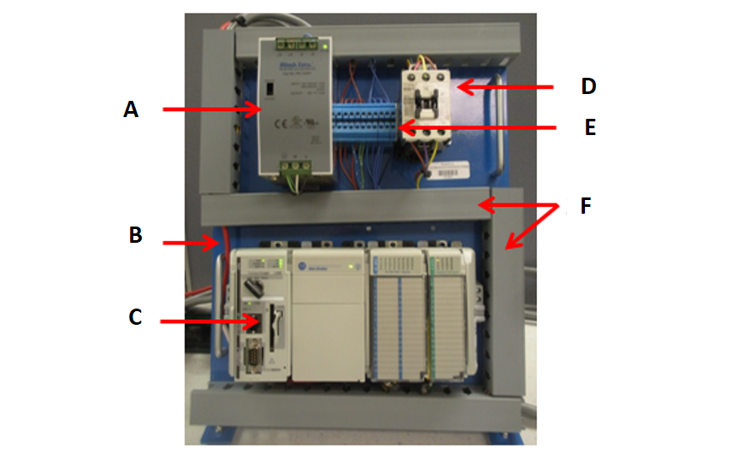
Match the part of the PLC panel with it's corresponding place on the image above.
A - 24 Volt Power Supply
B - Serial Port
C - PLC
D - Master Contactor
E - Terminal Block
F - Wireways
points:1.00

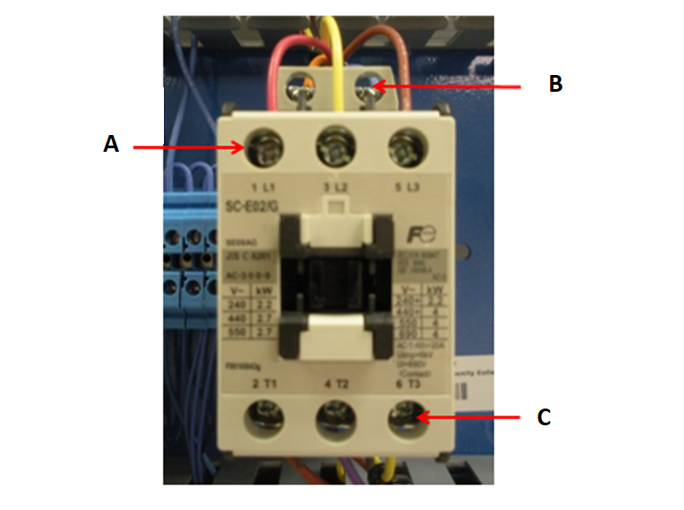
Match the part of the master control relay to it's corresponding place in the image above.
A - Line Terminals
B - Coil Terminals
C - Load Terminals
points:1.00

When looking at a catalog number for an I/O module, what does the I stand for in 1756-IB16D/A?
points:1.00

Explain the differences between an open-loop and closed-loop system?
points:1.00

What are two limitations of open-loop control?
points:1.00

Define what mechatronics is?
points:1.00

What is an actuator?
points:1.00

Describe the difference in a discrete-event system and a feedback control system?
points:1.00

How does a light curtain work?
points:1.00

How does a presence-sensing mat work?
points:1.00

Explain how the process of Lockout/Tagout works?
points:1.00

Describe the process of calibrating an analog sensor.
points:1.00

Describe the difference between normally open and normally closed contacts.
points:1.00

