MNT-110 Intro to Maintenance Procedures Quiz Questions and Answers

Module 1 Quiz Questions and Answers

What does OSHA stand for?
Occupational Safety and Health Administration*
Occupational Standards and Health Administration
Occasional Safety and Health Administration
Occupational Sanitization and Healing Administration
points:1.00

True or False: OSHA requires safety data sheets to communication hazards of chemical products.
True*
False
points:1.00

What type of hazards are discussed on a safety data sheet? (Select all that apply)
Biological Hazards*
Ergonomic Hazards*
Safety Hazards*
Chemical Hazards*
Physical Hazards*
points:1.00

True or False: Lockout/Tagout ensures the system is energized when doing maintenance and repair operation.
True
False*
points:1.00

What type of hard hat is not rated for electrical protection?
Class G
Class C*
Class E
points:1.00

What type of gloves would you wear for welding?
Cloth
Latex
Rubber
Leather*
points:1.00

Which of the following is not a fall protection safeguard?
Safety nets
Handrails
Grab handles
Wet floors*
points:1.00

What is the most common shock-related injury?
Death
Electrical burns*
Falling
Frizzy hair
points:1.00

Which of the following does not usually damage flexible cords?
Aging
Door Edges
Stables
Wind*
Window Edges
points:1.00

Match the electrical term with it's definition:
Current - the movement of electrical charge
Resistance - opposition to current flow
Voltage - a measure of electrical force
Conductors - substances, such as metals, that have little resistance to electricity
Insulators - substances, such as wood, rubber, glass, and bakelite, that have high resistance to electricity
Grounding- a conductive connection to the earth which acts as a protective measure
points:6.00

Define what a pinch point is.
points:1.00

What are the 6Ss in a 6S program?
points:1.00

Upload your word document where you listed the hazards presented in the hazard assignment here.
points:5.00

Module 2 Quiz Questions and Answers

The longer that defects are left unattended to, the more time and expense will incur once the machine is repaired.
True*
False
points:1.00

What are warning signs of a machine breaking down? (Select all that apply)
Change in vibration*
Temperature changes*
Motor current signature*
Oil condition*
points:1.00

The sound of vibration changing is not a warning sign of a machine breaking down
True
False*
points:1.00

What is the correct sequence of steps for a predictive maintenance program?
Setup &gt; Monitoring &gt; Testing &gt; Repair &gt; Scheduling Inspection
Setup &gt; Repair &gt; Scheduling Inspection &gt; Testing &gt; Monitoring
Setup &gt; Testing &gt; Monitoring &gt; Repair &gt; Scheduling Inspection*
Testing &gt; Setup &gt; Monitoring &gt; Scheduling Inspection &gt; Repair
points:1.00

Which of the following is NOT a primary use of ultrasound analysis (UA)?
Leak detection &nbsp;
Mechanical inspection &nbsp;
Employee productivity tracking&nbsp;*
Electrical inspection &nbsp;
points:1.00

What is one of the main advantages of ultrasound analysis (UA) compared to other predictive maintenance (PdM) technologies?
Higher data accuracy &nbsp;
Lower acquisition costs and ease of use&nbsp;*
Ability to detect software issues &nbsp;
Longer equipment lifespan &nbsp;
points:1.00

Which of the following is a primary method used in oil analysis for predictive maintenance?
Visual inspection for contamination and viscosity &nbsp;*
Monitoring employee performance&nbsp;
Analyzing software issues &nbsp;
Testing fuel efficiency &nbsp;
points:1.00

What is one of the benefits of conducting oil analysis as part of a predictive maintenance strategy?
Reducing the need for visual inspections &nbsp;
Early detection of unexpected equipment wear &nbsp;*
Increasing the frequency of oil changes &nbsp;
Improving software performance &nbsp;
points:1.00

Which of the following is a practical task that thermal imaging helps accomplish in preventative maintenance?
Enhancing software performance&nbsp;
Detecting early signs of equipment failure or malfunctions*
Monitoring employee productivity &nbsp;
Reducing material costs &nbsp;
points:1.00

What is one of the main benefits of using thermal imaging in a preventative maintenance program?
Identifying abnormal operating behavior quickly&nbsp;*
Increasing the frequency of oil changes
Enhancing visual inspection capabilities &nbsp;
Improving water content measurement &nbsp;
points:1.00

Which of the following is NOT typically included in a work order letter?
Company name
Work order title &nbsp;
Employee salary details&nbsp;*
Work location &nbsp;
points:1.00

True or False: if gloves are worn during work, an employer must make sure that the hand tools being used can still be gripped easily without risk of slipping?
True*
False
points:1.00

<p>Which of the following is not a common injury from a hand tool:</p>
<p>Severe cuts</p>
<p>Punctures that require stitches</p>
<p>Eye injuries/blindness</p>
<p>Carpal tunnel syndrome</p>
<p>Scrapes and abrasions</p>
Amputations*
points:1.00

What are things to take into consideration when selecting a hand tool? (Select all that apply)&nbsp;
It is designed for the task*
It fits your hand size*
Keeps your wrist straight*
<p>Fits in the workspace available</p>*
<p>Can be used in a comfortable work position</p>*
<p>Requires minimum use of force</p>*
points:1.00

<p>True or False: always inspect hand tools before using them?</p>
True*
False
points:1.00

<p>True or False: it is ok to use hand tools that are rusted.</p>
True
False*
points:1.00

<p>What tool can be used as an alternative to a wrench?</p>
<p>Hex Keys</p>
Sockets*
<p>Screwdrivers</p>
<p>Pliers</p>
points:1.00

<p>What type of wrench is used with sockets?</p>
Torque*
<p>Phillips head</p>
<p>Crescent</p>
<p>Pipe</p>
points:1.00

<p>True or False: every screwdriver with a plastic handle is properly insulated.</p>
True
False*
points:1.00

<p>Which of the following are types of pliers?</p>
Slip-joint&nbsp;*
Lineman's*
<p>Phillips head</p>
<p>Racket</p>
points:1.00

<p>Which of the following is not a type of hammer?</p>
Claw
Ball-peen
Lock jaw*
Brass
Dead-blow
points:1.00

<p>True or False: when working with drills, be sure to unplug it before changing bits</p>
True*
False
points:1.00

<p>Which type of saw is most often used to cut wood?</p>
Circular*
Reciprocating
points:1.00

When using a 3/4th inch hole saw and cutting on aluminum material, what is the RPM you should use?
1800*
690
270
240
points:1.00

True or False: as a general rule, the harder or more brittle the material, the slower you should cut.
True*
False
points:1.00

When using a 3/4th inch hole saw and cutting on ceramic material, what is the RPM you should use?
430
500*
370
210
points:1.00

Explain the difference between proactive maintenance and reactive maintenance.
points:1.00

Upload your preventative maintenance assignment here.
points:5.00
Module 3 Quiz Questions and Answers
What letter designation of blueprint is 8.5x11 in. in size?
A*
B
C
D
points:1.00

True or False: on a title block, scale is a inverse relationship between actual size and size shown.
True
False*
points:1.00

How many views can there by on one drawing?
Three
Four
Five
Six*
points:1.00

True or False: maximum material condition is the size condition containing greatest amount of material within tolerance limits?
True*
False
points:1.00

True or False: each wiring diagram should have a legend/abbreviation page.
True*
False
points:1.00

Match the type of diagram with its definition.
Schematic Diagrams - Shows electrical connections and operation of circuit without showing exact location of each component
Ladder diagram - Shows function of a circuit and resemble a ladder.
Wiring diagrams - Shows arrangement and location of electrical components in a circuit.

What is the purpose of phantom lines?
points:1.00

What is an assembly drawing and what is it's purpose?
points:1.00points:4.00

Module 4 Questions and Answers
Which of the following is not a main thread series in Unified system?
Unified Coarse
Unified Fine
Unified Extra Fine
Unified High Pitch*
points:1.00

True or False unified fine (UNF) series has smaller thread depth than coarse threads.
True*
False
points:1.00

Which of the following thread classes has the greatest tolerance?
2A
2B
1A*
3B
points:1.00

True or False: Bolts are internally threaded fasteners screwed to a nut.
True
False*
points:1.00

Which of the following is not a fastener head type?
Flat Head
Oval Head
Hex Head
Pentagon Head*
points:1.00

Which of the following is not a type of nut?
Hexagonal
Jarn
Jam*
Tee
points:1.00

What is one of the tools you can use to tighten a nut and bolt by hand?
Electric drill
Pliers
Ratchet wrench*
Screwdriver
points:1.00

Which method is recommended to remove a stuck bolt if lubricant and leverage fail?
Heating the bolt *
Using an adjustable wrench
Stabilizing the bolt with pliers
Using a screwdriver
points:1.00

True or False: taper pins position parts and lock them together.
True*
False
points:1.00

Explain the difference between dies and taps.
points:1.00

Upload your maintenance procedure here.
points:5.00

Module 5 Quiz Questions and Answers

Which of the following is a not tool typically used for smaller lifts?
Pry bar
Manual jack
Hydraulic jack
Dolly
Chains*
points:1.00

Which of the following is not a common rope material?
Manila
Nylon
Leather*
Polypropylene
Polyester
points:1.00

According to federal regulations, rope used for rigging must have a safety factor of what?
5:1*
4:1
1:1
3:1
points:1.00

What is creep in rope safety?
Tendency of rope to stretch when load is applied
Tendency of rope to turn when load is applied
Permanent separation of fibers over time*
points:1.00

Every time you use rope you should inspect it for (select all that apply):
Stretch*
Thin areas*
Abrasions*
Chemical exposure*
points:1.00

Every time you use a sling you should inspect it for (select all that apply):
Deformation*
Damage*
Frays*
Kinks*
points:1.00

OSHA mandates sling angles be how many degrees or greater?
50
30*
40
20
points:1.00

True or False: shackles can be used to connect to chains to hooks?
True*
False
points:1.00

What situation would you use shackles for rather than using an eyebolt?
points:1.00

What situation would you use a chain rather than a robe when rigging something?
points:1.00

Module 6 Quiz Questions and Answers
Kinetic energy is measured by what?
Watts
Grams
Joules*
Meters per second
points:1.00

True or False: Potential energy is the stored energy of an object?
True*
False
points:1.00

What is a measure of force applied to unit area?
Torque
Pressure*
Voltage
Work
points:1.00

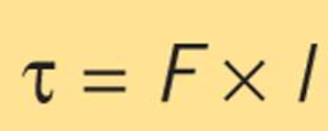
What calculation is the above image for?
Pressure
Power
Torque*
Potential Energy
points:1.00

True or False: more power is required to do work in shorter time.
True*
False
points:1.00

True or False: levers are defined by the position of fulcrum, output force, and load.
True
False*
points:1.00

Screws convert ________ torque to output force.
Input*
Output
Clockwise
Counter clockwise
points:1.00

What is the definition of energy?
points:1.00

What are the three classes of levers?
points:1.00

What is the difference between static friction and kinetic friction?
points:1.00

Upload your PM schedule for the mill here.
points:1.00

Upload your lathe PM schedule here.
points:1.00

Module 8 Quiz Questions and Answers

Which of the following is not a fact about bearings?
They are mechanical components that supports moving parts
They reduce friction and restrict motion
Inside parts supports moving parts
Can be used for insulation*
points:1.00

True or False: ball bearings and roller bearings are types of rolling-element bearings.
True*
False
points:1.00

True or False: angular-contact bearings are the most common type of bearings.
True
False*
points:1.00

When removing bearings from packaging, you should:
Not clean or spin with pressurized air
Not lubricate prior to installation
Clean with pressurized air*
Not compromise cleanliness
points:1.00

What is one of the primary functions of bearing lubrication?
To increase friction between moving parts
To separate moving parts to prevent wear and tear*
To eliminate the need for maintenance
To replace the need for bearings
points:1.00

Which type of lubricant is generally used for high-speed or high-temperature applications?
Grease
Water
Oil*
Powder
points:1.00

What is the percentage of bearing applications that typically use grease as a lubricant?
10-20%
30-40%
50-60%
80-90%*
points:1.00

Which of the following is NOT a method for bearing lubrication mentioned in the text?
Drip feed lubrication
Oil splash feed lubrication
Water mist lubrication*
Force feed lubrication
points:1.00

What is a common mistake that can lead to bearing failure?
Using the correct amount of lubricant
Over- and under-lubrication*
Regularly monitoring lubrication levels
Using a compatible lubricant
points:1.00

What is the difference between a thrust bearing and a needle bearing?
points:1.00

Upload your bearing research assignment here.
points:1.00

Module 9 Quiz Questions and Answers

What material are shafts not typically available in?
Plastics
Ceramics
Steels
Clay*
points:1.00

True or false: checking for shaft runout is the easiest way to find bent or bowed shafts?
True*
False
points:1.00

Which of the following is not a factor that affects shaft tolerance?
Type of load
Type of bearing
Material of load*
Shaft diameter
points:1.00

A pillow block does what (select all that apply)
Houses bearings*
Supports rotating shafts*
Conduct electricity
Provides structural integrity to a machine
points:1.00

True or False: ball and roller bearings are self-aligning.
True
False*
points:1.00

Which of the following is not used to accomplish bearing-to-shaft fit?
Setscrews
Eccentric locking collar
Hammering*
Tapered adapter sleeve
points:1.00

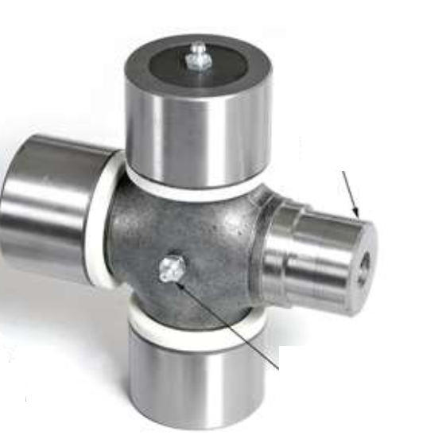
What type of joint/bearing is shown in the image above?
Universal Joint*
Ball Bearing
Cylindrical Bearing
Ball and Roller Bearing
points:1.00

True or False: couplings connect two shafts.
True*
False
points:1.00

What material are flexible couplings not made of?
Metal
Plastic
Wood*
Rubber
points:1.00

What do you check a baseplate for during a prealignment check? (select all that apply)
Cracks*
Voids*
Levelness*
Debris*
points:1.00

Which of the following alignment tools is inserted between the baseplate and machine's foot to achieve level?
Dial indicator
Shims*
Friction clamps
Machinist rule
points:1.00

During initial alignment the most important aspect is to get motor and driven machine as parallel as possible?
True*
False
points:1.00

What is the purpose of a universal joint?
points:1.00

How does a gear coupling work different compared to other couplings?
points:1.00

What is soft foot?
points:1.00

Module 10 Quiz Questions and Answers

Which of the following is not an advantage of belt drives?
Less regular maintenance
Easier to replace
Can be used over a wide range of speeds
Can be over tensioned without placing excess load on bearings*
points:1.00

Which of the following is not a type of belt?
V-belt
Double-side belt
Flat belt
Full belt*
points:1.00

True or false: for a process that requires running at a higher speed, you would use a synthetic belt?
True*
False
points:1.00

What is a sheave?
A type of pulley
A type of belt
The wheel component of a pulley
A type of conductor
points:1.00

Which of the following is not a sheave type discussed in the lecture?
Single-belt sheave
Copper belt sheave*
Multiple-belt sheaves
Variable-speed sheaves
points:1.00

Which of the following are considerations when designing a drive? (select all that apply)
Application*
Speed of drive and driven machine*
Distance between pulleys*
Material the pulley made out of
points:1.00

Ture or False: you can store belts on a shelf that gets hit by direct sunlight?
True
False*
points:1.00

True or False: when storing belts, be sure to keep them away from ozone-producing machinery?
True*
False
points:1.00

Which of the following is a main method of lubrication for chains?
Oil bath*
Water flinger
Grease bath
Water bath
points:1.00

True or false: gear backlash is side-to-side clearance between mating teeth.
True*
False
points:1.00

What type of machinery would you use a flat belt for?
points:1.00

What is the difference between dynamic balance and static balance?
points:1.00

What is a leaf chain?
points:1.00

What circumstances would you use a silent chain in?
points:1.00

Module 11 Quiz Questions and Answers

What is ductility?
Ability to deform without breaking*
Resistance to penetration
Measure of stress applied
Tendency to fracture
points:1.00

What is hardness?
Tendency to fracture
Resistance to penetration*
Ability to deform without breaking
Measure of stress applied
points:1.00

In a stress-strain curve, which value is shown on the Y axis?
Stress*
Strain
points:1.00

What is resolution?
How close measurement is to standard value
How well system reproduces an established outcome
Smallest increment system can measure/recognize*
Largest increment system can measure/recognize
points:1.00

True or False: Corrosion is the deterioration of metal components.
True*
False
points:1.00

What is natural frequency in machinery vibration analysis?
Speed at which rotating element reaches resonance
Measure object vibration with damping
Measure object vibration without damping*
The output force of an object
points:1.00

True or False: it is impossible to apply too much lubrication to machine parts?
True
False*
points:1.00

Which of the following is not a signifier of improper initial installation of a machine part?
Excessive piping strain
Improperly seated bearings
Long-term alignment problems
Excessive documentation*
points:1.00

Describe how the stress-strain curve works?
points:1.00

Describe how the bathtub curve works?
points:1.00

What is the difference between adhesive wear and corrosive wear?
points:1.00

Describe the procedure of measuring shaft speed?
points:1.00

Module 12 Quiz Questions and Answers
True or False: in pneumatic systems air treatment removes moisture?
True*
False
points:1.00

In a water/oil separator, what is the air filtered through?
Carbon
Zeolite*
Sand
Pebbles
points:1.00

True or False: secondary air treatment takes place after point of use?
True
False*
points:1.00

Which of the following is not true of single-state compressors?
Draws in standard-pressure air
Discharges compressed air
Air passes through intercooler between stages*
One or more pistons driven by same shaft
points:1.00

True or False: rotary compressors are designed for constant use.
True*
False
points:1.00

True or False: you do not have to do lockout/tagout when working with motors?
True
False*
points:1.00

Which of the following are signs of compressor failure? (Select all that apply)
Excessive heat generation*
Little to no vibration
Excessive noise*
Consistent noise
points:1.00

True or False: you should check lubrication levels at least every 500 hours.
True*
False
points:1.00

How do air compressors increase air pressure?
points:1.00

Describe how a directional flow regulator works?
points:1.00
Upload your completed maintenance procedure here.
points:5.00

Module 13 Quiz Questions and Answers
Which of the following statements is true about mass and weight?
Mass is dependent on its location, while weight is independent of location.
Weight is the amount of matter of an object, while mass is the force due to gravity.
Mass is the amount of matter of an object and is independent of its location, while weight is dependent on its location.*
Weight is measured in units of mass, while mass is measured in units of weight.
points:1.00

An object weighs 1000 pounds. Given that the acceleration due to gravity is 32.2 ft/s², what is the mass of the object in slugs?
31.06 slugs*
32.2 slugs
1000 slugs
2000 slugs
points:1.00

Which of the following is true about laminar flow?
It occurs when the fluid flows in parallel layers with no disruption between the layers.*
It is also known as chaotic flow.
It involves rapid variation of pressure and velocity of the fluid.
It is a good way to transfer thermal energy.
points:1.00

How many ports does a four-way control valve have?
One
Two
Three
Four*
points:1.00

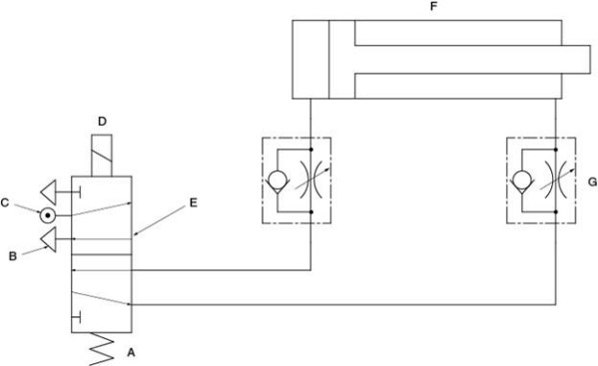
Identify the components on a schematic drawing of a pneumatic system.
A - Spring
B - Exhaust port
C - Air pressure inlet
D - Solenoid
E - Directional control valve
F - Cylinder actuator
G - Flow control valve
points:1.00
Module 14 Quiz Questions and Answers
What do pumps do in a hydraulic system?
Convert fluid energy into motion
Transfer energy into fluid/move fluid through system*
Store fluid
Control the hydraulic system
points:1.00

Which of the following is not something a reservoir removes from hydraulic fluid?
Heat
Air
Moisture
Plasma*
points:1.00

True or False: a reservoir can serve as a secondary cooling system for a hydraulic system?
True*
False
points:1.00

Which of the following is not a typical reservoir design?
Horizontal
Vertical
I-Shape*
L-Shape
points:1.00

True or False: you do not need to utilize lockout/tagout when servicing a hydraulic system?
True
False*
points:1.00

Which of the following is a sign of a possible pump problem?
Excessive noise*
Little to no particles in filter after pump
Consistent output power
Consistent discharge pressure
points:1.00

True or False: directional control valves control flow of fluid into paths?
True*
False
points:1.00

True or False: varnishing is the accumulation of fine particles in a valve?
True
False*
points:1.00

What do hydraulic cylinders do?
Convert fluid energy to liminal motion
Convert fluid energy to linear motion*
Convert fluid energy to parallel motion
Convert fluid energy to potential motion
points:1.00

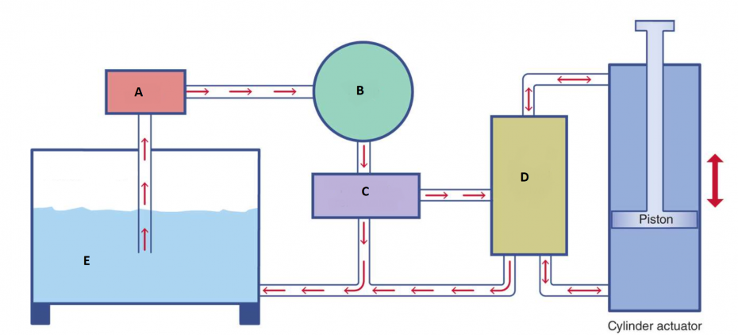
Match the part of the hydraulic system with the letter above that matches it's location in a typical system.
A - Filter
B - Pump
C - Pressure Relief Valve
D - Control Valve
E - Reservoir Tank
points:1.00

What is the purpose of a sacrificial anode?
points:1.00

How does a pressure-compensated van pump work differently than other hydraulic pumps?
points:1.00

