MNT-110 Intro to Maintenance Procedures Mid-Term Exam

True or False: when it comes to worker safety, the EPA and NIOSH work in conjunction with OSHA.
True*
False
points:1.00

Which of the following is not a hazard type that is reported on a safety data sheet?
Biological
Ergonomic
Safety
Psychological*
Physical
points:1.00

Lockout/Tagout procedures do what to sources of energy during equipment maintenance?
Amplify
Isolate*
Conducts
Lessens
points:1.00

True or False: lockout/tagout only deals with electrical energy.
True
False*
points:1.00

A ________ point is where two mechanical parts come together?
Punch
Pluck
Pinch*
Pass
points:1.00

True or False: when grinding metal, you should wear eye protection.
True*
False
points:1.00

Which class of hard hates does not offer electrical protection?
C*
G
E
points:1.00

What type of gloves do you wear while welding?
Latex
Cloth
Rubber
Leather*
points:1.00

Which of the items below is not part of fall protection?
Guardrail systems
Safety nets
Stair rails with no handrails*
Grab handles
points:1.00

True or False: all fire extinguishers can be used on all types of fires?
True
False*
points:1.00

Which of the following is not one of the S's in a 6S program?
Sort
Set to order
Sanitize*
Shine
Standardize
Sustain
Safety
points:1.00

What is the definition of electrocution?
Non-fatal electrical injury
Electrical shock without injury
Death due to electrical shock*
Fall caused by electrical shock
points:1.00

Which of the following substances is considered an insulator?
Copper
Aluminum
Rubber*
Steel
points:1.00

What does the Ground-Fault Circuit Interrupter (GFCI) protect you from?
Overheating
Electrical shock*
Voltage fluctuation
High resistance
points:1.00

What is one of the main advantages of ultrasound analysis (UA) compared to other predictive maintenance (PdM) technologies?
Higher accuracy
Lower acquisition costs and ease of use*
Longer data collection period
Requires extensive training
points:1.00

How does ultrasound analysis (UA) help in the maintenance of steam systems?
By increasing steam production
By monitoring steam temperature
By replacing faulty steam traps automatically
By detecting leaks and inefficiencies in steam traps*
points:1.00

Which of the following is NOT a primary method used in oil analysis for predictive maintenance?
Condition-based monitoring
Visual inspection for contamination and viscosity
Fluid property inspection
Thermal imaging*
points:1.00

Which of the following is NOT a practical task that thermal imaging helps accomplish in preventative maintenance?
Detect early signs of equipment failure or malfunctions
Monitor operating conditions over time
Improve visual inspections with human*
Spot abnormalities quickly
points:1.00

What is the primary purpose of a work order letter?
To request a meeting with a client
To formally request work to be completed*
To advertise company services
To update employees on company policies
points:1.00

Which of the following should NOT be included in a work order letter?
Company name
Work order number
Detailed company financials*
Work location
points:1.00

True or False: scale is the proportional relationship between actual size and size show.
True*
False
points:1.00

How many views can be in a multiview drawing?
Six*
Five
Four
Three
points:1.00

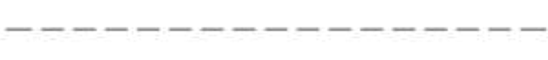
What type of line is shown above?
Object Line
Center Line
Section Line
Hidden Line*
points:1.00

Which of the following are reasons GD&T is utilized?
Clarifies relationships between features*
Helps verify that parts meet functional requirements
Used in conjunction with standard dimensioning and tolerancing practices
Places emphasis on function and relationship of features
points:1.00

What does UNF mean for thread series in unified system?
Unified Coarse
Unified Extra Fine
Unified Constant Pitch
Unified Fine*
points:1.00

True or False: you screw a nut to a bolt.
True*
False
points:1.00

Which tool is recommended for tightening nuts and bolts when using an electric power tool?
Adjustable wrench
Impact drill*
Ratchet wrench
Torque wrench
points:1.00

What is one method suggested for removing a stuck bolt?
Using a plastic washer
Applying penetrating oil*
Tightening it further
Using a smaller wrench
points:1.00

True or False: Dollies are used for larger lifts
True
False*
points:1.00

True or False: kinetic energy is stored energy of an object.
True
False*
points:1.00

What is a measure of force applied to unit area.
Pressure*
Force
Work
Power
points:1.00

What is the difference between proactive and reactive maintenance?
points:1.00

What is the purpose of object lines?
points:1.00

What is the purpose of a break line?
points:1.00

What types of circuits do fluid power circuit diagrams identify?
points:1.00

Define what energy is.
points:1.00

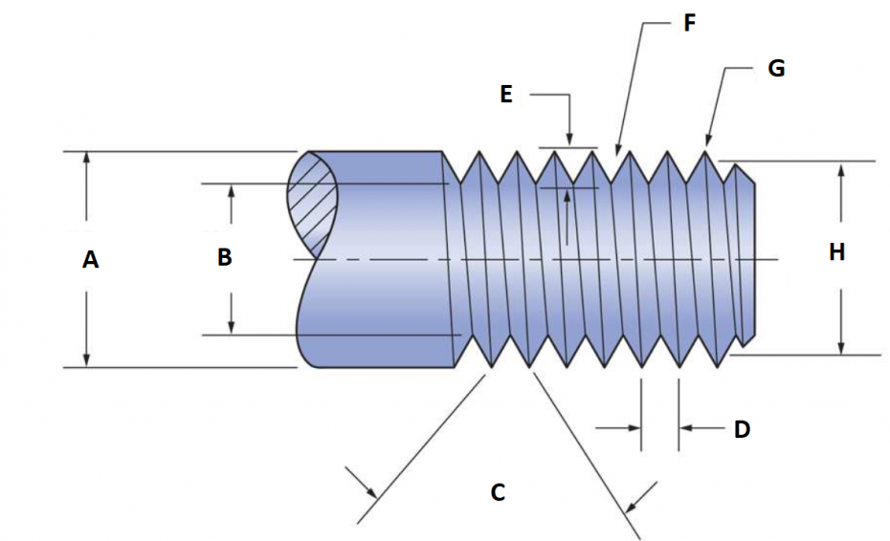
Match the part of the thread terminology with it's matching letter/location on the image above.
A - Major Diameter
B - Minor Meter
C - Thread Angle
D - Pitch
E - Thread Depth
F - Root
G - Crest
H - Pitch Diameter
points:1.00

