MNT-110 Intro to Maintenance Procedures Final Exam Questions and Answers

What type of information is not found on a safety data sheet?
Biological hazards
Ergonomic hazards
Financial hazards*
Safety hazards
points:1.00

Which of the following is not an ergonomic hazard?
Repetitive motions
Awkward postures
Chairs with lumbar support*
Heavy lifting
points:1.00

True or False: Lockout/Tagout processes isolate sources of energy from equipment during maintenance and repair operations.
True*
False
points:1.00

What is a point where two mechanical parts come together?
Punch points
Pinch points*
Crush points
Clamp points
points:1.00

True or False: all types of hard hats offer electrical protection?
True
False*
points:1.00

What situations would you wear eye protection for? (Select all that apply)
Grinding*
Welding operations*
Working with chemicals*
Punching in a timecard
points:1.00

Which of the following is considered fall protection?
Safety nets*
Slippery floors
Shoes with no traction
Cluttered floors
points:1.00

Which of the following is NOT one of the four main types of electrical injuries?
Electrocution
Electrical shock
Burns
Asphyxiation*
points:1.00

Which term describes substances such as metals that have little resistance to electricity?
Insulators
Conductors*
Grounding materials
Resistors
points:1.00

What severity factors affect the impact of an electrical shock on the body?
Path of current through the body, amount of current, length of time in the circuit*
Temperature, humidity, body mass
Voltage, distance from the source, body fat percentage
Blood pressure, heart rate, respiratory rate
points:1.00

What type of electrical injury is most common and typically occurs on the hands?
Electrocution
Electrical shock
Burns*
Falls
points:1.00

Which of the following is not one of the S's in the 6S methodology?
Sorting
Shining
Sanitizing*
Safety
Sustaining
points:1.00

True or False: standard operating procedures (SOPs) are established and accepted method for performing tasks
True*
False
points:1.00

Which of the following is not a rule of hand tool safety?
Use the correct and right size tool for the job
Pass tools to others handle last*
Cut away from your body
Wear the appropriate personal protective equipment
points:1.00

Which of the following is not a type of hammer?
Claw hammer
Clam hammer*
Brass hammer
Ball-peen hammer
points:1.00

What is the correct sequence of steps for a predictive maintenance program?
Setup > monitoring > testing > repair > scheduling inspection
Set up > repair > scheduling inspection > testing > monitoring
Setup > testing > monitoring > repair > scheduling inspection*
Testing > setup > monitoring > scheduling inspection > repair
points:1.00

Which of the following is a primary method used in oil analysis for predictive maintenance?
Visual inspection for contamination and viscosity*
Monitoring employee performance
Analyzing software issues
Testing fuel efficiency
points:1.00

Which of the following tools would you use to tighten a nut and bold by hand?
Electric drill
Pliers
Ratchet wrench*
Screw driver
points:1.00

Which of the following is not a tool typically used for smaller lifts?
Pry bar
Manual jack
Hydraulic jack
Dolly
Chains*
points:1.00

What is creep in rope safety?
Tendency of rope to stretch when load is applied
Permanent separation of fibers over time;*
Tendency of rope to turn when load is applied
points:1.00

Which of the following is not a common rope material?
Manila
Nylon
Leather*
Polypropylene
Polyester
points:1.00

True or False: energy is defined as the capacity to do work.
True*
False
points:1.00

True or False: potential energy is the stored energy of an object
True*
False
points:1.00

What is defined as a measure of force applied to unit area?
Pressure*
Force
Kinetic energy
Torque
points:1.00

True or False: screws convert output torque to input force?
True
False*
points:1.00

Which of the following is not true regarding bearings?
They reduce friction and restrict motion
They support moving parts
Inner part is secured to the non-moving machine part&nbsp;*
Inside part supports the moving machine part
points:1.00

True or False: ball bearings are the most common type of bearing.
True*
False
points:1.00

True or False: needle bearings are used where space is restricted and high load-carrying capacity is needed.
True*
False
points:1.00

What are some functions of bearing lubrication?
Protecting surfaces from corrosion
Sealing against contaminants
Creating a barrier between rolling contact and sliding surfaces
All of the above*
points:1.00

Why is grease often preferred over oil as a lubricant for bearings?
Grease is cheaper than oil
Grease adheres to bearing surfaces better and has a longer lifespan*
Grease requires more maintenance than oil
Grease is less effective in high-speed applications
points:1.00

Which method of lubrication involves oil being distributed by wicking or submerging?
Drip feed lubrication
Splash feed lubrication
Force feed lubrication
Splash method*
points:1.00

What is the primary reason for using proper tools and techniques during bearing installation?
To save money on tools
To shorten the installation time
To achieve the full service life of the bearing*
To reduce noise during operation
points:1.00

Which method is NOT recommended for removing a failed bearing due to the potential for causing damage?
Using a puller
Using an arbor press
Using a high-speed cut-off tool carelessly*
Using a hydraulic press
points:1.00

What material are shafts not typically available in?
Plastics
Ceramics
Steels
Clay*
points:1.00

Which of the following is not a factor that affects shaft tolerance?
Type of load
Type of bearing
Material of load*
Shaft diameter
points:1.00

True or False: couplings connect two shafts.
True*
False
points:1.00

What are the advantages of belt drives over other methods of power transmission? (Select all that apply)
Usually easier to replace*
Have a very long life when properly aligned*
Can be stored anyway with no special considerations
Immune to environmental elements
points:1.00

What is not a type of belt?
V-Belt*
W-Belt*
Flat Belt
Double-Sided
points:1.00

Which of the following is a main method of lubrication for chains?
Oil bath&nbsp;*
Water flinger
Grease bath
Water bath
points:1.00

What is ductility?
Ability to deform without breaking*
Resistance to penetration
Measure of stress applied
Tendency to fracture
points:1.00

What is hardness?
Tendency to fracture
Resistance to penetration*
Ability to deform without breaking
Measure of stress applied
points:1.00

Which of the following is not a signifier of proper alignment of a machine?
The machine is level
Shafts coupled together are aligned
Lack of tension in chains or belts*
No excessive noise or vibration after equilibrium
points:1.00

During regular downtime what is something a technician might not do?
Evaluate equipment and maintenance records
Step inside the machine while it is running*
Fix and replace deteriorated equipment
Enter in data in management system
points:1.00

What is not something that happens during air treatment?
Moisture is added*
Moisture is removed
Removes heat
Removes particulate contamination
points:1.00

Which of the following is not true of single-state compressors?
Draws in standard-pressure air
Discharges compressed air
Air passes through intercooler between stages*
One or more pistons driven by same shaft
points:1.00

True or False: you do not have to do lockout/tagout when working with motors?
True
False*
points:1.00

True or False: a reservoir can serve as a secondary cooling system for a hydraulic system?
True*
False
points:1.00

Match the type of diagram with its definition.
Schematic Diagrams - Shows electrical connections and operation of circuit without showing exact location of each component
Ladder diagram - Shows function of a circuit and resemble a ladder.
Wiring diagrams - Shows arrangement and location of electrical components in a circuit.
points:1.00

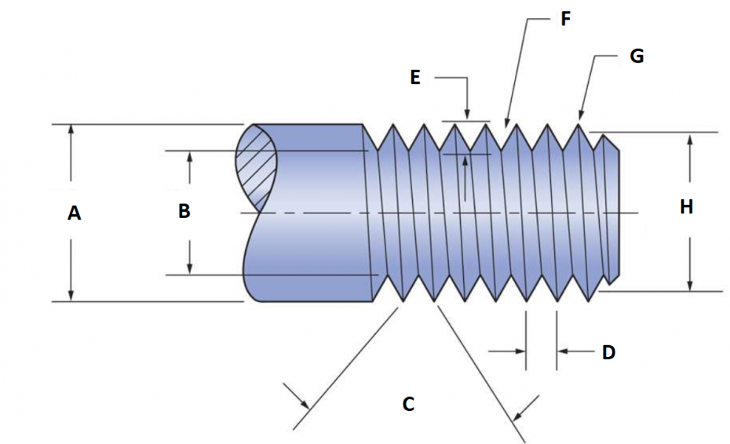Match the part of the thread terminology with it's matching letter/location on the image above.
A - Major Diameter
B - Minor Meter
C - Thread Angle
D - Pitch
E - Thread Depth
F - Root
G - Crest
H - Pitch Diameter
points:1.00

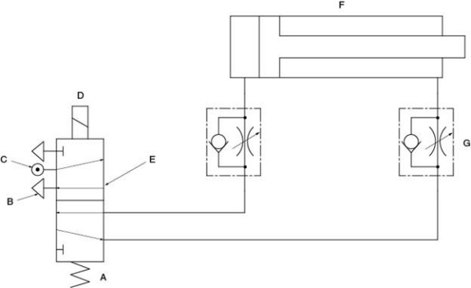
Identify the components on a schematic drawing of a pneumatic system.
A - Spring
B - Exhaust port
C - Air pressure inlet
D - Solenoid
E - Directional control valve
F - Cylinder actuator
G - Flow control valve
points:1.00

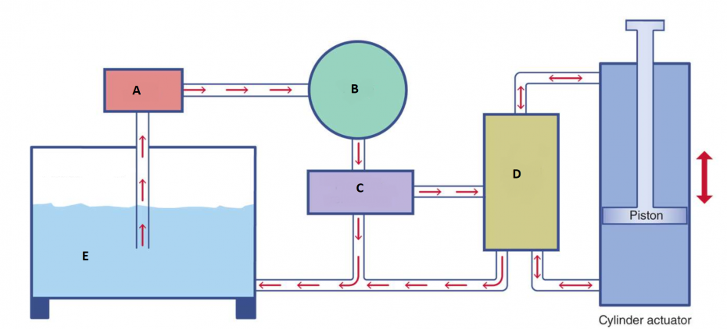
Match the part of the hydraulic system with the letter above that matches it's location in a typical system
A - Filter
B - Pump
C - Pressure Relief Valve
D - Control Valve
E - Reservoir Tank
points:1.00

Describe the differences between reactive and proactive maintenance?
points:1.00

What does a hex key do?
points:1.00

What is soft foot?
points:1.00

What is a sheave to a pulley?
points:1.00

