ELC-117 Mid-Term Exam

True or False: all matter consists of atoms.
True*
False
points:1.00

Which of the following is not part of an atom?
Proton
Neutron
Electron
Molecule*
points:1.00

What part of the atom has no electrical charge?
Proton
Neutron*
Electron
Nucleus
points:1.00

True or False: an insulator is a material with an atomic structure that allows few free electrons to pass through it.
True*
False
points:1.00

What is the opposition to the flow of electrons?
Conductance
Amperage
Resistance*
Electricity
points:1.00

What type of power is power absorbed and returned to a load due to its inductor and/or capacitive properties?
Potential Power
Reactive Power*
Kinetic Power
Left Over Power
points:1.00

What type of drawing is a drawing that shows the length, height, and depth of an object in one view?
Pictorial Drawing*
Orthographic Drawing
Blueprint
Sketch
points:1.00

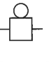
What type of alarm is shown by the image above?
Horn
Buzzer
Bell*
points:1.00

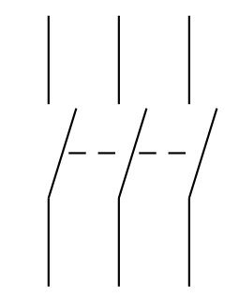
What does the above symbol show?
Disconnect*
Circuit Interrupter
Circuit Breaker With Thermal Oil
Normally Open Limit Switch
points:1.00

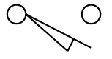
What type of limit switch is shown above?
Held Open
Held Closed
Normally Closed
Normally Open*
points:1.00

Which of the following is not a safety rule for electrical power tools?
Review and understand all manufacturer safety recommendations
Clean and lubricate all tools as needed
Ensure that the workpiece is free of obstructions and securely clamped
It is fine to use a power tool with a frayed power cord*
points:1.00

Which of the following is not a type of wrench?
Open-end
Adjustable end
Hammerhead*
Box End
points:1.00

Which of the following is not a type of pliers?
Needle Nose
Groove
Flat nose
Open End*
points:1.00

True or False: safety glasses cover the entire face with a plastic shield.
True
False*
points:1.00

Which of the following is not something a load converts electrical energy to?
Motion
Sound
Light
Dark*
points:1.00

Which of the following is not a logic function?
AND
OR
SORT*
NOR
points:1.00

True or False: Jogging is the frequent starting and stopping of a motor for short periods of time.
True*
False
points:1.00

A solenoid is an electric output device that converts electrical energy into a linear _____________ force?
Mechanical*
Fluid
Electrical
Heat
points:1.00

Which of the following is not a selection method for solenoids
Push or Pull
Required Force
Mounting
Centrifugal Force*
points:1.00

Define what a semiconductor is.
points:1.00

Describe the difference between potential energy and kinetic energy.
points:1.00

What is a series connection?
points:1.00

Describe the molecular theory of magnetism?
points:1.00

What is a continuity tester?
points:1.00

What type of test instrument shows a visual display of the measured value?
points:1.00

Define electrical shock?
points:1.00

What is the difference between a danger signal word and a warning signal word?
points:1.00

Except in an emergency, who is allowed to remove a lockout and/or tagout device?
points:1.00

Define confined space?
points:1.00

When in industry is OR logic used?
points:1.00

How is a lamp added into a control circuit so it is ON anytime the motor is ON?
points:1.00

What is a flush button operator?
points:1.00

What is a limit switch?
points:1.00

What type of limit switch actuator allows detection of a moving object from any direction except head on?
points:1.00

Is a diode used to help protect electrical contacts in a AN or DC load switching circuit?
points:1.00

