ELC-128 Final Exam Questions and Answers

True or False: PLCs are equipped with input/output interfaces and a control programming language.
True*
False
points:1.00

True or False: it is harder to change a program in a PLC than to wire and rewire a circuit.
True
False*
points:1.00

Which of the following is not part of the scan cycle?
Read inputs
Execute program
Update outputs
Delete outputs*
Diagnostics &amp; communication
points:1.00

Which of the following is not an output device?
Motor starters
Solenoid valves
Indicator lights
Motor stoppers*
points:1.00

Which type of control management system involves one PLC controlling one process?
Single-ended*
Multitask
Control management
Single-sided
points:1.00

What is the name of the hardware assembly that houses I/O modules, processor modules, and power supplies?
Logical rack
Chassis*
Processor rack
Module holder
points:1.00

True or False: Discrete output modules are used to turn field output devices either on or off.
True*
False
points:1.00

What numbers are used in the binary system?
1 and 0*
1 and 2
2 and 0
3 and 4
points:1.00

Which numbering system uses both numbers and letters?
Binary
Decimal
Octal
Hexadecimal*
points:1.00

Which of the following is not a logic function?
AND
NOT
OR
STOP*
points:1.00

True or False: hardwired logic is fixed and changeable only by altering the way devices are electrically interconnected?
True*
False
points:1.00

Which of the following is not a part of determining scan time?
Speed
Length
Type
True/False
Open/Closed*
points:1.00

True or False: output branching allows a true logic path to control multiple outputs?
True*
False
points:1.00

True or False: an internal output does directly control an output device?
True
False*
points:1.00

What does MCR stand for in a PLC?
Master Control Rod
Manual Control Reset
Master Control Reset*
Manual Control Rod
points:1.00

The difference between standard and safety PLCSs is that safety PLCs are designed to be _____________ and ___________.
Fault tolerant and fail-safe*
Fault tolerant and fool proof
Fail-safe and automatically energized
Fail-safety and manually operated
points:1.00


What type of contact is shown in the symbols above?
Normally open, timed closed contact*
Normally closed, timed open contact
Normally open, timed open contact
Normally closed, timed closed contact
points:1.00

True or False: another name for an on-delay timer is DOE (delay on energize)
True*
False
points:1.00

Which of the following is not a common PLC timer instruction?
On-delay timer (TON)
Off-delay timer (TOF)
Retentive timer on (RTO)
Retentive timer stop (RTP)*
points:1.00

True or False: accumulated time is the intervals that the timers time out at?
True
False*
points:1.00

True or False: the Enable (EN) bit is true whenever the accumulated value of the timer is changing?
True
False*
points:1.00

True or False: PLC counter instructions do not operate on an internal clock.
True*
False
points:1.00

Up counts are used to count __________
false to true transitions*
true to false transitions
points:1.00

Count-Up (CU) enable bit is true whenever the count-down counter instruction is true?
True
False*
points:1.00

Down-counters will count down or decrement by 1 each time the counted event occurs?
True*
False
points:1.00

True or False: NO (Normally Open) contacts are open when the coil is de-energized and closed when the coil is energized.
True*
False
points:1.00

A contactor is a special type of relay designed to handle what?
Light power loads
Heavy power loads*
Multiple power loads
Multiple power relays
points:1.00

What type of settings do dual in-line packages use?
Hexadecimal
Decimal
Binary*
Octal
points:1.00

Inductive proximity sensors are used to detect what types of metals?
Ferrous only
Nonferrous only
Both ferrous and nonferrous*
No metals
points:1.00

True or False: capacitive proximity sensors can sense both metal and nonmetallic objects.
True*
False
points:1.00

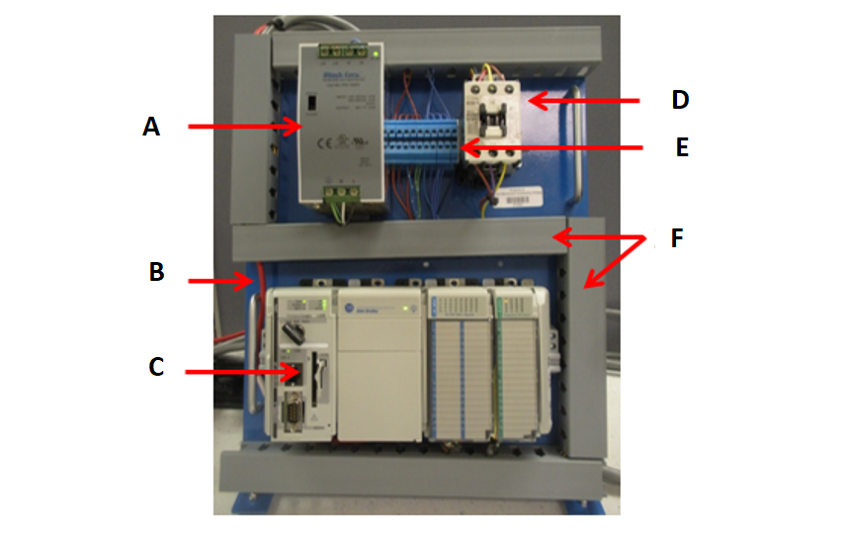Match the PLC control panel part with it's corresponding letter placement from the picture above.
A - 24 Volt Power Supply
B - Serial Port
C - PLC
D - Master Contactor
E - Terminal Block
F - Wireways
points:1.00

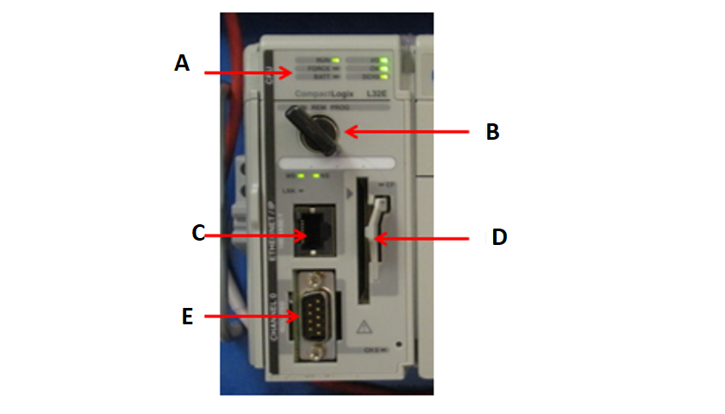Match the part of the PLC processor module to the letter that indicates it's position in the image above.
A - Status Indicators
B - Mode Selector Switch
C - Ethernet Port
D - Memory Card Receptacle
E - Serial Port
points:1.00

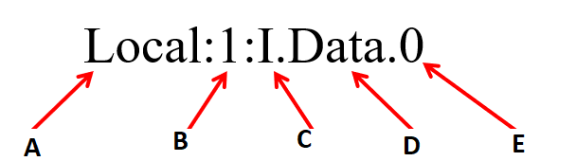Match the part of the tag name to it's location as indicated by the letter above.
A - Location
B - Slot Number
C - Type
D - Member
E - Bit
points:1.00

Analog I/O modules use a ______________ addressing format?
points:1.00

Explain the difference between nonvolatile and volatile memory?
points:1.00

What is a nested branch?
points:1.00


What type of contact is indicated by the above symbol.
points:1.00

What is run mode of operation used for?
points:1.00

What is a subroutine?
points:1.00

What does a fault subroutine do?
points:1.00

What are mechanical timing relays are used for?
points:1.00

Explain how an normally closed, timed open (NCTO) contact works.
points:1.00

When would you use an on-delay timer?
points:1.00

What is a retentive timer?
points:1.00

What is a cascading timer?
points:1.00

What is an Overflow (OV) bit?
points:1.00

What is an actuator?
points:1.00

Describe the difference between open and closed PLC architecture?
points:1.00

