ELC 128 Mid-Term Exam
Which of the following is not true for a PLC?
It is designed for machine process controller
It is a computer built to operate in industrial environments
It is manually operated*
It is equipped with input/output interfaces
points:1.00

True or False: since all logic in a PLC is contained in it's memory, there is no chance of making a logic wiring error.
True*
False
points:1.00

True or False: it is harder to change a program in a PLC than to wire and rewire a circuit.
True
False*
points:1.00

Which of the following is not part of the scan cycle?
Read inputs
Execute program
Update outputs
Delete outputs*
Diagnostics &amp; communication
points:1.00

Which of the following is not an output device?
Motor starters
Solenoid valves
Indicator lights
Motor stoppers*
points:1.00

True or False: a program is a series of instructions that directs the PLC to execute actions.
True*
False
points:1.00

True or False: input interface modules covert controller signals into external signals used to control the machine or process.
True*
False
points:1.00

What is the name of the hardware assembly that houses I/O modules, processor modules, and power supplies?
Logical rack
Chassis*
Processor rack
Module holder
points:1.00

Analog I/O modules use a ___________ addressing format?
Word*
Label
Excel
Notepad
points:1.00

True or False: combination I/O modules can have both input and output connections in the same physical module.
True*
False
points:1.00

Which of the following is not a point value for an I/O module?
8
16
24*
32
points:1.00

How many bits make up a byte?
2
4
6
8*
points:1.00

The decimal system has a base of how many digits?
2
10*
16
24
points:1.00

What numbers are used in the binary system?
1 and 0*
1 and 2
2 and 0
3 and 4
points:1.00

What numbers are not allowed in the octal number system?
0 and 1
8 and 9*
8 and 10
1 and 11
points:1.00

In a binary system, the two numbers can represent which of the following (select all that apply)
ON or Off*
Start or Stop
True or False*
Locked or Unlocked
points:1.00

Which of the following is not a logic function?
AND
OR
NOT
STOP*
points:1.00

The most common PLC programming language is ____________.
Boolean algebra
Ladder logic*
Table logic
Fixed logic
points:1.00

True or False: For PLC, the data file portions stores input and output status, processor status, the status of various bits, and numerical data?
True*
False
points:1.00

For the output image table, if a program calls for an output to be on, it's corresponding bit in the table is set to what?
1*
2
3
4
points:1.00

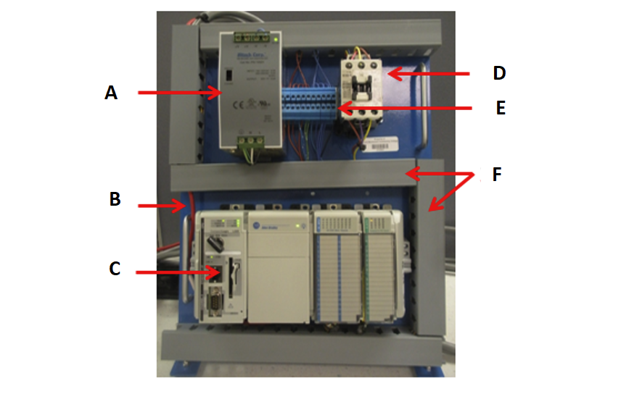Match the PLC panel part with it's correct position as indicated by the picture above.
A - 24 Volt Power Supply
B - Serial Port
C - PLC
D - Master Contactor
E - Terminal Block
F - Wireways
points:1.00

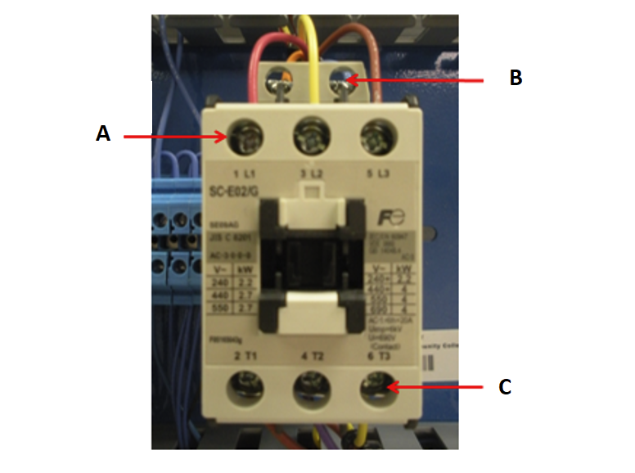Match the part of the master control relay with it's correct position above.
A - Line Terminals
B - Coil Terminals
C - Load Terminals
points:1.00

Describe the difference between open and closed PLC architecture?
points:1.00

Described the difference between Fixed I/O and Modular I/O?
points:1.00

What is the most commonly type of logic that PLCs are programmed with?
points:1.00

Explain the differences between single-ended and multitask PLC applications.
points:1.00

What type of addressing is used with Allen-Bradley ControlLogix controllers?
points:1.00

Explain the difference between a bipolar input module and a unipolar input module?
points:1.00

What is Boolean algebra?
points:1.00

What is ladder diagram programming?
points:1.00

