ELC-128 Quiz Questions and Answers

Module 1 Quiz Questions and Answers

True or False: Fixed I/Os come with separate removable units.
True
False*
points:1.00

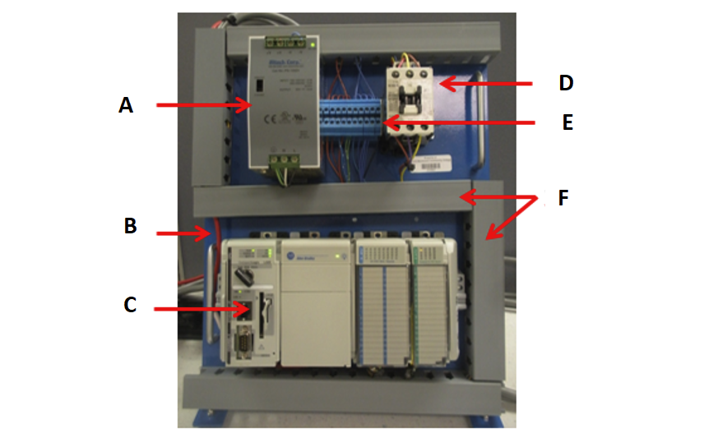Match the PLC panel part with it's correct position as indicated by the picture above.
A - 24 Volt Power Supply
B - Serial Port
C - PLC
D - Master Contactor
E - Terminal Block
F - Wireways
points:1.00

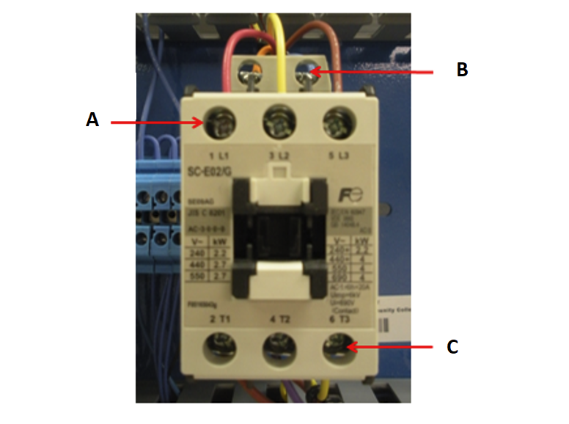Match the part of the master control relay with it's correct position above.
A - Line Terminals
B - Coil Terminals
C - Load Terminals
points:1.00

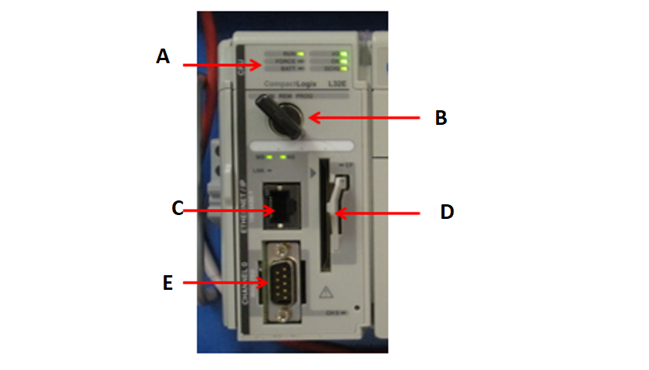Match the part of the processor module with it's correct position as indicated above.
A - Status Indicators
B - Mode Selector Switch
C - Ethernet Port
D - Memory Card Receptacle
E - Serial Port
points:1.00

List three advantages of PLCs over relays
points:1.00

Module 3 Quiz Questions and Answers

What two numbers are part of the binary system
1 and 2
1 and 0*
2 and 3
3 and 4
points:1.00

True or False: a logic gate is a circuit with several inputs but only one output that is activated by particular combinations of input conditions.
True*
False
points:1.00

What is the most common PLC programming language?
Hardwired Logic
Programmable Control
Ladder*
Parallel
points:1.00

Explain how the AND function works.
points:1.00

Explain how the OR function works.
points:1.00

Explain how the NOT function works.
points:1.00

Module 4 Quiz Questions and Answers

The decimal system has a base of how many numbers?
8
10*
5
2
points:1.00

True or False: in the binary number system, the only allowable digits are 0 and 1.
True*
False
points:1.00

The hexadecimal system has a base of how many numbers?
10
12
14
16*
points:1.00

Which of the following is not a part of PLC memory organization?
Words
Bytes
Triple Words*
Double Words
points:1.00

What two numbers are not allowed in the octal numbering system?
1 &amp; 2
4 &amp; 5
8 &amp; 9*
10 &amp; 11
points:1.00

Which of the numbering systems we covered this week utilizes letters?
Binary
Hexadecimal*
Octal
Decimal
points:1.00

True or False: the binary coded decimal (BCD) system uses 4 bits to represent each decimal digit.
True*
False
points:1.00

Which numbering system does a thumbwheel switch use?
Hexadecmial
Binary
Binary coded decimal*
Decimal
points:1.00

True or False: gray code is set up so that as we progress from one number to the next, two bits change?
True
False*
points:1.00

What is the BCD representation of the number 1 in a decimal system?
points:1.00

Module 5 Quiz Questions and Answers

Which of the following are not values 1 and 0 can represent in a binary system?
ON or OFF*
Open or Closed
True or False
Near or Far*
High or Low
points:1.00

True or False: a logic gate is a circuit with several inputs but only one output that is activated by particular combinations of input conditions.
True*
False
points:1.00

True or False: for an OR gate, the output is 1 only if both inputs are 1.
True
False*
points:1.00

True or False: for a NOT gate, the output is 1 if the input is 0.
True*
False
points:1.00

Which logic gate can only have one input?
AND
OR
NOT*
NAND
points:1.00

True or False: the mathematical study of the binary number system and logic is called Boolean algebra.
True*
False
points:1.00

If you want to know when matching bits in two different words are both ON you use the ______________ function.
NOR
NOT
OR
AND*
points:1.00

If you want to know when one or both matching bits in two different words are ON you use the _______________ function.
NOR
NOT
OR*
AND
points:1.00

Module 6 Quiz Questions and Answers

What type of memory addresses are derived using the rack number, the I/O module slot number and the screw terminal number where the I/O device is wired.
Rack-Based*
Tag-Based
Ladder Logic
Lock-Based
points:1.00

True or False: Data files are the part of processor memory that stores the user ladder logic program.
True
False*
points:1.00

The SLC 500 stores data in data tables that are based on how many bit words?
8 Bit
16 Bit*
32 Bit
64 Bit
points:1.00

True or False: the time it takes to complete a scan cycle is a measure of how fast the controller can react to changes in inputs.
True*
False
points:1.00

Which of the following is not a function of scan time?
The length of the ladder program
The speed of the processor module
The type of instructions executed
The length of the processor module*
points:1.00

True or False: two major categories of PLC programming languages are textural and graphical.
True*
False
points:1.00

Memory space is divided into two types of files? What are they?
points:1.00

Define what ladder logic is.
points:1.00

Module 8 Quiz Questions and Answers

True or False: address indicates what input is connected to what device.
True*
False
points:1.00

What shapes are inputs and outputs typically represented by?
Diamonds and circles
Circles and squares
Squares and diamonds*
Circles and triangles
points:1.00

True or False: parallel branches can be used to allow more than one combination of input conditions.
True*
False
points:1.00

True or False: an internal output does directly control an output field device.
True
False*
points:1.00

What mode is used to operate or monitor the user program without energizing any outputs?
Program mode
Run mode
Test mode*
Remote position
points:1.00

Module 10 Quiz Questions and Answers

True or False: the done bit is the bit set when the accumulated value reaches the preset value.
True*
False
points:1.00

True or False: mechanical timing relays are used to speed up the opening or closing of contacts for circuit control.
True
False*
points:1.00

What term compares to when one timer's output triggers another timer's input?
Hardwired
Cascaded*
Rushed
Combined
points:1.00

What is the difference between retentive timers and non-retentive timers?
points:1.00

What is the difference between preset value and accumulated value?
points:1.00

Module 11 Quiz Questions and Answers

What type of counters are the majority of counters used in industry?
Down-counters
Up-counters*
Up/down counters
Side counters
points:1.00

Up-counters are always rest to what number.
0*
2
4
6
points:1.00

Up-counters are used to count what types of transitions?
Left to right
Right to left
True to false
False to true*
points:1.00

A one-shot contact is also known as what?
A transitional contact*
A mechanical contact
A parallel contact
A decrement contact
points:1.00

In regards to status bits, what is the difference between overflow and underflow?
points:1.00

Module 12 Quiz Questions and Answers

PLCs were originally designed to replace control ____________ that made logic decisions?
Starter switches
Relays*
Contactors
Push buttons
points:1.00

What type of relay is designed to handle heavy power loads?
Motor Starters
Relays
Contactors*
Manually Operated Switches
points:1.00

True or False: mechanically operated switch is controlled automatically by factors such as pressure, position, or temperature.
True*
False
points:1.00

True or False: pressure switches are used to control the pressure of solids.
True
False*
points:1.00

True or False: Capacitive proximity sensors operate within an electrostatic field.
True*
False
points:1.00

Describe the difference between normally open (NO) and normally closed (NC) contacts.
points:1.00

Describe how electromagnetic latching relays work?
points:1.00

