HYD-110 Module Quiz Questions and Answers

Which of the following is not an advantage of pneumatics over hydraulics?
Higher speeds
Cannot leak oil
Components cost lower
Are better for higher force applications*
points:1.00

Which of the following is not a basic component of pneumatic systems?
Power Input Device
Control Device
Oil*
Gas
Conductors
points:1.00

True or False: the definition of pressure is the intensity of force created when a force from one object acts over the area of another.
True*
False
points:1.00

Which of the following is not the component of a cylinder?
Piston Seals
Rod Seals
Rotary*
Rod Bushing
points:1.00

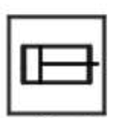
What component of a pneumatic system is the above a symbol for?
Conditioning Device
Pressure Valve
Cylinder*
Air Motor
points:1.00

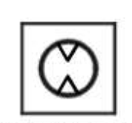
What is the pneumatic component that the above image is a symbol for?
Air Motor*
Junction
Plug
Pressure Valve
points:1.00

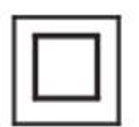
What pneumatic component is the above image a symbol for?
Cylinder
Pressure Valve*
Variable
Flow Direction
points:1.00

What do control valves do?
points:1.00

What is the mathematical formula for measuring pressure?
points:1.00

How does a pressure gauge work?
points:1.00

Module 2 Quiz Questions and Answers

Single-acting pneumatic cylinders are powered by compressed air in how many directions?
One*
Two
Three
Four
points:1.00

In a single-acting, spring-return cylinder, the spring is there to return the rod assembly to it's de-energized position.
True*
False
points:1.00

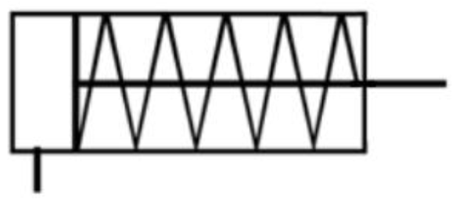What type of cylinder is the above schematic symbol for?
Single-Acting to Retract Cylinder
Single-Acting to Extend Cylinder*
Double-Acting to Retract Cylinder
Double-Acting to Extend Cylinder
points:1.00

True or False: you would use an air motor where high force rotary output is needed.
True
False*
points:1.00

Which of the following is not a part of an air motor?
Housing
Rotor
Shaft
Cylinder*
Vanes
points:1.00

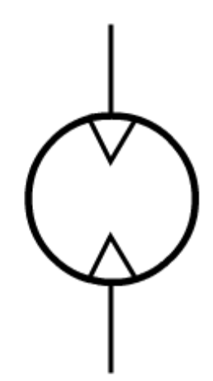
What type of motor is shown in the image above?
Uni-Directional Air Motor
Uni-Directional Gas Motor
Bi-Directional Air Motor*
Bi-Directional Gas Motor
points:1.00

Match the cylinder options and the description for it.
Cushions - In either or both ends of the cylinder control deceleration and relieve impact at the end of the stroke, improving durability.
Bumpers - Rubber discs that absorb impact and noise at the end of stroke, reducing noise and vibration.
Stop tubes/dual pistons - Manage side loads by distributing the forces over a larger area of the cylinder.
Rob wipers - Help keep contaminants out of the cylinder by wiping the rod as it retracts
Flow controls - Help assure constant, controllable air flow for precise and consistent speed control regardless of variations in air pressure.
points:5.00

Explain the difference between normally open and normally closed set ups.
points:1.00

Explain the difference between pivot mounting and rigid mounting.
points:1.00

Explain the difference between double-acting and single-acting cylinders?
points:1.00

Module 3 Quiz Questions and Answers

In a pneumatic cylinder, the pressure will rise to a level that creates a force equal and opposite to the force created by what?
Weight
Current
Load*
Vacuum Seal
points:1.00

True or False: spring rate is the force it takes to compress a spring a given distance?
True*
False
points:1.00

When retracing a load, the pressure can be exerted all over the surface inside the rod end of the cylinder.
True
False*
points:1.00

Which of the following are the two ways that pneumatic pressure can be stated? (Select all that apply)
Absolute pressure*
True pressure
Force pressure
Gauge pressure*
points:1.00

True or False: gauge pressure indicates the amount of pressure above atmospheric pressure.
True*
False
points:1.00

What part of a pneumatic system creates the air pressure that makes the system work?
Air Gauge
Motor
Valves
Air Compressor*
points:1.00

What does the following formula measure: F = k x d
points:1.00

Explain how Pascal's Law works.
points:1.00

Module 4 Quiz Questions and Answers

An air compressor creates _________________
points:1.00

Boyle's Law states that ________________
points:1.00

Delta P is the difference in pressure between __________________
points:1.00

Pascal's Law applies only to ______________________
points:1.00

Pressure beyond that to overcome all resistive loads determines ____________
points:1.00

Two types of resistance to air flow in a pneumatic system are __________
points:1.00

To convert gauge pressure to absolute, ________________
points:1.00

Module 5 Questions and Answers

Which of the following is not a component of a needle valve?
Valve Body
Adjustment knob*
Adjustment Screw
points:1.00

What is flow most often measured by?
Weight
Pressure
Volume*
Width
points:1.00

The way to read a rotameter is to read the scale ______.
top of the ball
center of ball*
bottom of the ball
none of above
points:1.00

Two common types of check values used in pneumatics are the ______.
spool and sleeve
vane and rotor
radial and axial
ball and poppet*
points:1.00

Which of the following is not a part of a flow control value?
Body
Vane*
Adjustment screw
Check valve
points:1.00

What is the primary function of a needle valve?
points:1.00

Define flow rate.
points:1.00

Describe the differences between volume at a given pressure, free air volume, and standard air volume.
points:1.00

Module 6 Questions and Answers

The valve control element that consists of a precision hole used to control the rate of airflow is called a{n} _________.
Inlet port
Land
Fixed orifice*
Outlet port
points:1.00

What type of valve allows free flow of air through a line in only one direction?
Shutoff valve
Check valve*
Three-way valve
Four-way valves
points:1.00

What does a diaphragm do in a pneumatic system?
points:1.00

What does a pressure booster do?
points:1.00

What are exhaust mufflers used for?
points:1.00
Module 8 Quiz Questions and Answers

Which of the following components is not part of a hydraulic system?
Power input device
Control devices
Power output devices
Air*
Conductors
Liquid
points:1.00

True or False: the suction line is where the oil from the reservoir enters the hydraulic system.
True*
False
points:1.00

True or False: an singular actuator line can carry oil both to and from the actuator.
True
False*
points:1.00

Which of the following is not a component of a hydraulic power unit?
Reservoir
Hydraulic pump
Prime mover
Prime motor*
points:1.00

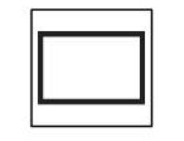
Which of the following components is the above schematic symbol showcasing?
Cylinder*
Blocked line
Conductor
Spring
points:1.00

Define what force is.
points:1.00

Describe how force is calculated.
points:1.00

Upload your video summaries here.
points:1.00

Module 9 Quiz Questions and Answers

Which of the following are not common types of flow meters? (select all that apply).
Rotameter
Tube flow meter*
Turbine flow meter
Barometer*
points:1.00

Which of the following is not a common type of fixed-displacement pump?
Piston pumps
Vane pumps
Rotary pumps*
Gear pumps
points:1.00

True or False: piston motors are used where high performance is needed.
True*
False
points:1.00

True or False: vane motors are best used for light-duty mobile situations.
True
False*
feedback: Gear motors are best for this type of situation
points:1.00

True or False: one basic rule when drawing hydraulic schematics is that lines are drawn either vertically or horizontally.
True*
False
points:1.00

Describe how a flow meter works.
points:1.00

Describe how a turbine flow meter works.
points:1.00

Describe the difference between variable displacement and fixed-displacement.
points:1.00

Upload your video summary/responses here.
points:1.00

Module 10 Quiz Questions and Answers

True or False: in a hydraulic cylinder, the pressure will rise to a level that creates a force which is equal and opposite to the force created by the load.
True*
False
points:1.00

True or False: hydraulic leverage makes it impossible to generate very large forces to move heavy loads with a small input force.
True
False*
points:1.00

When using hydraulic leverage, distance is ___________
Contained
Flowing
Sacrificed*
Solid
points:1.00

The energy used to overcome frictional resistance is lost in the form of _______________
Heat*
Air
Momentum
Fluid
points:1.00
Explain how Pascal's Law works.
points:1.00

Module 11 Quiz Questions and Answers

As oil is pumped through a hydraulic system, it progressively _______.
drops in flow rate
drops in pressure*
increase in flow rate
increase in pressure
points:1.00

Delta P is another name for ______.
flow rate
the flow direction arrow on a valve symbol
pressure differential*
valve
points:1.00

Flow occurs between two connected points in a hydraulic system when _____.
there is a vacuum
a pressure differential exists*
there is high pressure
pressure is the same at both points
points:1.00

Pascal's Law states that pressure in a confined fluid is equal and acts ______.
on each flat surface
perpendicular to all surfaces*
only at the bottom of the vessel
only against the external load
points:1.00

Pressure is created by the ______.
pump
reservoir
resistance to flow*
flow meter
points:1.00

Pressures are stated as _____.
PSI
PSIA
PSIG
All of the above*
points:1.00

The area of a circle can be calculated by ______.
pi times (r squared)
pi times (d squared divided by 4)
0.7854 times (d squared)
All of the above*
points:1.00

The hydraulic level provides ______.
flow multiplication
a pressure drop
power multiplication
force multiplication*
points:1.00

The rod side area that produces the pull force on a double-acting cylinder is called the ______.
blind
cap
annular*
rod
points:1.00

Module 13 Quiz Questions and Answers

True or False: a sequence valve is a relief valve with an internal drain line.
True
False*
points:1.00

True or False: sequence valves are best used for simple applications.
True*
False
points:1.00

Which of the following is not a part of a direct-operated sequence valve?
Body
Adjustment Knob
Spool
Slide*
Spring
points:1.00

Which of the following is not a component of a pressure reducing valve?
Body
Spool
Spring
Adjustment Knob
Clamp*
points:1.00

Describe how sequence valves function.
points:1.00

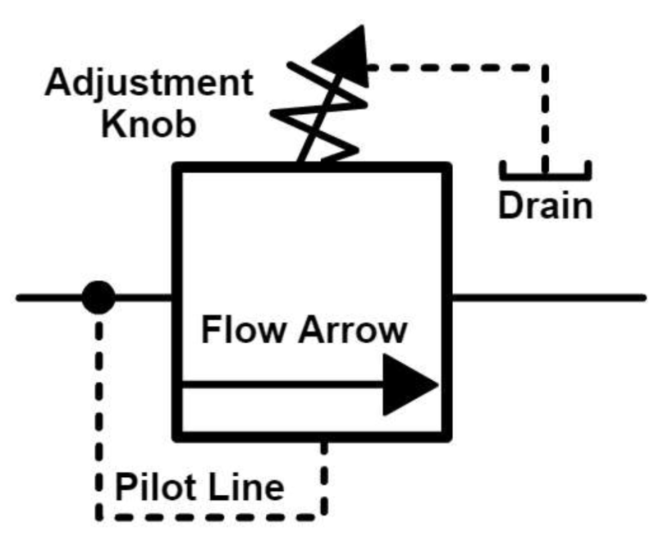
What type of valve is the above a schematic symbol for?

Describe the function of a check valve.
points:1.00

Describe the function of an integral check valve.
points:1.00

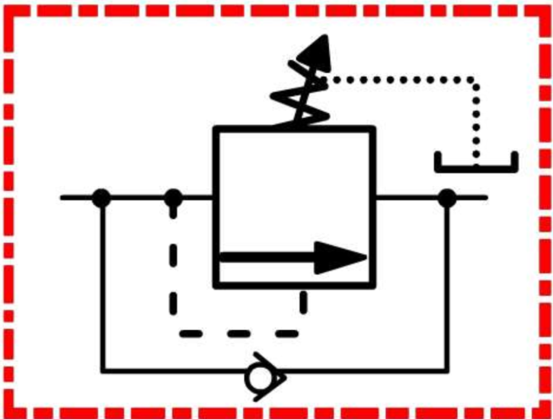What type of valve is the above a schematic symbol for?
points:1.00

Describe the function of pressure reducing valve applications.
points:1.00

