HYD-110 Final Exam

Which of the following is not a branch of fluid power?
Pneumatics
Hydraulics
Phonics*
points:1.00

Which of the following is not an advantage of hydraulics over pneumatics?
Higher speeds
Can operate above 150 PSI*
Lower cost
Cannot leak oil
points:1.00

All pneumatic systems consists of five basic components, which of the following is not one of them?
Control Device
Conductor
Oil Reserve*
Gas
points:1.00

Three examples of valve types are:
Flow control
Directional control
Pressure regulator
All listed are valve types*
Only flow and directional control are
points:1.00

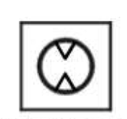
What component is symbolized by the schematic symbol above?
Air Motor*
Storage
Junction
Pressure Valve
points:1.00

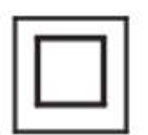
What component is symbolized by the schematic symbol above?
Junction
Plug
Conductor
Pressure Valve*
points:1.00

True or False: a general safety rule for working with pneumatics is to use safety glasses.
True*
False
points:1.00

True or False: in a single-acting, spring-return cylinder, the spring is there to return the rod assembly to it's de-energized position.
True*
False
points:1.00

In a pneumatic cylinder, the pressure will rise to a level that creates a force equal and opposite to the force created by what?
Weight
Current
Load*
Vacuum Seal
points:1.00

True or False: Boyle's Law describes the relationship between the volume of air and its pressure at a fixed temperature.
True*
False
points:1.00

What type of valve allows free flow of air through a line in only one direction?
Shuttoff valve
Check valve*
Three-way valve
Four-way valve
points:1.00

True or False: brake systems for cars and trucks are powered by hydraulics.
True*
False
points:1.00

True or False: hydraulic systems can operate underwater and other harsh environments that pneumatic systems cannot.
True*
False
points:1.00

True or False: the return line in a hydraulic system carries oil from control devices to the actuators.
True
False*
points:1.00

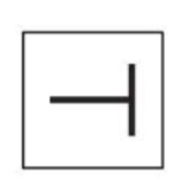
What component of a hydraulic system is shown by the schematic symbol above?
Rotating Device
Conductor
Spring
Blocked Line*
points:1.00

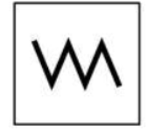
What component of a hydraulic system is shown by the schematic symbol above?
Blocked Line
Spring*
Valve
Restriction
points:1.00

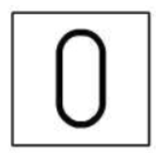
What component of a hydraulic system is shown by the schematic symbol above?
Restriction
Conductor
Accumulator*
Valve
points:1.00

Which of the following are not common types of flow meters? (select all that apply).
Rotameter
Tube Flow Meter*
Turbine Flow Meter
Barometer*
points:1.00

Which of the following is not a common type of fixed-displacement pump?
Piston pumps
Vane pumps
Rotary pumps*
Gear pumps
points:1.00

True or False: in a hydraulic cylinder, the pressure will rise to a level that creates a force which is equal and opposite to the force created by the load.
True*
False
points:1.00

True or False: hydraulic leverage makes it impossible to generate very large forces to move heavy loads with a small input force.
True
False*
points:1.00

When using hydraulic leverage, distance is _________
Contained
Flowing
Sacrificed*
Solid
points:1.00

The energy used to overcome frictional resistance is lost in the form of _______________
Air
Momentum
Fluid
Heat*
points:1.00

As oil is pumped through a hydraulic system, it progressively ___________
drops in flow rate
increase in flow rate
increase in pressure
drops in pressure*
points:1.00

Delta P is another name for _________________.
Pressure differential*
Valve
Flow rate
The flow direction arrow on a valve symbol
points:1.00

Flow occurs between two connected points in a hydraulic system when ______________________
there is a vacuum
a pressure differential exists*
there is high pressure
pressure is the same at both points
points:1.00

Pascal's Law states that pressure in confined fluid is equal and acts _____________.
Perpendicular to all surfaces*
On each flat surface
Only at the bottom of the vessel
Only against the external load
points:1.00

Pressures are stated as ________________.
PSI
PSIA
PSIG
All of the above*
points:1.00

The hydraulic level provides _____________________.
Flow multiplication
Power multiplication
A pressure drop
Force multiplication*
points:1.00

True or False: a relief valve opens at preset pressure to allow flow to return to the reservoir.
True*
False
points:1.00

Which of the following is not a common type of check valve?
Ball
Swing
Screw*
Poppet
points:1.00

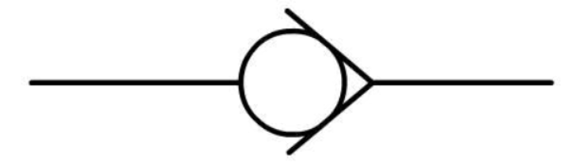What type of valve is shown by the schematic symbol above?
Check Valve*
Flow Control Valve
Adjustment Knob
Meter Out Control Circuit
points:1.00

True or False: a sequence valve is a relief valve with an internal drain line.
True
False*
points:1.00

Which of the following is not a component of a pressure reducing valve?
Body
Spool
Spring
Adjustment Knob
Clamp*
points:1.00

Match the filter type with it's function.
Particulate Filters - Remove solid particles.
Coalescing Filters - Remove water and oil mist by causing them to coalesce into droplets.
Activated Carbon Filters - Remove oil vapors and odors, often used in sensitive applications.
points:3.00

Define pressure.
points:1.00

Describe Pascal's Law.
points:1.00

Explain the difference between double-acting and single-acting cylinders.
points:1.00

Describe how a needle valve works?
points:1.00

Describe the process of a hydraulic system driving the movement of a conveyor.
points:1.00

What does the suction line to in a hydraulic system?
points:1.00

Explain how the size of the area of pressure can affect the force of that pressure.
points:1.00

What is the prime mover in a hydraulic system?
points:1.00

What does a flow meter measure?
points:1.00

Describe the operation of a double-acting cylinder.
points:1.00

Describe the difference between variable displacement and fixed-displacement.
points:1.00

What are check valves used for?
points:1.00

Describe how sequence valves function.
points:1.00

