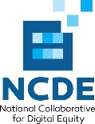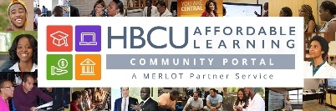

Five Years of Free Broadband for Income-Eligible K12 Students
Audiences for this Overview:
- HBCU leaders who want their current and future students, school and community partners, and alumni with school-age children to take advantage of Project 10 Million, the T-Mobile free hotspot & broadband access program.
What Project 10Million Provides
- Free mobile hotpot (includes shipping)
- Five years of free unlimited broadband access, wherever T-Mobile provides Internet service
Who’s Eligible?
- Households with at least one free/reduced-lunch eligible child in grades K-12
- Even students just one day away from high school graduation get five-years of free broadband access, so long as they apply a moment before graduation
How Can Eligible Families Sign Up?
- The household – or someone who serves them – can complete the application here,

OR

- A school district can apply on behalf of all the eligible households they serve (click on “I’m a school administrator” here)
What Proof of Income Eligibility Will T-Mobile Accept?
- The child(ren) participate in the National School Lunch Program
- Supplemental Nutrition Assistance Program (SNAP)
- Temporary Assistance for Needy Families (TNAF)
- Medicaid
- Head Start
- Foster youth, migrant, homeless or runaway youth
- Community Eligibility Provision
- Food Distribution Program on Indian Reservations
What’s A Mobile Hotspot?
- A portable way to share internet access with mobile devices (see here)
Setting Up A T-Mobile Hotspot: see here
Using Your T-Mobile Hotspot Effectively: see here
Video Tutorials:
- T-Mobile 5G Hotspot Unboxing and Setup:
- How To Set Up a Hotspot for Android device
- How to Set Up a Hotspot for Windows device
- How to Set Up a Hotspot for Apple device
- T-Mobile WiFi Hotspots User Guide

For more information, please contact

Ms. Jenelle Leonard, chief operating officer, National Collaborative for Digital Equity



