Sample assignment for the course

Sample modules with content and assignments:

Every module is organized similarly to the following examples (I have translated everything, since the original is in Spanish):

Module 1-What is Linguistics?
- THEORY-QUIZ
Have you ever wondered why we speak the way we do? Or maybe you’ve written a text message and thought, “Why do I write my messages like this, and people understand me perfectly well, but I can’t write my Spanish class essays the same way?” And even if you’ve never asked yourself these questions, you’ve probably met someone who doesn’t speak like you — someone with a different accent or who uses unfamiliar words — and you noticed the difference. So, how can we answer your questions and many others about language? Well, we’re going to explore them in this course. But before we begin, we should define what exactly we’re studying: linguistics.
Linguistics is the scientific study of language, its functions, and its applications in everyday life. However, students sometimes have misconceptions when they start linguistics courses. Many think that linguistics focuses only on grammar, or that linguists speak several languages — that is, that they are multilingual. While grammar is important for developing a language, linguistics examines many other aspects — for example, the creativity of language, the structure of words, the production of sounds, and more — and it’s not necessary to speak many languages to be a linguist.
Language is not fixed; pronunciation, grammar, and other elements can change over time. Therefore, it’s not fair to say that one language is less developed than another, or that one person speaks “better” than another in the same language, because language is adaptable and influenced by several factors — such as where it is learned or the context in which it is used.
In this module, we will learn about the characteristics of language, its practical functions, the different fields of study within linguistics, and finally, the opportunities available for those who pursue linguistics. This chapter will also discuss language acquisition — including second and additional languages — and address the questions mentioned earlier. The main goal is for you to see language as both a scientific and social subject, and hopefully, to become even more curious and ask more questions about language and linguistics.
Review all the materials carefully until you understand them. You can send me your questions.
Watch the video “Lingüística: definición, su objeto y sus ramas” and answer the questions.
Throughout the course, it’s a good idea to take notes on the videos and readings and keep them to review for the quizzes.
Quiz Type: Graded Quiz
Points: 9
Example of the first two questions:
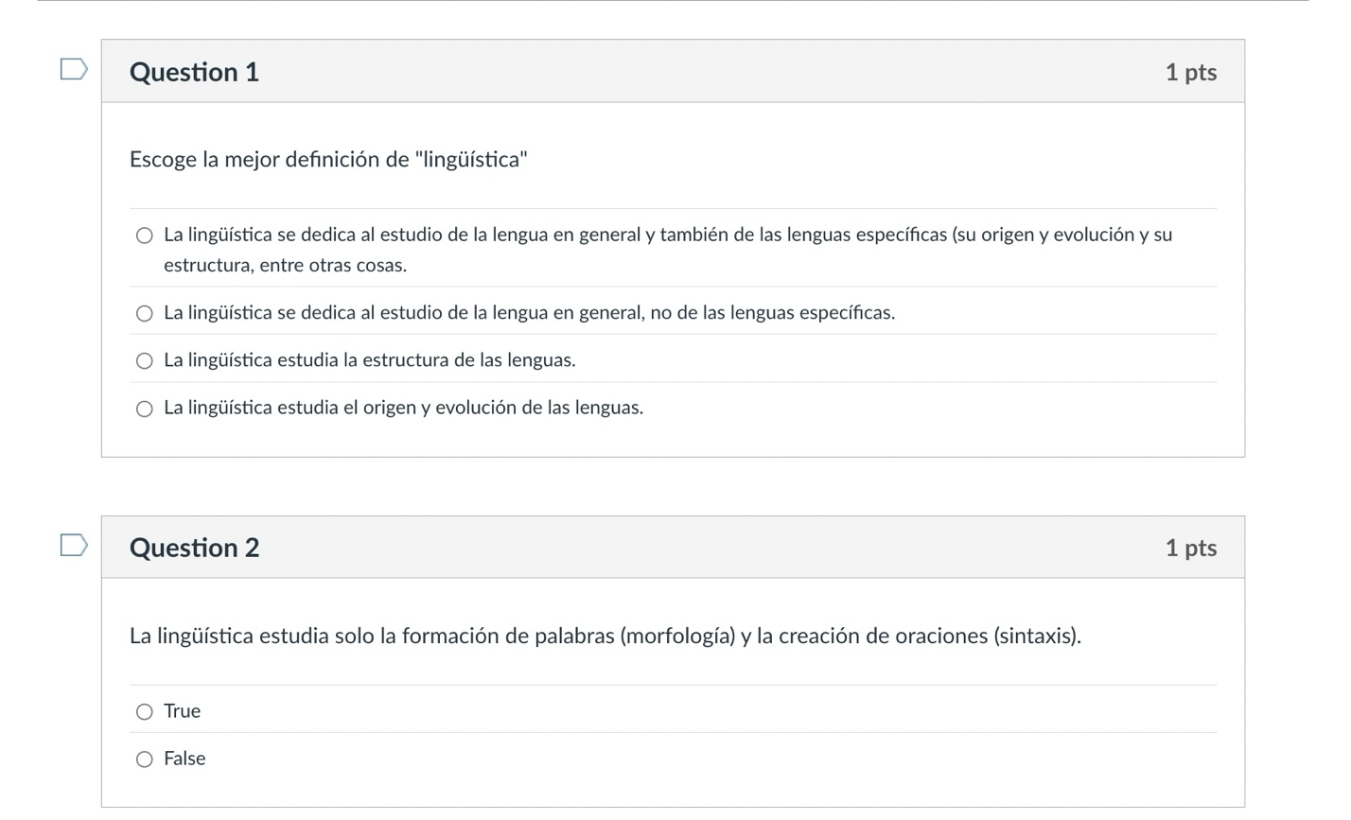
2. DISCUSSION: Applied Linguistics
Applied linguistics is used in various fields to solve linguistic problems and improve communication. Some of its main applications include:
- Language teaching: Applied linguistics is used to improve the teaching and learning of second languages.
- Translation: Applied linguistics is used to translate texts.
- Language planning: Applied linguistics is used to implement government policies related to language use.
- Natural language processing: Applied linguistics is used to process natural language.
- Speech therapy (Logopedics).
- Discourse analysis.
- Language pedagogy.
- Language assessment.
- Anthropological linguistics: Studies human beings through the language they use to communicate.
- Forensic linguistics: The science that studies language in order to use it as evidence in police investigations, judicial processes, or private investigations.
Applied linguistics developed during World War II within the field of American linguistics.
In addition, sociolinguistics, neurolinguistics, and psycholinguistics are branches of linguistics that study language:
- Sociolinguistics
  - Studies language as a social institution.
  - Identifies the languages used in a community and in which contexts.
- Neurolinguistics
  - Focuses on how language structures are represented in the brain.
  - Studies types of aphasia, such as Broca’s and Wernicke’s.
- Psycholinguistics
  - Studies the mechanisms used to process language.
  - Analyzes how words and sentences are constructed and understood during communication.
  - Evaluates language development in children.

Imagine that you have already studied linguistics and want to focus on one specific application or branch.
a) Research at least one of these areas and explain what that job would involve.
Cite the websites where you found your information—at least two sources, and one must be from a university (for example, a course, master’s program, or specialization they offer).
b) Then, look at these links and comment on at least one of them:
- Linguística Aplicada, UNAM, Mexico
- Linguística Forense, Universidad Europea del Atlántico, Santander, Spain
- Linguística Computacional, Universitat Pompeu Fabra, Barcelona, Spain
- Grado en Logopedia, Universidad Autónoma de Barcelona, Spain
Also, make comments related to at least one classmate’s discussion thread.
12 points total:
- 3 points for each part of the task (a and b)
- 3 points for writing
- 3 points for peer comments
MODULE 2. SOCIOLINGUISTICS
- THEORY AND QUIZ

Introduction to Sociolinguistics
Sociolinguistics is the branch of linguistics that studies the relationship between language and society. In other words, it analyzes how people use language in different social contexts and how factors such as age, gender, educational level, social class, or region influence the way they speak.
Unlike other branches of linguistics that focus on the structure of language (such as grammar or phonetics), sociolinguistics is interested in the real use of language. It doesn’t just ask “how does Spanish work?” but rather “who uses it, in what situations, and for what purpose?”

Linguistic Variation
Language is not uniform — it changes depending on people, places, and situations. This phenomenon is called linguistic variation, and it can appear in different ways:
- Diatopic (geographical) variation: depends on the speaker’s place of origin. For example, ordenador in Spain and computadora in Latin America.
- Diastratic (social) variation: related to education level, age, or social class.
- Diaphasic (situational) variation: changes depending on the context or formality. We don’t speak the same way with friends as we do in a job interview.
- Diachronic (historical) variation: shows how language evolves over time.
All varieties of Spanish are legitimate, although some may have more social prestige than others. This prestige does not depend on linguistic reasons, but rather on historical, political, and cultural factors.

Key Concepts
- Speech community: a group of people who share not only a language, but also social norms about how to use it.
- Register: the way of speaking adapted to a specific communicative situation.
- Diglossia: the coexistence of two language varieties (one of higher and one of lower prestige) within the same community.
- Prestige: the social value attributed to a linguistic variety.

Key Figures
The linguist William Labov is considered the founder of modern sociolinguistics. Based on his studies in New York in the 1960s, he demonstrated that differences in the way people speak reflect social structures — but also that people can modify their speech depending on the context to project an identity or belong to a group.
Quiz Type: Graded Quiz
Points: 8
Example of questions:
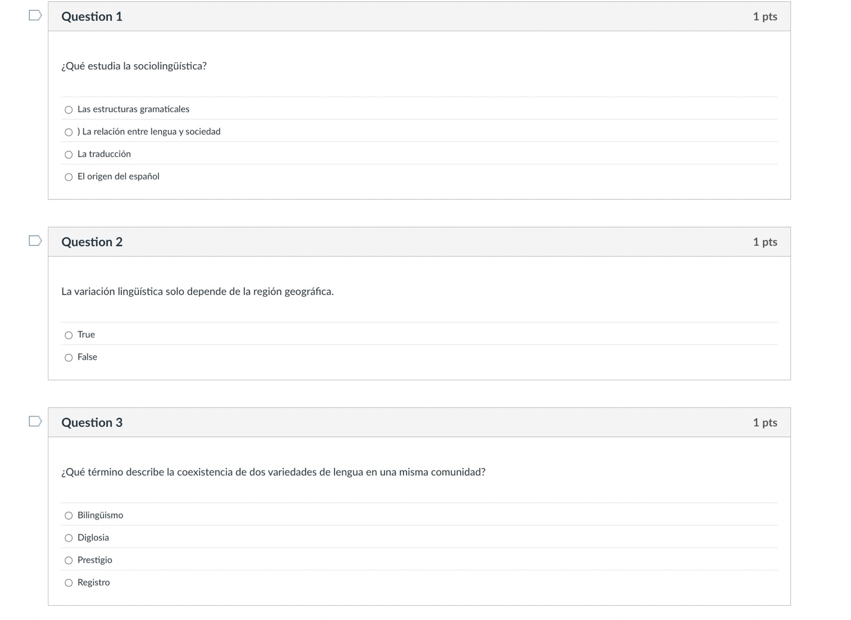

DISCUSSION: STANDARD SPANISH
Discussion: Do you think a “standard Spanish” exists, or do all speakers use legitimate varieties?
Write 6–10 sentences justifying your answer. If you have studied dialectology and/or linguistics, try to recall concepts or ideas discussed in other classes.
Consult the following websites dedicated to the Spanish language and include at least one citation:
- Mexican Academy of Language
- FundeuRAE
- Centro Virtual Cervantes
Then, reply to another person’s post.
Points:
- 6 points for the content of your initial comment
- 2 points for citation(s)
- 2 points for replying to a classmate
- 2 points for correct writing
…
MIDTERM:

PART 1. Discussion:
Language changes for internal reasons (those belonging to the linguistic system itself) and external reasons (social or cultural). Sometimes both interact: an internal variation can become established or disappear depending on social factors.

Discussion Questions:
- Can you think of an example where an internal variation (such as the use of ustedes or haiga) has spread due to social or geographical reasons (external variation)?
- Which type of variation do you think has a greater impact on the evolution of a language — internal or external? Why?
- In what ways do you think your own use of Spanish combines both types of variation?
Points: 6 points for content, 2 points for replying to another person, and 1 point for correct writing.
PART 2. QUESTIONS:

A) Provide a definition of what sociolinguistics is (3–4 sentences).

B) Quantitative Analysis — Research and Analysis Activity
Read this journal article:
“Rata de dos patas: análisis de insultos en el español de España en el siglo XXI”, Discurso y Sociedad, 18(1), 2024, pp. 116–152.
In this study, the authors quantitatively analyze the frequency, geographical variation, and social factors related to insults in Spanish. Using a corpus of current examples, they code linguistic variables (type of insult, formulation) and social variables (speaker’s gender, region, urban/rural context). The results are presented in statistical tables, showing that insults are not merely isolated acts but rather reflections of social identities, power dynamics, and cultural stereotypes. This type of study perfectly illustrates how quantitative methodology reveals connections between language, society, and ideology in contemporary Spanish.

Questions:
- What elements of the article show that it is a quantitative study in sociolinguistics?
- What types of linguistic and social variables are analyzed, and how are they related to each other?
- How do the results reflect the ideological or cultural factors of current Spanish society?
- In what ways do insults function as markers of social identity or power?
- Locate a table or statistical figure and briefly explain what information it presents and what conclusions can be drawn from it.
- Quantitative analysis is often accompanied by qualitative analysis. Do you observe that here?

Clarification
In sociolinguistics, qualitative analysis focuses on understanding the social, identity-related, and contextual meaning of language use, rather than measuring it numerically.
20 points (critical thinking rubric below).



