Discussion Research Exercise
Interest Groups: “The Scene of Influence”
Oil, Power, and Influence in Kern County
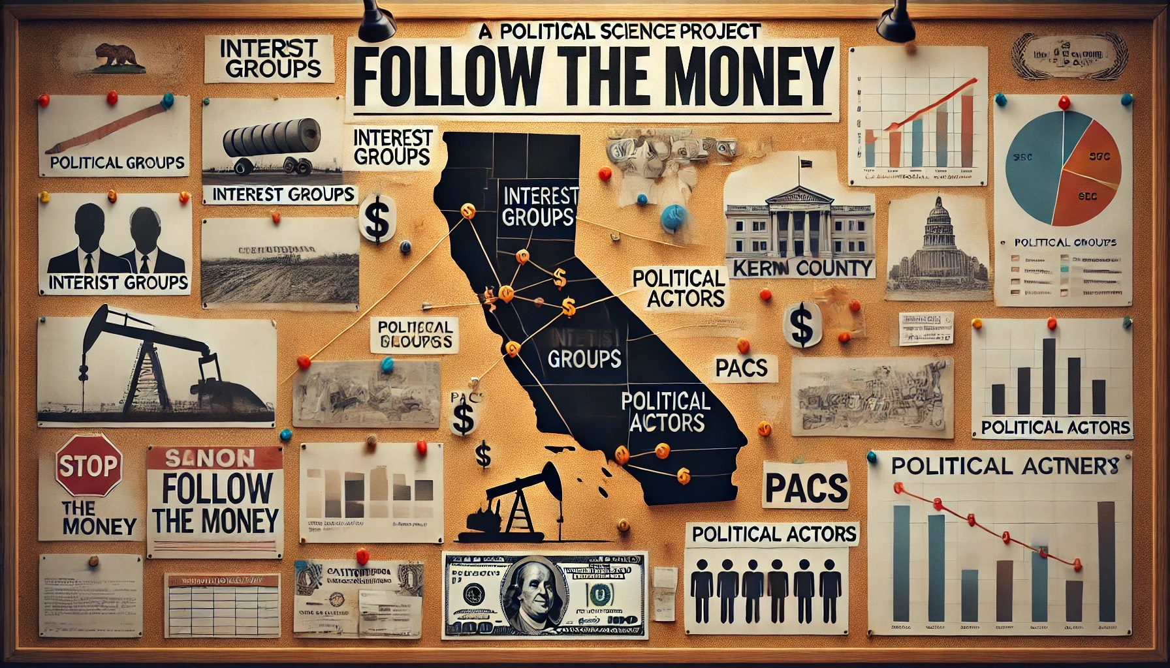
This week’s Interest Group Assignment takes inspiration from those classic scenes in detective movies. You know the ones: the investigator stands in front of a framed cork board that is covered with photos, arrows, and timelines, trying to piece together who’s connected to whom.
You’ll be doing the same, but instead of suspects, you’ll be mapping interest groups, political actors, and key moments in California politics. Your task is to reconstruct the “scene of influence”: who’s funding whom, what coalitions are forming, and how power circulates across government, business, and advocacy organizations.
Think of yourself as a political investigator. Start by identifying the major players (interest groups, industries, or PACs), trace their connections (campaign contributions, lobbying efforts, public endorsements), and place them on your own virtual “evidence board.” The goal of this assignment is to identify patterns, not just individual actions, but the web of influence that drives policy in our state.
The timeframe for this assignment is two weeks. This will give you time to research the interest groups involved, and experiment with actual software, apps, or digital tools that can help you create a visualization of your “scene of influence.” Or, another path could be, you could create your own cork board and make a short film. Be creative: maps, flow charts, videos, and web diagrams are all welcome ways to bring your investigation to life.
Bring your analytical eye, and maybe a little bit of detective flair.

Objective
Explore the relationship between campaign finance, institutional access, and policy outcomes, using the recent California law expanding oil drilling in Kern County as your focal case.
At the completion of this assignment, you will be able to:
- Use real campaign contribution data to trace which actors are investing in this legislative outcome.
- Analyze how money may align with access, influence, or political leverage in Sacramento.
- Reflect on the potential implications for environmental justice, democracy, and accountability.
Context / Background
In 2025, California passed a sweeping energy-climate package that both extends the state’s cap-and-trade system and, controversially, eases environmental-review constraints for oil drilling in Kern County. (See: Newsom signs climate overhaul, extending cap and trade while boosting oil drilling)
One key provision, Senate Bill 237, establishes a streamlined environmental impact report (EIR) for new and reactivated wells in Kern County, capping further CEQA review for those projects, and allows up to 2,000 new well notices unless the state documents additional need (See, SB 237: Oil spill prevention: gasoline specifications: suspension: California Environmental Quality Act: exemptions: County of Kern: transportation fuels assessment: coastal resources.)
Proponents argue this reduces legal delays and keeps refineries supplied; opponents warn it amounts to a giveaway to the oil industry, weakening environmental oversight and exposing vulnerable communities to harm. (See, Gavin Newsom warms to Big Oil in climate reversal)
Because Kern County is a major oil-producing region and home to key legislators, this case offers a concrete lens to examine how interest groups use campaign finance to seek influence over state-level policy.
Step-by-Step Instructions
For this assignment, you will be uploading a final PDF document to this discussion space. Your post will include your short analysis and any visuals or tables you create. Once you post your work, read and comment on at least TWO classmates’ submissions, focusing on how their findings compare to yours.
1. Choose a Focal Actor or Industry
Pick one of the following (or another you prefer):
- A major oil industry trade association (e.g. Western States Petroleum Association)
- A large oil producer operating in Kern County
- An allied player (refinery operators, pipeline firms, local associations)
- Opposing interest groups (environmental NGOs, environmental justice coalitions)
2. Collect Campaign Contribution Data
Use these resources (and others as needed):
- Cal-Access (California Secretary of State) — for state-level contributions and receipts
- FollowTheMoney.org — to trace donors by industry and recipient
- OpenSecrets — for any relevant state-level breakdowns
- News reports & investigative sources (for major donors or backers)
Collect data on:
- Which legislators, committees, or candidates received contributions
- Amounts and timing (e.g. just before or during the bill’s progression)
- Whether contributions are to campaigns, PACs, ballot measure committees
- “Counter-donations” (funding from environmental groups) if relevant
3. Map Connections & Timing
- Create a table, network map, or timeline showing money flows between your focal actor and policy actors (legislators, committees, regulatory agencies).
- Highlight contributions occurring just before key legislative actions (committee votes, amendments, floor votes).
- Note geographic ties (e.g. donors based in or near Kern County) or institutional ties (e.g. representatives on energy or environmental committees).
4. Analyze Patterns
In approximately 450 words, address these guiding questions:
- Do contributions appear to anticipate or follow legislative actions?
- Is there evidence of access or leverage (e.g. repeat donors, leadership recipients)?
- Are contributions clustered by party, geography, or committee assignment?
- How do environmental or counter-interest group donations respond (if at all)?
- What might this reveal about how the pro-drilling coalition sought to shape SB 237 or negotiate its terms?
5. Connect to Theory & Implications
In your analysis, explicitly engage at least one of these theoretical lenses (See Section 7.5 of the Chapter, but you should research how these theories have been used to explain political decision-making in the United States and California).
- Pluralism — multiple voices competing, money as one of many influences
- Elitism / Dominance — powerful interests dominating agenda setting
- Hyperpluralism / capture — regulatory capture, coalition formation, “rent-seeking” dynamics
Also reflect:
- What does this case tell us about the limits or strengths of transparency reforms in California?
- What risks or dilemmas does the new law pose for environmental justice, public oversight, or community trust?
- If you were a reformer, what campaign finance or procedural changes might you propose to limit undue influence in future energy legislation?
6. Visual Component
- Include one or more visual aids (bar chart, network diagram, timeline) highlighting your key financial findings.
- Embed it in your submission (PDF or slide) or upload as a supplementary file.

