Syllabus

California State University, San Bernardino
Department of Geological Sciences

GEOL 5220: Neotectonics and Seismic Hazard Analysis

Spring 2025

Basic Information

Instructor: Sally McGill

Office location: BI-113E

Telephone: 909-537-3304

Email: smcgill@csusb.edu

Student hours*: T 3:30 – 4:30 pm and Th 2-3 and by appointment

Class Days/Time: T 5:30 – 6:45 pm and R 4:00 – 5:15 pm
Lab Days/Time: R 5:30 – 8:15 pm

Classroom: BI-117 (for both lecture and lab)

website: https://csusb.instructure.com/courses/46686

*More on Student hours:
Student hours are your opportunity to drop by my office in-person without an appointment or to call my office phone and know that I will be there. You can use this time to ask questions and get help with the course material or assignments, to chat about careers in geology and related fields or about what graduate school is like, or how to find a summer internship. If the student hours listed don’t work for you, feel free to email me to make an appointment to meet either in-person or on Zoom.

Who this course is for:
This course is designed for upper division undergraduates, graduate students and professional geologists with a desire to learn more about neotectonics, paleoseismology and seismic hazard analysis.

Student Learning Objectives
At the end of this course, students will be able to:

1. Earthquake Geology: Tectonic geomorphology and paleoseismology:
- Recognize and distinguish active right-lateral, left-lateral, normal, reverse and thrust faults and folds, as well as subduction zone features, both in the field and using various forms of remote sensing (topographic maps, stereo aerial photographs, and digital elevation models (DEMs) constructed from LiDAR imagery or other sources).
- Be able to find and make use of publicly available sources of imagery and digital elevation models appropriate for the study of active faults and folds.
- Recognize the tectonic settings in which each of the above types of faults and folds form.
- Recognize, describe, sketch and explain the various geomorphic features that form along each type of fault.
- Construct accurate measurements of fault slip from geomorphic and stratigraphic features.
- Recognize, describe and explain evidence for prehistoric earthquakes in photographs or diagrams of trenches across faults.
- Explain the techniques currently used to measure fault slip rates, dates and amounts of slip in prehistoric earthquakes and recurrence intervals on each type of fault.

2. Geochronology:
- Explain the principles behind and potential uses and pitfalls of various techniques that can be used for absolute or relative dating of Quaternary features for use in measuring fault slip rates and dates of prehistoric earthquakes (e.g., radiocarbon dating, soil development, rock varnish, scarp degradation, comsogenic radionuclide dating, luminescence dating, marine oxygen isotope stages).

3. Basic Seismology:
- Construct and accurately interpret earthquake focal mechanisms.
- Explain the differences between and strengths and weaknesses of various measures used to describe the size of an earthquake.

4. Earthquake Mechanics:
- Sketch and describe the properties of fault zones within the brittle and ductile portions of the Earth’s crust.
- Explain and apply the Coulomb Fracture Criterion.
- Explain and apply elastic rebound theory.
- Explain the various models for earthquake recurrence (periodic, time-predictable, slip-predictable, random, clustered) and describe the evidence supporting or refuting each model.

5. Geodesy:
- Describe the various geodetic techniques (GPS, InSAR) that can be used to measure interseismic, co-seismic and post-seismic deformation between faults and along faults.
- Use a one-dimensional, elastic model to infer the rate of ductile shear beneath a strike-slip fault from observations of surface deformation.

6. Seismic Hazard Analysis:
- Use estimates of slip in past earthquakes, fault length and depth of seismicity to estimate sizes of future earthquakes on a fault.
- Use various types of paleoseismic studies to estimate recurrence intervals for earthquakes on a fault and conditional probabilities of future earthquakes.
- Use seismic wave attenuation relationships to estimate strength of shaking in future earthquakes.

7. Research Skills:
- Read, summarize and discuss current literature in the fields of neotectonics, paleoseismology and seismic hazard analysis.

Textbook and other materials

Textbook: Tectonic Geomorphology, 2nd Edition, by Douglas Burbank and Robert S. Anderson, published by John Wiley & Sons, Incorporated in 2011 (print version) or 2012 (e-book). The ISBN for the print book is 9781444338867. The ISBN for the e-book is 9781444345032.
There are a couple of options for accessing the textbook:
- You can purchase a printed copy from the Coyote bookstore for the price of $99.75 new or $75.00 used. Or purchase it somewhere else, if you can find it cheaper. We will be using the 2nd edition. I have not looked at the first edition, so I don’t know how different it is from the 2nd edition.
- Or, you can access the e-book for free via Pfau Library using this link: https://csu-sb.primo.exlibrisgroup.com/permalink/01CALS_USB/6rdjcv/alma991067618200102901. (You may need to log into MyCoyote before clicking on this linl). Once this link opens, click on the link that says “ProQuest EBOOK Central Academic Complete”. With this option you can do any or all of the following:
a. Read the book online and save it to your Proquest bookshelf along with any highlighting you add. I think you will continue to have access to it as long as you are a CSUSB student.
b. In addition, you can download individual chapters to pdf files, up to a limit of 96 pages total (the book is 478 pages long). On the first day of class (or sooner), I’ll make a recommendation for which chapters will be most important for our class.
c. In addition, you can also download the entire book using free software, but your access to the book via that software will end after 180 days.
For detailed instructions on how to access the e-book for free via Pfau Library, click here.

Required Supplementary Readings will be available on Canvas.

Recommended supplies: colored pencils or pens, or variously colored highlighter markers. Calculator, ruler, protractor, right triangles.

Website: Powerpoint slides and reading assignments will be posted in the appropriate module of the Canvas website https://csusb.instructure.com/courses/46686 .

Grading and Assignments
25% Laboratory
10% Reading assignments (10 @ 1% each)
20% Midterm 1
20% Midterm 2
25% Final Exam
100%

Your total percentage earned is converted to a letter grade as follows:
A 93-100% C+ 77-79.99% D- 60-62.99%
A- 90-92.99% C 73-76.99% F 59.99% or less
B+ 87-89.99% C- 70-72.99%
B 83-86.99% D+ 67-69.99%
B- 80-82.99% D 63-66.99%

For lab exercises and exams, I use the practice of “Minimum Grading”, in which any lab exercise or exam that is not turned in or that earns a grade of <50% is given a score of 50%, which is the minimum score that will be given for any lab exercise or exam. Fifty per cent is a failing score, but it does not pull down your average as much as a 0% score would. Minimum grading does not apply to reading assignments; points will only be awarded for reading assignments that are submitted.

More details on graded assignments and exams:
Labs (worth 25%): Completed lab exercises are due one week after the lab period in which the exercise is conducted, unless otherwise noted.
Reading assignments (worth 10%): There will be 15 journal articles that we will discuss in class. Of these 15, you must read 10 and must turn-in written answers to questions on the reading assignments before we discuss them in class. Reading assignments are worth 1% each. Assignments turned in after we discuss them in class are only worth ½ credit. You may do additional reading assignments for extra-credit (up to a maximum of 5%).
Exams: Exams will consist of problem-solving and short essay questions. All exams are open-book, open-notes. If your notes are on your laptop, you may use your laptop, but you may not visit any websites other than Canvas during an exam. Exams will cover material from lectures, labs and assigned journal articles. The final exam will be cumulative. Textbook material will only be included on exams to the extent that it was discussed in class.

Hints for Success in this Course
- Come to every class session, every lab session and every scheduled exam. This is absolutely essential.
- Complete and submit all lab exercises and at least 10 reading assignment question sets.
- Together, let’s try to cultivate a sense of community and an atmosphere of safety and belonging for everyone. I’d like for class sessions to become a place where you feel free to engage in active learning. My goal is for you to become comfortable wrestling with new concepts that you may not understand at first and to not be afraid to make a mistake, to say something wrong, to ask a question, or to say “I still don’t understand”.
- During class continually check in with yourself on what you understand and what you don’t understand yet. Raise your hand (and call out to me if I don’t notice your hand!) if you have a question, or if you didn’t hear something, or if you would like me to repeat something or to slow down. Or, come up after class to ask me a question. If I don’t have time to answer your question right after class, we can make an appointment to talk about with in the next day or two.
- When there are opportunities in class for students to think about a question and then discuss it with a neighbor and/or to share your thinking with whole class, please participate fully. These are important opportunities for you to clarify and consolidate your learning. If you don’t make an attempt to articulate what you think you understand, you will miss out on the opportunity to have your understanding affirmed, clarified or corrected. These are important parts of the learning process. No one expects any student to understand something fully the first time the hear it or read it. Only when you express your understanding out loud, will I be able to discover the specific issue that may be a source of confusion.
- Set aside at least 6 hours per week to study for this course (at least two hours per week for every hour of lecture). Below are some suggestions for how to use this time. Find what works best for you.
  - After each class, skim through the PowerPoint slides that were covered and
    - make a list of what you think were the 3-5 most important things to remember from that lecture.
    - If available, read the Student Learning Objectives for the class period and mark which ones you think you understand well, partially or not at all.
    - Make a list of things that you did not understand well and come to my office hours to ask me, or ask at the beginning of the next class period (because other students might have the same questions).
  - Before each exam, review the Student Learning Objectives for the lectures that will be covered on the exam.
    - Check to see if you still understand the things that you understood well immediately after each lecture. If not, review the appropriate PowerPoint slides from the relevant lecture(s) or the appropriate lab exercise(s).
    - If there are Student Learning Objectives that you still don’t understand, come to my office hours or make an appointment to get some help from me.
    - Try to imagine at least one type of question that could be asked on an exam to assess each of the Student Learning Objectives that will be covered on the exam, then see if you would be able to confidently answer that question.
    - Make sure your notes, lab exercises and anything you might want to refer to during the exam are easily accessible.
- Many students find it helpful make friends in the class whom they can study.
- If you find it helpful, you can read the portions of the textbook that correspond to each lecture, either before or after each lecture (see Tentative Course Schedule below).

University Policies

Support for Students with Disabilities
If you are in need of an accommodation for a disability in order to participate in this class, please see the instructor and contact Services to Students with Disabilities at (909)537-5238. If you require assistance in the event of an emergency, you are advised to establish a buddy system with a buddy and an alternate buddy in the class. Individuals with disabilities should prepare for an emergency ahead of time by instructing a classmate and the instructor.

Withdrawal, Plagiarism and Cheating: See Academic Regulations and Standards in the University Bulletin of Courses for the University policies on course withdrawal, cheating, and plagiarism.
Field Trip Policy: Two of our lab exercises will be off-campus field trips that will be completed during class hours. These are a required part of the instruction in this course. Please be advised that ground travel involves risks and could result in damage to property, injury to persons, and death. Please be informed that the Department of Geological Sciences and the California State University assumes no liability for damage, injury, and death, which may occur during ground travel associated with this elective geology course at CSUSB. Therefore your participation in the required field activities associated with this course is at your own risk.
Prior to undertaking the CSU-affiliated ground travel associated with this course, you will be required to sign a “Release, Hold Harmless and Informed Consent” statement. Please review the statement carefully before signing it.

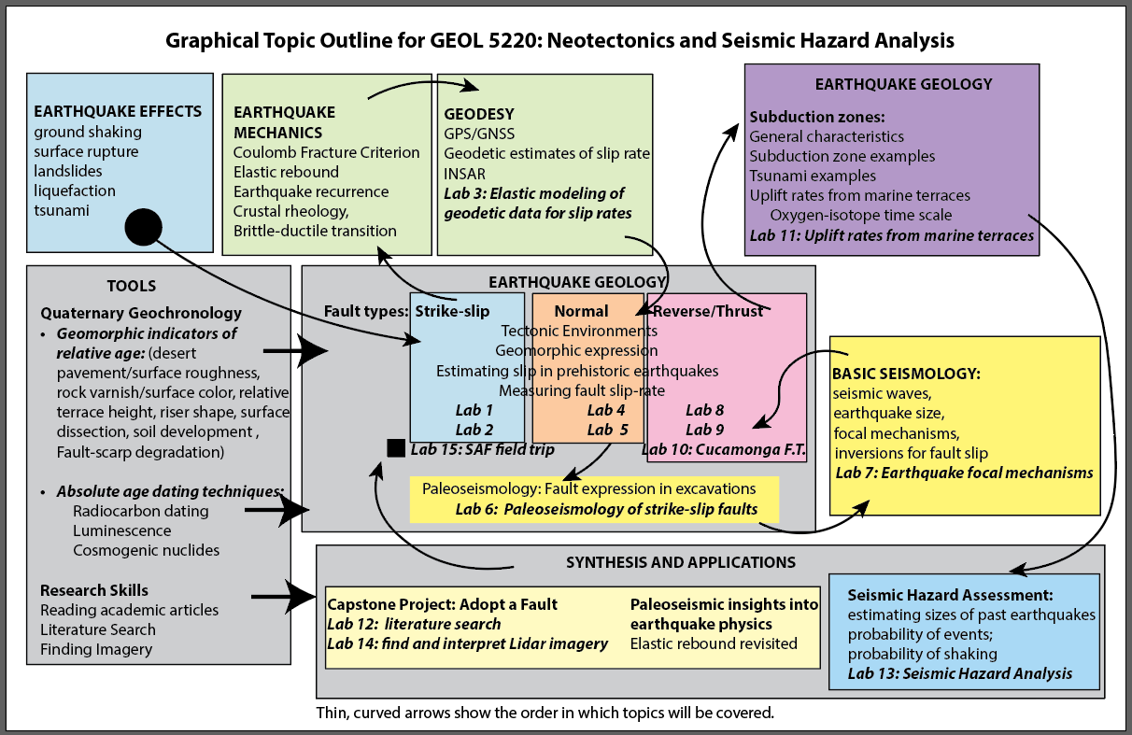

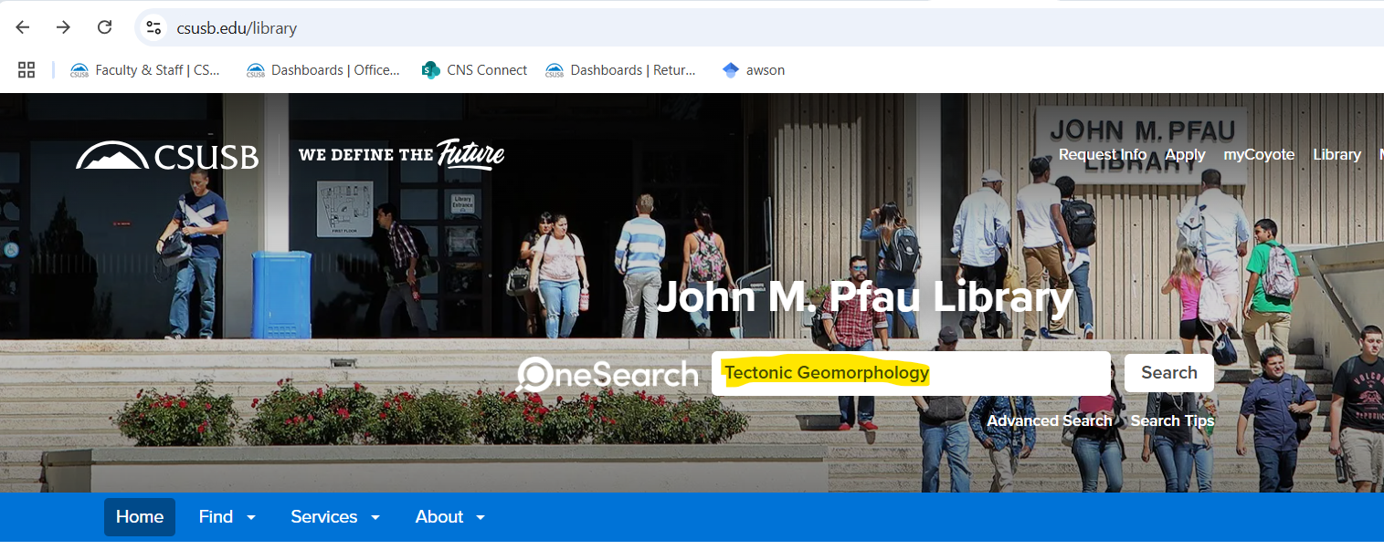

- That should take you to a page in which the Geology 5220 textbook (Tectonic Geomorphology, by Douglas Burbank and Robert Anderson, 2nd edition) is the first book in the list. Within the entry for this book, click on the link that says “available online”.
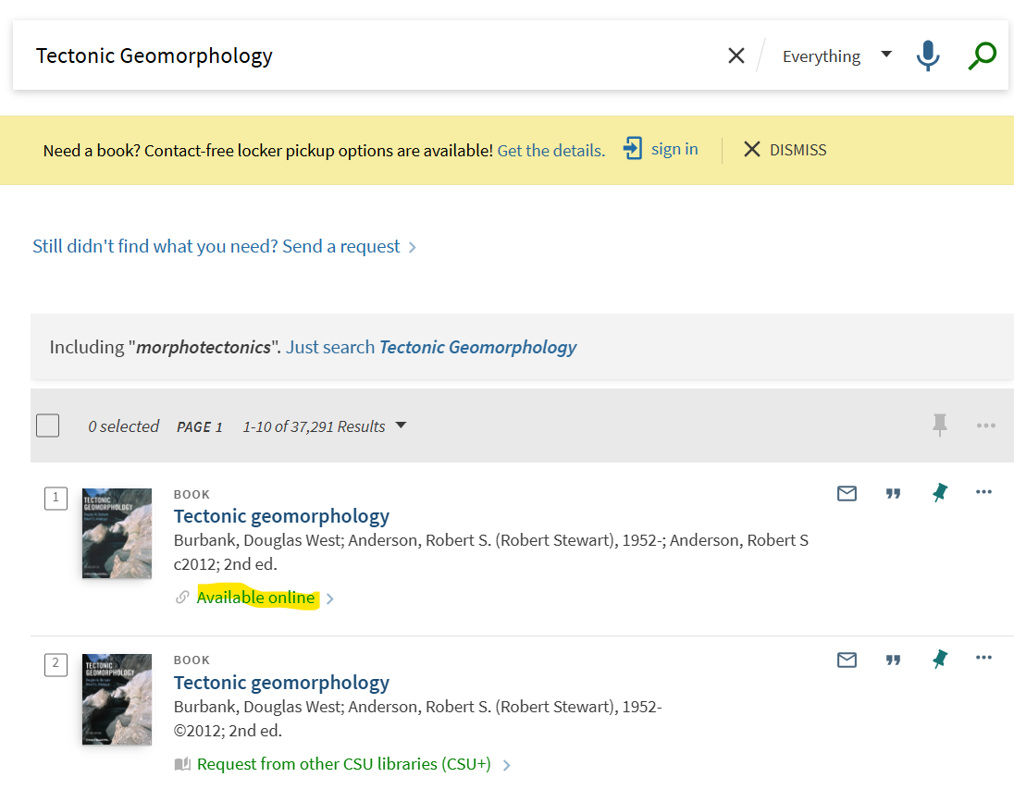
- That should take you to a page that looks like the screenshot below. Click on the link that says “ProQuest EBOOK Central Academic Complete”
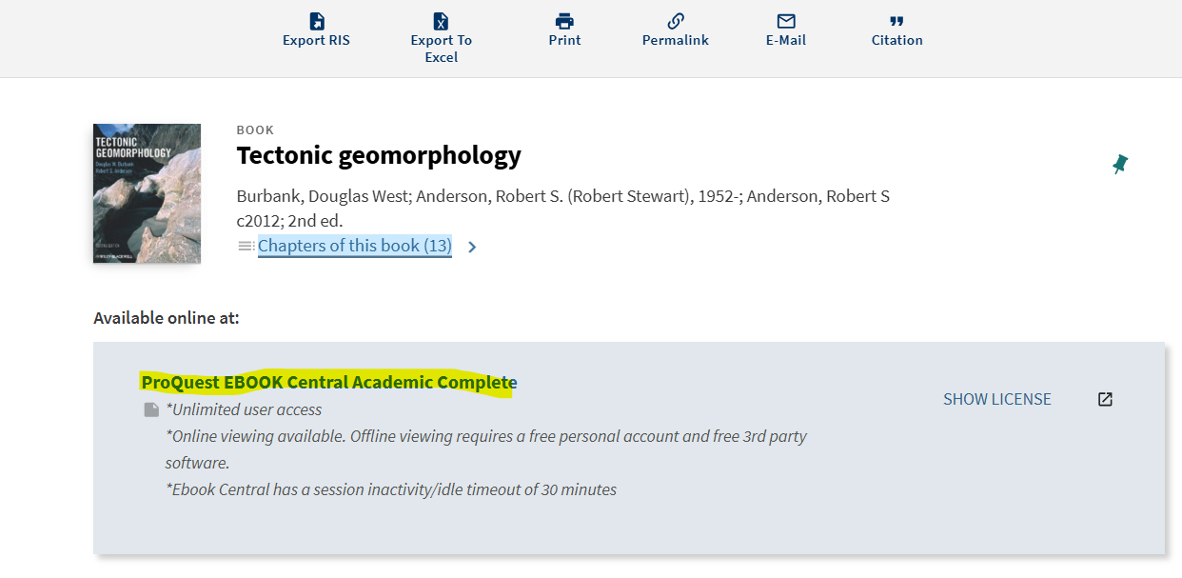
- That should take you to a page that looks like the screenshot below. From here you can
  - click on “Read Online” to read and highlight the book online
  - and/or click on “Download Book” to download the entire book using free software that will allow you to access the book for 180 days.
  - and/or click on “Download PDF Chapter” to download individual chapters as pdf files (up to a maximum of 96 pages) that you can keep as long as you want.
